I Want Jesus

Why is Jesus important to us?
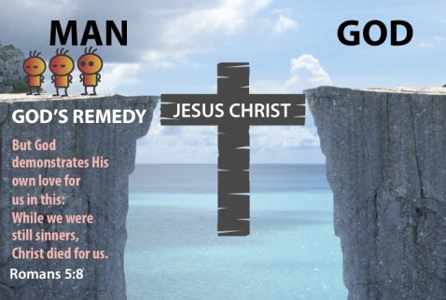
Jesus is the bridge to God
Jesus said, “ I am the way and the truth and the life. No one comes to the Father except through me. (John 14:6) Jesus’ sacrifice, made it possible to have a personal relationship with God. How to accept Jesus?
Romans 10:9, “that if thou shalt confess within they mouth the Lord Jesus . and shalt believe in thine heart that God hath shalt Him from the dead, thou shalt be saved.
What’s next?
Discipleship...Learning the Bible and living it daily.
If you want to know more, please click on Contact Us tab on the Home page.

