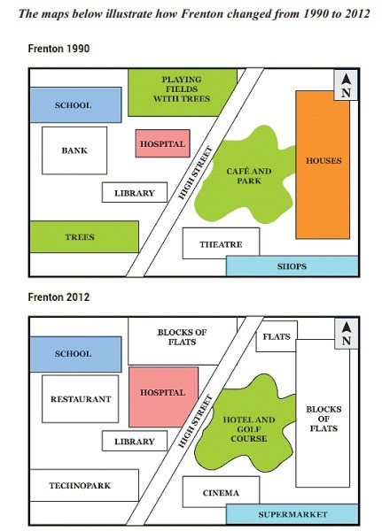

Outline

Intro: use format

Overview: trees cut down, more flats

Body 1: in 1990

* cover by trees
* left of High Street: a bank >< school, near small hospital
* right of High Street: a café and par, in front of houses
* several shops

Body 2: after 22 years 🡪 the decrease in number of trees

* southwest: tree cut down 🡪 technopark
* playing ground coverted into flats
* bank, café and park were destroyed 🡪 restaurant, hotel and golf
* hospital was extended
* theatre, library unchange

Given are the maps illustrating the transformation of the town called Frenton from 1990 to 2012.

Overall, the town witnessed radical changes with the cutting down of a lot of trees and the erection of more flats.

In 1990, the town was mostly covered by trees, especially in the southwest and north. Besides, to the left of the High Street, there was a bank which was opposite a school and near a small hospital. In addition, next to the High Street to the right is situated a café and park which is in front of houses, and there were several shops to the southeast ⇒ Thường mô tả nên mô tả từ phải sang trái

After 22 years, the most significant change is the decrease in the number of trees. Particularly, while the trees to the southwest were cut down to make way for a technopark, the playing ground with trees to the north was converted into flats. In fact, the bank and the café and park were both destroyed completely to give way for a restaurant and an area of hotel and golf course respectively. Moreover, the hospital was substantially extended whereas the theatre and the library remained unchanged. ⇒ Mình mô tả nó không theo hướng nhất định, nên là mô tả từ phải sang trái từ trong ra ngoài, nếu mà đã lỡ body 1 mô tả từ trái trước rồi thì body 2 theo thứ tự như vậy ở đây câu cuối mô tả ngược lại hospital

Words: 189

Tham khảo

* Overview:
  + It is clear that Frenton underwent a dramatic transformation over the period, becoming noticeably less green and more built up
* Body 1: map 1
  + Mô tả từ bao quát đến chi tiết:
    - Bao quát:
      * In 1990, Frenton was a small town, which was bisected into almost equal parts by the High Street.
    - Chi tiết (mô tả theo ngoài vào trong, phải sang trái)
      * Phải của High Street:
        + Some shops & a theatre were there towards the South-east of the street
        + Towards the East of the street, there were settlements (Houses) & a café and a park
      * Trái của High Street:
        + The four major establishments to the West of the street were a library, a hospital, a school and a bank
        + There was a playing field with trees at the North of the town, adjacent to the street.
* Body 2: map 2
  + Mô tả từ bao quát đến chi tiết (từ ngoài vào trong, từ phải sang trái )
    - Phải
      * Houses were developed to flats, which expanded towards the North.
      * The Café and park got transformed to a hotel and a golf course.
      * A supermarket replaced shops, whereas a cinema replaced the theatre
    - Trái
      * Trees at the South were cleared for a technopark.
      * A restaurant occupied the space of the bank.
      * the hospital increased its size.
      * The only places that remained the same in Frenton over the period were the school and the library.