Đề bài
The table shows the change in the number of cinemas in different regions in a European country between 2004 and 2009.
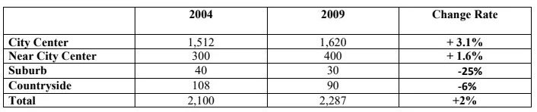

Tham khảo cách làm dạng table https://www.ieltstutor.me/blog/table
Presented is the table comparing the changes in the number of cinemas in five different areas in a European country for a duration of 5 years from 2004 to 2009.

As transparent from the statistics, the quantity of cinemas in City Center and Near City Center took a sharp upturn, while the figures for others fell dramatically during the surveyed period.

In 2004, the total number of movie theaters was 2,100, and the City Center area dominated at 1,512, while Suburb had the smallest quantity which was 300 cinemas. The data for Near City Center region was at 300 whereas Countryside had less than half the number of cineplexes which was 108.

In 2009, the total quantity of cinemas experienced an upsurge to 2,287, which witnessed a growth of 2%. More specifically, the figure for City Center rocketed by 3.1% to 1,620, and for Near City Center increased by 1.6% to 400. By contrast, both Suburb and Countryside areas had undergone a sharp decrease to 30 and 90 respectively which witnessed shrinking of 25% and 6% sequentially.
→ Bài làm mình triển khai ổn nhé, chỉ lưu ý đặc biệt ở Chủ Ngữ miêu tả số liệu nhé. Có thể tham khảo cách chia bố cục theo category sẽ dễ viết hơn nhé, mình sẽ gom những đối tượng có đặc điểm chung thành 1 nhóm, ở đây là những category tăng, nhóm khác là những category giảm bài sẽ rõ ràng hơn
  - Overall:
    - There were upward trends in the figures for City Center, Nearby City Center and the total
    - The most remarkable change could be found in Suburb area. >> IELTS TUTOR hướng dẫn Cách dùng danh từ "trend" tiếng anh
  - Body 1: Số liệu tăng (Total, City center, near city center)
    - Total: a slight rise of 2% from 2,100 cinemas in 2004 to 2,287 cinemas in 2009
    - City Center: The graph witnessed a growth of 3.1% from 1,512 in 2004 to 1,620 in 2009 in the number of cinemas, which constantly accounted for the highest numbers. >> IELTS TUTOR hướng dẫn Cách dùng danh từ "tendency" tiếng anh
    - Near City Center: the figure stood at 300 in 2004 and then slightly increased by 1.6% to 400 in 2009, which were one-fifth and one-fourth respectively in comparison with those in City Center.
  - Body 2: Số liệu giảm (Suburb, Countryside)
    - Regarding Suburb and Countryside, It demonstrates the opposite trend, with figures decreasing by 25% from 40 to 30 for the former and by 6% from 108 to 90 for the latter. >> IELTS TUTOR hướng dẫn Cách dùng động từ"soar"tiếng anh

