The Maddern Stones | Website

https://www.oldmanofthestones.com/blog/maddernstones

The Maddern Stones | Website text

Maddern Stones

Who is Ben Maddern
Ben is the original strongman of South Australia
Ben is South Australia’s first professional level strongman and the first man to showcase strongman events to crowds in South Australia.

Standing 6.6ft and weighing in at 135kg Ben represented a true mountain of a man and chose to live and compete as a natural athlete, in search of his natural strength limits.

The evolution of strongman in South Australia
Ben started training strongman events in his backyard with equipment he designed and had fabricated in 2002. Two years later Ben was carrying 125kg in each hand for 70 metres as a natural athlete, at the time a world class achievement.

Ben’s accomplishment led to showcasing his strongman demonstration at the annual Mt Barker Highland Games. This represented South Australia’s first glimpse of live strongman action and the crowd loved it.

South Australia’s Strongest Man Competition.
Ben’s commitment to strongman propelled him to win the South Australia’s Strongest Man title five times between 2005-2009. During this time Ben also competed nationally against Australia’s best strongmen with the Tartan Warriors.

After retiring from competitive events Ben continued to support the growth of strongman in the state by organising South Australian Strongman and Strongwoman competitions, including events at the Royal Adelaide Show.

Ben’s grip strength
Ben is a world class athlete but what defines Ben is his his unbelievable grip strength. This is evidenced by once carrying a pair of 110kg (each hand) farmers walk handles continuously for 110 meters. Amazingly, ben he had to turn 180 degrees every 25 meters.

Ben’s Strongman legacy
Ben, affectionally known as “Big Ben”, is a Legend in South Australia’s strength community and has built the foundations for the sport in South Australia.

These stones are made by Adelaide Hills Sandstone as a testament to Ben’s world class grip strength and a lasting reminder of the legacy he created.
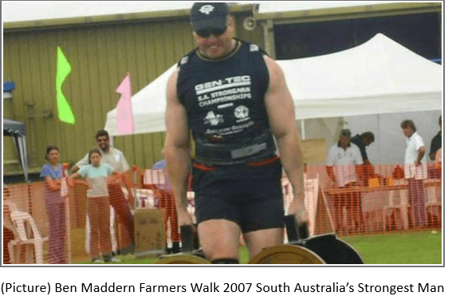

The stones
This set of stones came from the local Basket Range Sandstone Quarry in South Australia. Neil Mullard (OAM) is the mastermind behind finding and crafting these stones.

From the original location the stones have found a new home, to be looked after by the awesome team at the Uraidla Hotel, the “Best Pub in Uraidla”.

The handles were crafted by Cliff Waters Lewis. Their unique styling creates a formidable grip challenge. These stones weight 112kg and 117kg, 227kg in total.

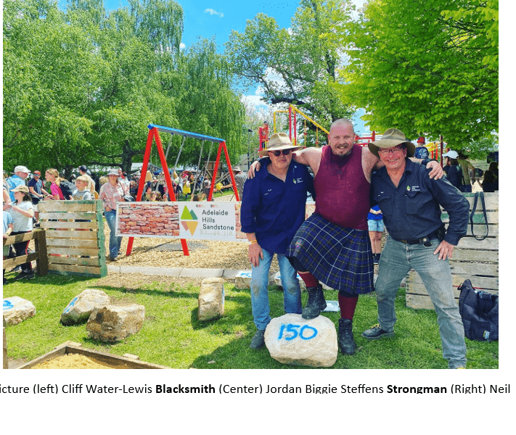

The Home
Yureidla, meaning the place of the two ears – referring to the profile of Mount Lofty and Mount Bonython, when viewed against the skyline. The shape being similar to the ears of a mythical creature in the folklore of the Kaurna Aboriginal people.
Uraidla was not a surveyed township, but rather developed over time on land owned by the Cutting, Wilcox, Wotton and Dyer families. A cluster of houses and other buildings gradually evolved over the years into the gardening and fruit-growing township we now recognise.

The Uraidla Hotel
The Uraidla Hotel is located in the Adelaide Hills, the heartbeat of the vibrant yet quaint Uraidla township the pub presides over. After undergoing a significant four-year renovation and re-opening in 2016, the iconic pub is a must-visit gem amongst the rolling Hills landscape.
Edmund Wilcox was involved with the Uraidla Hotel from 1867 until 1883. In 1892, the hotel comprised over 3 acres with the hotel having 21 rooms and stables.
As with most country pubs, the Uraidla Hotel became an important part of local life both as a gathering place but also a meeting venue for local organisations ranging from sporting groups to lodge meetings and church congregations.
The hotel property was originally much larger than we see today. Wilcox’s orchard, garden and paddock at the rear of the hotel are now the Uraidla Oval, Memorial Park and Uraidla Showgrounds.
The Uraidla Hotel has had numerous owners and licensees over the last 150 years. A change of ownership occurred in 2015 when the hotel was purchased by the Peter family. It reopened to much acclaim in August 2016 following extensive renovations. A bakery and brewery have since been established in the adjoining building. This initiative has been a major driving force in the revitalisation of the township in association with the community-based group Imagine Uraidla.

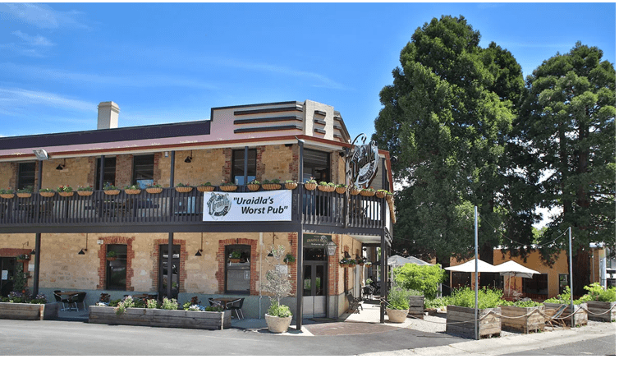

The Challenge
This lift challenge pays homage to Ben Maddern’s unbelievable grip strength. The weight is merely one consideration, alongside an individuals willpower and determination to hold on.

The challenge is to lift the two stones together off the ground and hold as long as possible. The time will start when you the stones have been elevated and a standing locked-out position (legs fully straightened, body upright and braced) is achieved.

This will be considered a successful lift and the timer will stop when any part of either stone hits the ground. No grip assisting equipment is allowed.

Lifting the stones can be attempted in two ways:
- Straddle style, where the lifter stands over the stones, usually with one stone in front and one behind for a more mechanically advantaged position
- A side-by-side style

Housekeeping
- The Indemnity Waiver is to be signed before any attempt to lift The Maddern Stones.
- The stones can only be lifted from the rubber mats.
- Respect the stones by lowering them in a controlled manner.
- Respect the rules and the adjudicator of the lift.
- Complete the paperwork to ensure your attempt is documented.

