The two maps illustrate the changes of a school campus from 1985 to 2012.
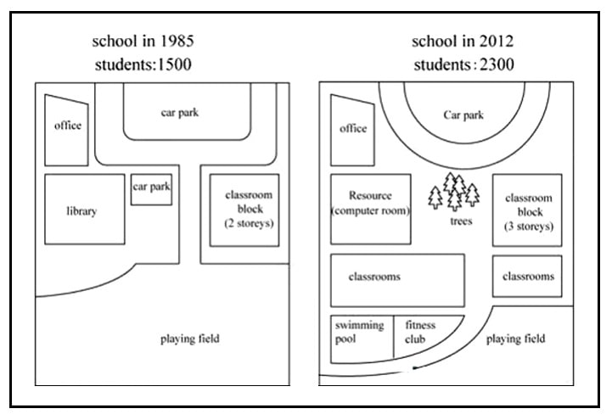
Given are the two pictures delineating the development of a school campus during a period of 27 years, starting from 1985.
In general, it is clearly evident that there were various shifts taking place in the school such as the presence of new classrooms and the shrinkage of a playing field.
Regarding the diagram in 1985, around 1500 students enrolled in the school. An office was located in the Northeast corner. Next to the office building, there was a car park. To the south of the office, a library and its car park were constructed. In addition, the area opposite them was a 2-storey classroom block. Towards the south, there was a playing field. → Thật ra nên mô tả từ bao quát đến chi tiết trước nha, cái bao quát nhất của Map 1985 chính là playing field (rất rộng) → nối đến car park qua 1 street (an enormous playing field was linked to a big car park through a street) >> Sau đó mình sẽ nên mô tả office >> library with a smaller car park >> opposite là a two-storey classroom block https://www.suabaiieltswriting.com/blog/cach-mo-ta-map-ielts-writing-tu-bao-quat-den-chi-tiet-tu-ngoai-vao-trong-tu-phai
According to the map in 2012, further transformations could be seen when the number of students increased to 2300. One of the significant change to the area was that the school built another storey for the classroom block and converted a part of the field into two classrooms. The year 2012 witnessed the erection of a swimming pool and a fitness club, which led to the reduction in size of the original playing ground. Besides, both the library and the park were demolised to make way for a computer room and trees. The office building and the car park remained unchanged. ⇒ Mình chưa thống nhất mô tả bao quát đến chi tiết nên trình tự 2 đoạn thân bài chưa thống nhất với nhau, còn lộn xộn thứ tự ý nha. Tóm lại 2 đoạn thân bài trước tiên mình xét cái bao quát nhất là playing field >> big car park >> Sau đó mình sẽ nên mô tả office >> library with its smaller car park >> opposite là two-storey classroom block. Tương tự với các sự thay đổi nhé cũng lần lược xét từng vị trí theo thứ tự như này nha (đương nhiên có chọn lọc thông tin để mô tả cho gọn ko mô tả hết ra vì bài sẽ bị dài)

