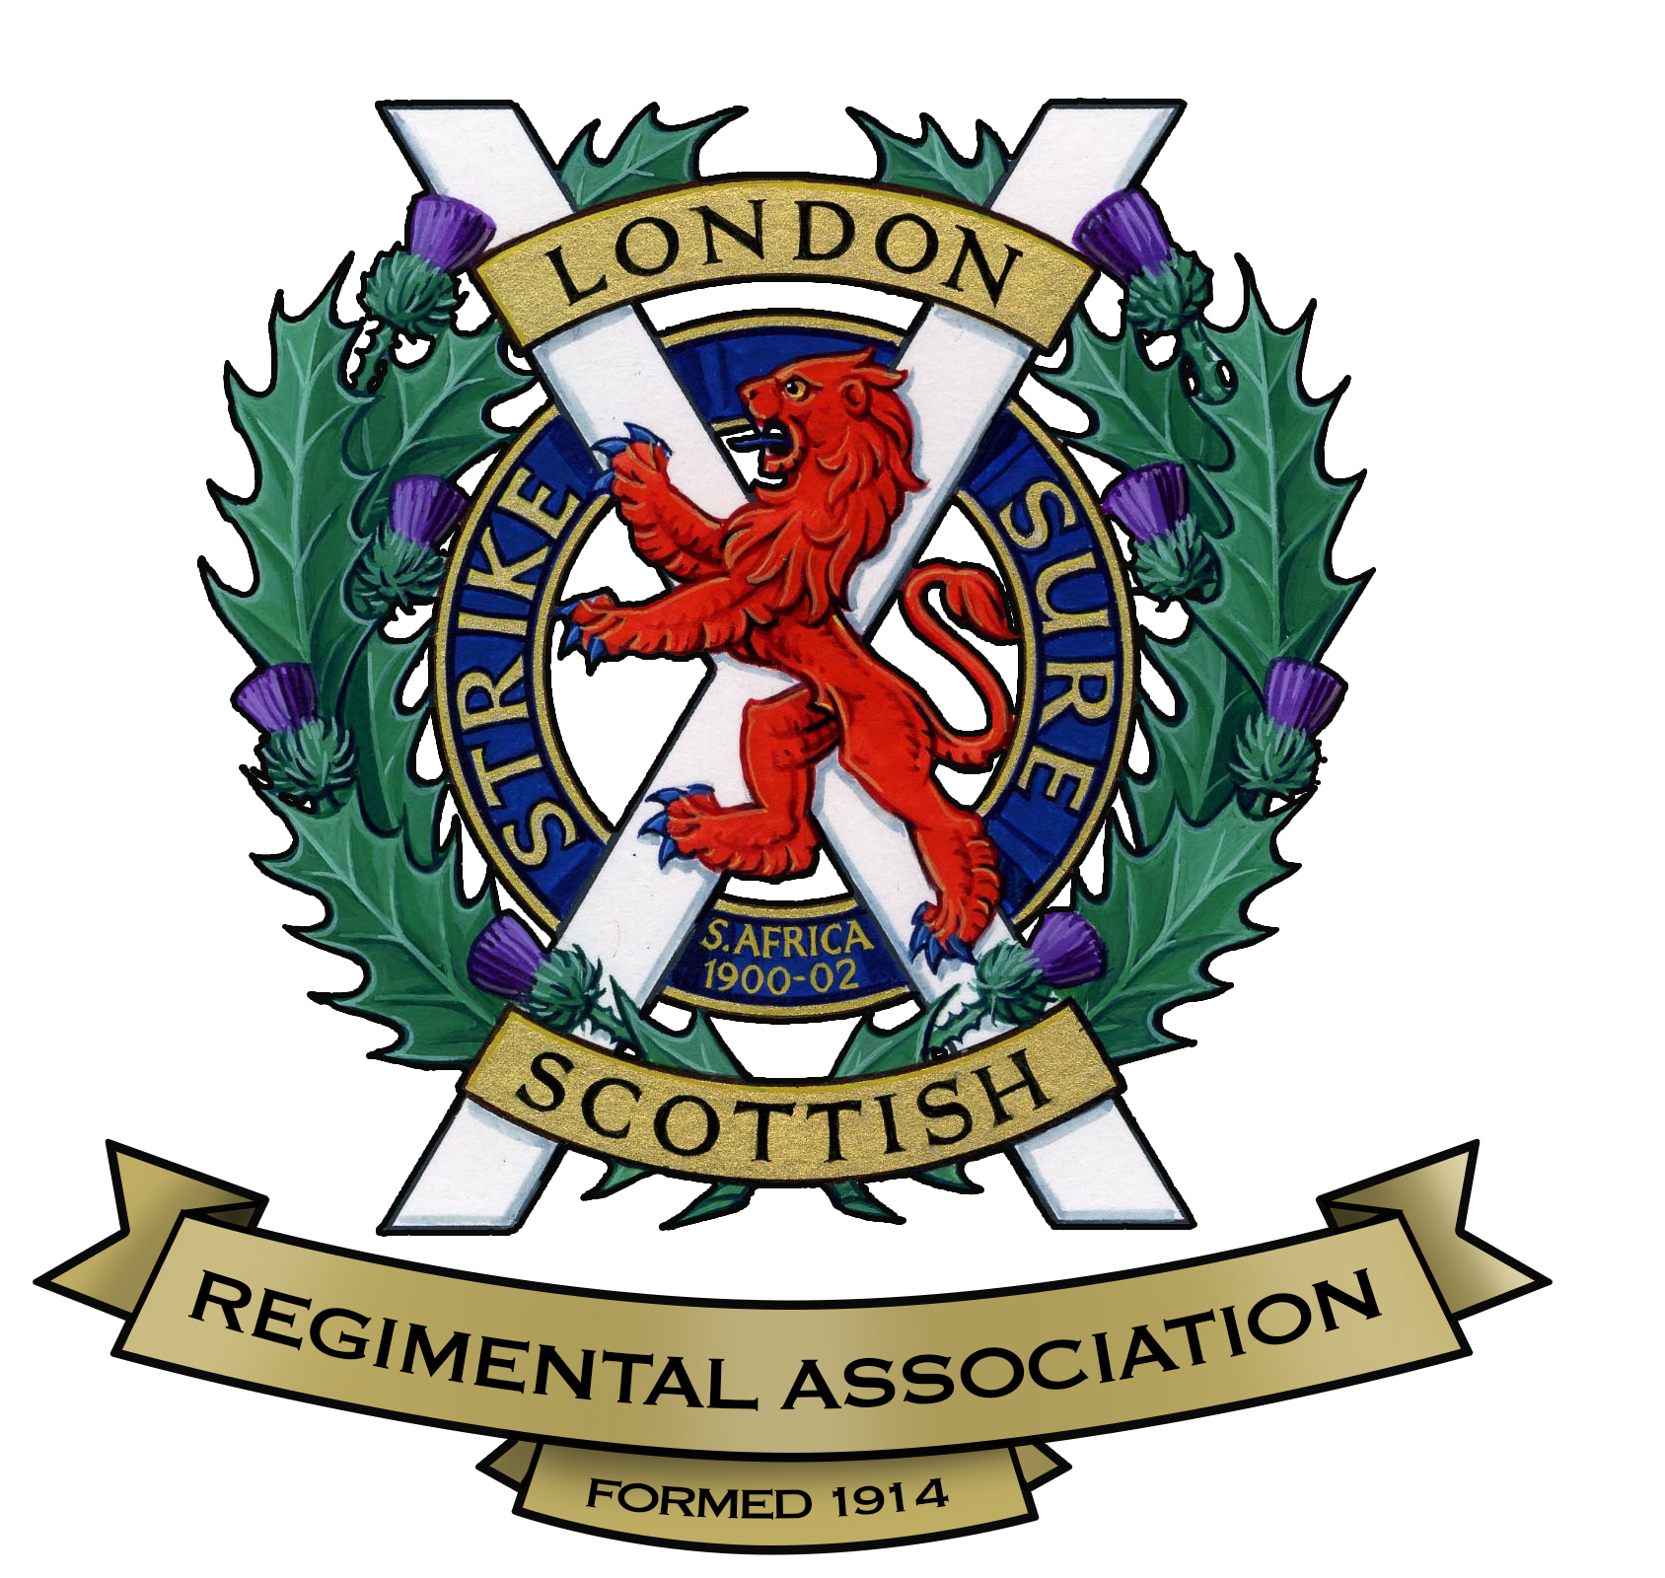

LONDON SCOTTISH REGIMENTAL ASSOCIATION

APPLICATION FOR MEMBERSHIP

The objects of the London Scottish Regimental Association are:-
- To preserve that spirit of comradeship which exists and has always existed amongst all ranks of the London Scottish Regiment, and to keep in touch with members overseas.
- To promote the well being of serving units and sub-units of the London Scottish Regiment and units and sub-units bearing that name in their title, especially as regards recruiting.
- To provide opportunities for reunions and other social and military gatherings.
- To provide a channel of communication with the various Benevolent and other Funds for members and their dependents in need of assistance.

I am applying to become a member of the London Scottish Regimental Association and agree that the Association will retain my personal information in accordance with the GDPR Policy of the Association.

Name……………………………………………………………………………………………………

Address…………………………………………………………………………………………………

Tel No. ……………………………………… E-mail address……………………………………….

Date Joined ………………. Army No.………..………… Rank………..……… DOB……………

Date of Discharge……………… Decorations……………………………………………………....

Service in other units…………………………………………………………………………………...

Or I did not serve in any constituent unit of the London Scottish but wish to join because…………………………………………………………………………………………………..

An immediate payment of £15* is required for membership, and thereafter an Annual Subscription of £15* for UK residents (£20* for overseas members) payable on 1st November each year.

Please note, a failure to pay the subscription on time will result in a cancellation of your membership. Payment by bankers order or electronic transfer using the below proforma is preferred.

(* Annual subscription rates are subject to periodic review)

The Manager ………………………………………………………………… Bank/Building Society

Sort Code ………………. Account Number………………………………………………………

Branch Address……………………………………………………………………………………….... …………………………………………………………………………………………………………….

Please pay the sum of £15 / £20 on the 1st November next and annually until cancelled by me to the National Westminster Bank, 57 Victoria Street, London SW1 0HN (sort code 56 00 33) to the account of the London Scottish Regimental Association a/c no. 48278092

Signature ……………………………………………………………………….. Date ……………..

Full Name………………………………………………………………………...

Address…………………………………………………………………………………………..……….……………………………………………………………………………Post Code……………..….

LSRA Members are entitled to full benefits including attending functions, events, reunions, battlefield tours and receipt of the Regimental Gazette. It is customary for members to attend headquarters on the 1st Thursday of each month.

ONCE COMPLETED PLEASE SEND TO THE HONORARY SECRETARY:
Martin Felstead, 41 Carlton Road Walton-on-Thames Surrey KT12 2DF
mjfelstead99@gmail.com
v.20211028

