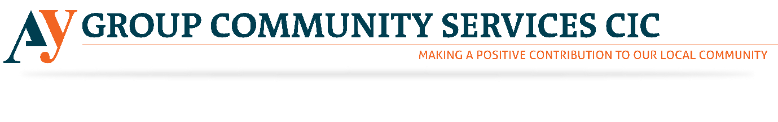
Fundraising Volunteer
AY Group is currently hiring Fundraising Volunteers for its community service organisation. Please see below to find the detailed information regarding the roles mentioned above. With increasing Knife crime, AY Group has started selling First Aid Courses to train the people to stay safe. Please revert us if the above-mentioned opportunity excites you. However, through this noble job, you will get a chance to give something back to the society. Our society needs your hearty support. Please come and join us to this noble venture.

About AY Group CIC
AY Group CIC aims to offer a facility that will provide social, educational, recreational and wellbeing activities in a safe and secure community environment. We will also promote community cohesion through dialogue and discussions at the centre where all groups from diverse backgrounds will be welcome.
Who are we looking for?
The role of the fundraising volunteer is to administer and contribute to the development of the organisation’s external communications activities. We need someone who can focus on assisting the Senior Management and directors to generate funding from relevant funders.

Tasks
- Conduct research on potential funding opportunities
- Maintain and update fundraising databases
- Organise and help with traditional fundraising activities such as sponsored or promotional events, raffles, business-to-business and street collections
- Work with mass media to promote events.
- Recruit and coordinate the work of volunteers during organised events
- Assist in preparing funding proposals and reports
- Assist in managing relationships and communications with individuals, corporate
- and government bodies.
- Approach individuals, schools, universities, local authorities, shops and commercial organisations for sponsorship and donations
- Develop new fundraising ideas and events.
- Create reports related to AY groups activities.
- Ensure AY group CIC’s digital fundraising communications are up to date, relevant and engaging.

Skills and qualifications required
While no formal qualifications are required we would like volunteers to have the following skills:-
- Good knowledge of fundraising, previous experience of fundraising is not essential but is useful
- Excellent working knowledge and comprehension of written English
- Demonstrative proficiency in the use of Microsoft Office including PowerPoint, Excel and Word

- Able to work as part of a team, liaising regularly with the Marketing volunteer
- Committed to producing high standards of work
- Reliable and organised
- Flexible and able to volunteer during the evenings and weekends
- Able to work to tight deadlines
- Able to travel as and when required to meetings and funding event.
- Good communication skills both written and spoken
- Innovation and the ability to develop resources
- Good timekeeping

Commitment required
The volunteer will need to be able to attend AY Group CIC two to three times per week arranged in advance. We need a volunteer to commit to at least three months.

Induction and Training
Volunteers will receive a full induction into AY Group CIC and training relevant to the role of an AY Group CIC fundraising volunteer.

Support and supervision
All volunteers will be offered ongoing support by the CEO of AY Group CIC.

Recruitment process
Volunteers will need to complete an application form before being invited for an informal discussion with the Director and the CEO.

Screening
- Volunteers are asked to provide details of two referees on their application form. Volunteers who are unable to provide this information a trial period will be arranged.
- Volunteers need to be DBS checked for this role

Benefits to the volunteer
- Gain experience in a third sector organisation
- Develop transferable skills or enhance your existing skills
- A reference for volunteers seeking paid employment
- Continued support with your professional development from AY Group CIC staff members and trustees

