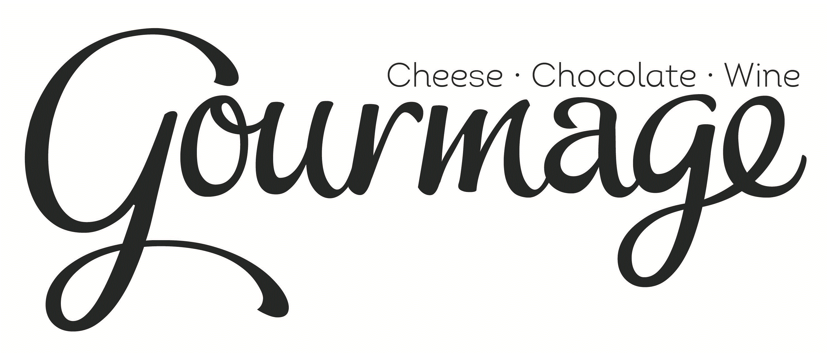
ITEMS IN INVENTORY FOR PARKING-LOT PICKUP March 30, 2020
Perishables/Staples | Price
Eggs (limit 1 dozen) | 3.00
Green onion (bundle of 5 large) | 1.50
Yellow onions | 1#/1.50
Lemons (limit is 1 order, which is 2 large lemons) | 2 for $1.00
Cucumbers (limit is 1 order, which is 2 cukes) | 2 for $1.50
Red Potatoes (limit 2 pounds) | 1# for $1.50
Broccoli crowns (about 12 oz); limit 1 | 1.25 each
Fresh Celery bunch; limit 1 | 1.50 each
Fresh carrots (large) | 1#/1.00
Flour (limit 2#) | 2#/1.50
Sugar (limit 2#) | 1#/1.50
Brioche Slider Rolls | 7.00
Orowheat Wheat Bread (24 oz) | 4.50
French Baguette (full size) | 3.50
French Baguette (mini) | 2.50
Shredded Gruyere | 4.00
Shredded Swiss | 3.00
Shredded Sharp Cheddar (8 ounces) | 3.00
Shredded Monterey Jack (8 ounces) | 3.00
Shredded Queso Quesadilla (8 ounces) | 3.00 (great for tacos/enchiladas/etc.!)
Fresh mozzarella (8 ounce ball) | 6.00

Custom Cut Cheese | Description | Milk | Price per HALF-POUND
Goat cheese truffles | Fresh chevre, flavored with garlic and herbs; 1-oz each | Goat | 2.00/each
Belletoile | Our best seller; triple cream Brie from France | Cow | 8.25
Prairie Breeze | Domestic young cheddar, with “crystals”; a best-seller | cow | 10.45
Cottonwood Cheddar | New at Gourmage! Raw milk, and aged 2 years for a bold flavor with a bit of sweetness and a touch of citrus. Also crystalized. | Raw cow | 10.50
Red Leicester | A bright orange English cheddar, crumbly and crystalized | cow | 11.61
Irish Cheddar | Aged 12-18 months, with full, rich flavor | cow | 5.50
Classic Sharp Cheddar | A nice basic cheddar for snacking or grating | Cow | 6.00
Feta | Great for crumbling on a salad! | cow | 6.50
Manchego 12 | Aged to perfection; nutty and firm-textured. Perfect with fig jam. | sheep | 10.52
Taleggio | A washed-rind beauty from Italy; a stinky rind with lovely, milky paste | cow | 9.43
Gruyere | A cave-aged, nutty, semi-firm cheese; if you like Swiss, you’ll love this | cow
Vela Dry Jack | Aged Monterey Jack. Firm and crumbly. A customer favorite. | Cow
Mango Ginger Stilton | A sweet cheese option! | Cow | 10.97
Stilton | The original Stilton; a classic English blue cheese | Cow
Grand Noir | From Germany; described as blue cheese and Brie had a baby. Very soft. | Cow | 15.00
Smoked Gouda | Smooth, rich and mellow; great with salami! | Cow | 5.45
Ammerlander | An alpine-style cheese smoked with Beechwood; great for snacking | Cow | 7.50
Pecorino Romano | The classic Italian sibling to Parmesan if you’re making Italian food. | Sheep

Other Goodies |  | Price per container
Stuffed Peppadew Peppers | Stuffed with garlic herb eurocreme (think cream cheese texture); 4 ounces | 6.00
French Cornichons | Tiny French dill pickles; 4 ounces | 4.00
Fig jam | Classic with cheese; 5 ounces | 4.00
Hummus with extra virgin olive oil (EVOO) and black pepper | 8 oz | 4.00
Hummus with EVOO and bourbon-smoked paprika | 8 oz | 4.00
Chicken Salad | One of the things we’re best known for! | $6 for ½#  $10 for 1#
Pimento Cheese | Perfect for Springtime; 7 oz | $4.00
Mac N Cheese | Sharp Cheddar, Smoked Gouda, Mushroom Swiss | 8.00 each
Sliced Hard Salami | Order by weight (doesn’t have to be a pound); ¼ pound is approximately 18 slices | $18 per pound
Sliced Prosciutto | Order by weight (doesn’t have to be a pound); ¼ pound is about 7 slices | $20 per pound
Marcona almonds | Spanish almonds that have been fried and salted; classic with Manchego but great with anything | 7.00
French Croissants | Baked, or frozen for you to bake at home | 2.50 each
Crackers | Firehook Multi Grain Flax; organic 5.5 oz | 9.00
 | La Panzanella Mini Croccantini; non-gmo 6 oz | 7.00
 | 34 degrees; Toasted Onion 4.5 oz | 6.50
 | Carr’s Table Water Crackers 7 oz | 6.00
 | Carr’s Whole Wheat Crackers 7 oz | 6.00
 | Carr’s Table Water 2.2 oz | 3.50
 | Everything & More Wisecrackers Flatbread 4.9 oz | 8.00
 | La Panzanella Gluten-Free Oat Thins; roasted garlic | 7.00
 | Castleton Crackers Multi-See Rye; non-GMO | 8.50
Olive Oil | Pons EVOO Arbequina 500 ml | 16.00
 | Iliada EVOO Kalamata 500 ml | 13.00
Maya Kaimal | Tikka Masala Indian Simmer Sauce Mild | 8.50
 | Tikka Masala Indian Simmer Sauce Spicy | 8.50
 | Spicy Ketchup | 7.50
Cheese Tray To Go | Three cheeses, fig jam, salami, prosciutto, grapes, walnuts, Marcona almonds, mini baguette. Cheeses are Red Leicester (English cheddar), Classic Gouda and Black Garlic Havarti | 21.00
Cheese Platters | Please see the Shop Online tab on our website
NUTELLA cheesecake | By the slice | 4.00
Limoncello Mascarpone Cake | By the slice | 4.00

WINE/BEER |  | Prices include tax
Rodney Strong | Cabernet Sauvignon | $20
Callaway | Cabernet Sauvignon | $15
Blackstone | Cabernet Sauvignon | $10
Rex-Goliath | Cabernet Sauvignon | $10
La Terre | Cabernet Sauvignon | $10
La Terre | Merlot | $10
Kudaw | Cinsault | $15
PWR (CA) | Red Zinfindel | $20
Tinto Negro | Malbec | $15
Honoro Vera | Rioja Tempranillo | $15
Decoy | Rose | $15
Imagery | Sauvignon Blanc | $20
Simi/Sonoma | Sauvignon Blanc | $15
Yalumbo The Y Series | Viognier | $15
Rex Goliath | Pinot Grigio | $10
LangeTwins | Moscato | $15
La Terre | White Zinfandel | $10
Simi/Sonoma | Chardonnay | $15
Ava Grace | Chardonnay | $10
Wycliff | Sparkling Rose | $10
Wycliff | Brut | $10
Modelo Negra | each | 2.50
Stella Artois | each | 2.50
Dos Equis | each | 2.50
AquaBrew Ape-Pricot | Made in San Marcos | 2.50
Karbach Love Street | Made in Houston | 2.50
White Claw | Raspberry, watermelon, tangerine, lemon | 2.50
Bud Light | Each | 1.50

