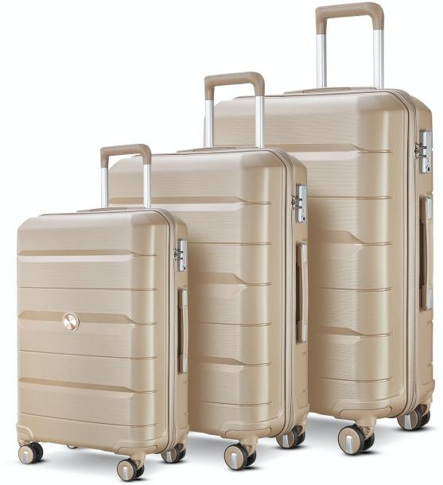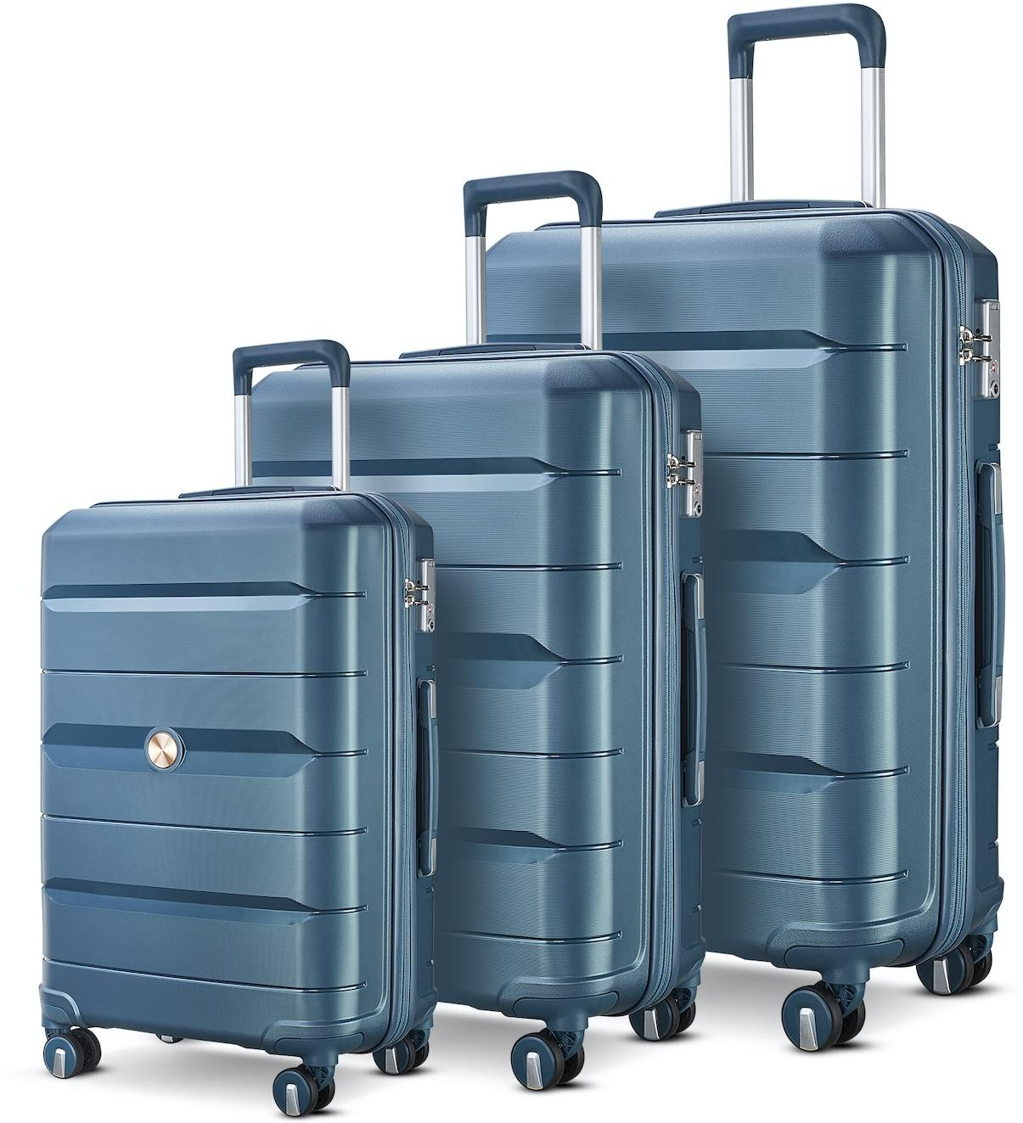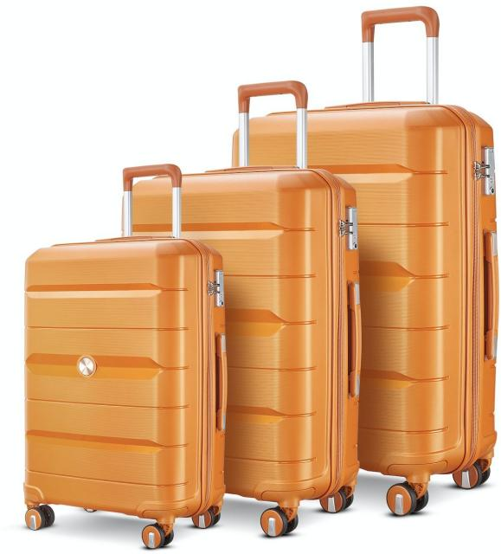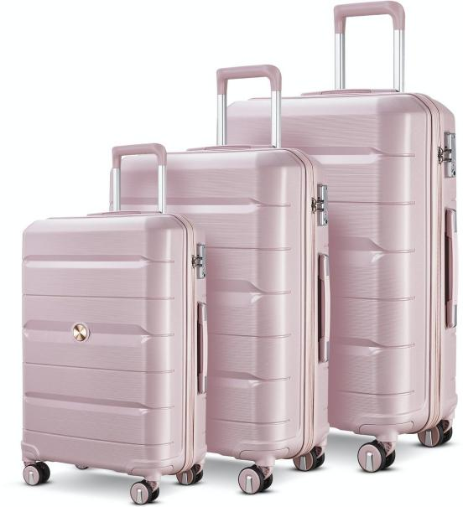

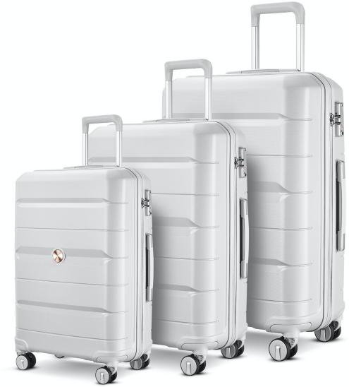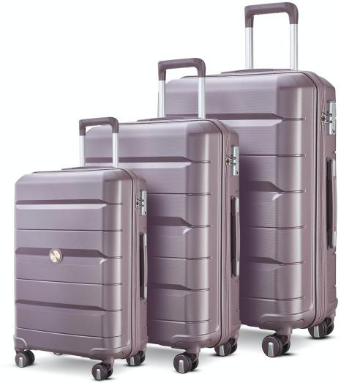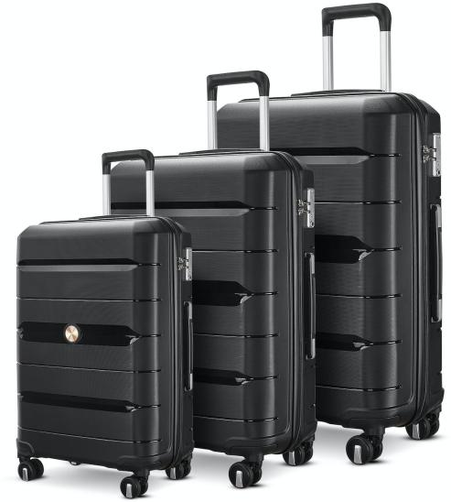

100%PP HARDCASE COLLECTION
Integral Colour Matching

100%PP ZIPPER STYLE

$ 59 USD
(FOB shenzhen)
ZIPPER: YKK ANTI THEFT ZIPPER SIZE: 20IN/24IN/28IN
WHEEL: 360° TWIN WHEEL（8 WHEELS）

LOCK: TSA RECESSED LOCK TROLLEY: ALUMINUM

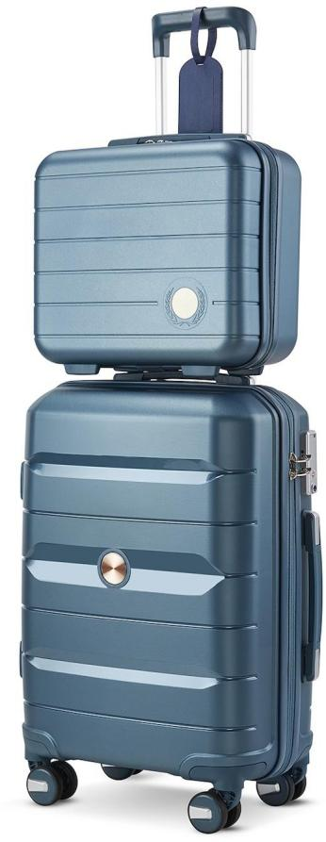
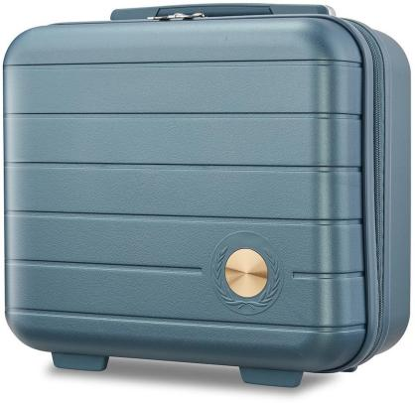
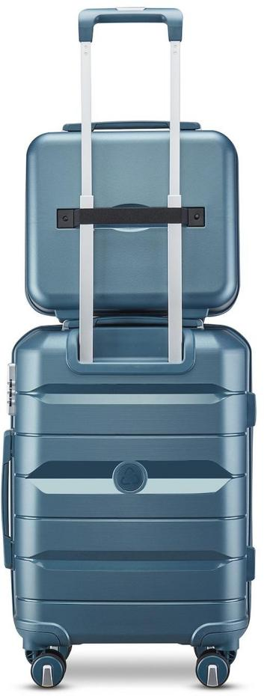
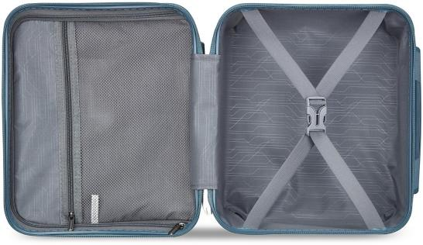
100%PP HARDCASE COLLECTION
Integral Colour Matching

100%PP ZIPPER STYLE

$ 64.5 USD
(FOB shenzhen)
ZIPPER: YKK ANTI THEFT ZIPPER SIZE: 14IN/20IN/24IN/28IN
WHEEL: 360° TWIN WHEEL（8 WHEELS）

LOCK: TSA RECESSED LOCK TROLLEY: ALUMINUM

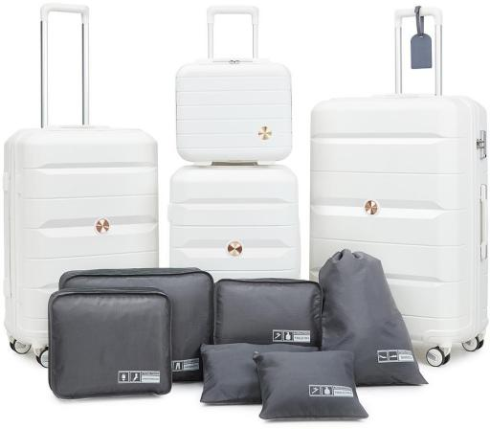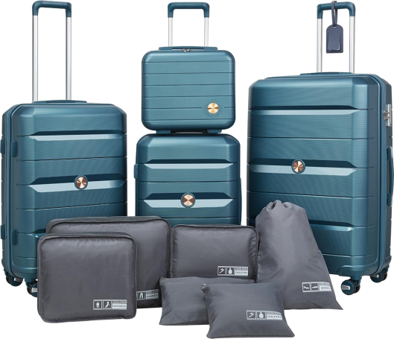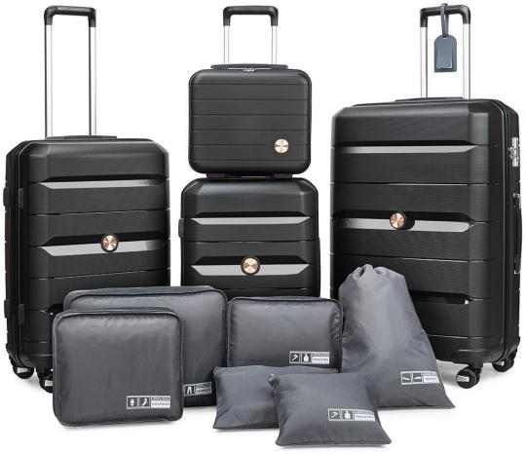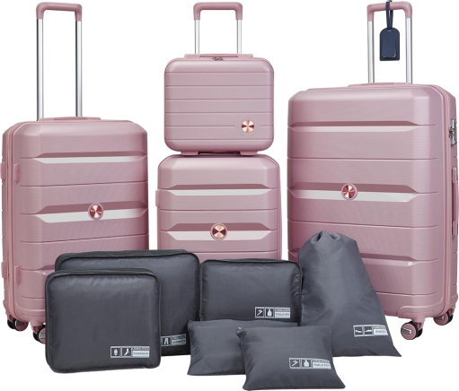
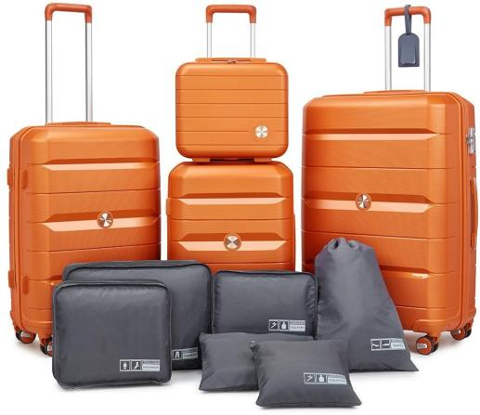
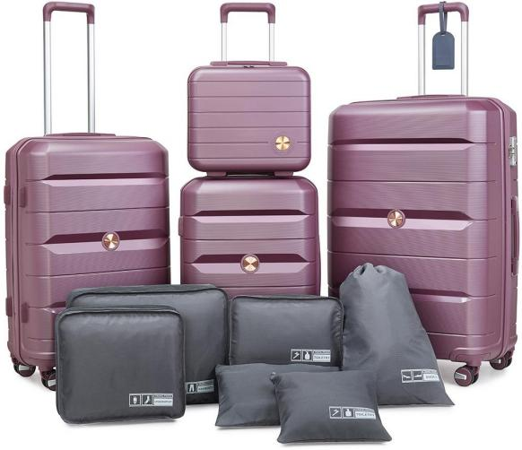
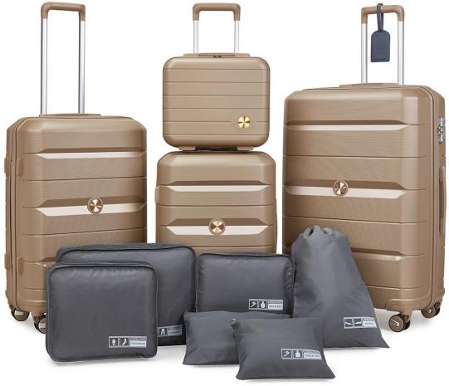




100%PP HARDCASE COLLECTION
ZIPPER: YKK ANTI THEFT ZIPPER SIZE: 14IN/20IN/24IN/28IN
(6 in one Wash a bag）

LOCK: TSA RECESSED LOCK TROLLEY: ALUMINUM


Integral Colour Matching

100%PP ZIPPER STYLE

$ 69 USD
(FOB shenzhen)
WHEEL: 360° T）WIN WHEEL（8 WHEELS）

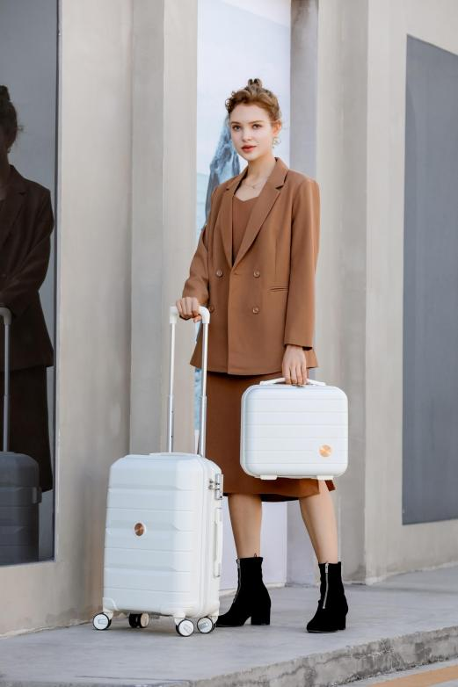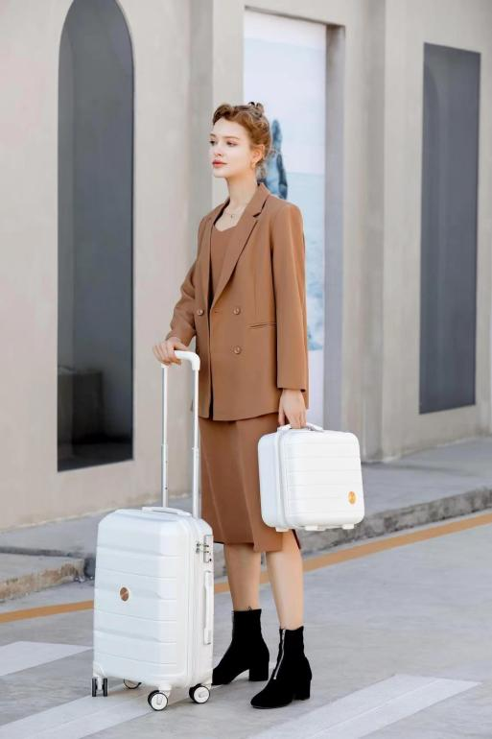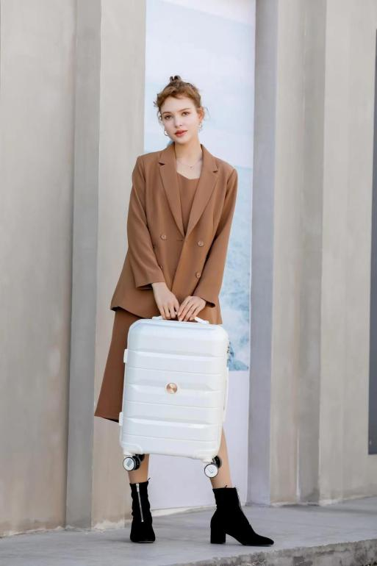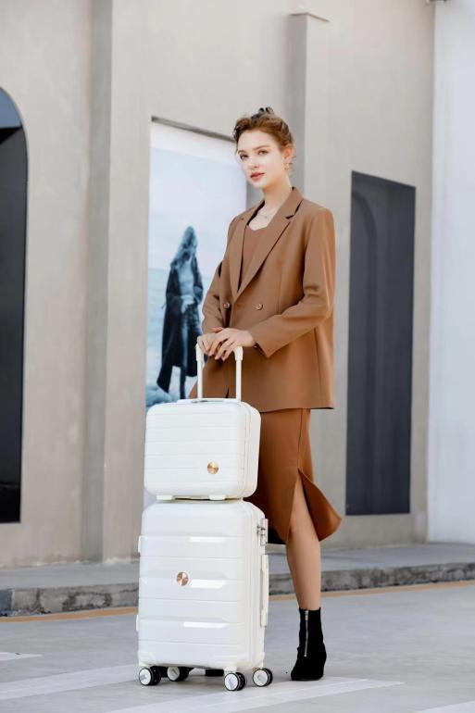
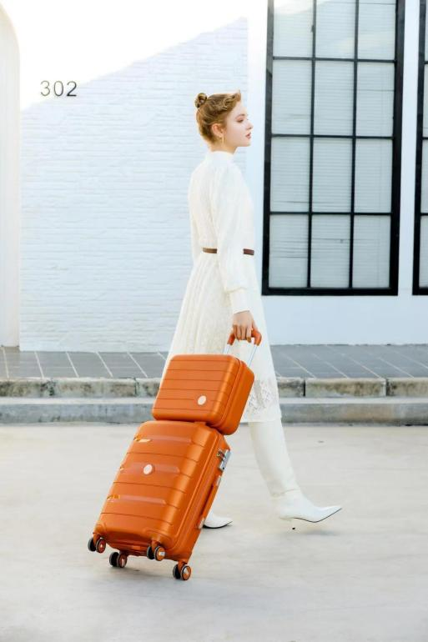
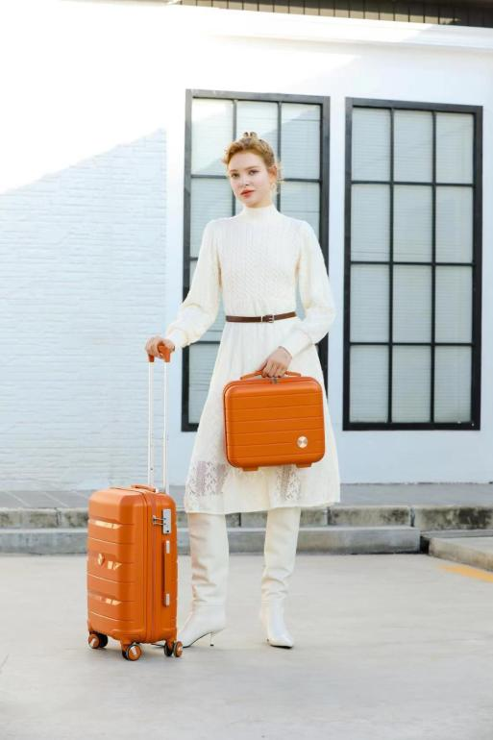
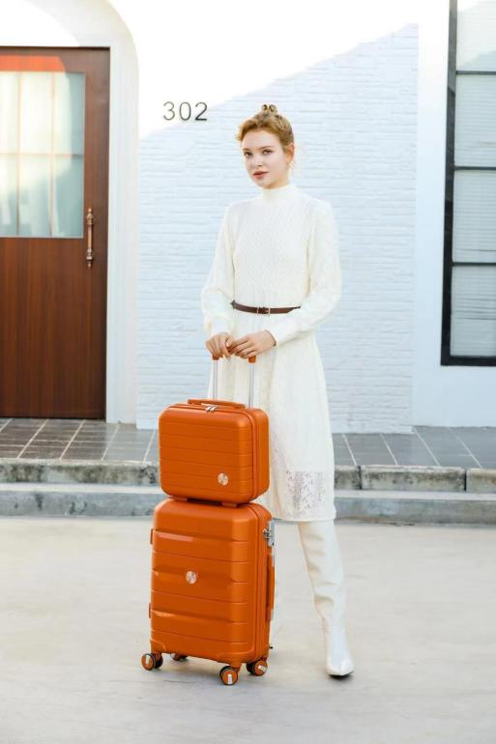
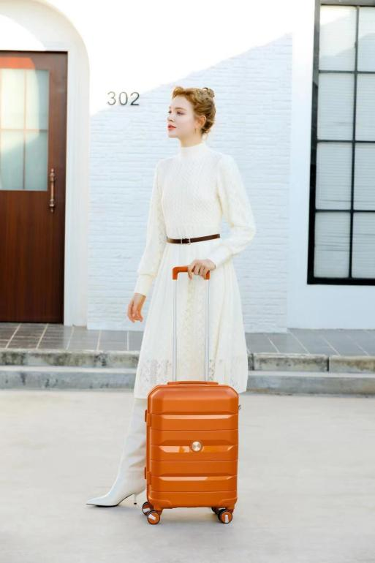

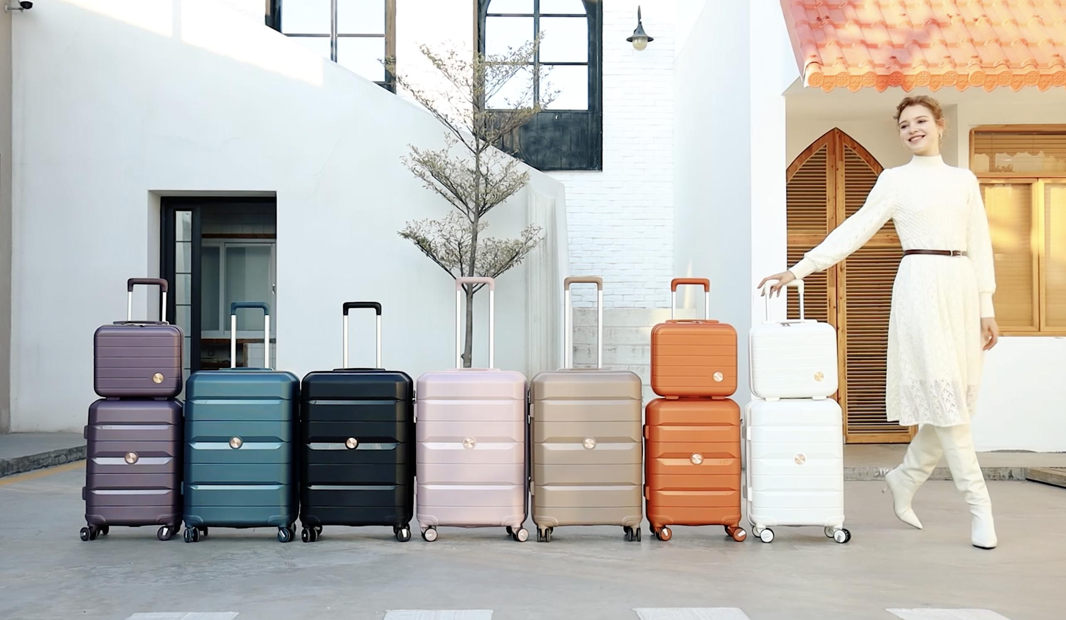

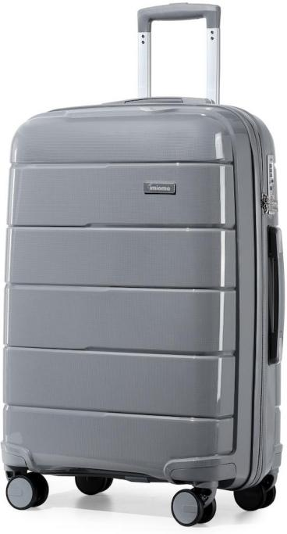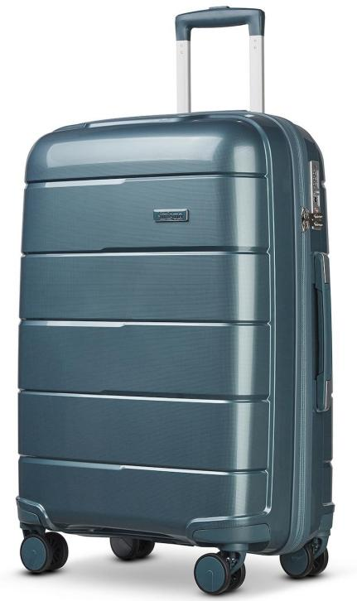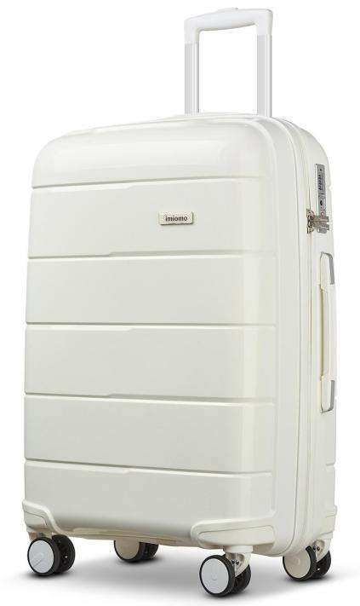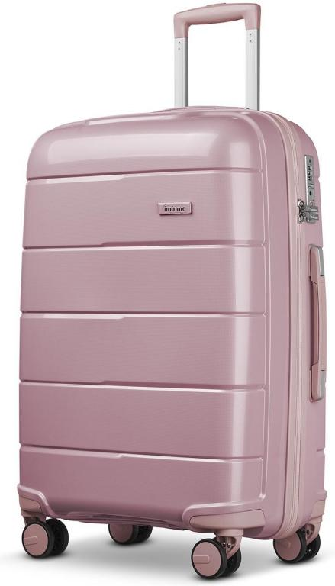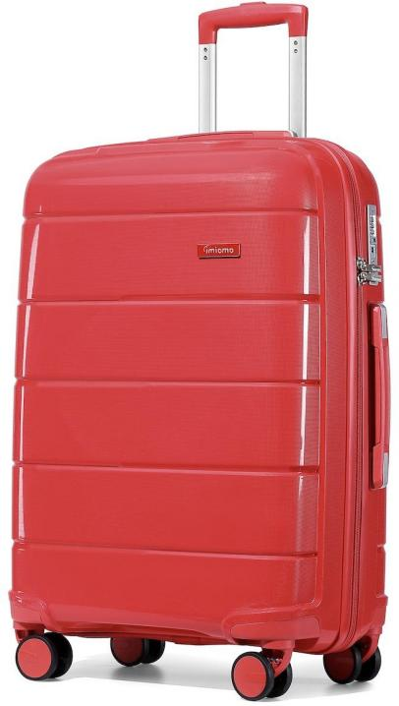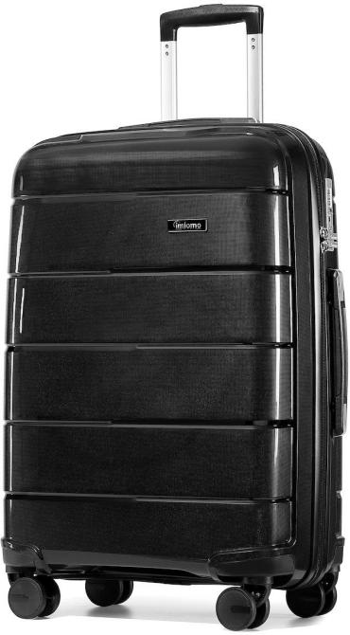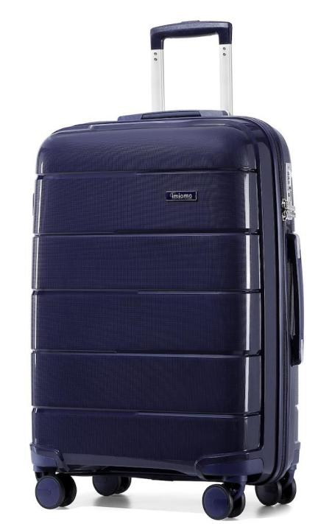


100%PP HARDCASE COLLECTION

ZIPPER: YKK ANTI THEFT ZIPPER SIZE: 20IN/24IN/28IN

LOCK: TSA RECESSED LOCK TROLLEY: ALUMINUM
Integral Colour Matching

100%PP ZIPPER STYLE

$ 59 USD
(FOB shenzhen)

WHEEL: 360° TWIN WHEEL（8 WHEELS）

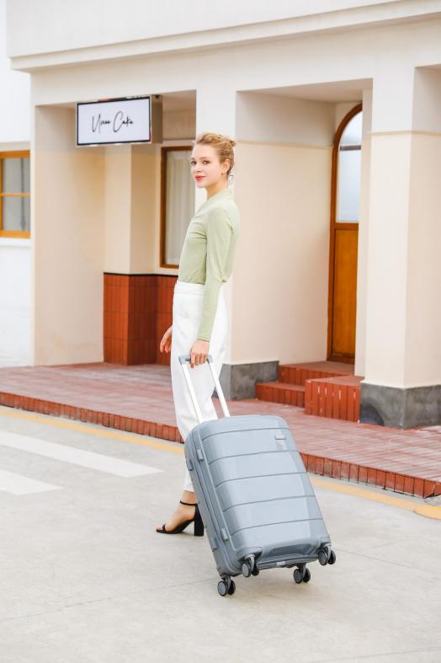
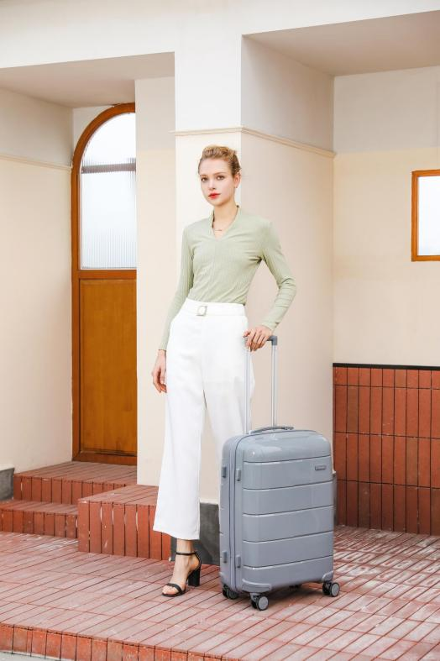
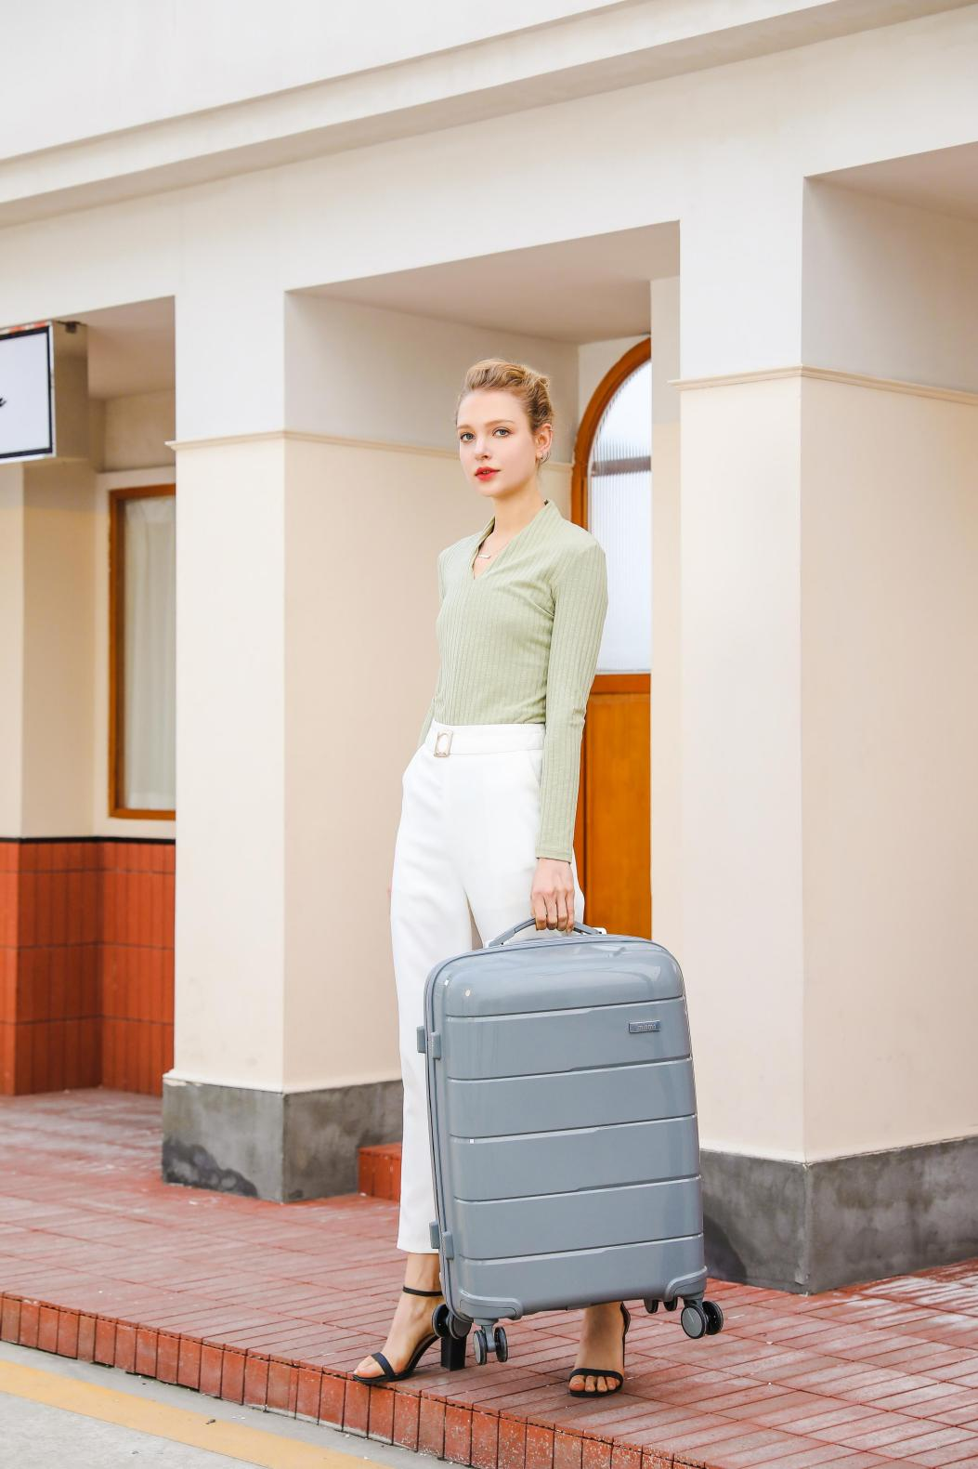
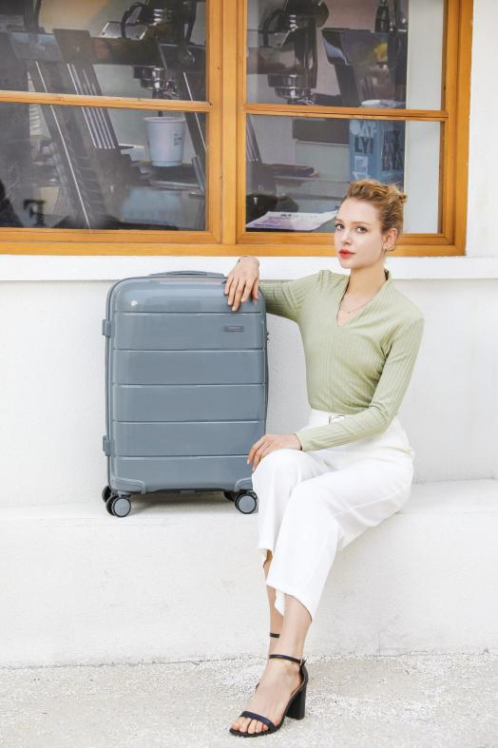
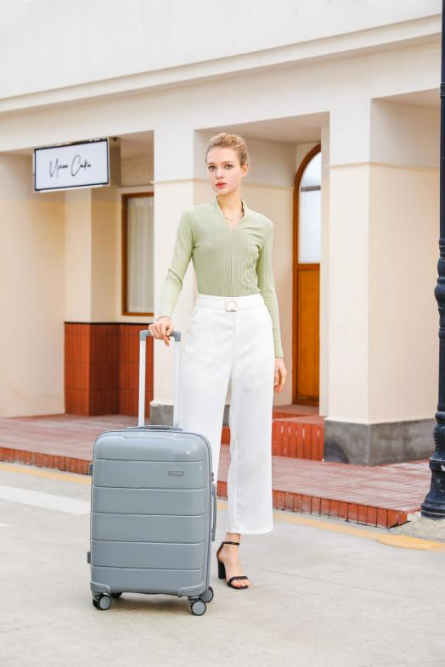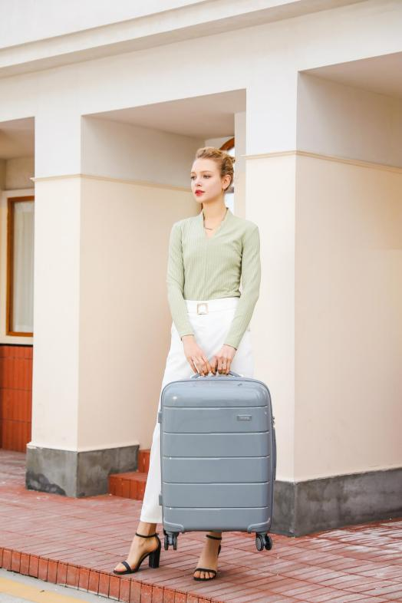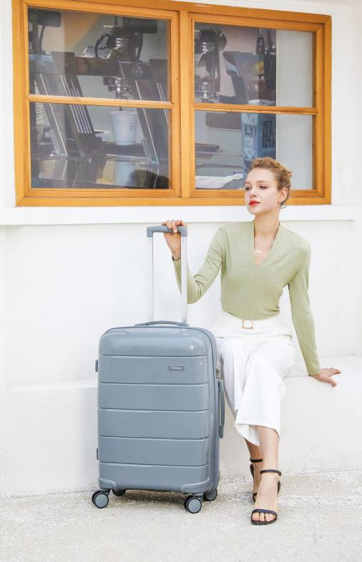

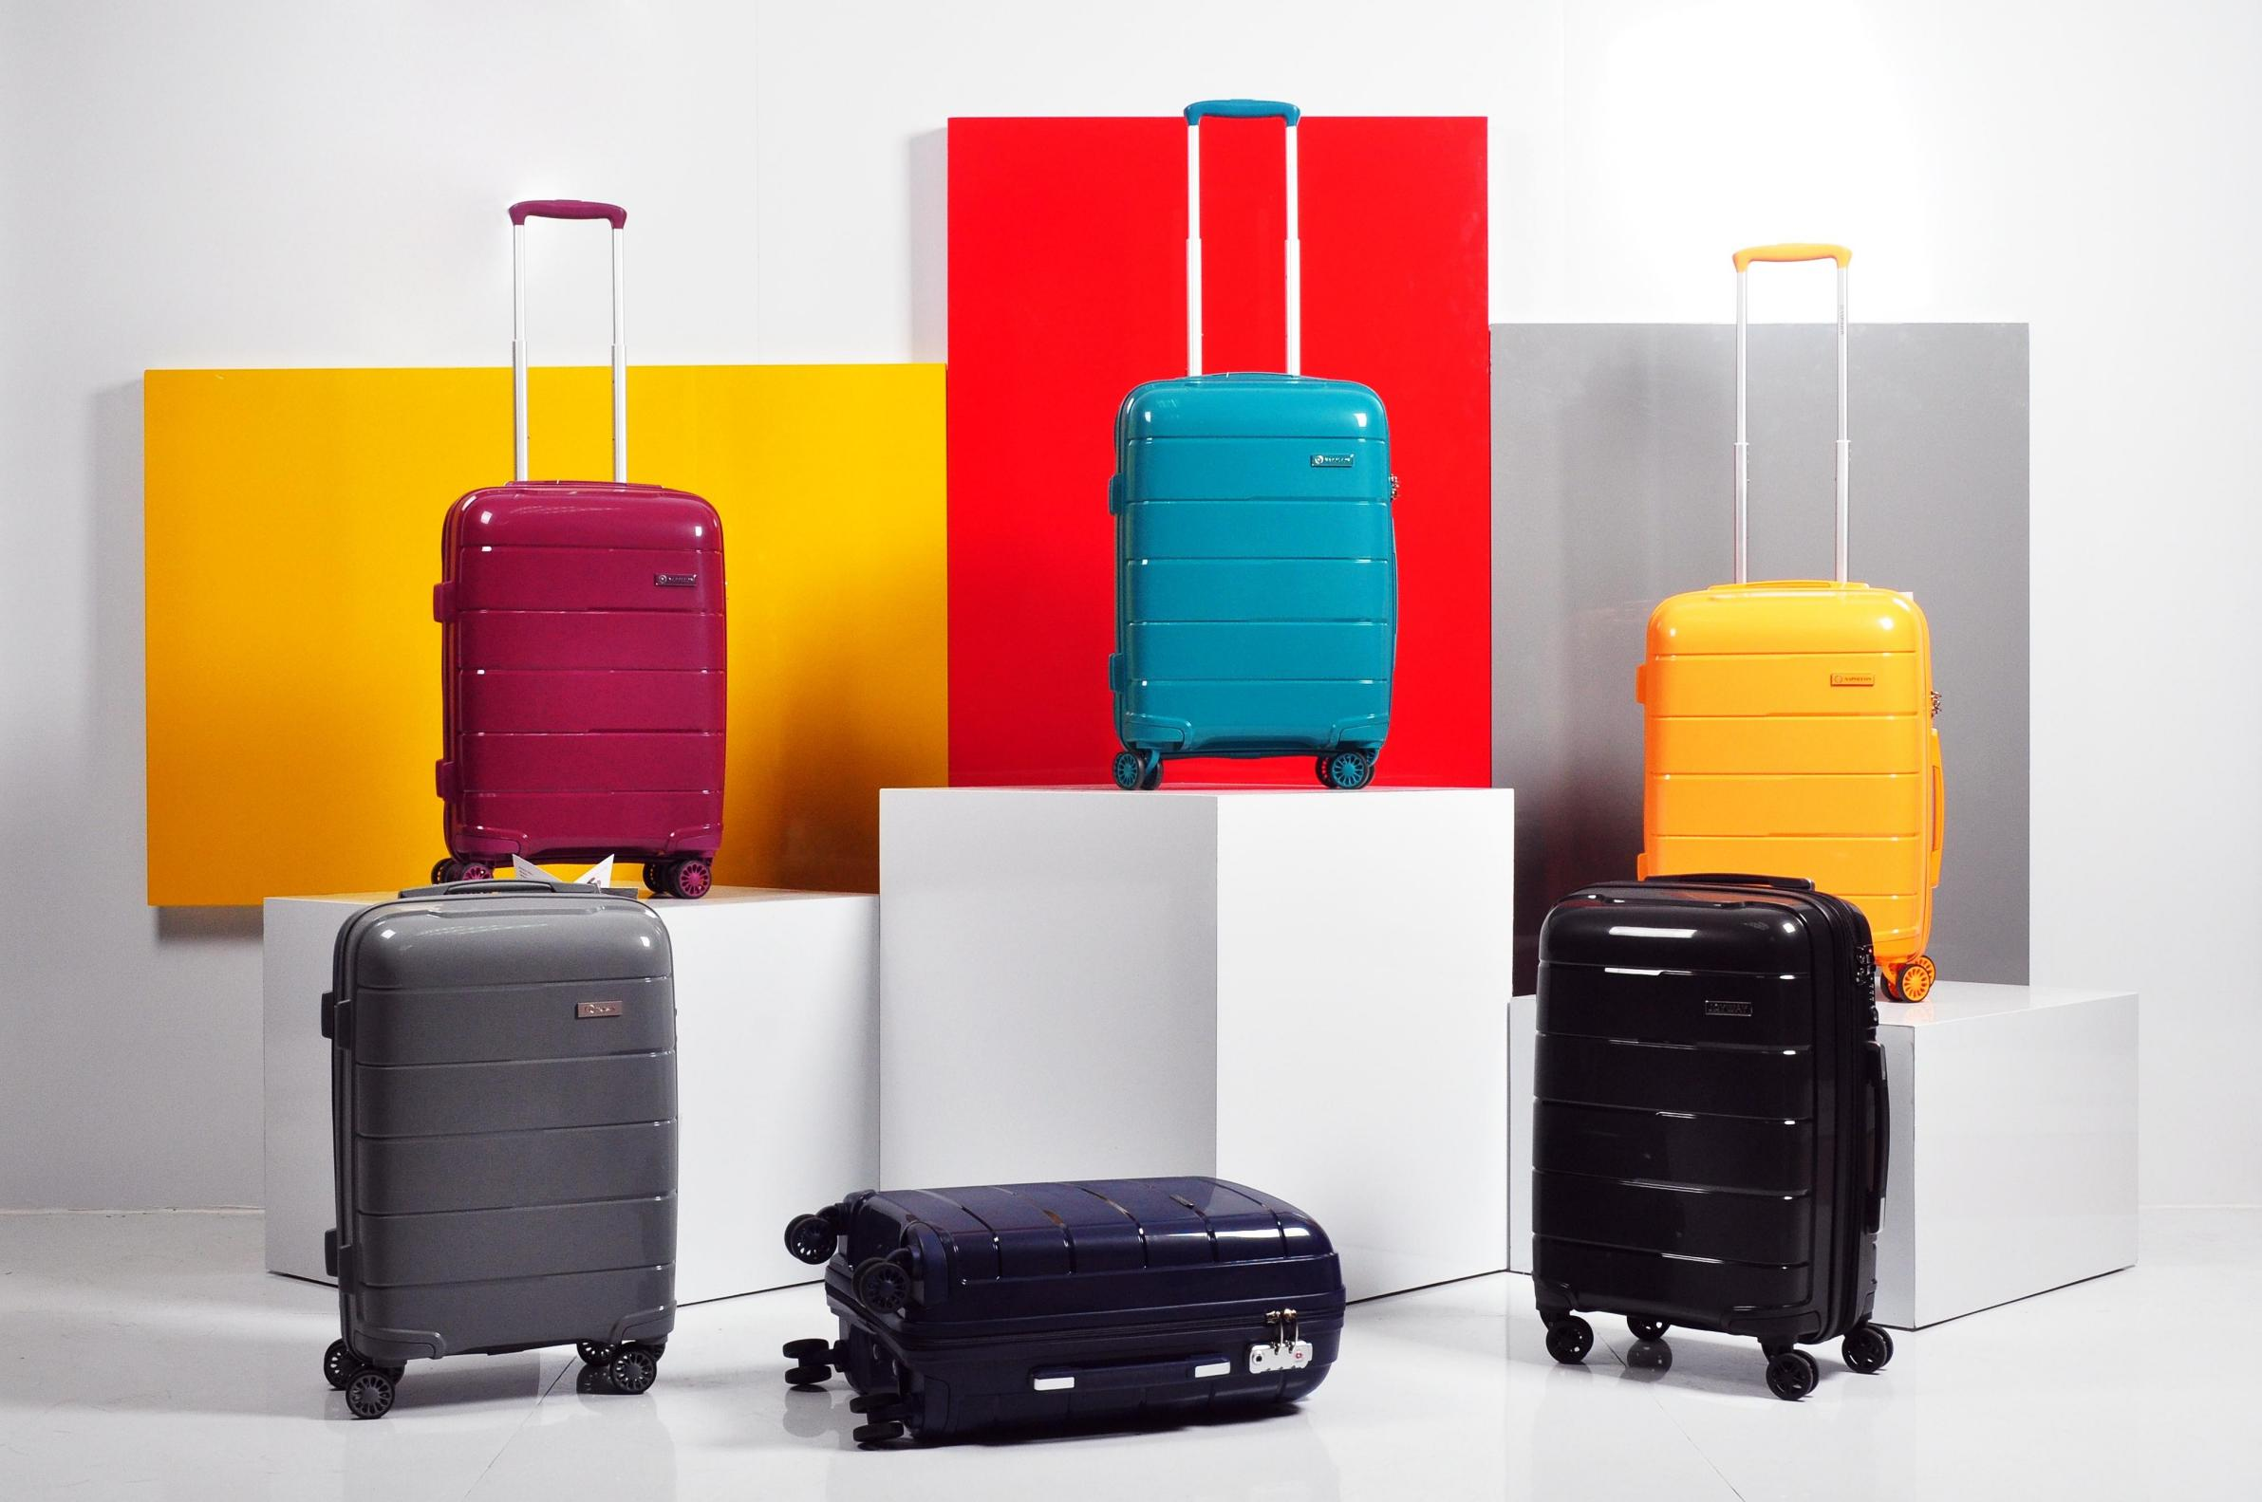

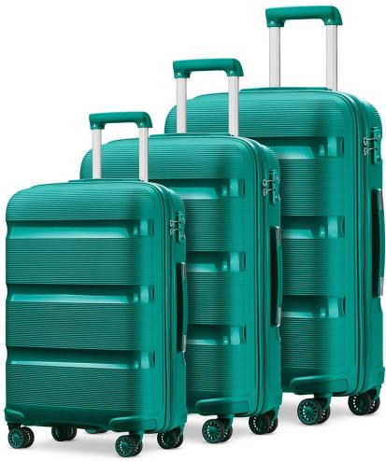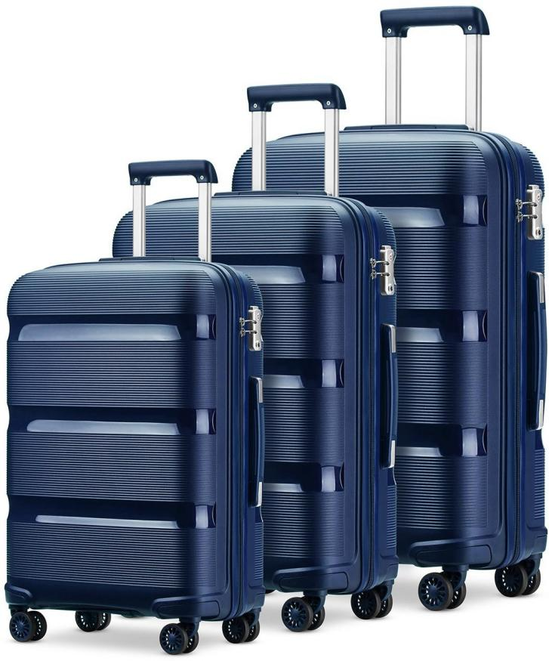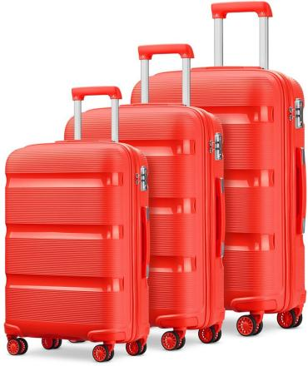



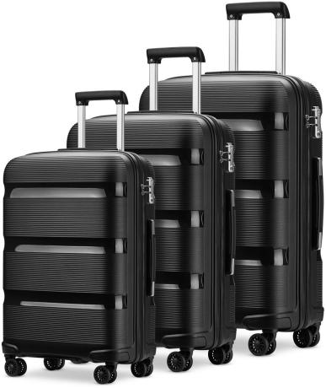
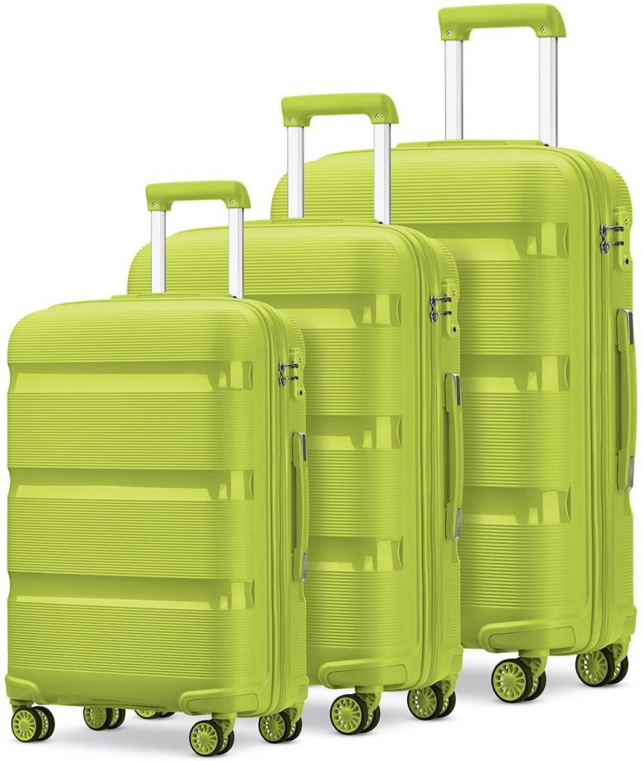
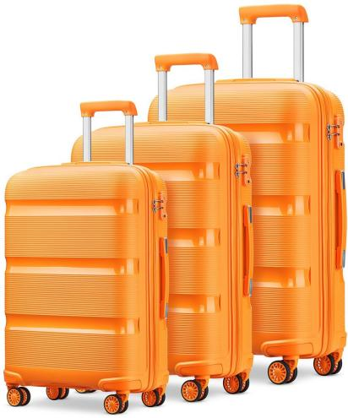
100%PP HARDCASE COLLECTION

ZIPPER: YKK ANTI THEFT ZIPPER SIZE: 20IN/24IN/28IN

LOCK: TSA LOCK TROLLEY: ALUMINUM
Integral Colour Matching

100%PP ZIPPER STYLE

$ 59 USD
(FOB shenzhen)

WHEEL: 360° TWIN WHEEL（8 WHEELS）

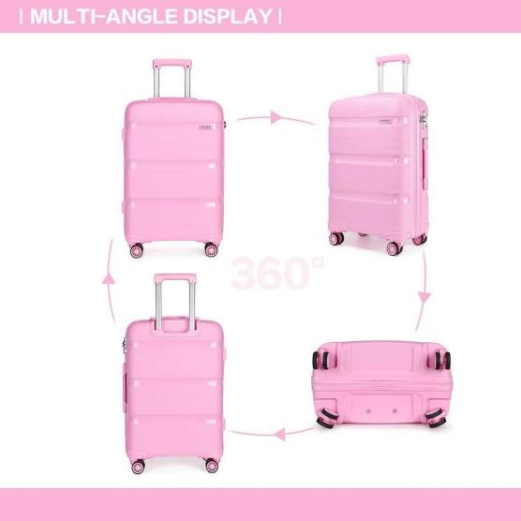
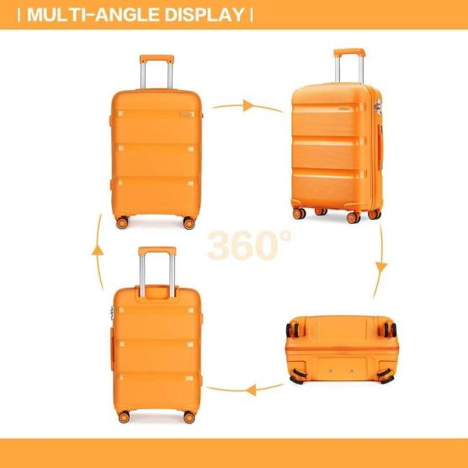
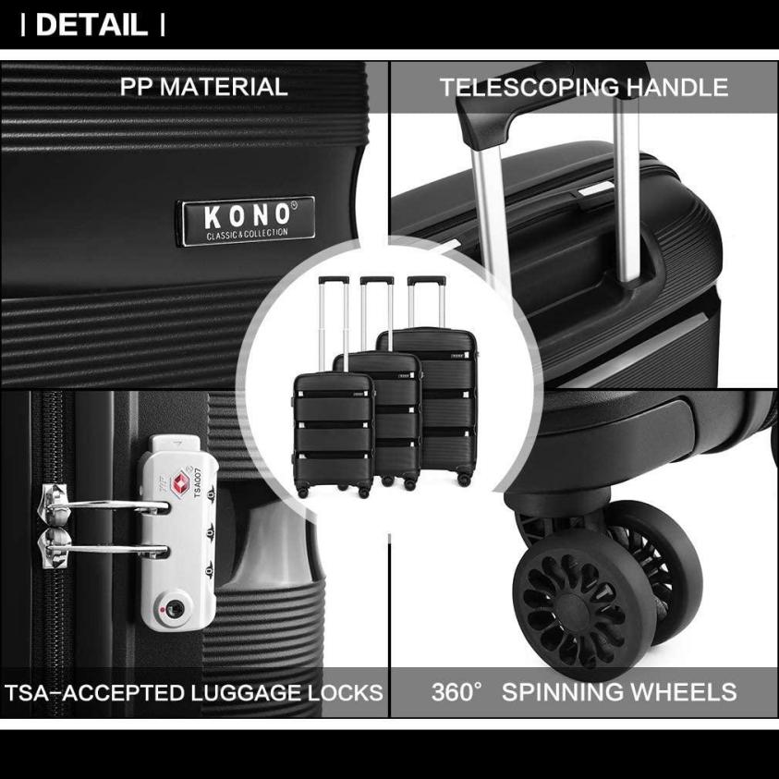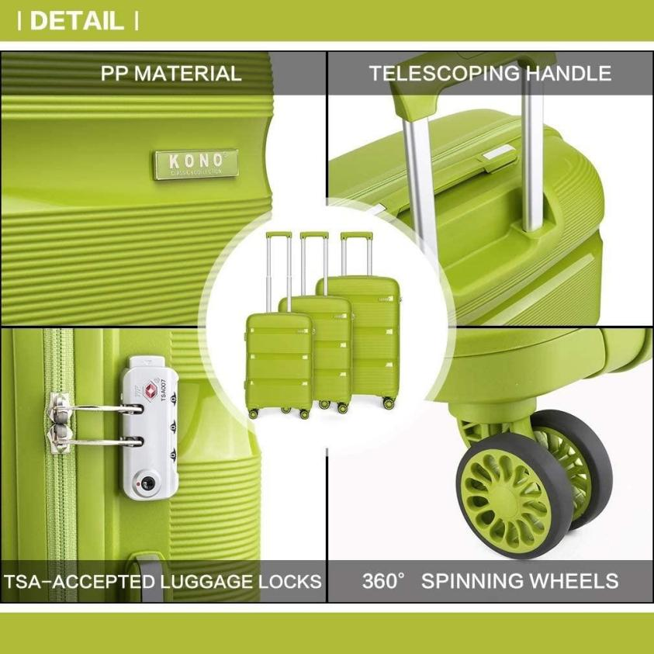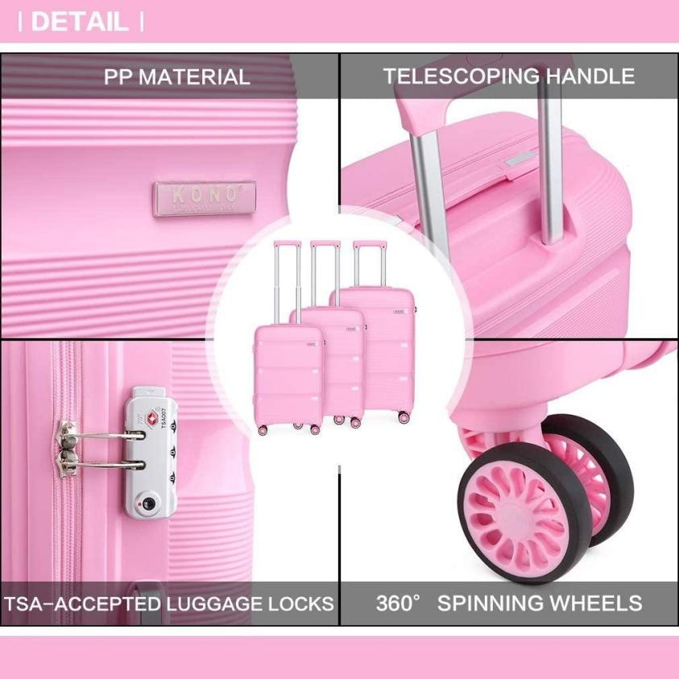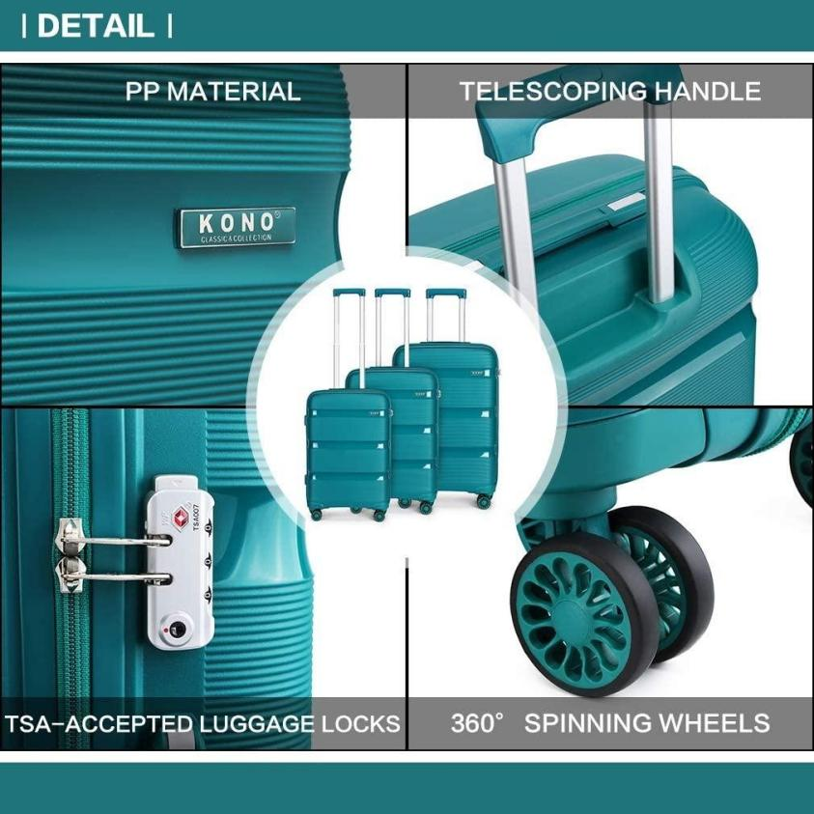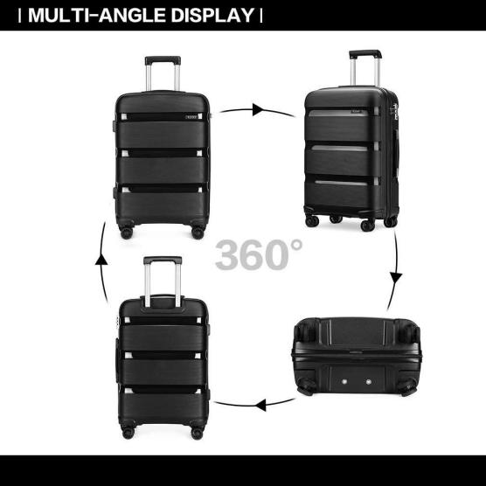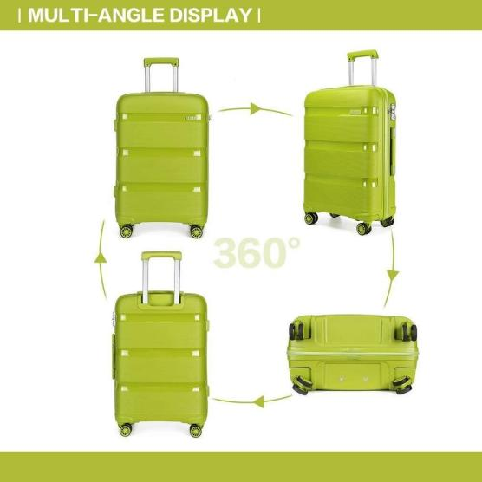

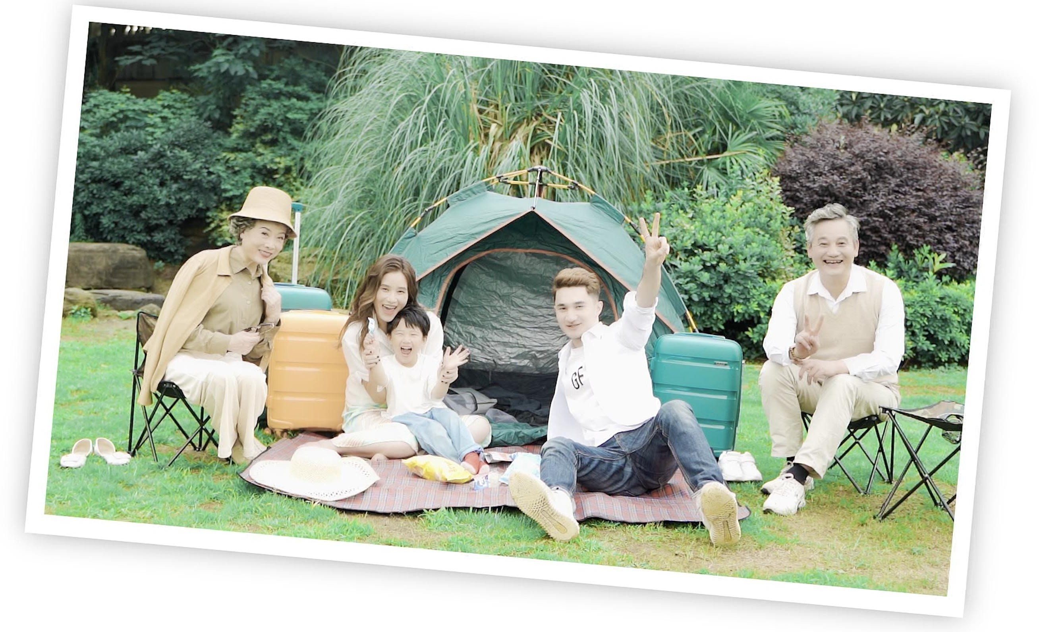



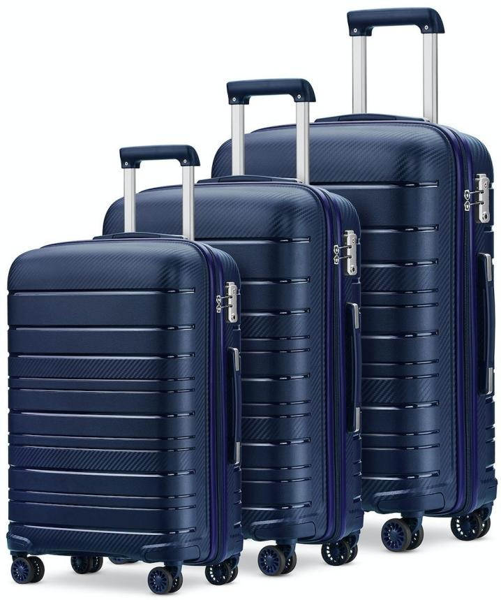
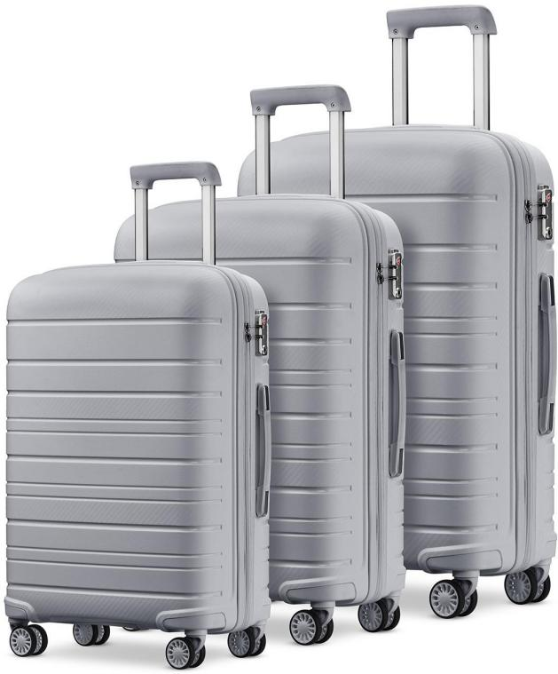
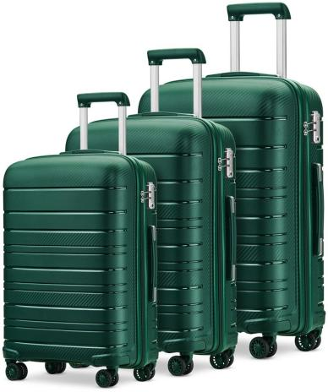
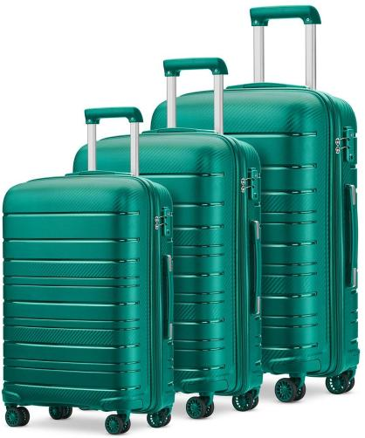
100%PP HARDCASE COLLECTION

ZIPPER: YKK ANTI THEFT ZIPPER SIZE: 20IN/24IN/28IN

LOCK: TSA LOCK TROLLEY: ALUMINUM
Integral
Colour Matching

100%PP ZIPPER STYLE
Integral Colour Matching

$ 59 USD
(FOB shenzhen)

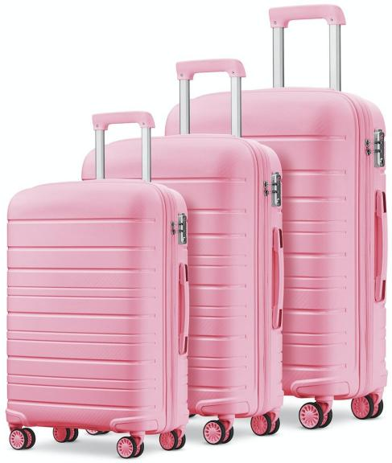
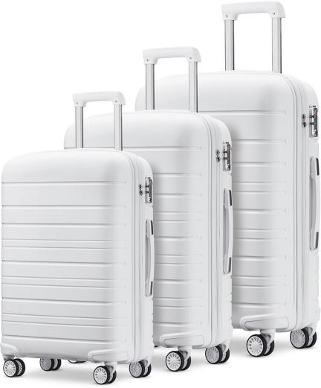
WHEEL: 360° TWIN WHEEL（8 WHEELS）

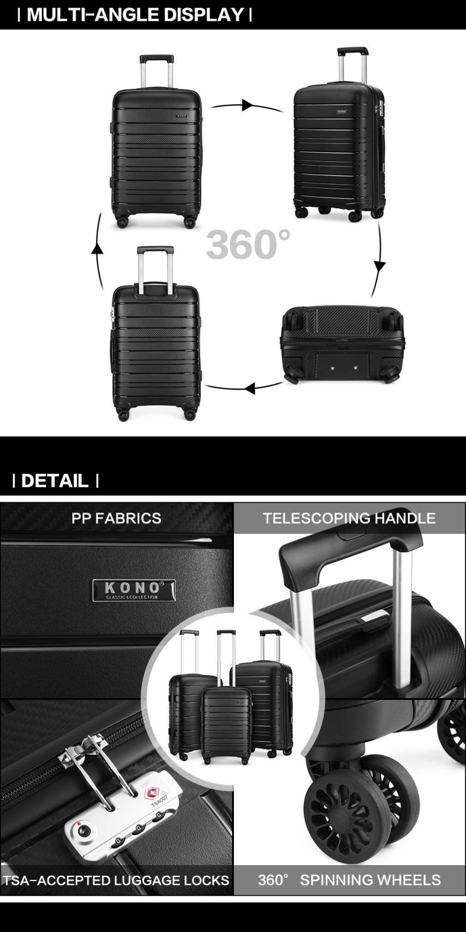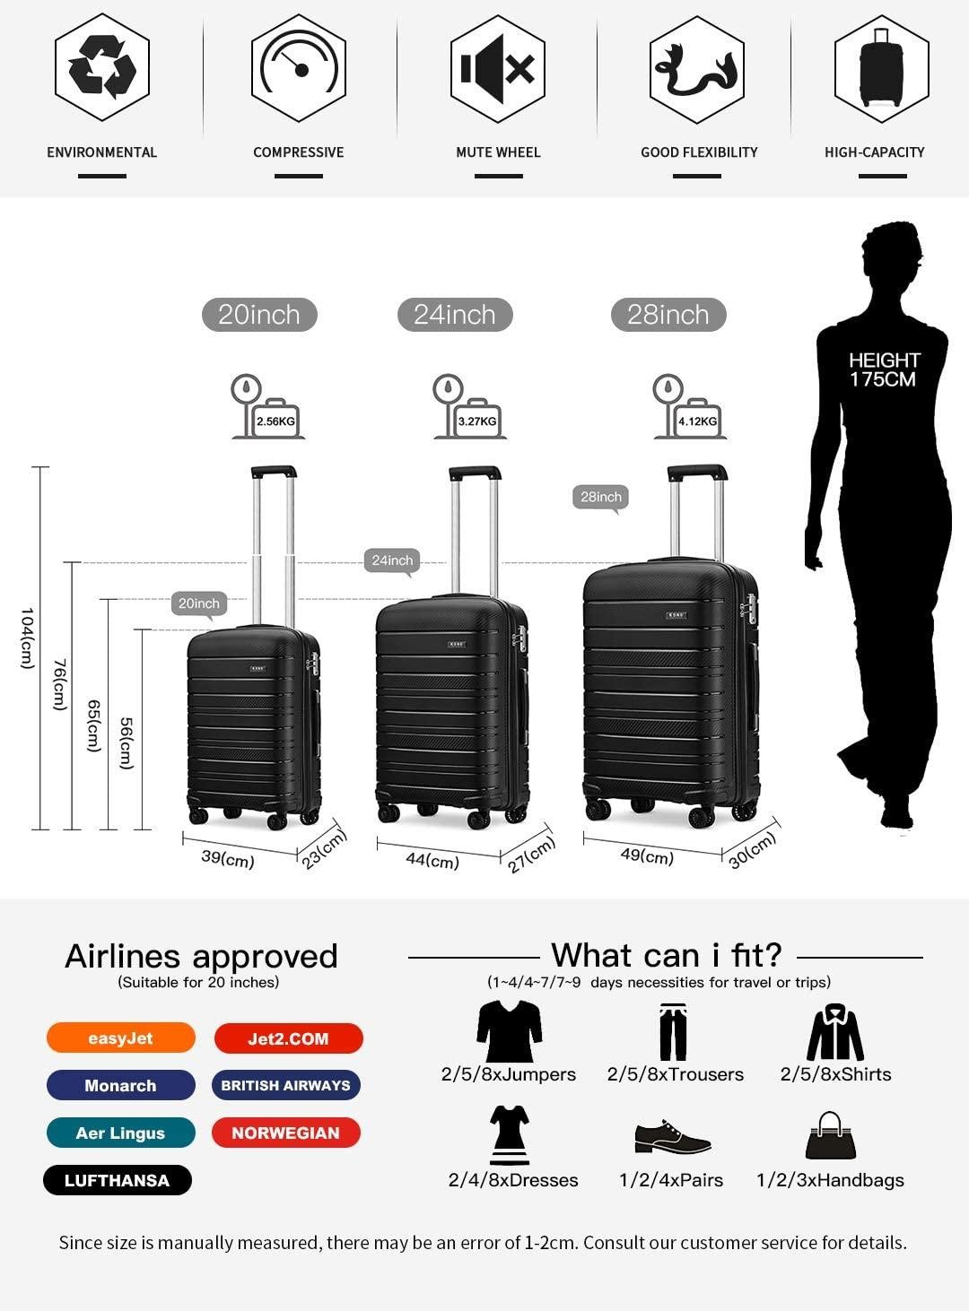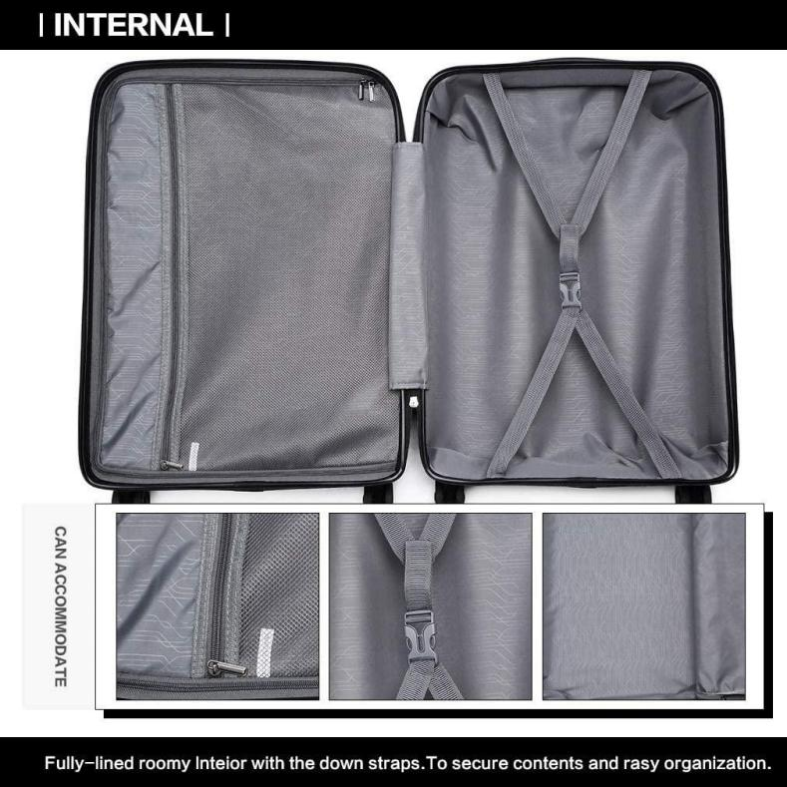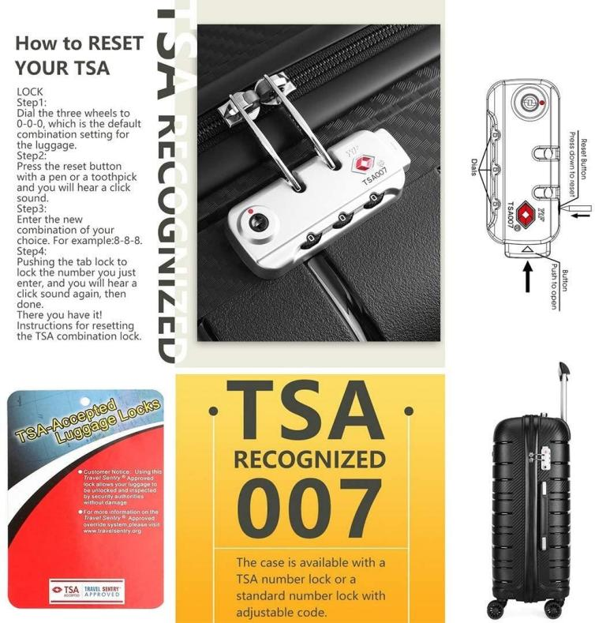

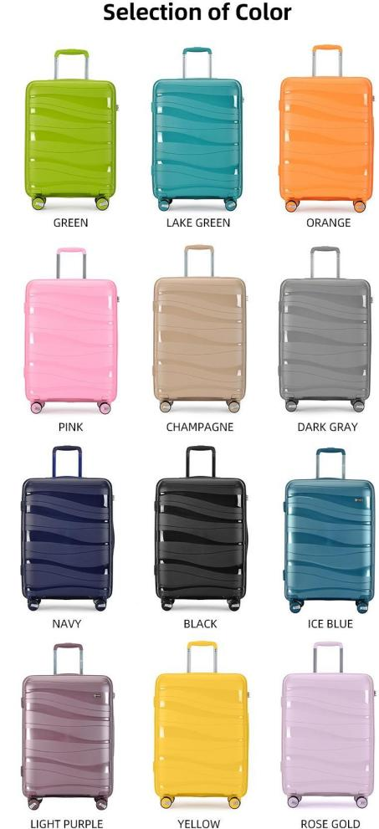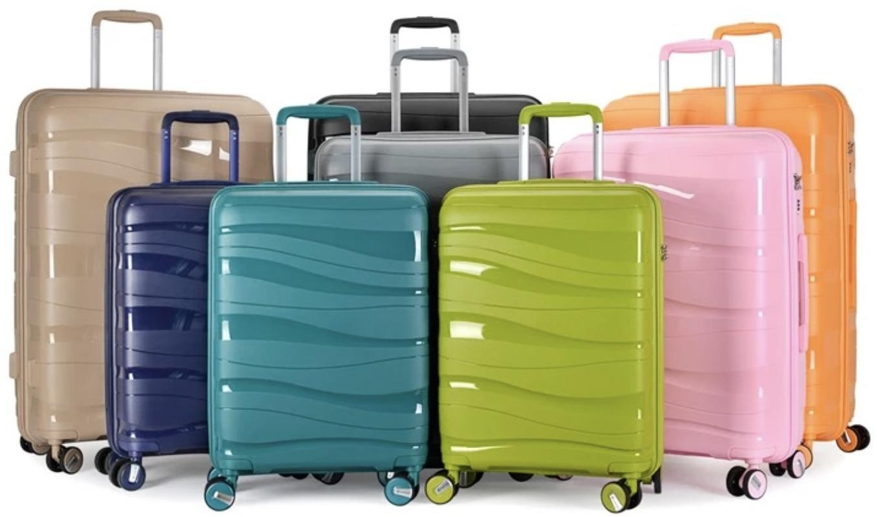



100%PP HARDCASE COLLECTION

ZIPPER: YKK ANTI THEFT ZIPPER SIZE: 14IN/20IN/24IN/28IN

LOCK: TSA RECESSED LOCK TROLLEY: ALUMINUM
Integral
Colour Matching
Integral Colour Matching

$ 65.5 USD
(FOB shenzhen)

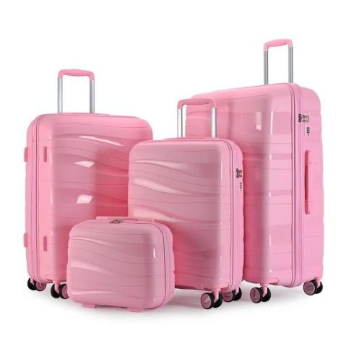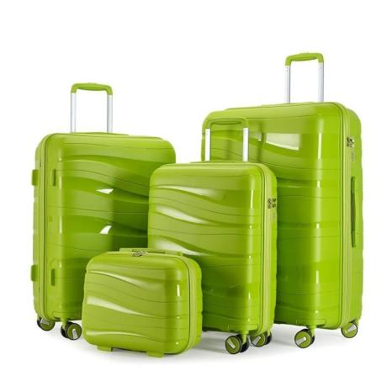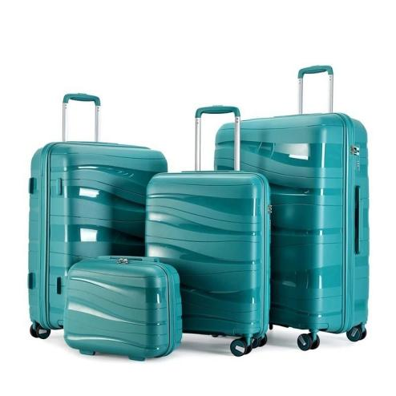WHEEL: 360° TWIN WHEEL（8 WHEELS）

100%PP ZIPPER STYLE



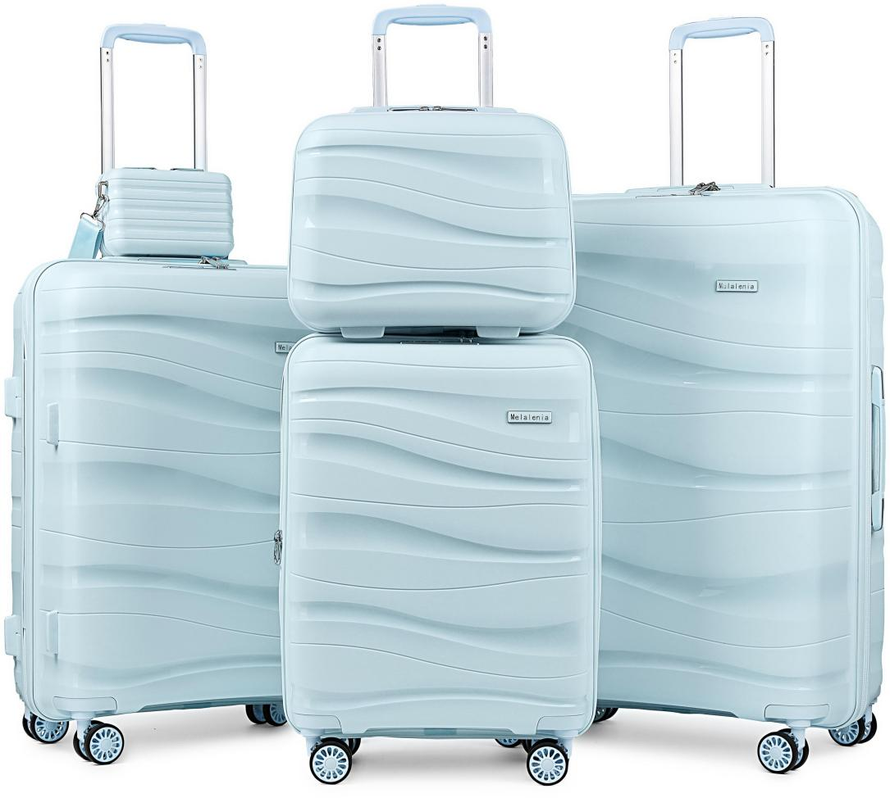
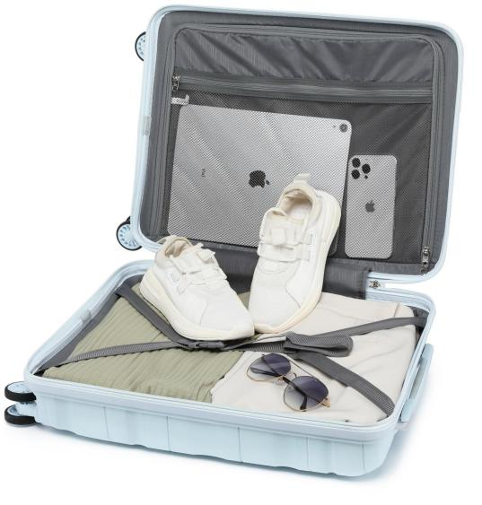
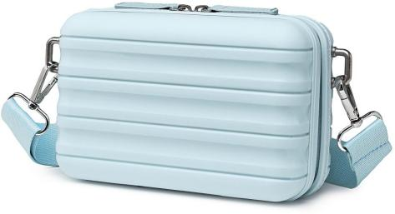
100%PP HARDCASE COLLECTION

ZIPPER: YKK ANTI THEFT ZIPPER SIZE: 7IN/14IN/20IN/24IN/28IN

LOCK: TSA RECESSED LOCK TROLLEY: ALUMINUM
Integral
Colour Matching

100%PP ZIPPER STYLE
Integral Colour Matching

$ 70 USD
(FOB shenzhen)

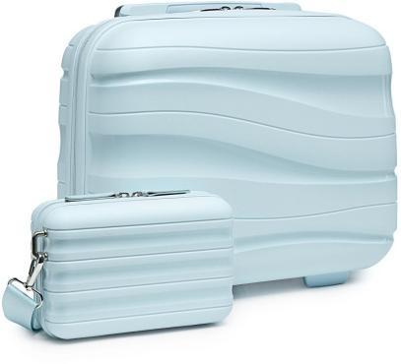
WHEEL: 360° TWIN WHEEL（8 WHEELS）

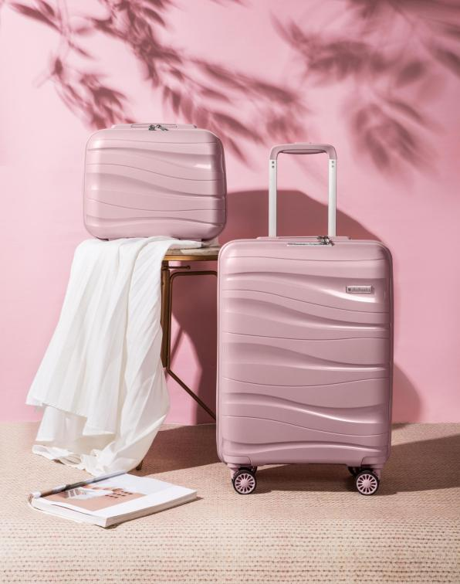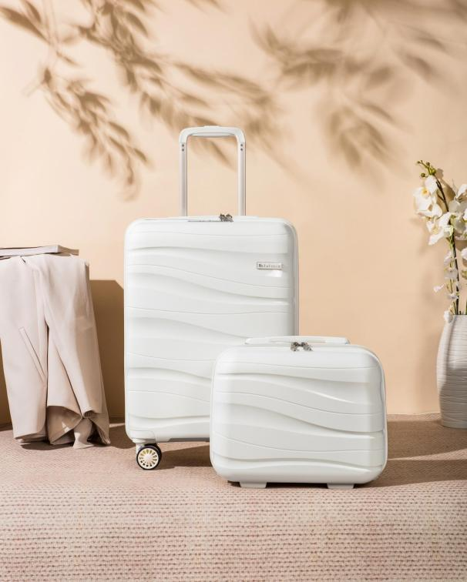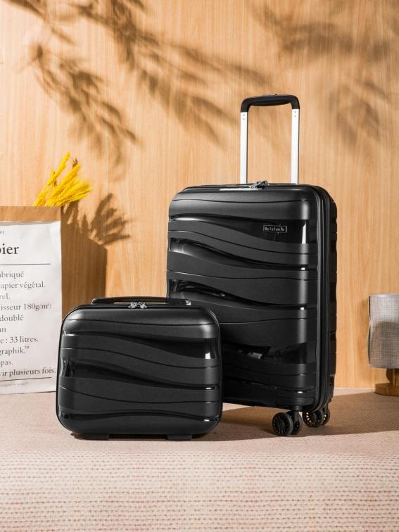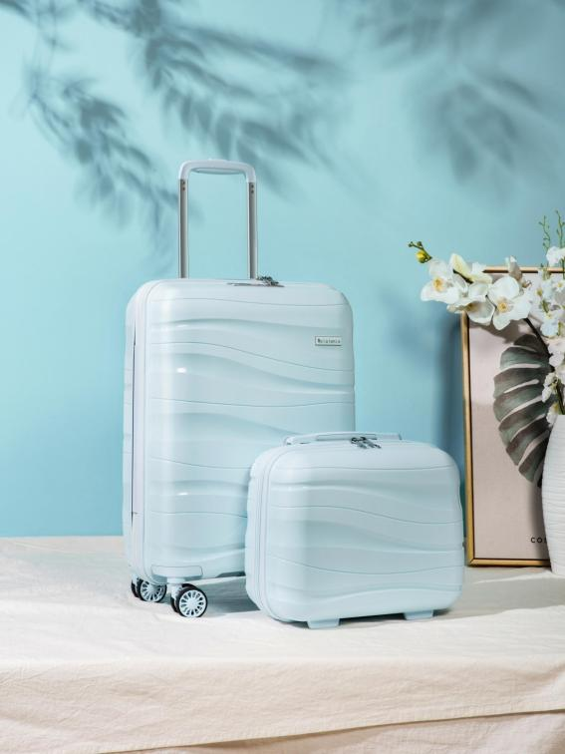
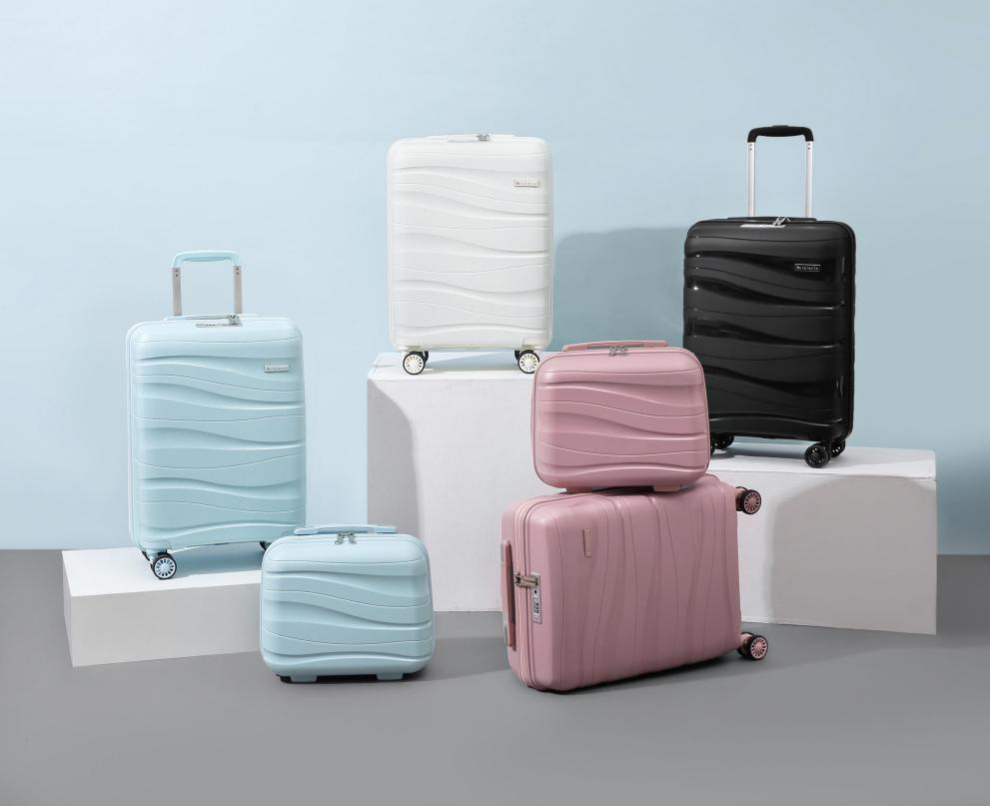
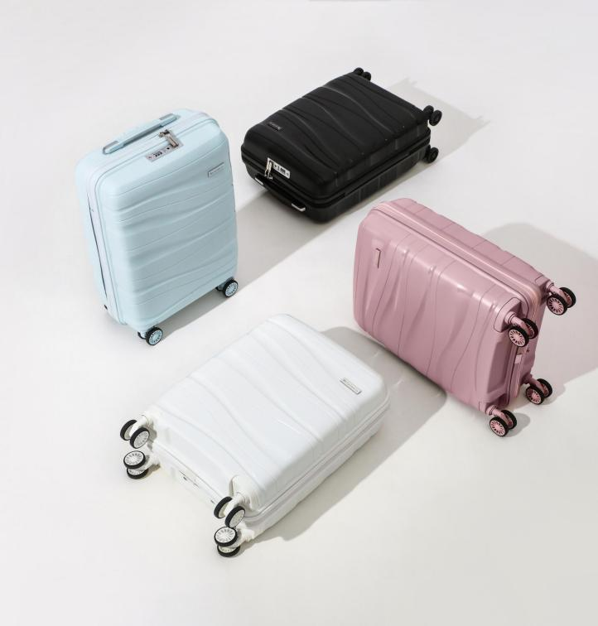
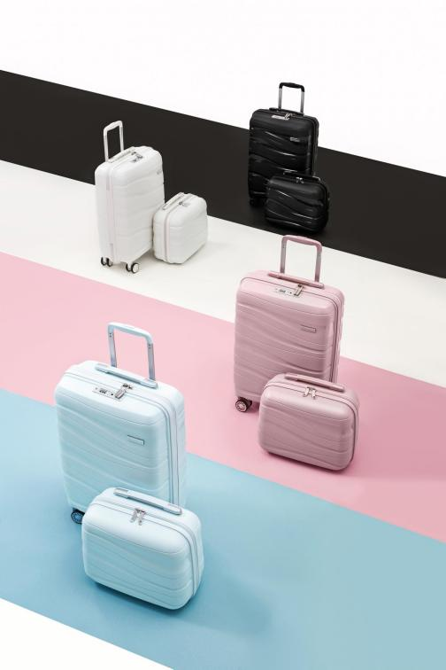

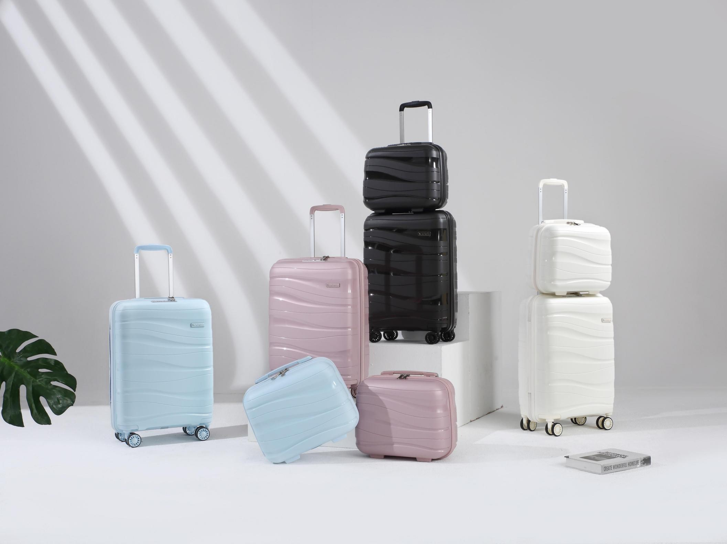


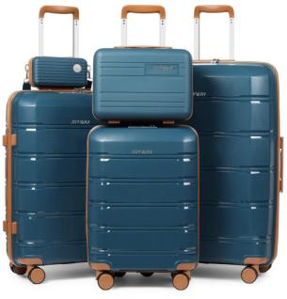
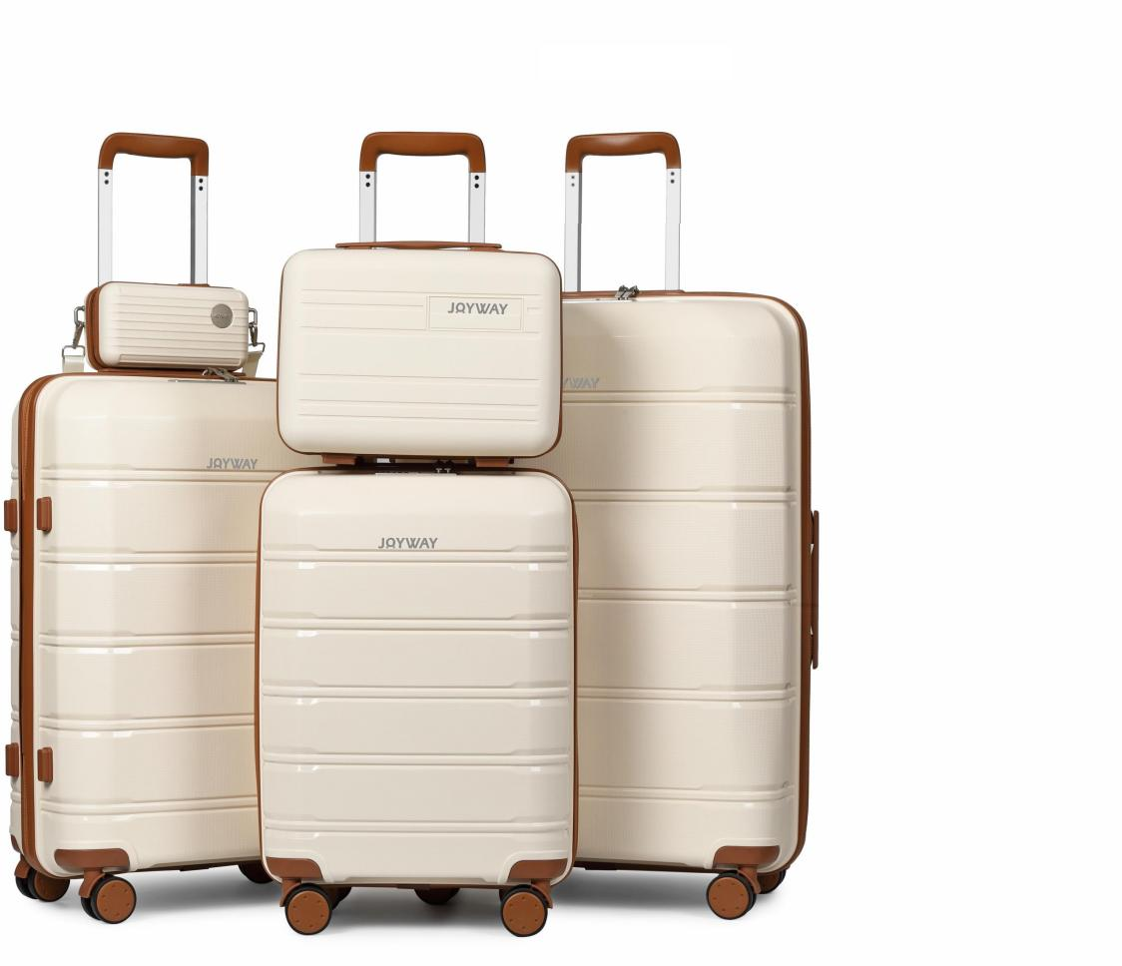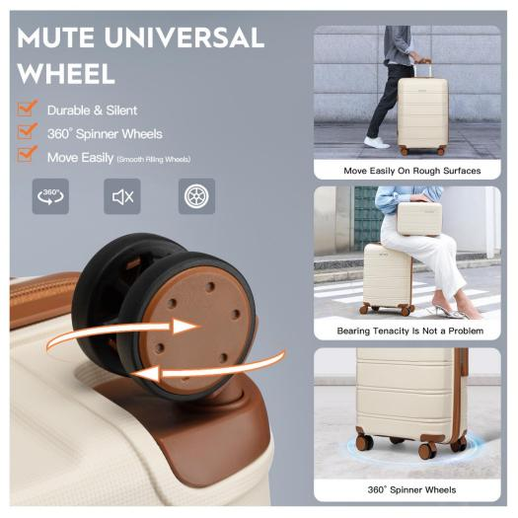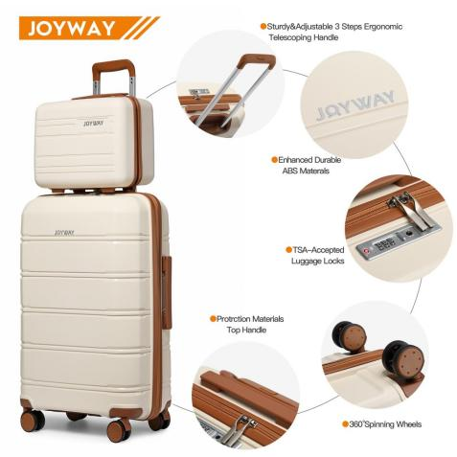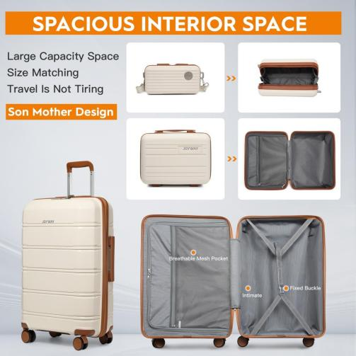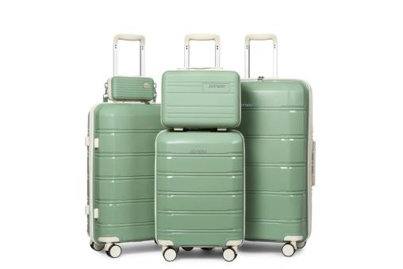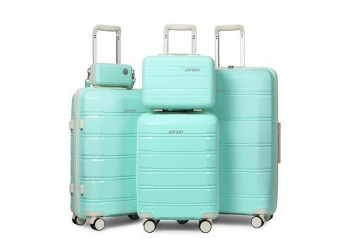100%PP HARDCASE COLLECTION

ZIPPER: YKK ANTI THEFT ZIPPER SIZE: 7IN/14IN20IN/24IN/28IN

LOCK: TSA RECESSED LOCK TROLLEY: ALUMINUM
Integral
Colour Matching

100%PP ZIPPER STYLE
Integral Colour Matching

$ 69 USD
(FOB shenzhen)

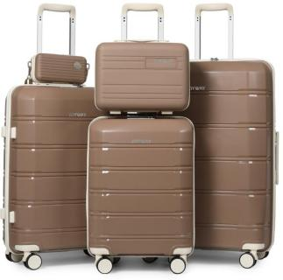
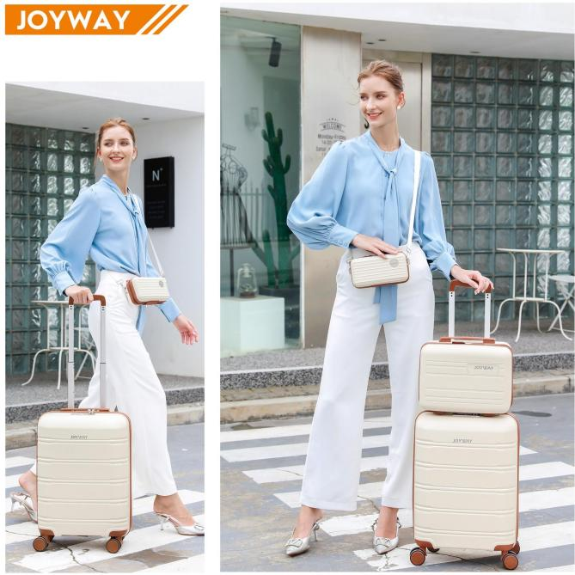
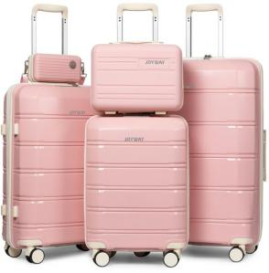
WHEEL: 360° TWIN WHEEL（8 WHEELS）

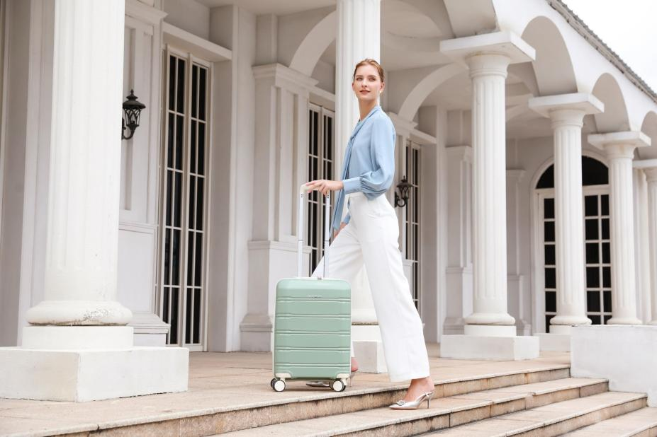
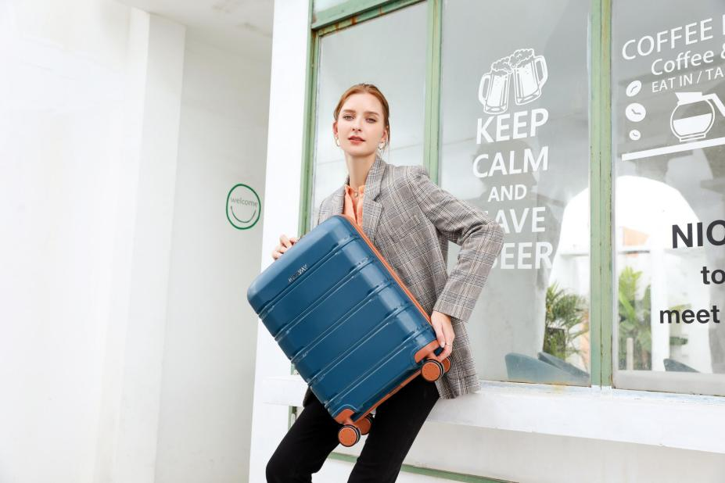
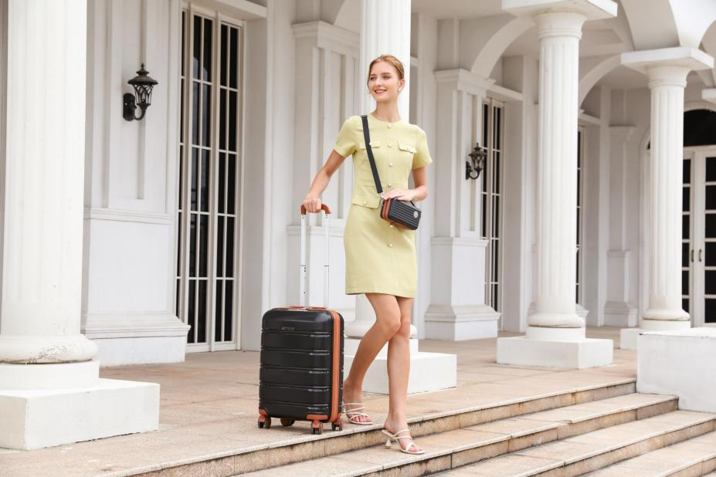
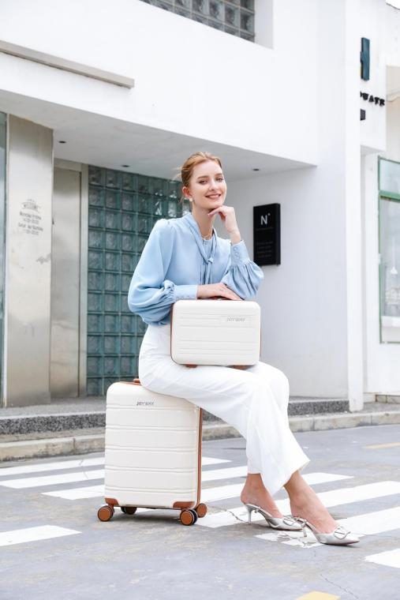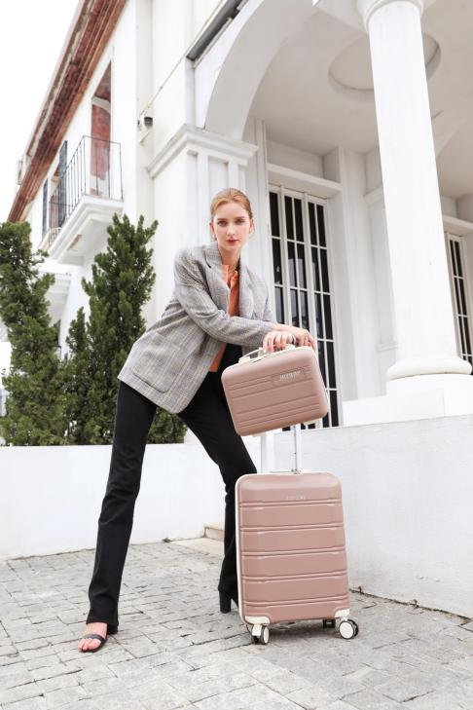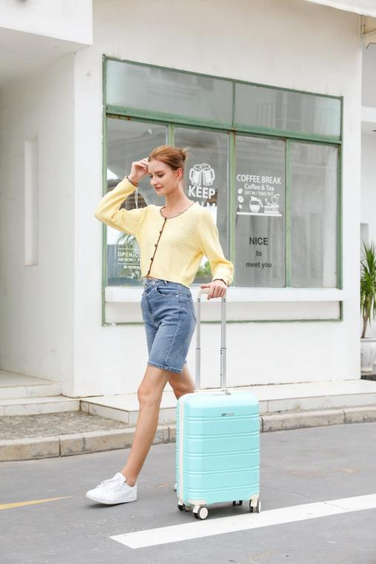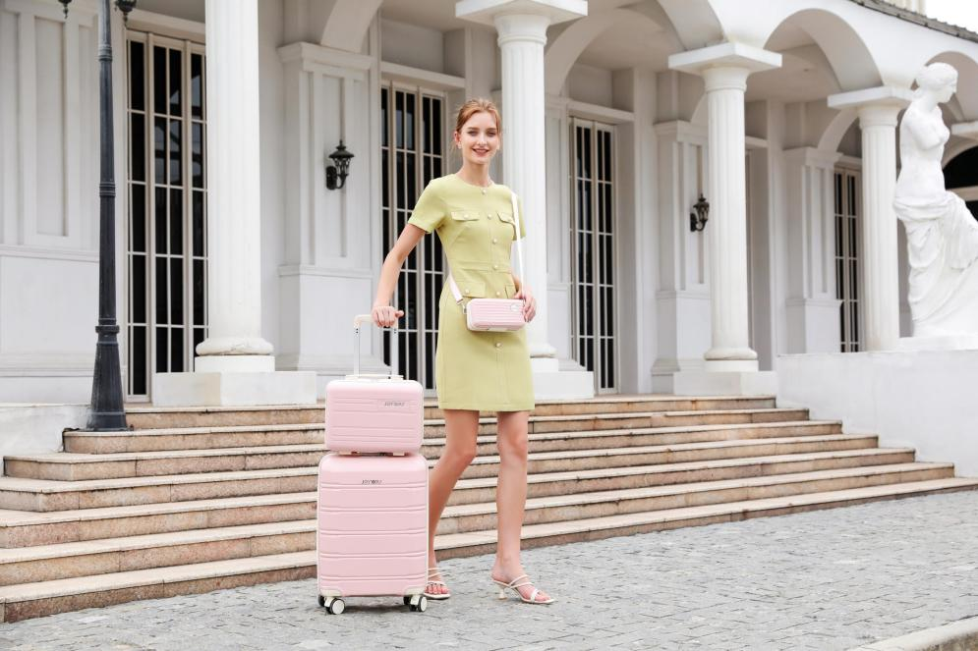

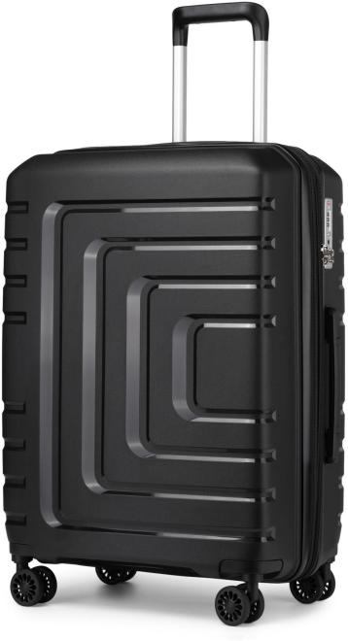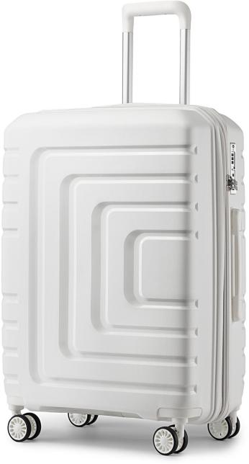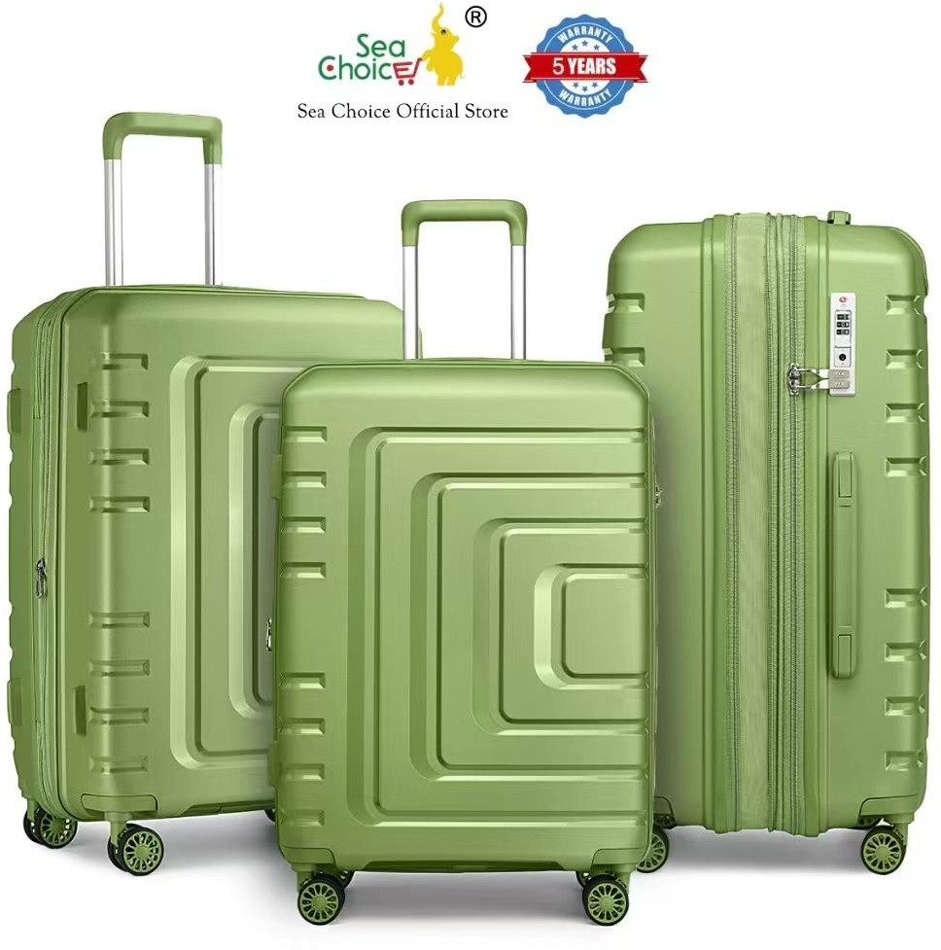


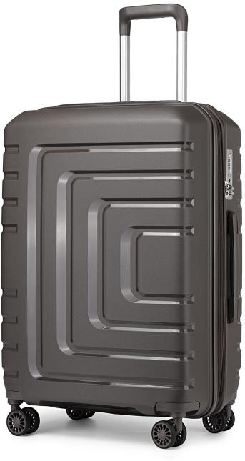
100%PP HARDCASE COLLECTION

ZIPPER: YKK ANTI THEFT ZIPPER SIZE: 7IN/14IN20IN/24IN/28IN

LOCK: TSA RECESSED LOCK TROLLEY: ALUMINUM
Integral
Colour Matching

100%PP ZIPPER STYLE
Integral Colour Matching

$ 59 USD
(FOB shenzhen)

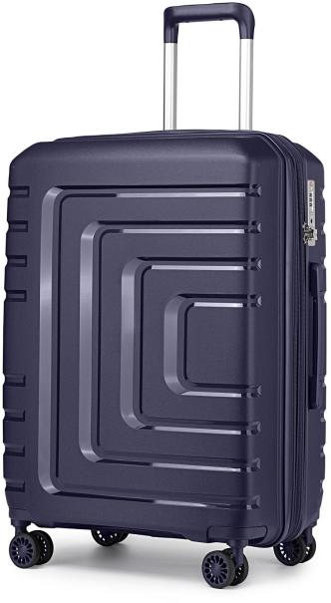
WHEEL: 360° TWIN WHEEL（8 WHEELS）

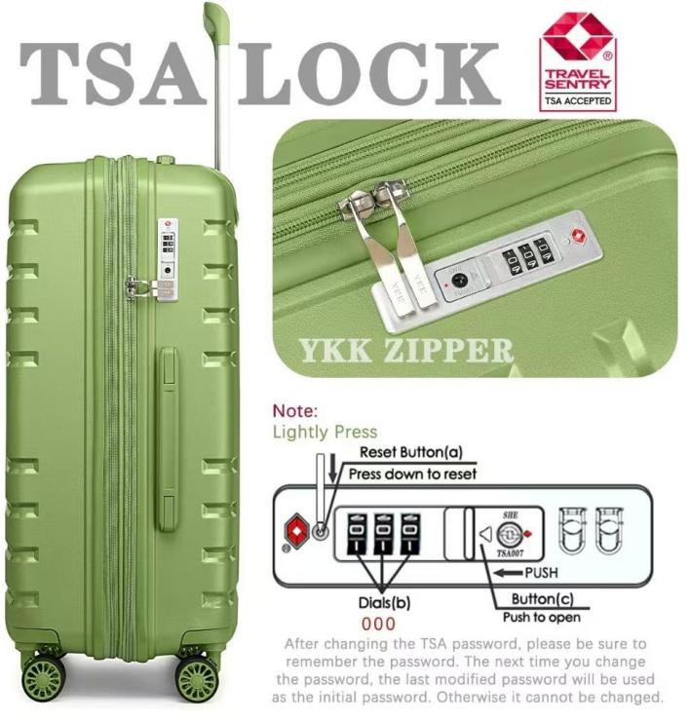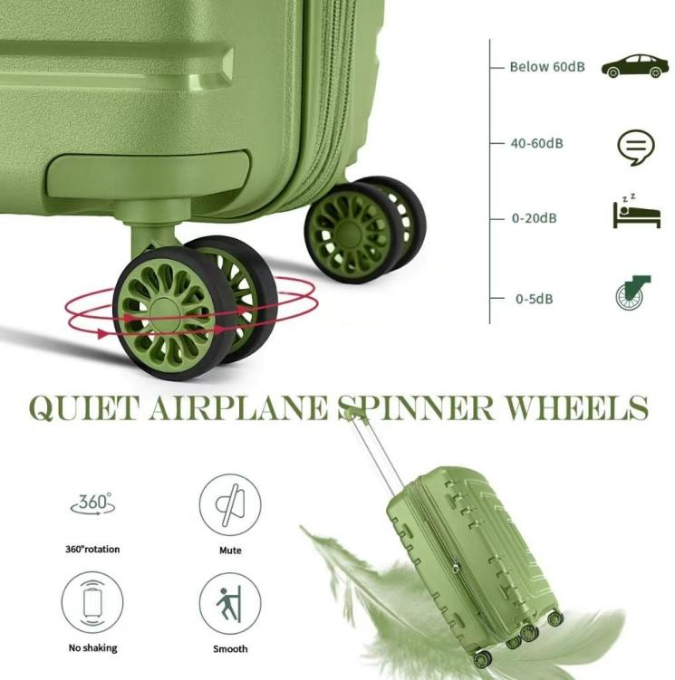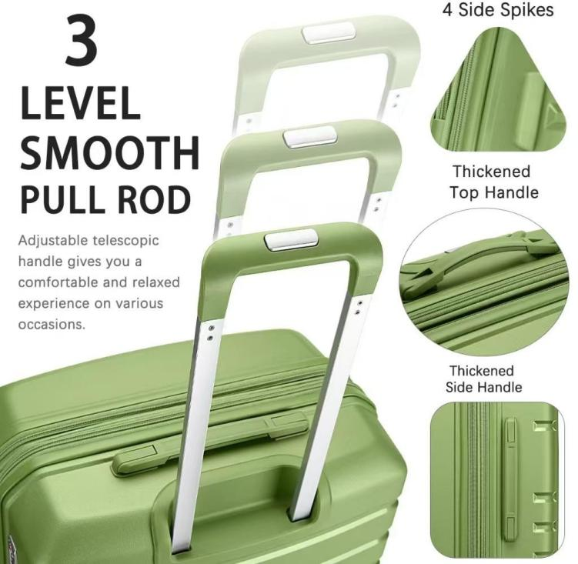
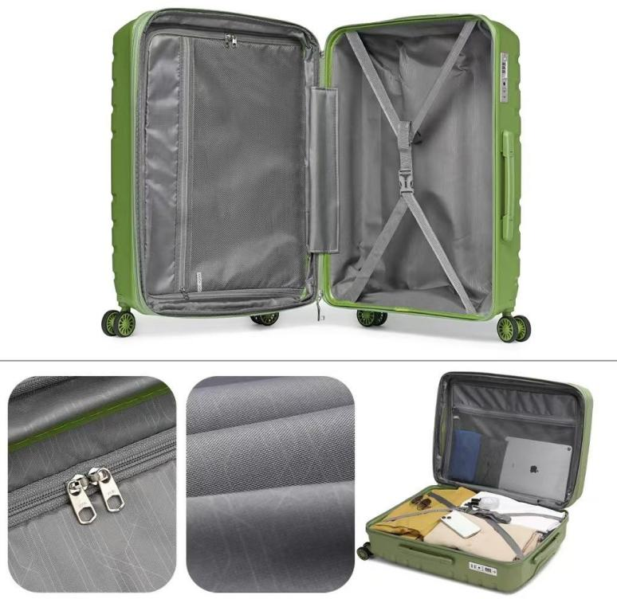
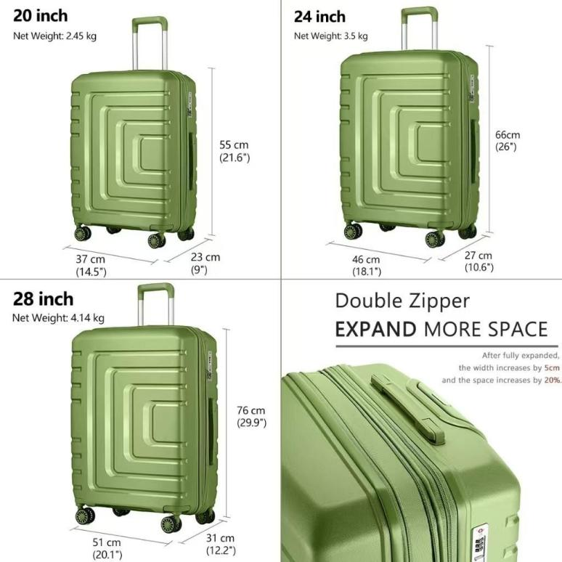


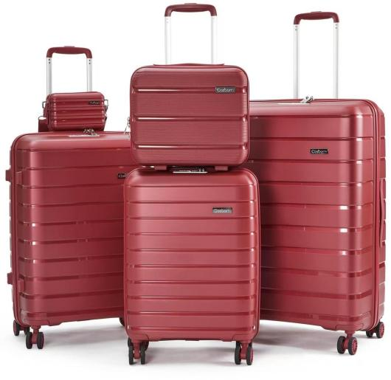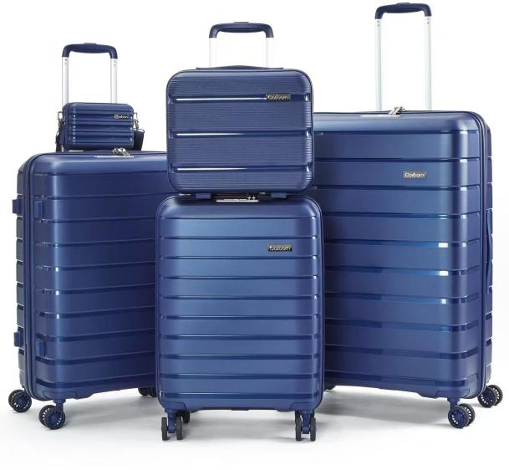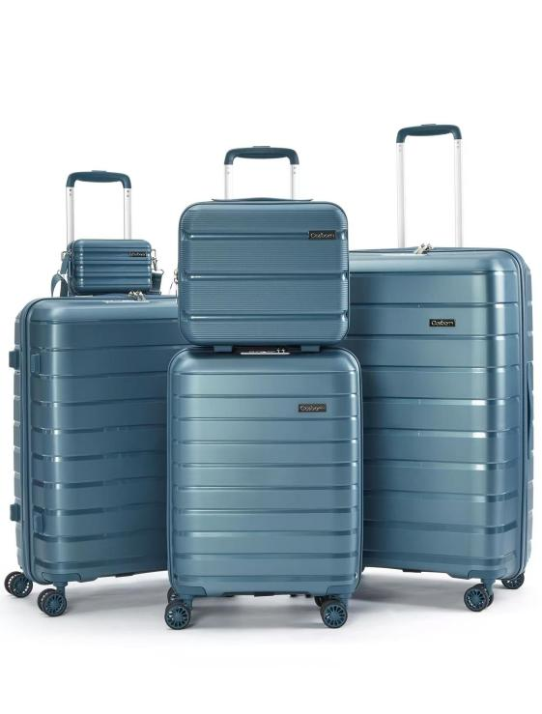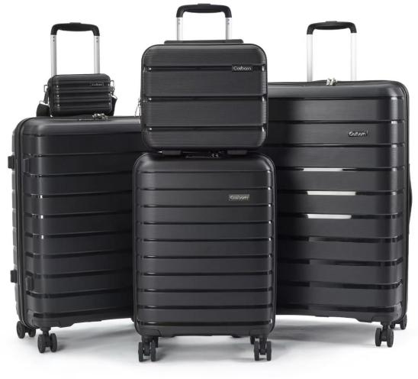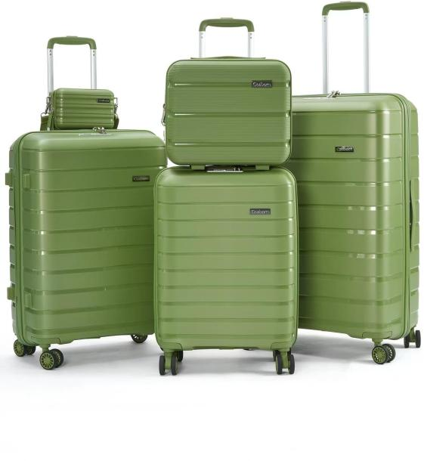

100%PP HARDCASE COLLECTION

ZIPPER: YKK ANTI THEFT ZIPPER SIZE: 7IN/14IN/20IN/24IN/28IN

LOCK: TSA RECESSED LOCK TROLLEY: ALUMINUM
Integral
Colour Matching

100%PP ZIPPER STYLE
Integral Colour Matching

$ 70 USD
(FOB shenzhen)

WHEEL: 360° TWIN WHEEL（8 WHEELS）

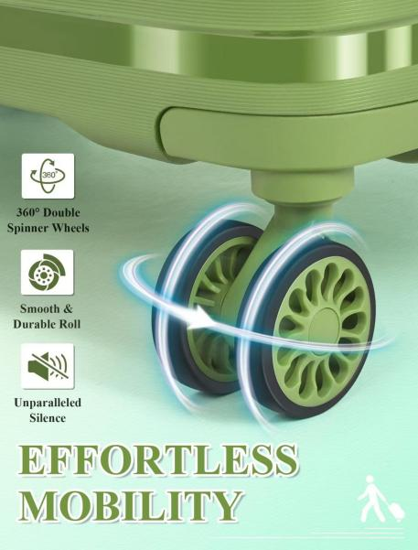
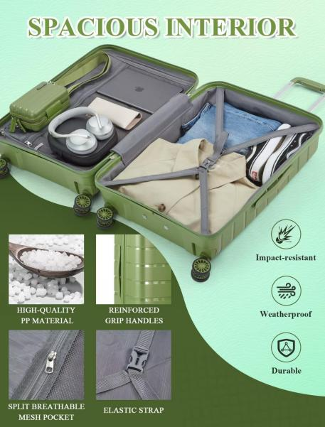
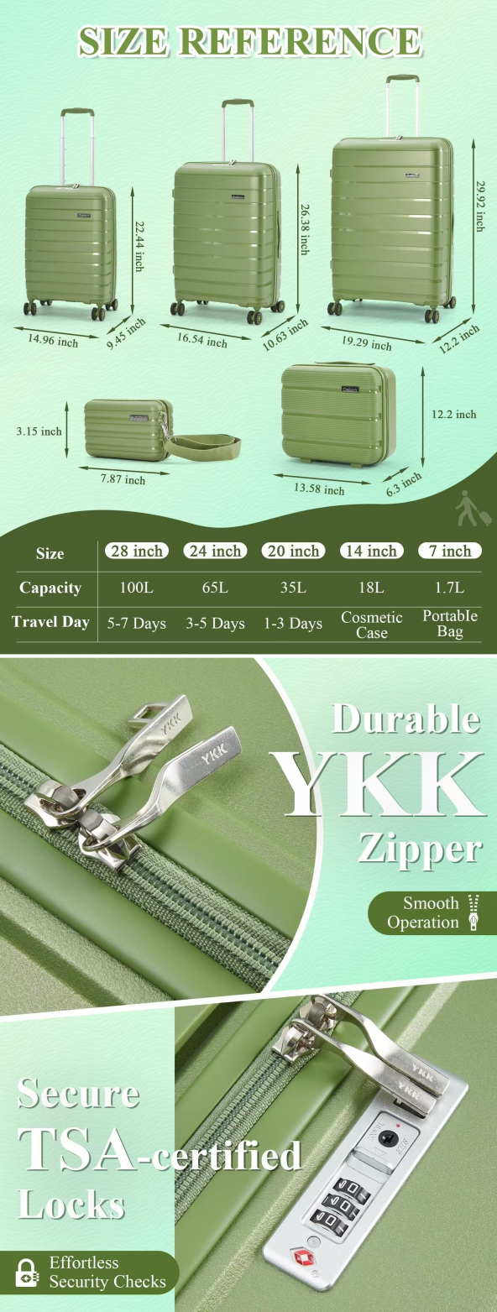
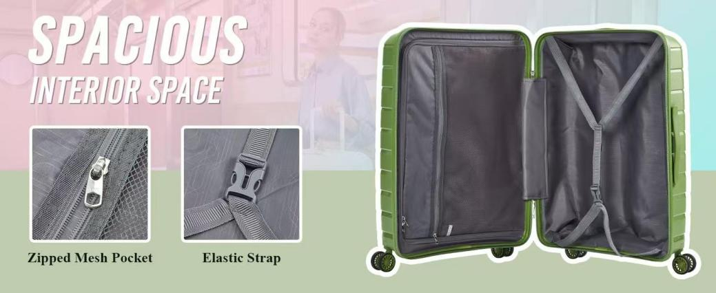
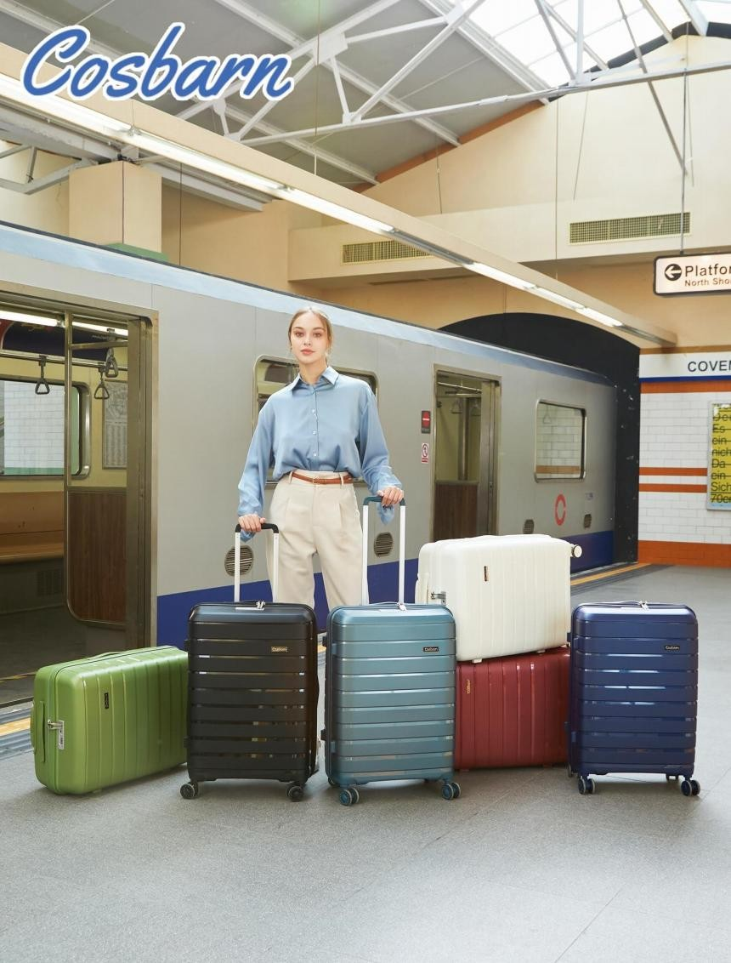

100%PP HARDCASE COLLECTION

ZIPPER: YKK ANTI THEFT ZIPPER SIZE: 20IN/24IN/28IN

LOCK: TSA RECESSED LOCK TROLLEY: ALUMINUM

100%PP ZIPPER STYLE

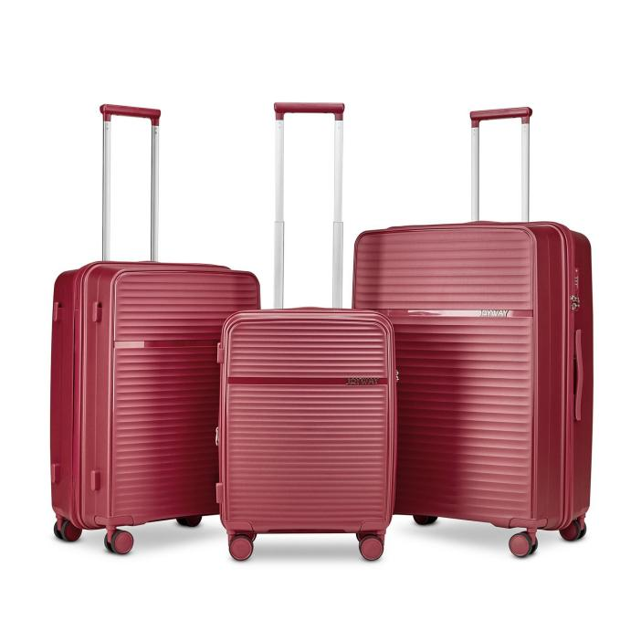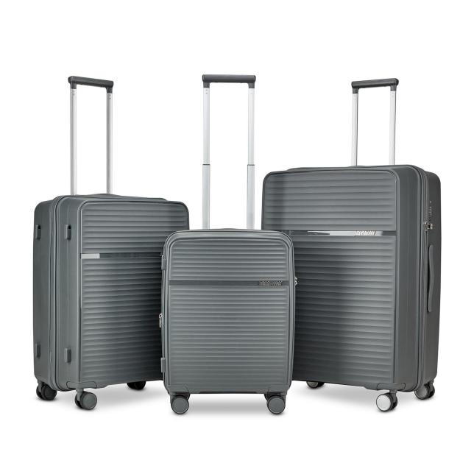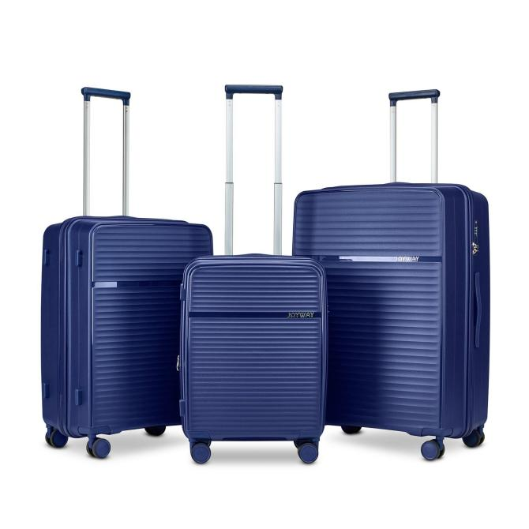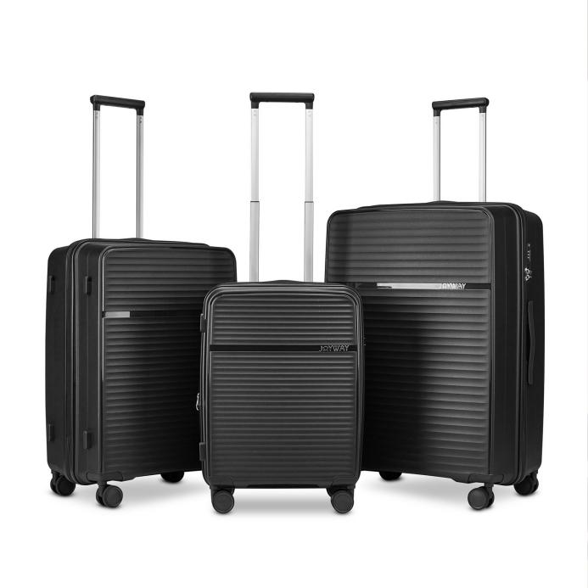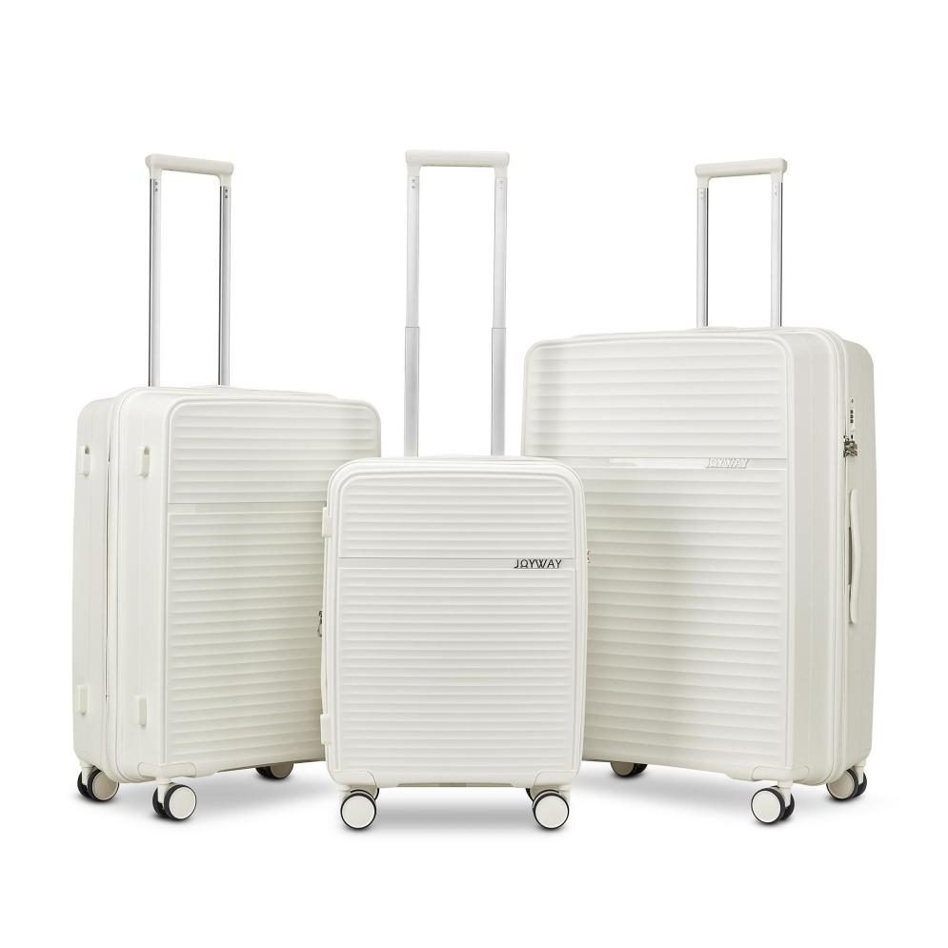WHEEL: 360° TWIN WHEEL（8 WHEELS）
Integral
Colour Matching

$ 63 USD
(FOB shenzhen)
20in Extension layer

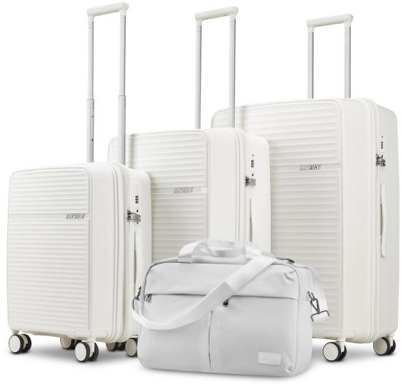
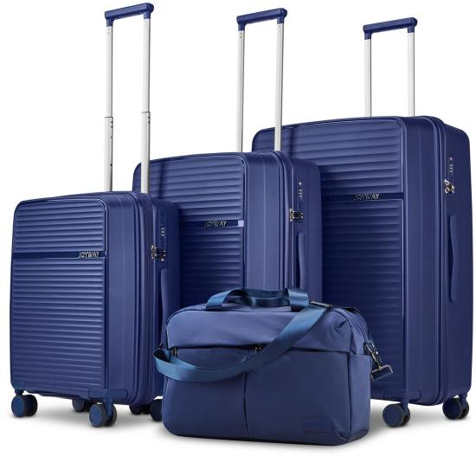

100%PP HARDCASE COLLECTION

ZIPPER: YKK ANTI THEFT ZIPPER SIZE: 20IN/24IN/28IN

LOCK: TSA RECESSED LOCK TROLLEY: ALUMINUM

100%PP ZIPPER STYLE

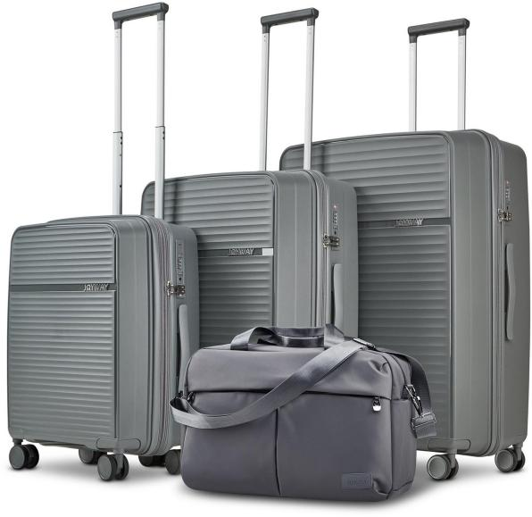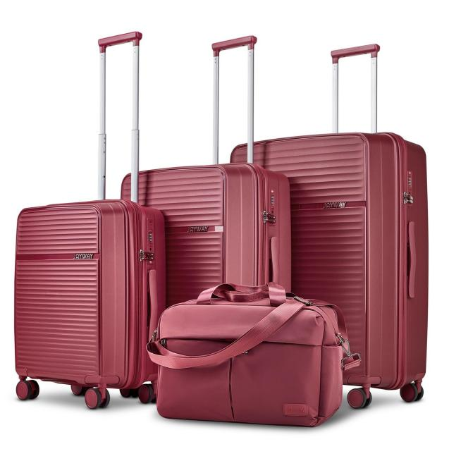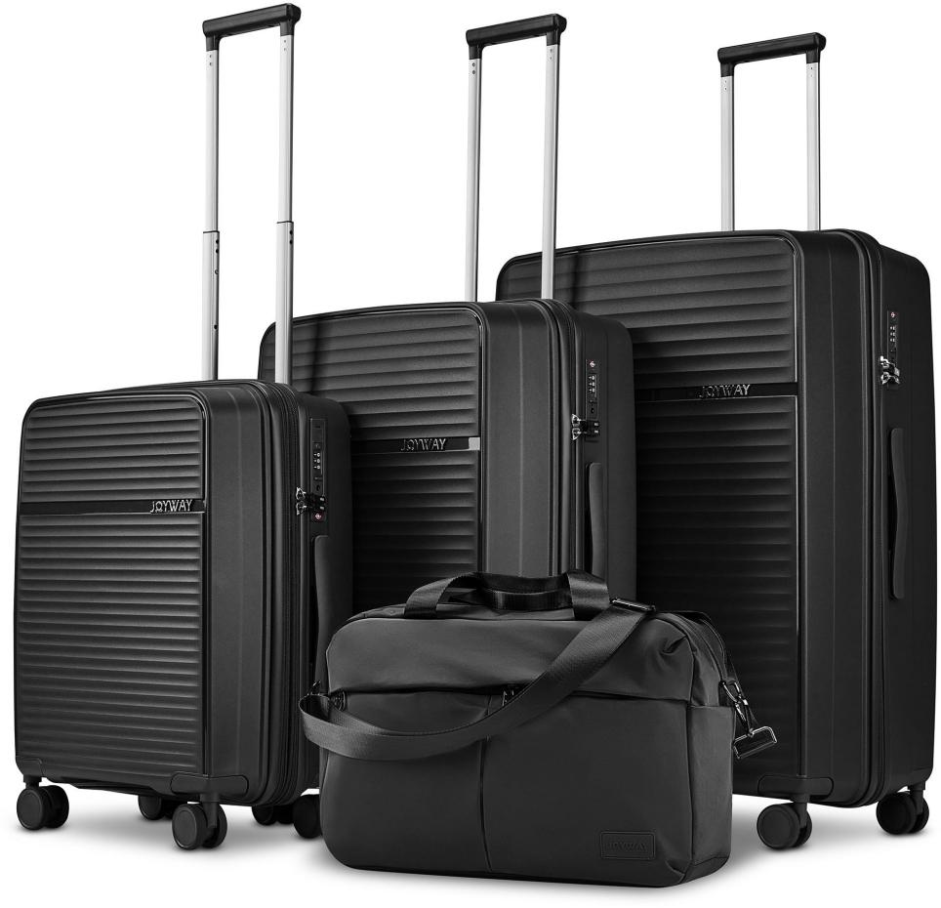WHEEL: 360° TWIN WHEEL（8 WHEELS）
Integral
Colour Matching

$ 72.3 USD
(FOB shenzhen)
20in Extension layer

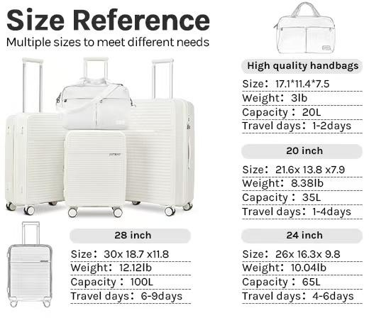
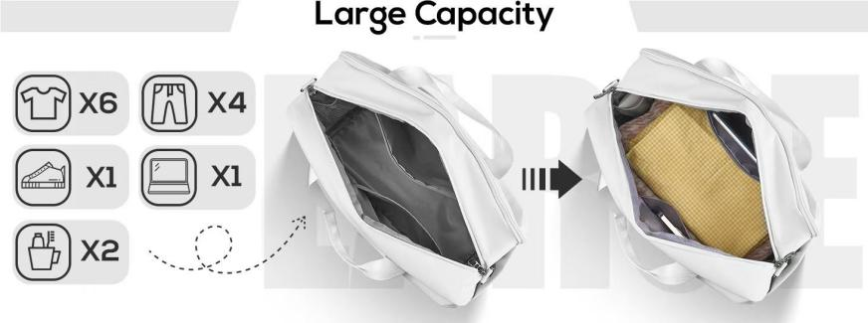
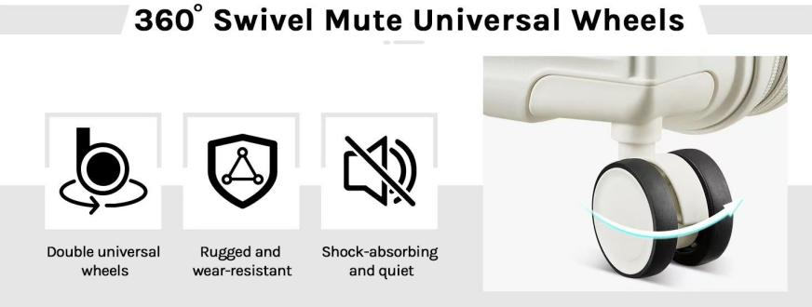
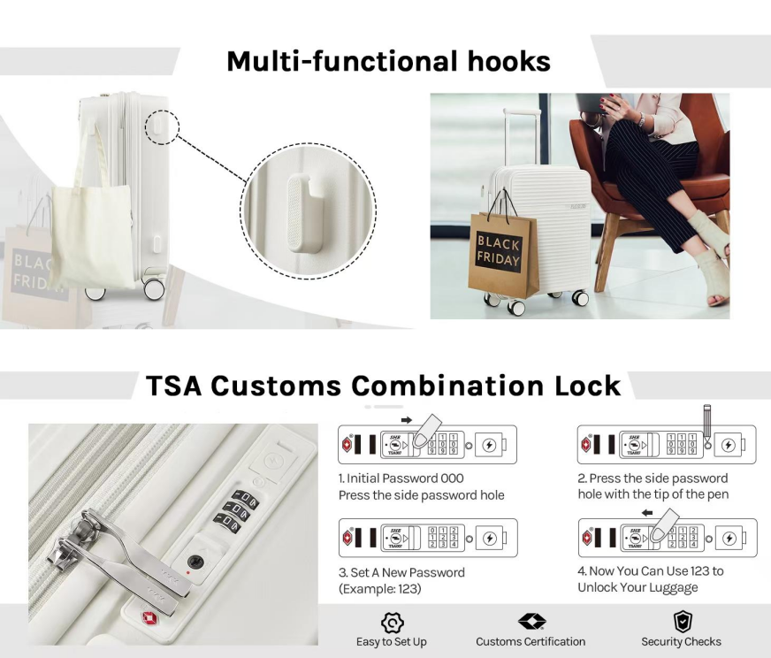
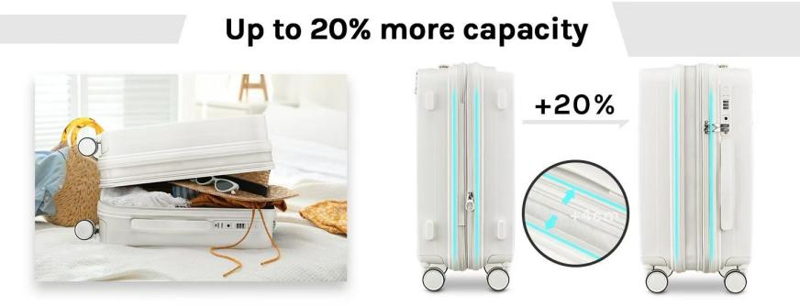
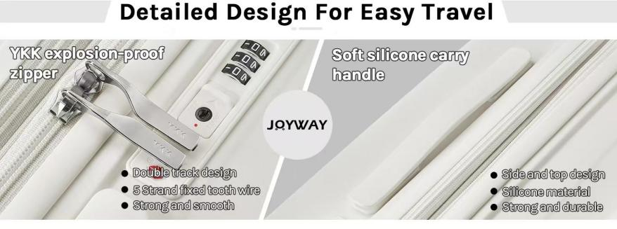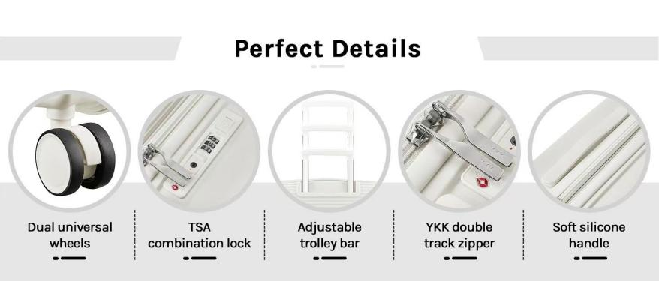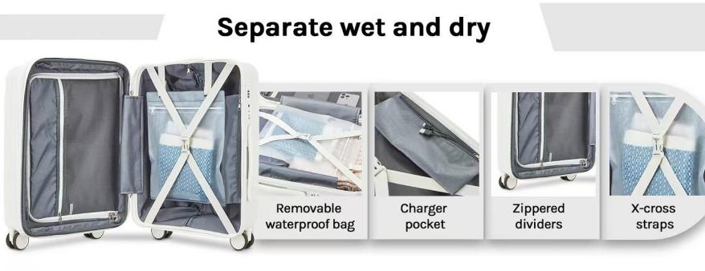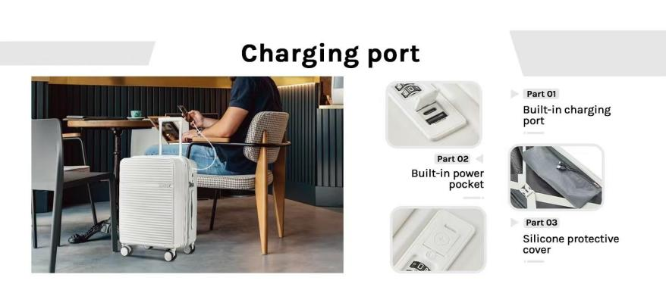
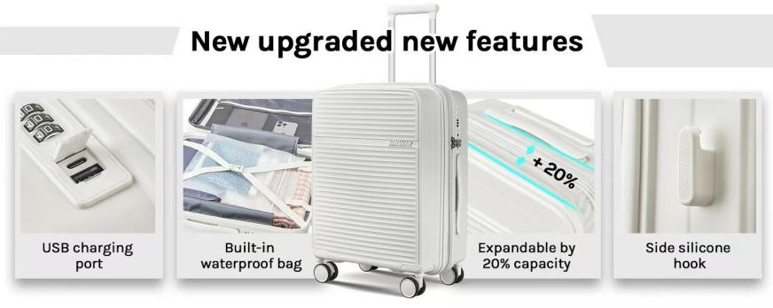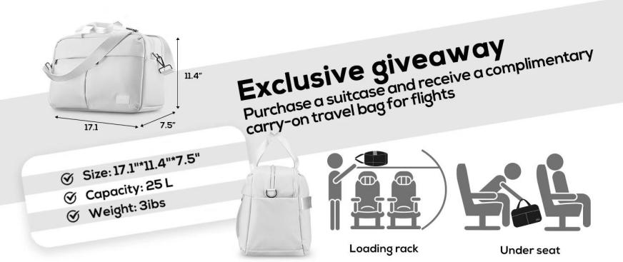

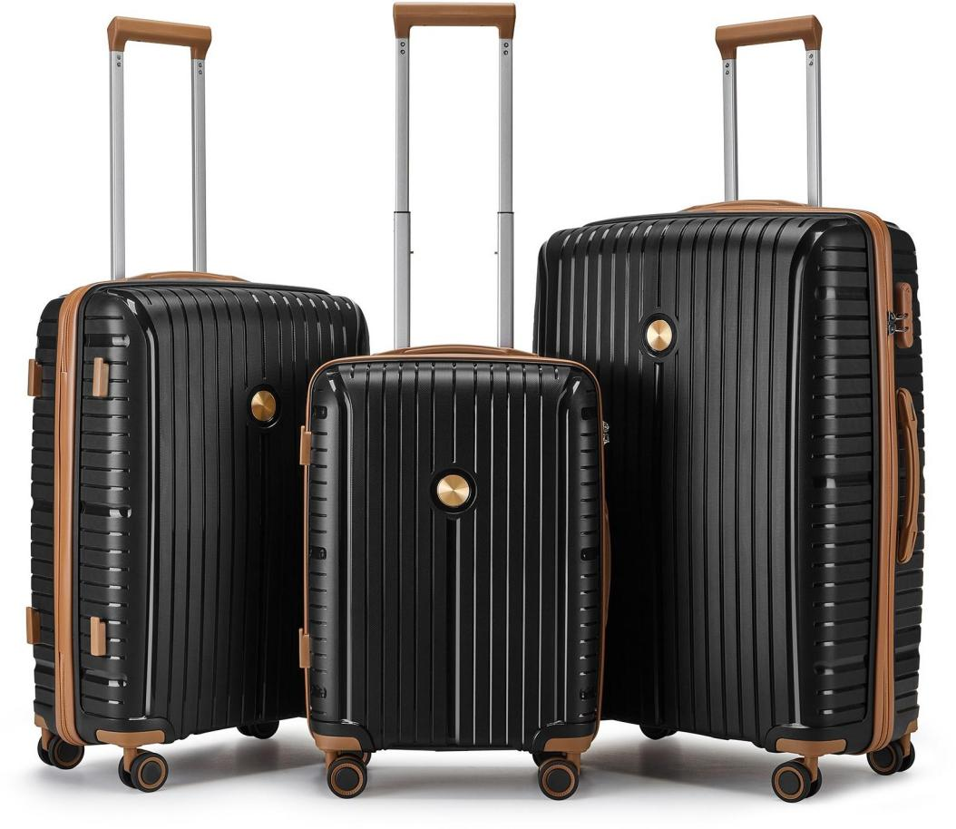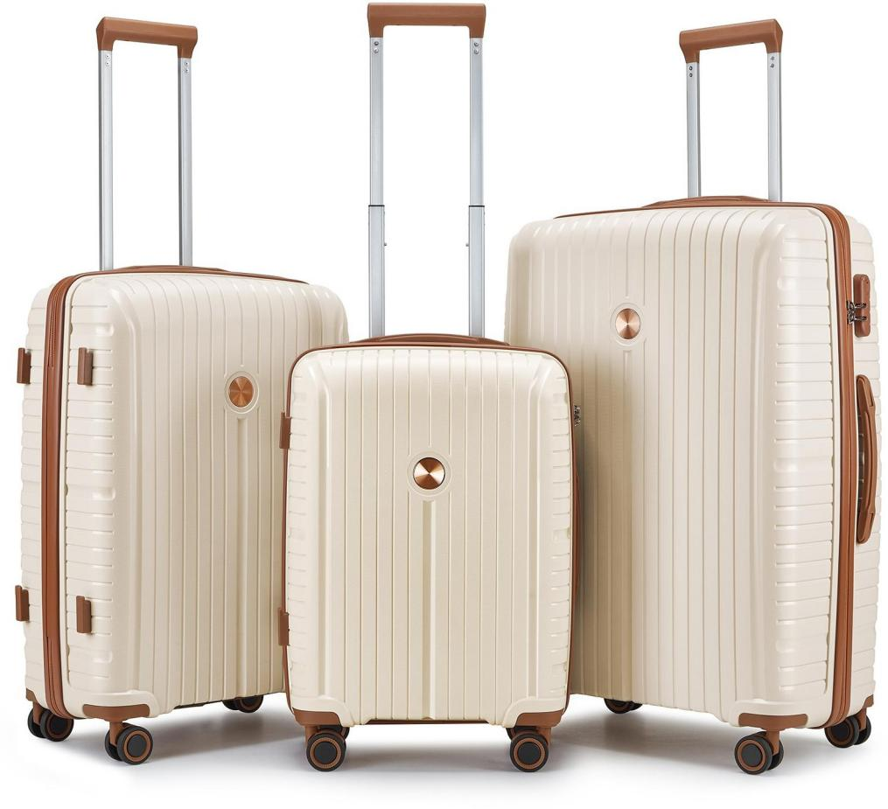


100%PP HARDCASE COLLECTION

ZIPPER: YKK ANTI THEFT ZIPPER SIZE: 20IN/24IN/28IN

LOCK: TSA RECESSED LOCK TROLLEY: ALUMINUM
Integral
Colour Matching

100%PP ZIPPER STYLE
Integral Colour Matching

$ 46 USD
(FOB shenzhen)

WHEEL: 360° TWIN WHEEL（8 WHEELS）

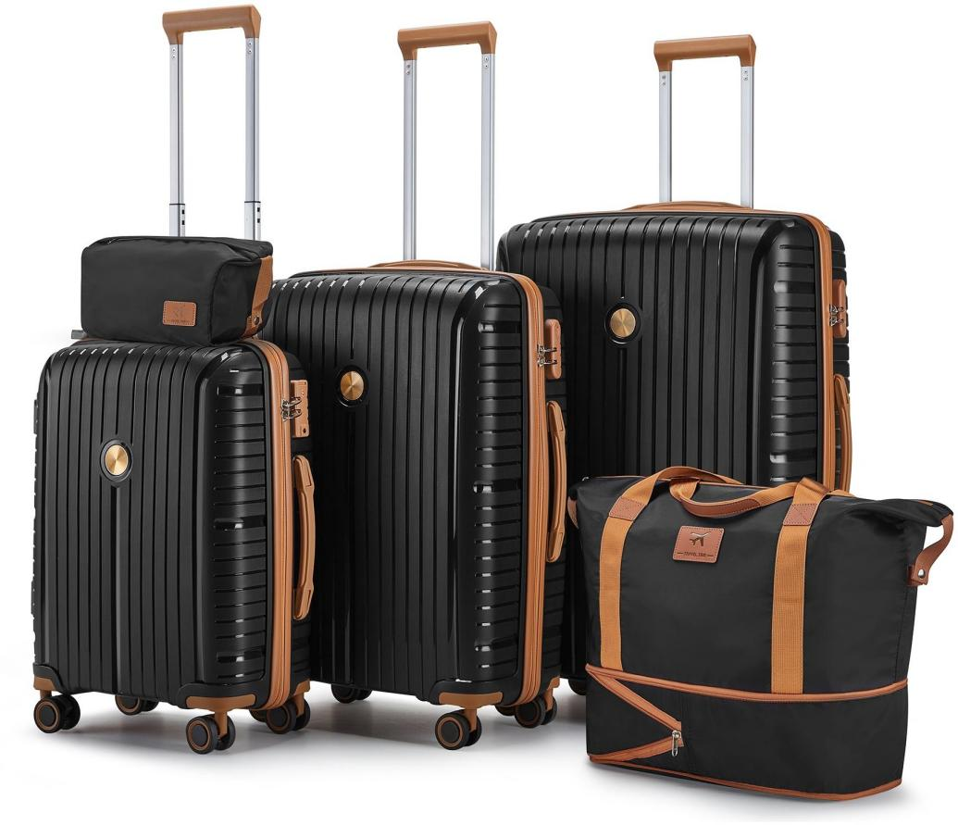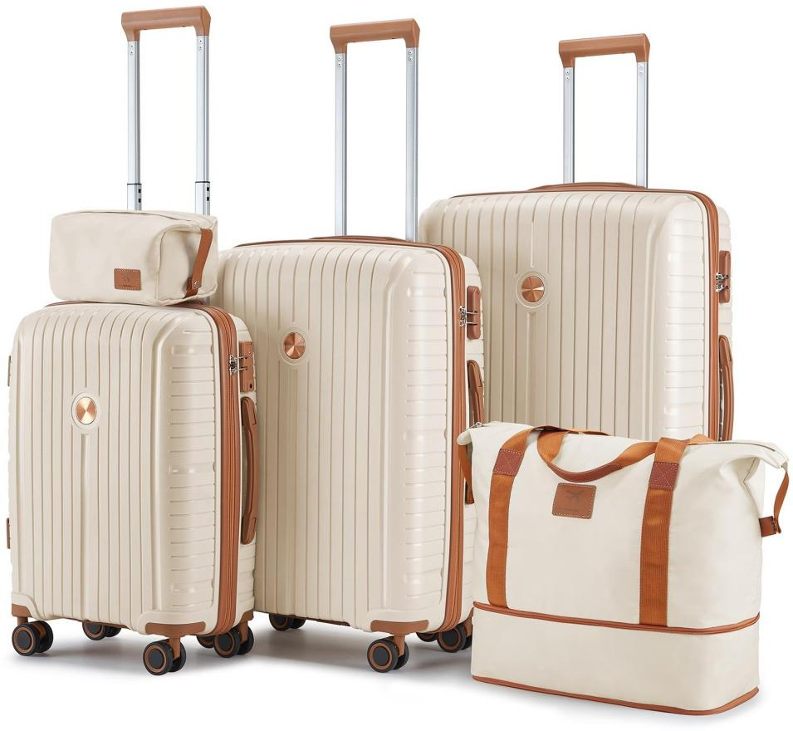

100%PP HARDCASE COLLECTION

ZIPPER: YKK ANTI THEFT ZIPPER SIZE: 7IN/18IN20IN/24IN/28IN

LOCK: TSA RECESSED LOCK TROLLEY: ALUMINUM
Integral
Colour Matching

100%PP ZIPPER STYLE
Integral Colour Matching

$ 53USD
(FOB shenzhen)

WHEEL: 360° TWIN WHEEL（8 WHEELS）

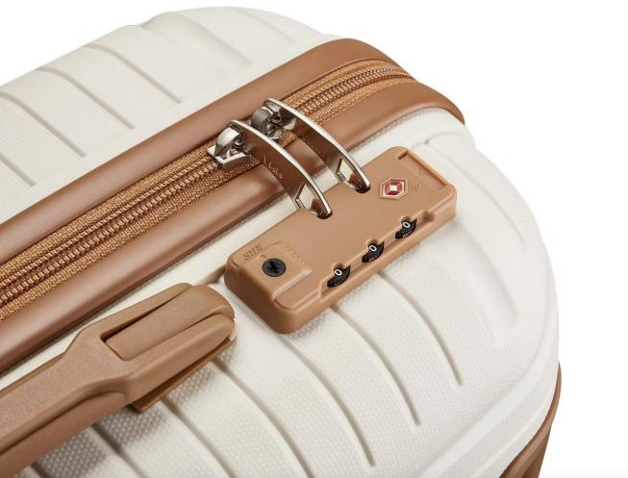
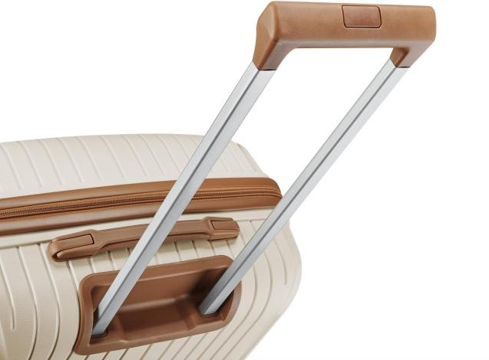
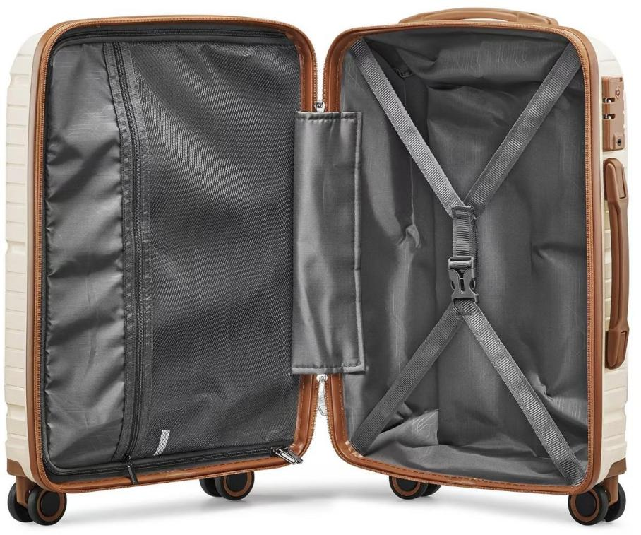
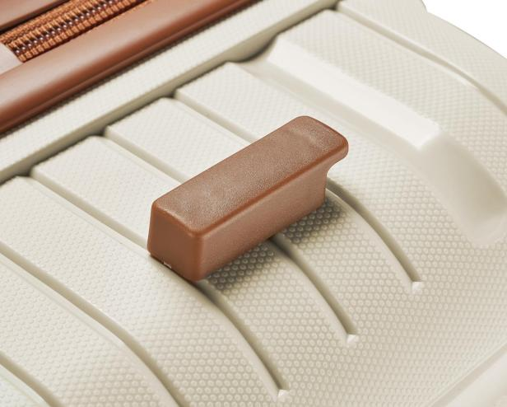
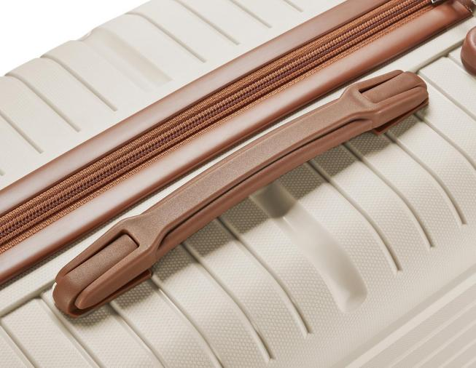
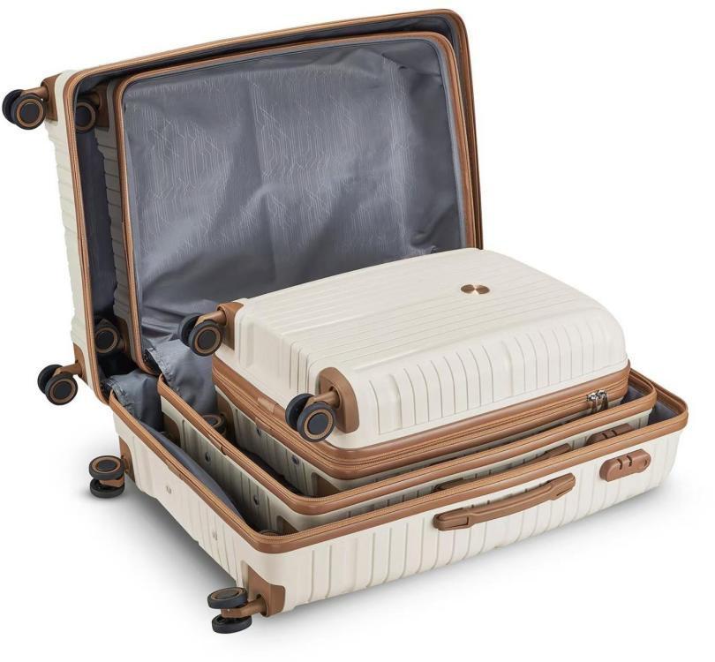
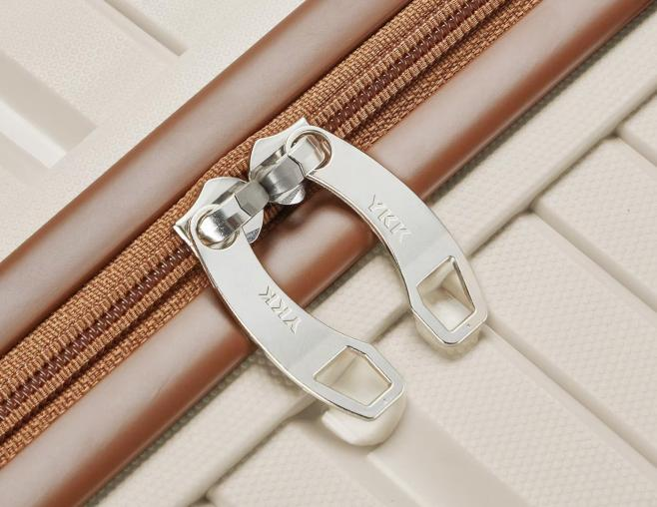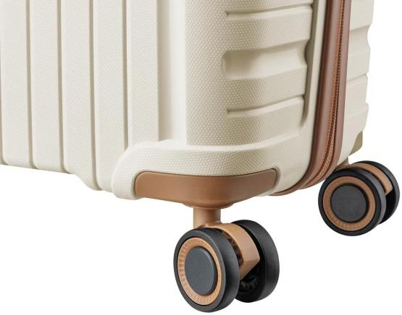

Packaging & Shipping
zipper luggage Size and Quantity per 20´/40´/40´HQ Container
Size | Weight(KG) | CTN SIZE(CM*CM*CM) | PCS/CTN | 20"GP(28CBM) | 40"GP(56CBM) | 40"HQ(68CBM)
20" | 2.6 | 39*24*57 | 1 PC | 600PCS | 1100PCS | 1250PCS
20"+24" | 5.9 | 43*27*67 | 1 PC | 430SETS | 830SETS | 880SETS
20"+24"+28" | 10.4 | 51*31*76 | 1PCS | 250 SETS | 525 SETS | 560 SETS
Package | 1pc/polybag,3pcs/set,1set/ctn

Remarks:
- The prices don't include special custom clearance documents cost. Any special requirements, please talk in advance.

All prices can be discussed according to different quantities or different specifications.You can provide your plan, we can make the exact price.
- We export through an trading agent.

Anything unclear,please don't hesitate to contact.
- The FOB fee is desided on the quality of order.

Remark
Mould Charge | USD$ 50/pcs,the express charge should be paid by yourself,will be return after place the order
Sample Delivery Time | Usually within 10-15 work days
Payment Terms | T/T, 30% deposit and the balance should be paid before shipment
Delivery Time | 45~50 working days after received deposit
The final price will be provided to you after you confirm the sample as well as the number of your specific purchases.



T h a n k s f o r a t t e n t i o n
LEADING INDUSTRY

OF TRAVEL GOODS IN CHINA

