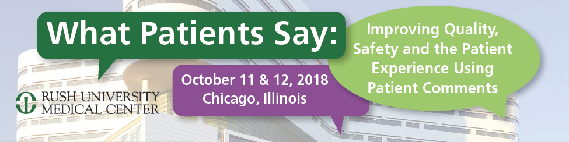
222 W Merchandise Mart Plaza Chicago, IL 60654
MATTER Conference Center Suite 1230
1871 Conference Center Suite 1212

Thursday, October 11, 2018

8:00 am Registration and Continental Breakfast at 1871 Conference Center Suite 1212

9:00 am Welcome and Opening Remarks
Francis Fullam, MA, Conference Co-Chair
Senior Director, Marketing Research, Assistant Professor, Health Systems Management, Rush University Medical Center

9:10am “Why Solicit Patient Comments in the First Place?”
Irwin Press, PhD. Co Founder, Press Ganey Associates. Emeritus Professor, University of Notre Dame, Department of Anthropology; Adjunct Faculty, Department of Health Systems Management, Rush University

9:20 am “Transparency”: Using Comments in Public Reporting to Inform Patients and Motivate Improvement
Presentations and panel discussion with health system leaders at the forefront of reporting patient comments about individual physicians.

Phil Shaw, MEM, Director Patient Relations, and Elizabeth Koszarek, MS-HSM, Process Improvement Consultant, Rush University Medical Center

Paul Sommer, MBA, Senior Director of Patient Experience, Geisinger Health

Moderator: Chrissy Daniels, MS, Partner, Strategic Consulting, Press Ganey Associates

10:35 am Break

10:55 am What the Research Evidence Tells Us About Consumer Use of Comments
Presentations and panel discussion with leading researchers studying consumer preference and use of comments posted on online reporting sites.

Introduction to Consumer Sentiment- An International Study
Jason Wolf, PhD, CPXP, President, The Beryl Institute

Are Online Reviews a Viable Tool for Reporting Health Care Quality?
Tara Lagu, MD, MPH, Associate Professor, University of Massachusetts Medical School-Baystate

Benefits Beyond Counting: How Patient Narratives Help Consumers Assess Clinician Attributes When Selecting a Doctor
Mark Schlesinger, PhD, Professor of Health Policy, Yale University School of Public Health

Choosing Doctors Wisely: How Comments Complicate Choice and Some Strategies That Can Help
Steven Martino, PhD, Senior Behavioral Scientist, RAND

Moderator: Jason Wolf, PhD, CPXP, President, The Beryl Institute

12:45 pm Lunch at MATTER Conference Center Suite 1230

1:30 pm Using Public Comments to Create a Dialogue Between Patients and Providers in the United Kingdom

The Care Opinion Model
James Munro, MD, Chief Executive, Care Opinion (UK)

2:15 pm Using Patient Comments to Drive Improvement
Presentations and panel discussion illustrating the use of patient narrative feedback to improve patient experience, safety and quality.

Using Patient Narratives to Improve Primary Care
Rick Evans, MA, Senior Vice President and Chief Experience Officer
New York-Presbyterian Hospital

From the Closest Observers of Care: Patient and Family Real-Time Safety Observations
Naomi Bardach, MD, Department of Pediatrics and Philip R. Lee Institute for Health Policy Studies at the University of California San Francisco

Experienced Based Co-Design: Patients and Staff Working Together to Improve Services
Jocelyn Cornwell, PhD, Chief Executive, The Point of Care Foundation (UK)

Moderator: Dale Shaller, MPA, Conference Co-Chair, Shaller Consulting Group
3:45 pm Break

Reassemble at MATTER Conference Center Suite 1230 for final presentation
(Down the hall from 1871 Conference Center)

4:00 pm Advancing the Science of Narrative Collection and Analysis
Presentations and panel discussion on efforts to elicit comments and techniques for understanding these narratives.

New Methods for Eliciting Patient Narratives
Rachel Grob, PhD, Center for Patient Partnerships,
University of Wisconsin-Madison

The Role of Natural Language Processing in Extracting Meaning from Comments
Senem Guney, PhD, Founder and Chief Experience Officer, NarrativeDx

Impact of Online Reviews
Aaron Clifford, MBA, SVP, Marketing, Binary Fountain

Moderator: Dale Shaller, MPA, Conference Co-Chair, Shaller Consulting Group

5:15 pm Day One Wrap-Up

5:30 pm Reception- Marshall’s Landing located atop the Grand Stair on the 2nd floor of Merchandise Mart

Friday, October 12, 2018

8:00 am Registration and Continental Breakfast at 1871 Conference Center Suite 1212

9:00 am Welcome and Opening Remarks
Francis Fullam, MA, Conference Co-Chair

9:10 am Global Learnings for US Solutions
Susan Mende, MPH, Senior Program Officer, The Robert Wood Johnson Foundation

9:30 am Leveraging Patient Complaints to New Heights – complaint management
Presentations and panel discussion of medical centers that manage patient complaints to provide greater insight into patient needs.

Case Study, Rush University Medical Center
Catherine Johnson, MS, Manager of Patient Relations

Case Study, Cancer Treatment Centers of America
Lisa Pittman, RN, MSN, MHA, NEA-BC, OCN, Nursing Quality and Patient Engagement/Director of Patient Care Services and Corliss Ivy, LCPC, Patient Relations/Guest Experience Officer

Case Study, UChicago Medicine
Caroline Costello, FACHE, CPXP, Director, Friends and Family Program, Destination UChicago, Patient and Family Insights and Guest Services Ambassadors
Moderator: Francis Fullam, MA, Conference Co-Chair

10:45 am Break

11:00 am Leveraging Patient Complaints to New Heights – Risk Reduction with PARS
Overview of the Patient Advocacy Reporting System (PARS)
William Cooper, MD, Vice President, Vanderbilt Center for Patient and Professional Advocacy

Case Study, Rush University Medical Center
Edward Ward, MD, Vice Chairperson for the Department of Emergency Medicine, Rush University Medical Center

Case Study, Sanford Health
Craig Uthe, MD, Director of Clinic Services, Physician Wellbeing & Professional Development, Sanford Health

Moderator: William Cooper, MD, Vice President, Vanderbilt Center for Patient and Professional Advocacy

12:15 pm Lunch at MATTER Conference Center Suite 1230

1:00 pm Adjourn

