Pastiche versus Quotation: A Tale of Two Exceptions?
On 9th May 2024, BLACA hosted ‘Pastiche versus Quotation: A Tale of Two Exceptions’, where Brigitte Lindner and Professor Tanya Aplin examined the purpose and scope of the pastiche exception from a UK and international perspective. Ms Lindner provided a comparative analysis of the pastiche exception in EU Member States, while Professor Aplin presented her proposal of pastiche as a subset of the quotation exception.
Ms Lindner began by examining the origins of the pastiche exception in the EU, noting the significant influence of French legislators. Pastiche works can be traced back to the French writer Marcel Proust in the 1920s, Pastiches et Mélanges, and the exception first appeared in 1957. In practice, pastiche is treated as a sub-category of parody, and specific conditions have emerged such as (i) no risk of confusion; (ii) humour; and (iii) compatibility with fair practice. Ms Lindner observed a subtle difference in terminology between parody and pastiche cases – ‘intention de faire rire’ (intention to make one laugh) vs ‘intention de faire sourire’ (intention to make one smile) – perhaps suggesting that courts acknowledge a difference between these exceptions.
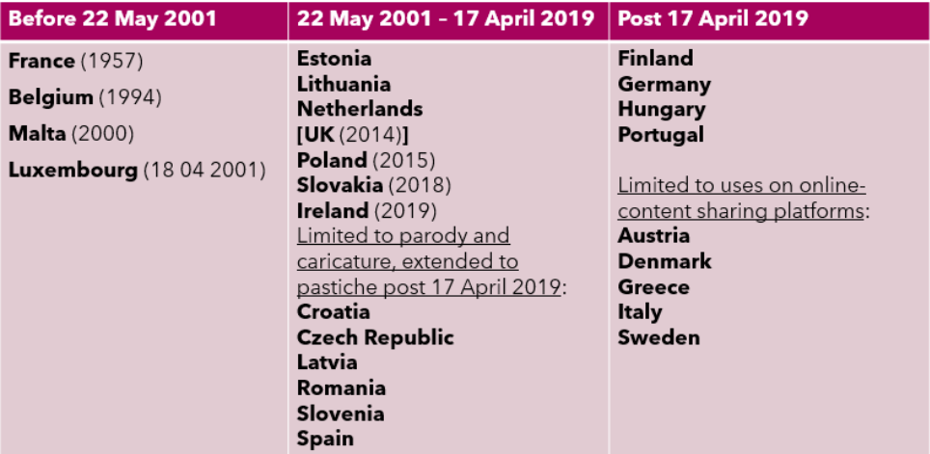
At the behest of France, caricature, parody and pastiche received protection across Europe through Article 5(3)(k) Directive 2001/29/EC (‘InfoSoc’). Implementation of this provision was optional for a number of years until the adoption of Article 17(7)(2) Directive 2019/790 (‘DSM Directive’). This directive partially rendered the pastiche exception mandatory – though only in the context of user-generated content uploaded to ‘online content-sharing services’. Ms Lindner provided a comprehensive account of EU Member States’ implementation of the pastiche exception pre- and post- InfoSoc and the DSM Directive, illustrating a large disparity between Member States:
Ms Lindner also examined the wide range of approaches to implementation, highlighting that despite the Directives, the pastiche exception is far from harmonised across the EU. Four distinct approaches can be seen: (i) standalone provisions dedicated to parody, caricature and pastiche; (ii) pastiche as a subgroup of quotation; (iii) reference to transformation or adaptation; and (iv) part of fair dealing. Ms Lindner observed various conditions of protection, including: disclosure; publication; fair practice; necessary/justified/motivated for the purpose of pastiche; and humour, mockery or critique inter alia.
Ms Lindner illuminated Germany’s unconventional approach to pastiche, having only provided a specific pastiche exception post-DSM. Prior to 2021, §24 aF on Author’s Right Urheberrechtsgesetz (UrhG) provided a ‘free use’ provision for works which were ‘inspired’ by another, but where the original work is ‘fading’. Where there is no fading, the new work would be considered infringing. This provision was considered incompatible with Art 5(3) InfoSoc since it was not covered by the exhaustive list of exceptions, and §23 UrhG governing adaptation was subsequently amended. Yet, Ms Lindner aptly pointed out that this provision is effectively a rewording of the former §24. Following the DSM Directive, §51a UrhG introduced a specific pastiche exception. Notably, it has already been invoked in five cases since 2021, the most significant being Metall auf Metall (‘Pelham’). Here, the Federal Court referred several questions to the CJEU, including: (i) whether Art 5(3)(k) InfoSoc can be considered a catch-all clause for artistic engagement with pre-existing works; (ii) whether pastiche is subject to limiting criteria; and whether (iii) intention is required. Ms Lindner noted that the Court of Justice’s response to these questions will have significant implications for the future of copyright in the EU, and opined that the issue of what constitutes a pastiche work could be resolved by returning to Proust. Indeed, one of the conditions for participation in the Proustian pastiche competition organised by the Société des Amis de Marcel Proust et des Amis de Combray is: ‘s’inspirer du style de [l’auteur] pour donner l’illusion que le texte pourrait être de sa plume’.
Professor Aplin proposes that parody, pastiche and caricature are a subset of the quotation exception. Prof Aplin explored the advantages and disadvantages of protection as distinct exceptions, or as part of the genus of quotation. Section 30A(1) CDPA, Art 5(3) InfoSoc and Art 17(7) DSM inter alia indicate significant legislative support at a national and international level for their distinct protection. National and EU case law also suggests distinct protection – for example, the CJEU expressed in Deckmyn and Pelham that ‘parody’ and ‘quotation’ have autonomous meanings in the EU, presupposing different conditions. Prof Aplin put forward three principal advantages of distinct protection: (i) clarity – more easily distinguishable; (ii) certainty – for users to know when their use falls within a certain exception; and (iii) cabining – restricts exempt uses to specific definitions. However, she questioned the tangibility of these ‘advantages’, highlighting that over-fixating on the categorisation of exceptions may pigeonhole uses.
Accordingly, Prof Aplin proposes that pastiche is part of the genus of quotation. She points out that the language of Art 10(1) Berne and its travaux make clear that it is a mandatory exception, requiring fairness, but not limited to a type of work, act or purpose. The first advantage of this approach is that it focuses on the overarching normative justifications of copyright exceptions – the balance of interests and values between users and rightholders. This approach also avoids some of the limitations of the three-step test by allowing a wide range of interests to be considered, including moral rights. Prof Aplin therefore suggests that the CJEU defined quotation too narrowly by providing specific purposes, and instead recommends a broader requirement of ‘dialogue’ with the source work. She also proposes that the CJEU should have considered Art 10(1) when interpreting parody. However, it does not follow that Prof Aplin and Professor Lionel Bently’s thesis requires a ‘fair use’ exception at the national level. Instead, it encourages reform to national quotation exceptions which are restricted by quantitative/purpose/work conditions, and justifies broad notions of parody/caricature/pastiche centred around freedom of the arts and expression. For UK courts, this means that specific definitions should be used loosely and instead, more emphasis placed on the fairness assessment. Prof Aplin’s thesis prompted much engagement amongst attendees, raising questions such as how authors would be attributed, and whether it would superficially insert a common law approach into civil law systems. Prof Aplin pointed out that attribution is not required under Art 10(1) Berne, and that her approach grants Member States flexibility to implement it how they desire – the thesis justifies, rather than mandates, fair use provisions.

OLG Hamburg 28.04.2022 5 U 48/05.
Case C-590/23
‘Being inspired by the author’s style to give the impression that the text could be from his pen’. Cf https://www.amisdeproust.fr/fr/concours/concourspastiches2024.
Case C-201/13

