**St Paul’s**

**Community Newsletter**

Summer 2025

# Welcome!

This community newsletter is a space to share updates across the different parts of our St Paul’s community. No matter what brings you to St Paul’s, whether it’s a meal, foodbank, or a service, you are a welcome part of this community.

# Contributing to the newsletter

Would you like to contribute something to the next community newsletter?

* News about upcoming local events that others might be interested in
* Your own art, writing, or photography
* A write-up of or photos from a recent trip or activity we did together

Please send anything to Emma ([emma@stpaulscambridge.org.uk](mailto:emma@stpaulscambridge.org.uk)) or bring it to the office.

# Dates for your diary

IMPORTANT: there will be no lunch clubs during the months of August. Our wonderful volunteers will have a well deserved break! A huge thanks to Julia, Marjan, Anthony, Jane, Elisabeth and especially Gary for all their cooking this year.

Thursday 24th July: tour of beautiful **Newnham College**, followed by tea and cake at the college café. Free (buy your own cake).

Thursday 7th August: **Botanic Gardens** walk, led by experienced volunteer.

Thursday 28th August: annual seaside trip to **Hunstanton**. Book now with Emma!

# Newnham College – 24th July

Newnham is one of the Cambridge colleges and it’s the oldest college to be run by women, for women. It was founded in 1871!

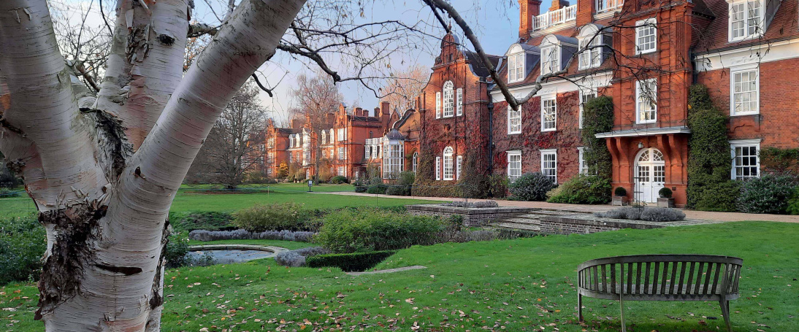

We will get a tour of their gardens as well as a special look into their Formal Hall, which is where the college holds its fanciest dinners. Then we can enjoy tea and cake at their café.

We will drive to Newnham in a minibus after lunch, arriving at 2pm, and be back at St Paul’s around 4pm. Give your name to Emma to book.

# Hunstanton – 28th August

Back by popular demand: we are going to the seaside in Hunstanton again!

We will leave St Paul’s at 9.30am and the journey takes two hours. The outing costs £10. Please book now and pay with Emma.

# Thursday Creative Group

Thursday morning is time to get creative! From 11am-12pm before lunch Emma has started an informal activity group. This is open to all older adults, with particular welcome to anyone with learning disabilities or mental health challenges.

Do join us in July. It is free and you are welcome to stay for lunch afterwards (£4) but you don’t have to.

# Botanic Gardens walk

First Thursday of every month, starting at the Station Road entrance at 11am. Free entry, for more information about the walk see our website: <https://www.stpaulscambridge.org.uk/social-activities>.

In **June**, there were seven of us again so we took the opportunity of being a small group to explore the greenhouses.

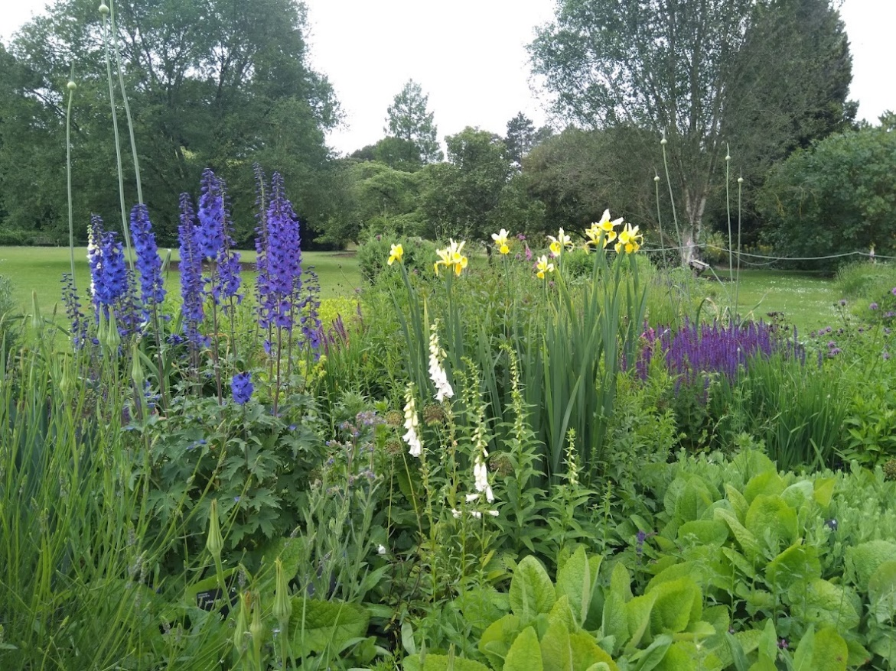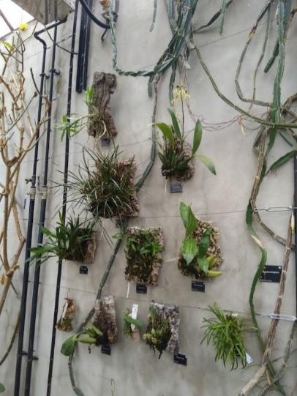

# Zoology museum trip

On Thursday 19th June, after lunch, we visited the university Zoology Museum. It was a very hot day so not everyone could make it but it was good to spend time with those who did! We saw some amazing animals, skeletons, and shells – everything from tiny insects to huge elephants.

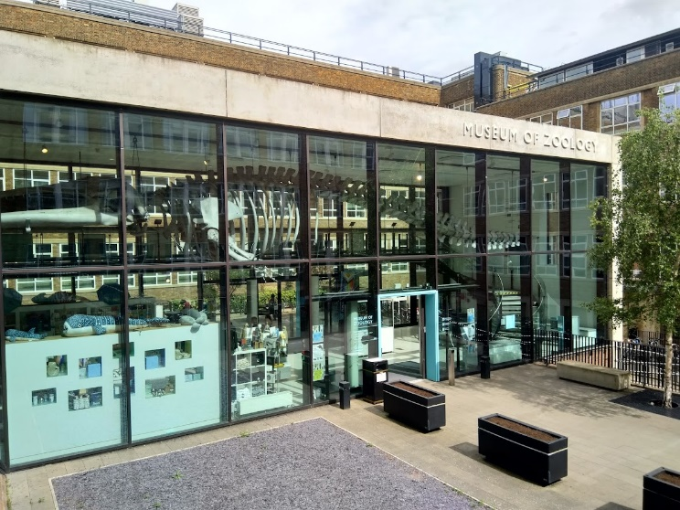

**ST PAUL’S COMMUNITY PROGRAMME**

**Monday Foodbank 4-5.30pm**. Emergency food provision, voucher required.

**Simple Supper** on **Mondays 6-7pm**. Free community meal, open to all (donations appreciated but optional). Followed by simple candle-lighting service in the chapel at 7pm.

**Thursday Creatives 11-12pm**. Informal arts, crafts, colouring, and friendly conversation.

**Thursday Lunch Club 12.30pm**. £4 for a homemade two course meal. Join for a short candle-lighting service beforehand at 12.15pm.

**Friday Lunch Club 12.30pm.** £5 for a homemade two course meal, followed by tea and coffee. Chapel service at 12pm midday.

**Friday Foodbank 3-5pm**. Emergency food provision, voucher required.

**KEY CONTACTS**

Imogen Nay, vicar

[vicar@stpaulscambridge.org.uk](mailto:vicar@stpaulscambridge.org.uk)

Emma Caroe, community development worker

[emma@stpaulscambridge.org.uk](mailto:emma@stpaulscambridge.org.uk)

Anna Pile, children and families worker

[anna@stpaulscambridge.org.uk](mailto:anna@stpaulscambridge.org.uk)

St Paul’s Office

[office@stpaulscambridge.org.uk](mailto:office@stpaulscambridge.org.uk), 01223 576899. Office hours 10am-4pm.

Rachel Hutchison, parish safeguarding officer

[safeguarding@stpaulscambridge.org.uk](mailto:safeguarding@stpaulscambridge.org.uk)

Safeguarding Duty Messaging Service: 01353 652747 (office hours)

Thirtyone:eight Helpline: 01353 652747 (out of hours)