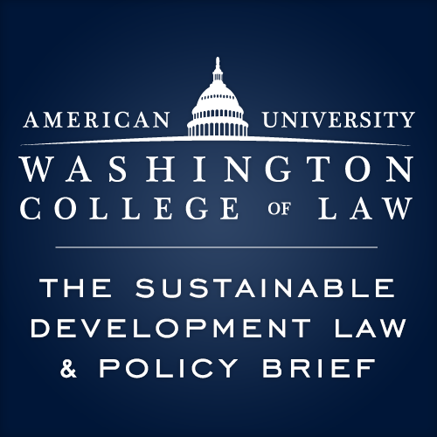

Sustainable Development Law & Policy Brief New Staffer Application
Volume 19, Spring 2019

What is the Sustainable Development Law & Policy Brief (SDLP)?
"SDLP" is a student-run initiative at AUWCL that spans a broad range of environmental issues such as sustainable development; trade; renewable energy; environmental justice; air, water, and noise regulation; climate change; land use, conservation, and property rights; resource use and regulation; and wildlife habitat preservation and animal protection.

Our mission is to serve as a valuable resource for practitioners, policy makers, and concerned citizens promoting sustainable development, environmental preservation, environmental justice, and biodiversity throughout the world.

Our publication also focuses on reconciling the tensions between environmental sustainability, economic development, ecology, human, and animal welfare.

Why Join?
- Staffers can publish a feature or full-length article.
- Staffers will sharpen their legal writing, research, and bluebook citation skills.
- Staffers will have opportunities to network with individuals in the sustainability and environmental law field.
- Our annual symposium gathers academics and practitioners from the public and private sectors to discuss recent developments in the sustainability and environmental law field.
- SDLP strives to foster close relationships between staffers through frequent, non-mandatory social gatherings.

How do I Apply?
Please submit your application packet as one single PDF via email to sdlp.wcl@gmail.com.

Please note: New staffers will be required to attend the All Staff Meeting on January 31 at 9pm in Y400.
Mandatory Bluebooking training will occur shortly thereafter.

If you have any questions about the application process or the brief itself, please stop by the SDLP office
(WCL CT03) or send us an email to sdlp.wcl@gmail.com.

Applications for Spring 2019 are due on January 25, 2019, at 5pm and must be submitted to sdlp.wcl@gmail.com.

What is the Application Packet?
The SDLP application packet has two components:
- Resume
- Response to Application Questionnaire (separate cover letter is not required).

Please note that while prior environmental law and sustainable development experience is desired, it is not necessary to become a staffer on SDLP.

SDLP Application Questionnaire

Please limit your answers to one to two paragraphs per question.

- What does sustainable development and/or environmental law mean to you?

- How does sustainable development and/or environmental law and policy relate to your life/career goals? If it doesn’t, that’s okay!

- What do you hope to gain out of your involvement with this brief?

- How would you enhance the current SDLP staff? Include specific skills, and feel free to brag!

- What other obligations do you have this semester?

