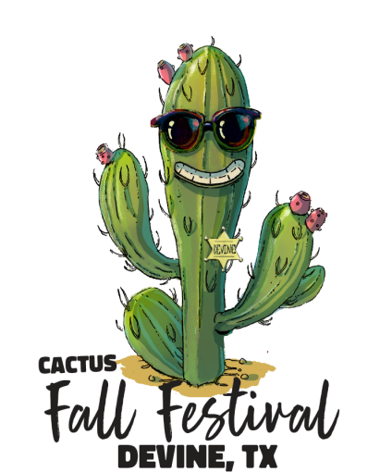

PARADE WAVIER

IF YOU HAVE ALREADY FILLED OUT YOUR PARADE ENTRY ONLINE, AND JUST NEED TO SIGN THE WAVIER, USE THIS DOCUMENT.

NAME:

Are you entering as an Individual or Group / Organization?

By signing below, I agree to indemnify and hold harmless the Devine Fall Festival from all claims, losses, damages, causes of action, suits and liability of every kind for damage to any property arising out of or in connection with the event, whether such injury or damages are caused by the sole negligence of the indemnified parties or the joint negligence of the indemnified parties and any other person or entity. I agree the Waive, Release and Indemnification Agreement shall be governed by the laws of the State of Texas and that venue for any litigation involving the indemnified parties shall be in a court of Medina County, Texas.

Participant Electronic Signature: (Please Type below)

Date:

Please Print and Mail To: Or Email to:
Parade Chairman devinechamberofcommerce@gmail.com
Devine Chamber of Commerce
P.O. Box 441
Devine, Texas 78016

