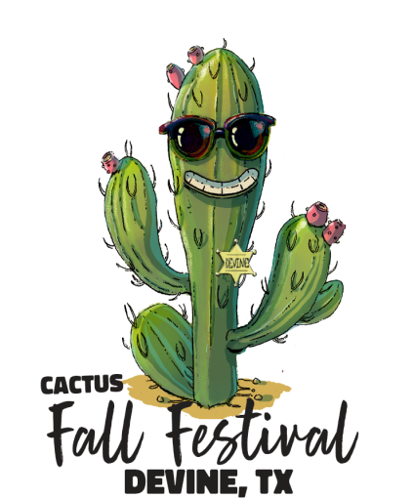

The Devine Fall Festival Committee invites you to participate in the Fall Festival Parade on the first Saturday of November. The Parade will begin at 10:00 a.m. and entries will need to be in place by 8:45 a.m. for judging. Hope to see you there!

The Parade is the kickoff for the Devine Fall Cactus Festival. The Festival is held each year in the downtown area in and around the Devine Community Center and on the parking lot of the American Momentum Bank, located in the 100 block of E. Hondo Ave. We have arts and crafts, live music, demonstrations, carnival and plenty of food booths, just to name a few. There will be entertainment for everyone.

Please fill out the form below and either fax, drop off or mail or e-mail to Parade Co-Chair
t at the address and phone numbers
below by October 18th. This will give us time to get the line-up made
Due to past incidents along the parade route, NO ONE is allowed to ask for donations except for the DHS Project Graduation selling tacos/drinks.
and notify all persons responsible for entries.

NAME:
Are you entering as an Individual or Group / Organization?

Contact Person:
Phone Number:
Address:
Email or Fax #:

Choose the appropriate category:
_____ Commercial / Business _____ Religious Group ______ School Organizations
_____ Youth Group _____ Antique Vehicles
_____ Ag Entries _____ Chamber or Associations
Approximate length of entry:
(Ex: truck/car (25 ft) * truck/trailer (60 ft) * _________ vehicles * 18 wheeler, etc., so we can leave enough room for everyone.)

On a separate card or piece of paper, please include information for the announcer about your entry.
By signing below, I agree to indemnify and hold harmless the Devine Fall Festival from all claims, losses, damages, causes of action, suits and liability of every kind for damage to any property arising out of or in connection with the event, whether such injury or damages are caused by the sole negligence of the indemnified parties or the joint negligence of the indemnified parties and any other person or entity. I agree the Waive, Release and Indemnification Agreement shall be governed by the laws of the State of Texas and that venue for any litigation involving the indemnified parties shall be in a court of Medina County, Texas.

Participant Electronic Signature: (Please Type below)

Date:

Please Print and Mail To: Or Email to:
Parade Chairman devinechamberofcommerce@gmail.com
Devine Chamber of Commerce
P.O. Box 441
Devine, Texas 78016

