**Magic Dragon Preschool**

26/4/21 • magicdragonpreschool@hotmail.co.uk • 07971 421 834

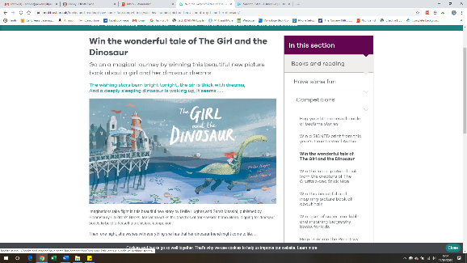

Hello Everyone,

What fun we have had huffing and puffing and trip trapping this week! The children have enjoyed the fairy tales and also the water outside, the mini toy characters, playing What’s the time Grandma Wolf, making mud concoctions, building dens, using our new digger-dumper trucks in the sand, sharing stories, sorting phonic sounds, painting shaving foam all over the garden, exploring the magnets, buying animals in the pet shop and printing with blocks…

Next week we will continue to follow the children’s interest in animals and there will be animals in ice, farm animal fun, printing animal footprints, animal number rhymes, dancing with streamers and more fun with writing and posting letters.

Yellow group will also be focussing on sharing toys.

***To help your child at home you could talk about their favourite animals. Find some animal books and try building a home for a cuddly toy animal. As you are doing this, talk out loud –*** *“Let’s build a home for the crocodile. It needs to be long and sturdy, I wonder what we can use? I’m going to lean the cushions together to make the roof and drape a scarf over the top to create some shade to keep it cool. Ooh, this is tricky because it keeps falling down. I’m going to try again”.* ***– The more you talk during your child’s play and everyday experiences, the more rich vocabulary you expose you child to and the more you help them develop their communication and language skills.***

We would love you to join us on Facebook and Instagram to look through what we have been up to at preschool this week. Please do ‘Like’ our posts to help promote us on social media as well.

<https://www.instagram.com/magicdragonpreschoolbristol/>

<https://www.facebook.com/magicdragonpreschool>

Enjoy your bank holiday weekend and we look forward to seeing you from Tuesday next week.

From Niki and the Magic Dragon team

Makaton sign of

the week = wait

**Snack next week:**

Wraps, fruit and crackers, bananas and rice cakes and vege sticks and breadsticks.

LUNCH CLUB Please remember we are a no nuts preschool (peanut butter/Nutella etc) and please can all grapes and cherry tomatoes be chopped in half. Thank you.

Phonics

The blue group children will be leaning the ‘d’ and ‘i’ sounds next week. These are pronounced ‘d’ not ‘deee’ and ‘i’ not ‘I’

Can you make a silly soup. Find things around the house that begin with d or i. Throw them into a the pan and say each item as you mix them round. Dandelion, dinosaur, doctor’s kit, dumper truck, dragon, dog, deer, dice, dish, doll, drum, duck or ink, ice cube, insects, iguana. Have fun stirring and saying what is in the silly soup.

Please remember to use lower case letters with your children at home if you are writing with them – thank you.

**A new chair, secretary and Child protection Officer for our Committee.** I wrote in the newsletter last week about three roles becoming available from September on our committee. We would love these roles to be filled so please do speak to Beth, Katie or Niki to find out more about what the roles entail.

**Things to try to remember next week:**

* Please put sun cream on your children in the mornings and bring a sun hat or raincoat!
* Please put named water bottles on the tray on the lunch trolley each morning so your child can access it freely during the morning.
* Please return the technology sheets that will be coming home
* Bank holiday on Monday! Have a lovely day.

Thank you.

