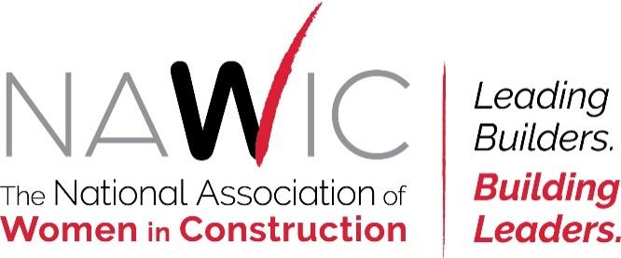

October 17, 2025

Greetings,
On behalf of the Minneapolis/St. Paul Chapter (MSP) of the National Association of Women in Construction (NAWIC), I’m reaching out to invite your support for our 2025 Virtual Scholarship Auction.
NAWIC is dedicated to enhancing the success of women in the construction industry by building education, careers, futures, and lives. Each year, our chapter raises scholarship funds for students pursuing construction-related degrees. This year’s auction will take place virtually at 32auctions.com/nawicauction2025, open for bidding from 6:00 a.m. on December 8 through 6:45 p.m. on December 10.
All proceeds benefit local colleges—including Dunwoody College, Saint Paul College, and North Hennepin Community College—which award these funds to students committed to the construction industry. Our focus is to empower women entering this field and to help meet the growing demand for skilled professionals and leaders.
Ways to support the auction:
- Make a monetary donation of any amount
- Contribute an auction item by December 5 — examples include themed gift baskets, event tickets, handmade goods, jewelry, artwork, décor, gift certificates, or tools
- Bid on items once the auction opens (December 8–10)
We’re happy to arrange delivery or pick-up of donated items before December 5.
Every contribution, large or small, helps us provide financial support and encouragement to women pursuing construction careers. We deeply appreciate your generosity and community spirit.
If you’d like to learn more about NAWIC or join an upcoming chapter meeting, please don’t hesitate to reach out. Thank you for considering this opportunity to make a difference.

Warm Regards,

Caitlin Kittle
Scholarship Auction Committee Chair
NAWIC Minneapolis - St Paul Chapter 164
www.nawicmsp.org
Senior Quality Manager
Mortenson
Caitlin.kittle@mortenson.com
952-836-4183

Thank you for donating to our scholarship fund!

- Tree Topper Donation: $500
Includes everything in Flurries and Snowfall levels plus (4) Holiday Party participation tickets, additional recognition during the auction, and your logo on table centerpiece decorations (Information needed by December 3rd)
- Blizzard Donation: $300
Includes everything in Flurries and Snowfall levels plus (2) Holiday Party participation tickets, additional recognition during the auction, and your logo on table centerpiece decorations (Information needed by December 3rd)

- Snowfall Donation: $200
Includes everything in Flurries Sponsor plus a thank you on social media

- Flurries Donation: $100
Includes recognition on the sponsor slideshow at event and on NAWIC Minneapolis St Paul Website; www.nawicmsp.org

- Donate any amount: $_________

Name of Organization: __________________________________________________________
Company Contact: ______________________________________________________________
Phone Number: ________________________________________________________________
Email Address: _________________________________________________________________

Please email your logo in a .jpg, .png or .pdf format to: NAWICMSP@gmail.com and cc: cjweber08@gmail.com

NEW! 2 ways to Pay
- NAWIC Minneapolis St Paul Website; www.nawicmsp.org under ‘Scholarship’ Tab

  - Include Completed Monetary Donation Form in email with Logo
- Checks can be made out to ‘NAWIC Chapter 164’ and mailed to the following address:
NAWIC Minneapolis/St. Paul Chapter 164
PO Box 270042
Minneapolis, MN 55427

Thank you for donating to our scholarship fund!
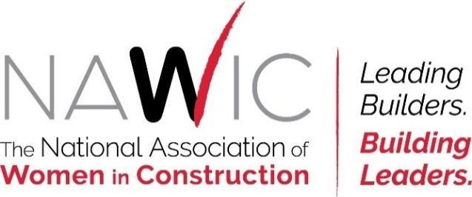

VIRTUAL SILENT AUCTION DONATION FORM

All silent auction donors will get recognition on NAWIC Minneapolis St Paul Website; www.nawicmsp.org plus a thank you on social media

Donation Item:_________________________________________________________________
Value: ________________________________________________________________________
Any special instructions: _________________________________________________________
Company Contact: ______________________________________________________________
Phone Number: ________________________________________________________________
Email Address: _________________________________________________________________

Please email your logo in a .jpg, .png or .pdf format to: NAWICMSP@gmail.com and cc: cjweber08@gmail.com
Include Completed Silent Auction Donation Form in email with Logo

We’ll arrange delivery/pick-up for auction items any time on or before December 5th.

Auction Item Ideas: themed gift baskets, event tickets, handmade goods, golf outings, blankets, spa packages, artwork, décor, gift certificates and tools, just to name a few

To review last year’s baskets please visit: https://www.32auctions.com/nawicauction2024

Thank you for donating to our scholarship fund!

