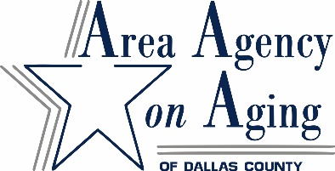
FISCAL YEAR 2021
SERVICE CONTRACTORS PROPOSAL SUBMISSION CHECKLIST
Deadline Date/Time: Friday, August 14, 2020 5:00 p.m.
Service Contractor:

For reference:
A - FY2021 Service Contractor Proposal Submission Instructions
B - FY2021 Direct Purchase of Service Information
C - FY2021 Service Contractor Proposal Submission Checklist
D - FY2021 Service Definitions
E – FY2021 DAAA Focal Points in Dallas County
1- FY2021 Direct Purchase of Service Application
2- Licenses/Bond as applicable
3- Certificate of Liability Insurance
4- Workers’ Compensation Form
5- FY2021 Service Contractor Agreement – Replace highlighted area with your service category
6- W-9 Tax Payer Identification Number
7- Debarment Certification
8- Standard Assurances
9- Data Use Agreement-Attachment 1. Subcontractor Agreement Form
10- Lobbying Certification
11- Non-Conflict of Interest
12- Child Support Certification (Required of for-profit Services Contractors only)
13- Attachment B-Proposed Pricing for Commonly Used Items
(Health Maintenance Applicants Must Complete)
14- New Applicants – Three References Form
15- Assurances Confirmation of Receipt and Review
Please submit original and one copy VIA U.S. MAIL to:
Sandra Luz/Francheska Dixon, Contracts Services Department
Community Council of Greater Dallas
Dallas Area Agency on Aging
1341 W. Mockingbird Ln., Suite 1000W
Dallas, TX 75247

Must be delivered by mail, with ample time to be received by due date.

