Minutes of the meeting of Mortehoe Parish Council held in the Council Chamber, The Esplanade, Woolacombe, on Monday October 15th 2018 at 7.00 p.m.
Present: Members: M Wilkinson, D Duffield, E Bond, J Dicker (Chairman), K Cook,
J Richards and S Woodman

Clerks: S Hocking and J Keiff
Also Present: No members of the public.

205/2018 Apologies for absence: Councillors: Davis (D.C.C.) and Barron.

206/2018 Public Speaking - There were no representations to speak

207//2018 Police Report – There was no report available this month

208//2018 Declaration of Interests
Planning Application 65526 6 Arlington Place - Councillors Duffield, Woodman and Wilkinson declared an interest in this application as near neighbours or, with family members as near neighbours of the applicant.

209/2018 Minutes:
Councillor Duffield pointed out that he was present at the meeting. Following alteration to the minutes, it was Proposed to approve as a correct record and sign the minutes of the Parish Council Meeting held on September 17th 2018 at 7 p.m. in the Council Chamber. Seconded PASSED Unanimously .

210/2018 County Council Report - Councillor Davis submitted the following written report:
Food Waste - A very successful Food waste conference was held in Crediton recently, the event was called ‘The Cutting Edge’ it looked at Food Waste Prevention opportunities across Devon.
The initial idea for a conference on food waste prevention came from the joint working group of Devon local authorities, the Devon Authorities Strategic Waste Committee that is DCC, Torbay Council and the 8 district councils of Devon.
The committee is set up to achieve the aims and objectives of the Resource and Waste Management Strategy for Devon. This is due to be updated early next year when the Government publishes their own Strategy later this year. The aim of the conference was to get the participants involved in developing the food waste prevention element of the Strategy.
The focus on food waste prevention took on new energy when an analysis of 1800 black bags/bins from across Devon and Torbay was carried out on behalf of the Joint Committee in October 2017. The results showed that despite nearly all the authorities collecting food waste separately, 30% of the rubbish in those black bins was food waste. Overall, 40.8% of the contents of the residual bin were found to be recyclable with the current systems – the cost of sending this material to disposal instead of recycling is £6.7 million.
This has led to behavioural change campaign work focussed on helping householders to reduce their food waste such as the Guilty Food Waste Secrets Competition to win a FridgeCam. The messages are communicated by the authorities’ RecycleDevon team, in schools, at roadshows and via social media.
Recycling - Devon has consistently been one of the top four recycling counties in the UK over several years. Unfortunately, three quarters of households (76 per cent) continue to include items to their recycling collections that are not accepted locally – this can cause problems in the recycling process. More than half of those households (54 per cent) put at least one item in the general rubbish that could be recycled. As a reminder please would you help by encouraging people to: 1. Recycle more bathroom items. - Almost a quarter (24%) of plastic shampoo and shower gel bottles and 19% of cleaning product bottles don’t get recycled. By recycling more empty containers you will help increase Devon’s recycling rate.
Food Waste - Make use of your local food waste collections* - any cooked or uncooked food waste, including bones and carcasses, can be put in your food waste collection or used for composting.
Specific Items - If you’re at all unsure about how to recycle a specific item, www.recycledevon.org can show you exactly what needs to go in the recycling bin where you live.

Highway Update from DCC - Really good progress has been made over the last few months in completing structural works on the road network, by the end of August we had completed over 50% of all the work on the non-principal network. There was some concern amongst County Councillors about progress with the gully cleaning programme last year, this year Skanska are ahead of programme at approximately 60% complete. Work starts with earnest on the 1st October on the cleaning works allowed for within the extra monies that were given to the highways team this year.
And finally, many of the salt bins are full and ready for the winter. Teams are also out replenishing the grit bins and good progress is being made on this, if you come across a bin that has been missed please report it to the number at the top of this report, thank you.
Structural repairs A399 and B3230 - Both works are vital. The roads need to be closed during the works for safety reasons. The A399 Combe Martin scheme will stabilise an embankment next to the highway while the B3230 Blakewell scheme involves the construction of a new retaining wall to stabilise the road. Both schemes were timed to avoid the peak summer season and the B3230 Blakewell scheme was planned in consultation with local businesses, so it falls outside their busiest periods. It is essential that both schemes are completed before the cold weather and by carrying them out at the same time we will be reducing the total length of time road works are in place in the area. However, there are contingency plans in place and I have been assured that both sets of works will be constantly monitored and could be reopened under traffic lights if it is safe and practical to do so. Official diversions are in place and the A39 from Blackmoor Gate to Barnstaple could be another option for some motorists. Diversions are a recommended route only, using roads of equal category to that on which the road works are taking place. They’re not compulsory, and people with good local knowledge of alternative routes are able to use those if they wish to. Readers can be assured that we’ll get the job done as quickly as we can.
A reminder of how to report a highway problem…..
https://new.devon.gov.uk/roadsandtransport/report-a-problem/
Phone 0345 155 1004 or 0845 155 1004
Please make a note of the reference number so I can follow up any issues arising.

211/2018 Planning (Councillors Wilkinson and Duffield left the chamber after declaring an interest in this application)
65526 Demolition of existing shed/store & replacement with guest annex at
6 Arlington Place, Woolacombe.
Members had no objections to this proposal. Proposed APPROVAL. Seconded. PASSED UNANIMOULSY.

65617 Erection of detached garage at
Willow House, Franklin, Station Road, Woolacombe. Members had no objections to this proposal. Proposed APPROVAL. Seconded. PASSED UNANANIMOULSY.

Planning Permission Received:
65309 Extension & alterations to dwelling together with erection of garden office at
Barton Lea, Beach Road, Woolacombe.
65374 Creation of roof terrace at
Flat 4, Glenhaven, Mortehoe.

Planning Refusal Received: None

Road Closure: December 10th – 14th - Road from Willingcott Bridge to the
Bungalow, Woolacombe junction of lane to Buttercombe Barton, West Down.

Road Closure: 21st January – 25th January Road from Woolacombe Station Road
to Hartnoll Cottages Junction

212/2018 District Council Report
Plastic Free Initiative – Councillor Wilkinson reported on a recent meeting of the organisation which had now enrolled 27 businesses in the community. Practical events and events to promote the aims of the organisation were being planned in the near future.
North Devon A.O.N.B. Meeting - Councillor Wilkinson reported on his attendance at the meeting held in Mortehoe.
West Down Parish Council Air Ambulance Community Landing Sights – Councillor Wilkinson reported on the discussion which had taken place at the meeting regarding the 3 year limited planning permission granted for all air ambulance night-time community landing sites. Members felt that a joint approach from all the Parishes to Mr Brailey (N.D.C.) would be appropriate in order to highlight the potential expense involved to each individual parish of the submission of separate planning applications.
Willingcott Open Day – Councillor Wilkinson informed members of the forthcoming ‘Open Day’ at Willingcott Club House to inform interested parties about the proposed plans for the site.
New Local Plan - will be formerly signed off on October 29th .

213/2018 Questions for the National Trust - none

214/2018 Correspondence i) Invitation from Woolacombe and Mortehoe Luncheon Club - and invitation to the Christmas Buffet on 11th December . ii Letter from David Jolley (Woolacombe National Trust ; Re Summer of Sport - Members were pleased to welcome the introduction of the new scheme and wished it well iii) Request from Cameron Maddocks - Beach Clean November 10th and request to use Marine Drive - Members requested more information from Mr Maddocks and the National Trust before any permission was granted.

215/2018 Register of Outstanding Matters
Flooding at Damage Barton Entrance – there were severe flooding problems at the entrance to the site and across the road on September 20th. Highways carried out temporary remedial work to clear the drains but Mr and Mrs Lethbridge have asked for the council’s help in a more permanent solution to the regular flooding. Councillor Davis has agreed to help as has the National Trust who own the field opposite.

Pleasure Lawns - a new fence to deter golf balls from escaping from the area will be erected over the winter. New Play Equipment - the four items of new play equipment has now been installed in the two play areas. The outstanding 106 funding will be available when the final payment (due at the meeting) is completed.
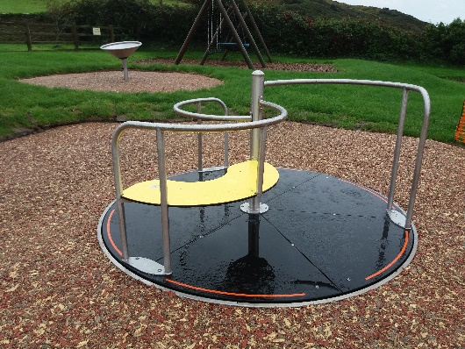 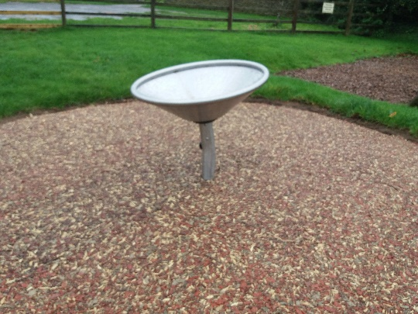 Mortehoe
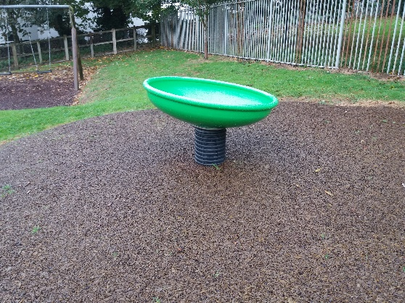 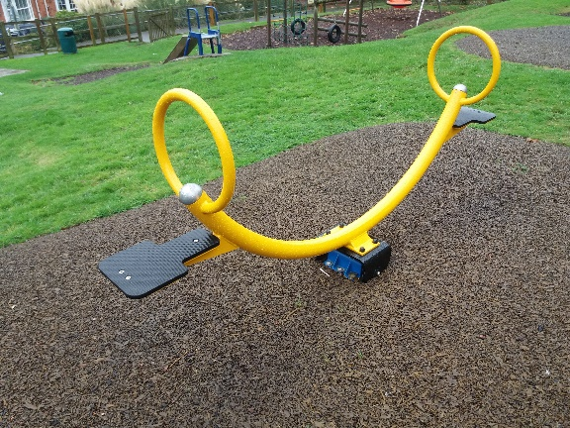 Woolacombe A.O.N.B Annual meeting – was held at Mortehoeon the 26th September. Councillor Wilkinson represented the council and the clerk attended the afternoon session which included a walk to inspected the work done in the ongoing project for the removal of the overhead power lines and the creation of the diverted Coastal Path. Meadow Sports Field – the key code for the Pavilion has been changed again following intrusion at the building a couple of weeks ago. A missing key has been returned. The sixth and final picnic table has been removed from outside the building and has been found at the camp at the bottom of the Meadow in amongst the trees. The National Trust have taken away large quantities of rubbish and other material. The police have been asked to include the Meadow in their regular patrol.

215/2018 Disabled access in the Parish
Possible New Tramper Route - The clerk reported that the Tramper chair hired through the Tourist Information Centre, in conjunction with the National Trust and Living Options, has proved very popular since its introduction last year. The current designated routes include the beach and bridle path across the dunes. A new route across the seafront had been investigated to enable users to go along the sea front as far as Combesgate Toilets, Upon walking the route the following improvements were suggested to improve the experience: Access - would be required via Parkin Car Park across the Greensward. Improvements to Access at Water Treatment works – this access is very steep. Possible improvements could be made to lessen the gradient.
Creation of extended path to cliff top seat - there is scope to extend the current path to include a second seat to make it accessible by wheelchair.
Improvements to paths along the sea-front - there are several areas where the path surfacing could be improved to widen, level out uneven areas and to improve drainage
Advice from Tony Potter (accessibility officer for the National Trust ) - has completed reviews of both Mortehoe and Woolacombe (sent separately) He comments:
“Lovely idea. My immediate thought - is not the Esplanade already quite accessible along the pavement etc? However, to get closer to the sea would be great. I note the SW coast path follows between the Esplanade and the shoreline so would this be an improvement to the existing path to make more accessible for wheelchairs, wheelchairs, scooters etc?
As for Mortehoe - the 2 issues I noted were access to the path to Morte Point. Just after the cemetery there is a large gate which is padlocked and to the left a small access gate - it is a narrow gap with tight turn if you wanted to travel this way on a scooter or power chair. Can anything be done to improve accessibility? In a similar vein the tarmac route to Bull Point is via the Trinity House road. At the start point on large sign it states no wheeled transport without permission - does this apply to mobility scooters, power chairs etc - surely we want this route to be accessible and the intention here is to prevent cars? Possible Grant funding - there are two possible sources of funding for a scheme . Communities Together Fund – applications are invited from Parish Councils by the 31st of October and then the scheme is open to other community organisations to apply. Mortehoe could be eligible for funding of £1,369.50 but applications for more than that amount are invited (unless the funding has already been allocated ). The Community Support Team indicate that an application for a scheme such as this would be suitable providing other Parishes give their written support. Grow Wild – this is a scheme which focuses on native wild flowers, plants and/or fungi, either through planting or as inspiration or helping people understand the importance of native species for the environment. It may be possible to include improve disabled access to an area on the seafront where an area of wild flowers has been created. One possible area is adjacent to the seat shown in picture 3. The land would need to be cleared and plants chosen with care to tolerate the salt air and wind. Permission would be necessary from the National Trust. Another possible area for the creation of a wild flower area could be the Meadow
In the vicinity of the Memorial trees .
Members suggested that the involvement of expert help to investigate possible schemes for both the tramper and wheelchair access would be useful to ascertain what might be possible.
It was agreed to invite Mr Potter and to investigate other possible advisors.

216/2018 Combesgate Toilet Conversion
Combesgate Toilets - Agenda Item 13 Outstanding T.A.P Grant - a grant of £1,915 from the TAP fund is currently outstanding for the conversion of the present facilities into a combined disabled toilet and combined Gents and Ladies Toilets. This would mean a reduction of toilet units from the current 5 to 1 and the loss of separate facilities for gents and ladies. Coastguard Plans – the M.C.A. have withdrawn their interest in the site and are looking for an alternative site to build a modular unit. They have asked for help in finding suitable land. Alterations to Plans for Combesgate – the clerk reported that a revised plan has been drawn up to incorporate refurbishment of the to the Gent’s facilities and a separate facility (within the much larger ladies toilets) for a combined disabled and ladies toilet. This would mean that the numbers of toilets available for public use would increase from 1 (in the original plans) to 4 (including the disabled unit) The remaining space in the building could then be converted into shower and toilet facilities for the Groundsman + space for a small work room and storage facilities. There would be minimal plumbing work required but an additional door would be required to allow new access to the new disabled/ladies toilet. The costing of the new scheme is currently being undertaken. The grants officer at N.D.C. has asked to see new plans and costings before making a decision on the payment of the outstanding grant.
Members agreed to discuss the matter further at the November Finance meeting.

217/2108 Matters Brought Forward with the Consent of the Chairman
Parking on the Esplanade – members had received complaints regarding overnight parking on the Esplanade. The clerk confirmed that when daytime parking restrictions were in force, it was possible to alert the authorities to their presence. The clerk was asked to contact the County Council as the enforcement of the parking regulations was the responsibility of D.C.C.
Review on Parking - would take place during the Neighbourhood Plan process.
Sea Gull Nuisance – it was agreed to produce warning signs for Woolacombe Village Centre for the season next year requesting that members of the public refrain from feeding the gulls.
World Surfing Reserve – Councillor Cook confirmed that the application had been submitted.
British Telecomm – it was agreed to contact B.T. to request the removal of the phone boxes at the end of the Esplanade.

218/2018 Cheques and payments for Approval and Signature.
The following payments were approved and signed at the meeting.The R.F.O. provided a list of payments in conjunction with bank statements which were also checked and approved at the meeting:
15 S Hocking 1295.52
15 S McCarthy 1150.50
15 K Ash 1141.55
15 D Hodges 929.44
15 HMRC 833.27
15 Gordons Window 754.00
15 Bloom Brothers 448.00
15 PLanscape 355.82
15 J Keiff 292.24
15 J & J Bins 69.33
15 Playdale 35.04
15 Simpsons 29.14
15 Jewsons 28.60
15 BFS 24.00
15 Ricoh 127.85

Part 2
Correspondence not requiring discussion is available in the Council Chamber

Part 3
Confidential Matters

219/2018 Marine Drive Toilets - Mr Joules and Kelly have sent the following response to the questions raised at the last meeting -

1. Legal Costs - will the Trust be meeting the legal costs? – Yes I confirm we would be paying both parties fair and reasonable legal fees.
2. Costs associated with the toilets - members asked for clarification that the Trust would be meeting the costs associated with water rates, rates, septic tank and cleaning etc.? Yes I confirm the Trust would take on all running costs; water, rates, septic tank cleaning repair and replacements.
3. Insurance - it was pointed out that the Parish Council insurance policy has just been renewed (September 30th ) which includes the toilets, when would the Trust envisage taking on the insurance liability? Yes I confirm the National Trust would look to insure the building and would expect any tenant to insure their contents.
4. Area of Operation – will the café be limited in its operation to the confines of the actual building and include the adjacent lay-bye? Sally – Rob will confirm. The catering kiosk will operate from the actual building yes, and the adjacent lay-bye will be left as is. Ie the lay-be will still be a turning area that can be used by cars. There will be a couple of temporary outdoor tables on the grass area (where the bush is at present) and these will be removed daily and put in the store behind.
5. Refreshment Agreement - members assumed that the present refreshment agreement would be considered redundant in the light of the new arrangements? Yes I confirm we would agree that the present refreshment would be considered redundant.
6. Signage - members queried where and how the café would be advertised. Sally – Rob will confirm. There are no plans at present for any fixed signage other than on the building (as per the planning application). If its deemed by the new tenant permanent signage is needed then due planning policy will be followed – however it’s not envisaged this will be needed. In the early days while the kisosk builds up its reputation they may put out a temporary A-frame as other traders have used on Marine Drive in the past – however consent will be sought from the PC for this. Once the tenant is selected I think a meeting with members of the parish council and the NT would be a sensible idea to agree ways of working / communication etc.

Members Proposed that the lease be surrendered to the Trust. Seconded, PASSED UNANIMOULSY

220/2018 . Meeting on October 11th with Seaxburg - update on the meeting.
Members asked the clerk to thank Seaxburg for coming to the meeting on Friday and to listening to the points made by those present. Whilst members appreciated the flexibility of the company in their approach to the possibilities of the potential site, they did fear that the site could lead to a considerable increase in 2nd home provision in the Parish. They felt that it was vital that the company conducted public consultation to gain an insight to the feelings of the community about the possible development of the area.

Report on the Neighbourhood Planning Seminar at Sampford Peverell 20th September – the clerk explained that the aim of the day was to provide information on the drawing up of plans , the integration of new housing within a community and tips on drawing up a successful plan. This section was given by a Chartered Town Planner and government examiner of over 30 Neighbourhood Plans . Her top tips were: 1, Identify what is needed with public consultation.
2. Think carefully what the plan is for i.e pressures on the community. Focus on a few issues. Keep the plan brief, short and relevant. Don’t spend too long compiling the plan (Newton Abbott have just completed theirs in 1 year)
3. Focus on policies rather than history, aspirations or planning policies and protection already in place. Find experts from within the community to lead the process and/or write the plan
4. Add value to the local plan with identification of green spaces and non-designated heritage assets.
Grants – a total of £9,000 is available but any funding has to be spent within a certain time frame. Therefore it is important to look at timescales of consultation Professional Help - is available through Community Council of Devon and ACORN. Affordable Housing - the provision of affordable housing plays a major part in most Neighbourhood Plans. If the National Trust scheme or Seaxbugh plans come to fruition, would it be sensible to include these in the Neighbourhood Plan consultation. Experience of other communities - Newton Abbott and other communities nearer bigger city conurbations were under pressure to accept large housing developments despite the views of the community expressed in their Neighbourhood Plans.

Members felt that it was important to move forward on the project and discussed possible questions that could be asked in an initial public consultation. The clerk agreed to put forward some suggested topics for the next meeting.

Correspondence to Note:
- ‘Everyone’s Tomorrow’ – Newsletter from Senior Council Of Devon
- Devon Senior Voice - Newsletter.
- Health Watch Voices

Yours faithfully Sally Hocking
The minutes of previous meetings are available from the Parish Clerk
The order of the agenda items may be altered with the consent of the chairman
Date of the next meeting:
November 19th 2018 Parish Council Finance Meeting at 6.30 p.m. followed by Parish Council meeting at 7 p.m.

The meeting ended at 9 15

