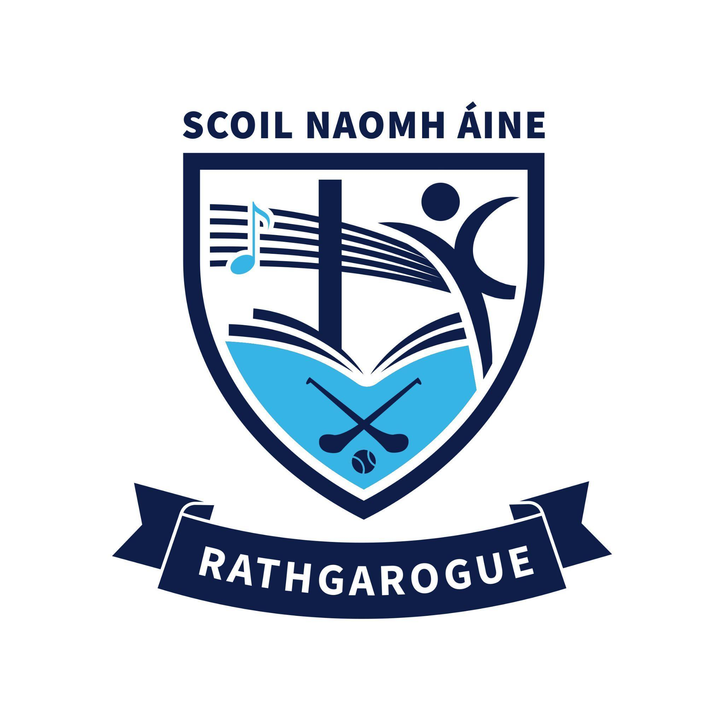
Subject: The Primary School Survey – our school’s results and next steps

Dear all members of our wider community

We are writing to update you on the Department of Education and Youth’s Primary School Survey.

This survey was carried out to understand the types of schools that parents and guardians prefer. Over 200,000 parents and guardians took part nationwide.
We are now sharing our school’s survey results with you for your information and review. We would welcome any feedback you may have on the results.

About the survey
The attached survey results show:
- The preferences of parents/guardians of children currently enrolled in our school; and
- The preferences of parents/guardians of children not yet enrolled who indicated an intention to enrol in our school.
The results outline the preferences of parents/guardians for:
- Co-educational or single-sex provision
- Patronage/ethos
- Language of instruction (English or Irish)
How to understand the survey results
In simple terms:
The percentages in green and gold show what the parents/guardians who took part in the survey prefer.

The red line shows the margin of error. This gives a range around the survey result, showing how much the result might be higher or lower if all parents/guardians of children in our school had responded.
For example:
- if the whole red line is above 50%, this means it is likely that more than half of all parents/guardians prefer that option, even allowing for the margin of error.
What happens next
The Board of Management will now review the survey results and think about what they mean for our school.
As part of this, we want to make sure that parents/guardians, students, staff, and the wider school community can share their views with us. Once we have gathered all feedback, we will consider it carefully and then let you know about any decisions we make and next steps.

For example, if there is a clear preference for a change, the school may submit an ‘expression of interest form’ for change to the department. If this happens, the department will provide us with a dedicated contact person and other supports, to help our school in this process.

Next steps
Please read the attached survey results for our school and guidance document.
You can send any comments or feedback to us at schooloffice@rathgaroguens.com by 30 September 2026

We have also included some additional information at the end of this email that you may find useful.

Thank you for your support with this survey and we look forward to receiving your feedback.

Yours sincerely,
Brendan Kelly and Eimear Lyng
Chairperson and Acting Principal

Further information on the Primary School Survey

The Department of Education and Youth carried out the Primary School Survey to find out what type of school parents and guardians prefer. These include:
- Co-educational or single-sex provision
- School ethos/patronage
- Language of instruction (English or Irish)
Over 200,000 parents/guardians took part. Each school has received results based on the views of parents with children in the school, or those who plan to enrol a child.

What happens if there is demand for change
If a school ‘expresses an interest’ in change the department will assign a dedicated point of contact to support the school throughout the process of considering and implementing a change in configuration. A range of additional supports will also be made available.

Co-educational schools
- About 90% of primary schools are co-educational. This means boys and girls are taught together in all classes.
- About 10% of schools are single-sex, meaning they teach only boys or only girls, in some or all classes.
- If a school wants to become co-educational, the Department of Education and Youth will consider this request through its Planning and Building Unit.
- When looking at these requests, the department will check things like whether there are enough school places for boys and girls in the area, and the timing of any changes would reflect this.
Multi-denominational schools
- About 95% of schools have a religious (denominational) ethos.
- About 5% of schools are multi-denominational. In a multi-denominational school, children learn about different religions and beliefs. These schools do not provide religious instruction during the school day.
- If a school wants to become multi-denominational the department will support the school to becoming a multi-denominational school.
- When a school changes to multi-denominational, most things in the school stay the same, for example the school remains open and operating from the same school building, and the department provides the same support, like grants, inspections, regulations, curriculum, and staff.
- A change of ethos to multi-denominational can take place all at once, or gradually, starting with younger classes over time.
Schools that teach through Irish (Gaelscoileanna)
- About 92% of schools teach through English
- About 8% of schools teach through Irish
- Children in schools that provide education through Irish follow the same curriculum as those in other schools but are taught all subjects (except English and other languages) through Irish.

- If a school wants to change and teach through Irish (gaelscoil), the department will support the school to transition to a school that teaches through Irish.

Read additional information at: www.gov.ie/primaryschoolsurvey

Communications 5

Further information on the Primary School Survey (include with all letters/emails)

The Department of Education and Youth carried out the Primary School Survey to find out what type of school parents and guardians prefer. These include:
- Co-educational or single-sex provision
- School ethos/patronage
- Language of instruction (English or Irish)
Over 200,000 parents/guardians took part. Each school has received results based on the views of parents with children in the school, or those who plan to enrol a child.

What happens if there is demand for change
If a school ‘expresses an interest’ in change the department will assign a dedicated point of contact to support the school throughout the process of considering and implementing a change in configuration. A range of additional supports will also be made available.

Co-educational schools
- About 90% of primary schools are co-educational. This means boys and girls are taught together in all classes.
- About 10% of schools are single-sex, meaning they teach only boys or only girls, in some or all classes.
- If a school wants to become co-educational, the Department of Education and Youth will consider this request through its Planning and Building Unit.
- When looking at these requests, the department will check things like whether there are enough school places for boys and girls in the area, and the timing of any changes would reflect this.
Multi-denominational schools
- About 95% of schools have a religious (denominational) ethos.
- About 5% of schools are multi-denominational. In a multi-denominational school, children learn about different religions and beliefs. These schools do not provide religious instruction during the school day.
- If a school wants to become multi-denominational the department will support the school to becoming a multi-denominational school.
- When a school changes to multi-denominational, most things in the school stay the same, for example the school remains open and operating from the same school building, and the department provides the same support, like grants, inspections, regulations, curriculum, and staff.
- A change of ethos to multi-denominational can take place all at once, or gradually, starting with younger classes over time.
Schools that teach through Irish (Gaelscoileanna)
- About 92% of schools teach through English
- About 8% of schools teach through Irish
- Children in schools that provide education through Irish follow the same curriculum as those in other schools but are taught all subjects (except English and other languages) through Irish.

- If a school wants to change and teach through Irish (gaelscoil), the department will support the school to transition to a school that teaches through Irish.

Read additional information at: www.gov.ie/primaryschoolsurvey

