Đề bài
The table below gives information about the temperatures and hours of daylight in 2 cities in May 2007. Summarise the information by selecting and reporting the main features and make comparisons where relevant. (ảnh ở comment)

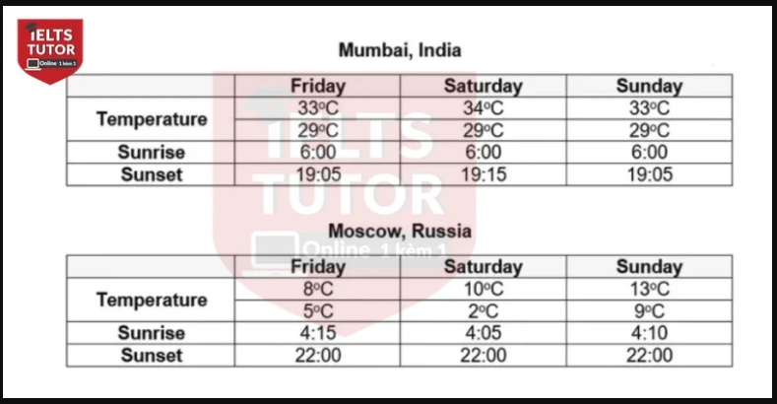

Overall: - Moscow colder than mumbai
- Sun Time in india < Russia

Body 1: Mumbai
- Friday + Sunday = similar temp in both periods with 33 celcius in daytime and 29 degree in nighttime
- Notably, also identical rising and setting phase between 6am and 7:05 pm

- Exception = Saturday, temperature slightly higher at 34 and sun set later by 10 minutes

Body 2: Moscow
- 8 degree in Friday => escalate to 10 in Saturday before peaking at 13 in Sunday
- Sunrise from 4:05 -> 4:15

- Sunset = stable time, yet fluctuate temp

Given is the table comparing Moscow and Mumbai in terms of hours exposed to the sun and temperatures in the year 2007.
Overall, despite recording less daylight time than Moscow in Russia, India’s Mumbai was generally hotter throughout the weekends. → overall ổn nhé

In Mumbai, there were similar temperatures on both Friday and Sunday, with 33 degrees Celsius in the daytime and 29 degrees Celsius in the nighttime. Notably, identical rising and setting phases of the sun were also evident, specifically from 6am to 19:05pm. In addition to this, whilst having the same sunrise time, Saturday witnessed the sun going down later by 10 minutes and temperatures higher by one degree compared to the dates mentioned above ⇒ Với bài miêu tả là [thời gian trời sáng], thì mình có thể tính ra [số giờ , vd : 13 hours] để miêu tả luôn nhé

As regards Moscow, Russia, an upward trend was seen in temperatures throughout the weekend. Initiating at just 8 degrees in Friday, the figure escalated to 10 degrees in Saturday before peaking at 13 degrees at the end of the week, with sunrise varying from 4:05 am to 4:15 am. In contrast, whereas the time during which the sun sets in Moscow stayed unchanged at 22:00pm, its temperature fluctuated wildly between 2 degrees and 9 degrees. ⇒ Với phần thông tin miêu tả cho [nhiệt độ], thì với mỗi ngày đều có nhiệt độ Cao nhất/ Thấp nhất khác nhau, mình vẫn nên triển khai cụ thể so sánh từng ngày, rồi nhấn mạnh ngày nào [lạnh nhất] ở đây chẳng hạn.
VD:
The maximums of the temperatures were 8, 10 and 13 degrees in Friday, Saturday and Sunday respectively + Moscow recorded tremendously cold days at around 2 to 8 degrees.
&
Tương tự như thân bài số 1, thì mình có thể dùng [số giờ , vd: 18 hours] để miêu tả.

IELTS TUTOR lưu ý:
- Dạng gì: mixed (table + table)
- Chủ ngữ của bài: the temperatures and hours of daylight in two cities during the same weekend in May 2007.
- Chia thì gì, vì sao: quá khứ 2007 >> IELTS TUTOR hướng dẫn CÁCH CHIA THÌ IELTS WRITING TASK 1
- Câu Overall:
  - Mỗi bảng 1 câu
    - In Mumbai, the temperatures recorded over three consecutive days were relatively consistent, whereas those in Moscow witnessed significant changes >> IELTS TUTOR gợi ý Phân biệt However/ Whereas
    - Despite being warmer, Mumbai enjoyed fewer hours of daylight compared to Moscow.
- Bố cục cách viết 2 đoạn thân bài:
  - Body 1: bảng India
    - The temperatures were nearly the same from Friday to Sunday, with the highest figure being 330C and the lowest one being 290C >> IELTS TUTOR hướng dẫn Cách dùng danh từ "figure" tiếng anh
    - The average number of daylight hours was approximately 13 hours, with the sun often rising at about 6 am >> IELTS TUTOR gợi ý Cách paraphrase từ "approximately" trong IELTS
  - Body 2: bảng Russia
    - The maximums of the temperatures were 8, 10 and 13 degrees in Friday, Saturday and Sunday respectively >> IELTS TUTOR hướng dẫn Cách dùng & paraphrase "respectively"/ "respective"
    - Moscow recorded tremendously cold days at around 2 to 8 degrees.
    - The average number of daylight hours in this city was more than 18 hours, from around 4.15 am to 10 pm.

Bài viết lần 4

