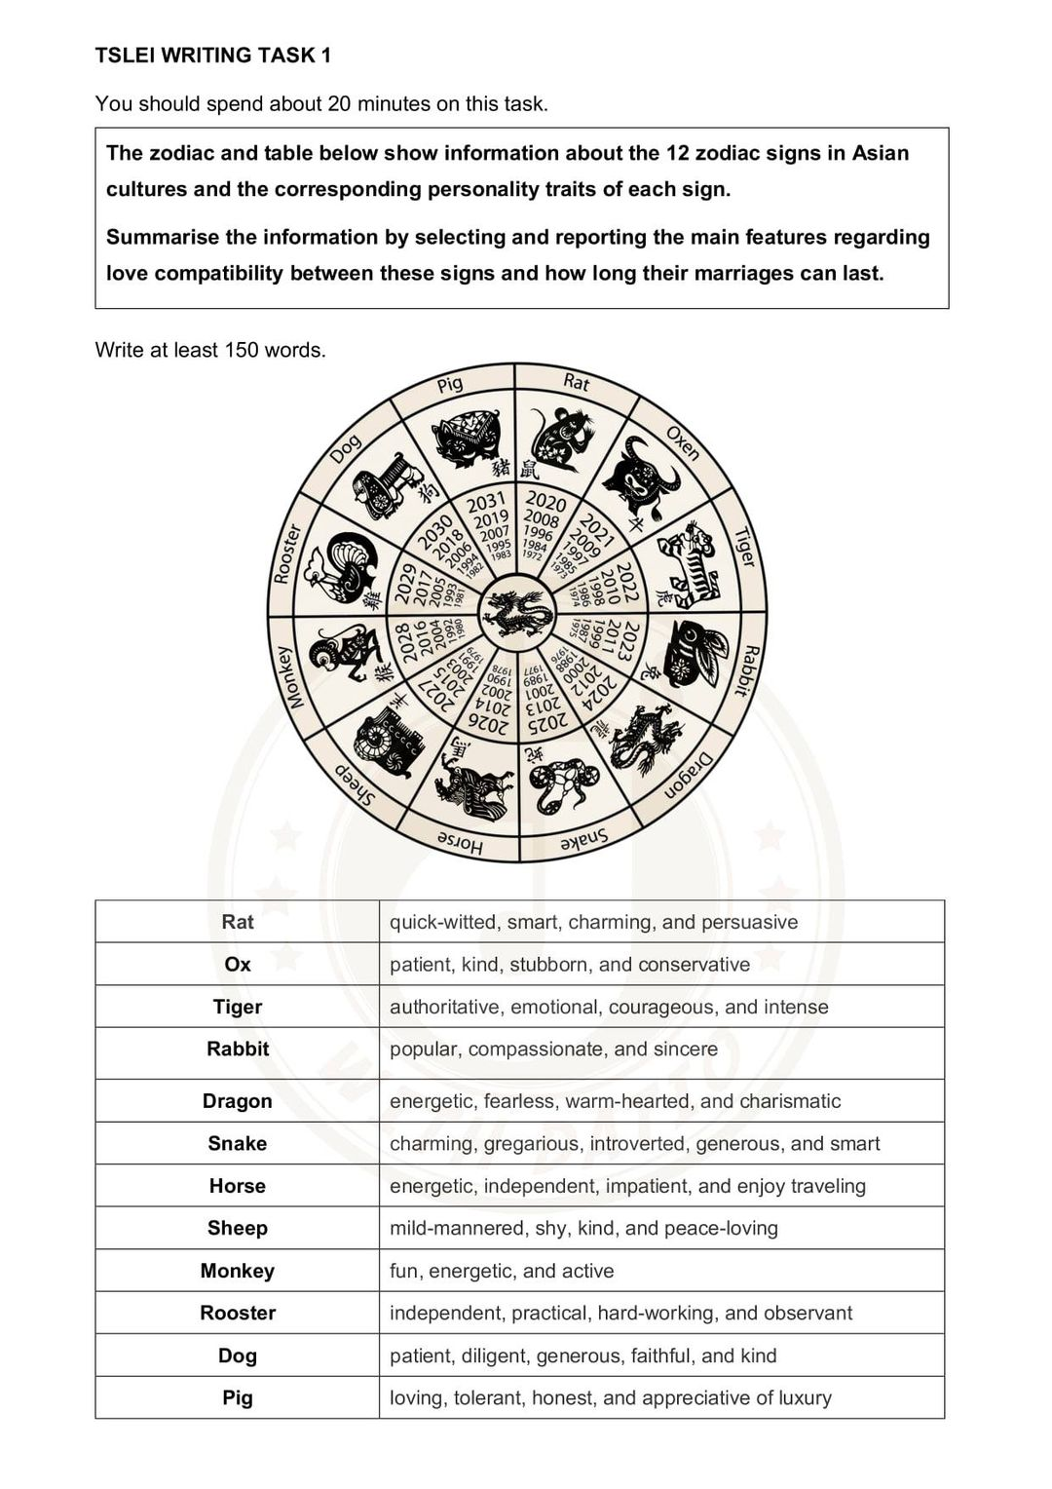

Outline

Intro: use format

Overview: 12 signs named by animals, years of birth, personality traits

Body 1: love compatibility

* Rat, Dragon, Dog
* Rabbit, Sheep, Horse

Body 2: Marriages period

→ [TỪ VỰNG TIẾNG ANH 12 CUNG HOÀNG ĐẠO](https://www.ieltsdanang.vn/blog/12-cung-hoang-dao-bang-tieng-anh)

Giving are a picture and a table illustrating the 12 zodiac signs in Asian cultures and the characteristic characters of each sign.

Overall, it can be seen that there are 12 zodiac signs which are named by a group of selected animals and years of birth. Also, there are a variety of outstanding personality traits of each sign.

To begin with, when it comes to love compatibility, it should be considered that the first compatible set included Rat, Dragon and Dog. In fact, people who belong to Rat sign have a quick-witted, smart, charming and persuasive character, and these traits are traditional believed to match with people who have Dragon and Dog signs. Next, the second compatible group is Rabbit, Sheep and Horse. Similarity to the first group, it is said to be well match due to some traits namely popular, compassionate, sincere of Rabbit, mild-mannered, shy, kind, peace-loving of Sheep and energetic, independent, impatient, enjoy traveling of Horse.

Additionally, the long period their marriages can last is depends on how they live with their partner and their appropriate behaviour, so it totally does not rely on the ancestral outlook.

Words: 190

Cái này em không biết làm sao để biết hôn nhân của họ kéo dài bao lâu…