Đề bài

The diagram below shows how the process of water filtration for household use. Summarize the information by selecting and reporting the main features and make comparisons where relevant.
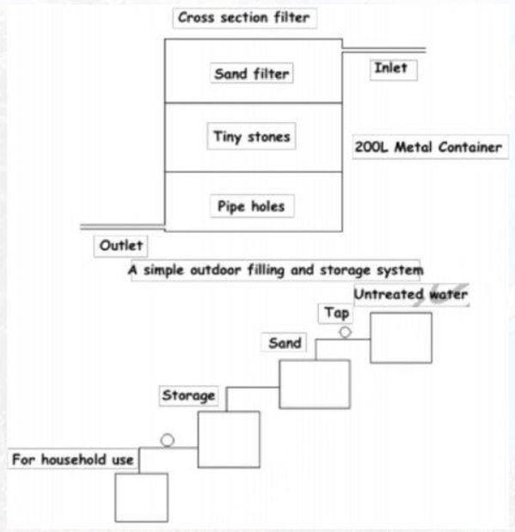

Bài viết (max 300 words cho Task 2, max 160 words cho Task

Dàn bài lần 1
Body 1: cross section filter
- Inlet-> container: cross section filter
- Sand-> stones-> pipe holes -> outlet
Body 2 filling and storeage system
- Untreated water -> sand through tap
- Storeage-> use

Từ vựng manufacturing process https://www.suabaiieltswriting.com/blog/ielts-writing-task-1-dang-process-tu-vung-manufacturing-process
Given is the picture illustrating how the water is filtered in order to provide drinking water for residents.

In general, there are various main steps in the process of water fileration, starting with the water going to a container and ending with the drinkable water.

Regarding the diagram, at the first stage, the water is caught through the inlet and delivered to the 200L Metal container where it undergoes the cross section filter. Then, after moving through the sand filter, the water is then transformed to tiny stones before getting into pipe holes. Subsequently, the pure water goes out the container through the outlet.

Following the process, once the untreated water from the container has overcome a simple outdoor filling and storage system, it runs down on the sand tank through a tap. Finally, the treated water is pumped through a storeage tank the connects to each of individuals’ houses where citizens can access it.
→ Bài làm mình triển khai ổn nhé.

