Designing your Touch Wood Ring

Your name
and contact information:
Full mailing address, phone number, email address and billing email (PayPal)

The first name of who the ring is being made for, if not for yourself
1.Primary Wood for your ring

2. Wood(s) for inlay(s)

3. Material other than wood for inlay?

4. Placement of Inlaid Bands

5. Order and width of inlaid bands

6. Do you want an interior wood. Also called a Liner

7. Your Ring size

8. Width of your ring in mm

9. Tapered to ____mm

10. Inscription

Copy/Paste Images as examples:

- PRIMARY WOOD: Is there a ring on the website, blog, Instagram or Facebook page that shows the grain and tone of the type of wood you like for the primary or main wood of your ring? Our Blog has a good search function, in the upper lefthand corner of the page. Also image search on our Facebook page will usually turn up examples of specific woods.
It’s helpful if you can copy/paste an image(s) or provide a link to an image. For example: “I like the dark swirly grain of the Juniper Heartwood used in this ring” or, “I like the mid-toned Hawaiian Koa in this ring”

- WOOD INLAY(S): How many inlays and what type of wood. David can make inlays very narrow (less than 1mm) or quite wide (as wide as 1.5mm narrower than the narrowest portion of your ring.)

- STONE or SHELL INLAYS: Material other than wood that you would like to have inlaid on your ring (shell, sand, stone, dry flower petals, etc ) We have a wonderful array of things you are welcome to use in your ring. Opaque stones like lapis or turquoise work best – as opposed to translucent stones like opal or crystal. You are welcome to send your own? I can send you some information on how much and how best to send to us.

- PLACEMENT OF YOUR INLAYS: Centered, offset, spiraled, cross spiraled, split, or braided? Please describe and/or provide an example. Below are just some examples of how you might want your inlays on your ring.
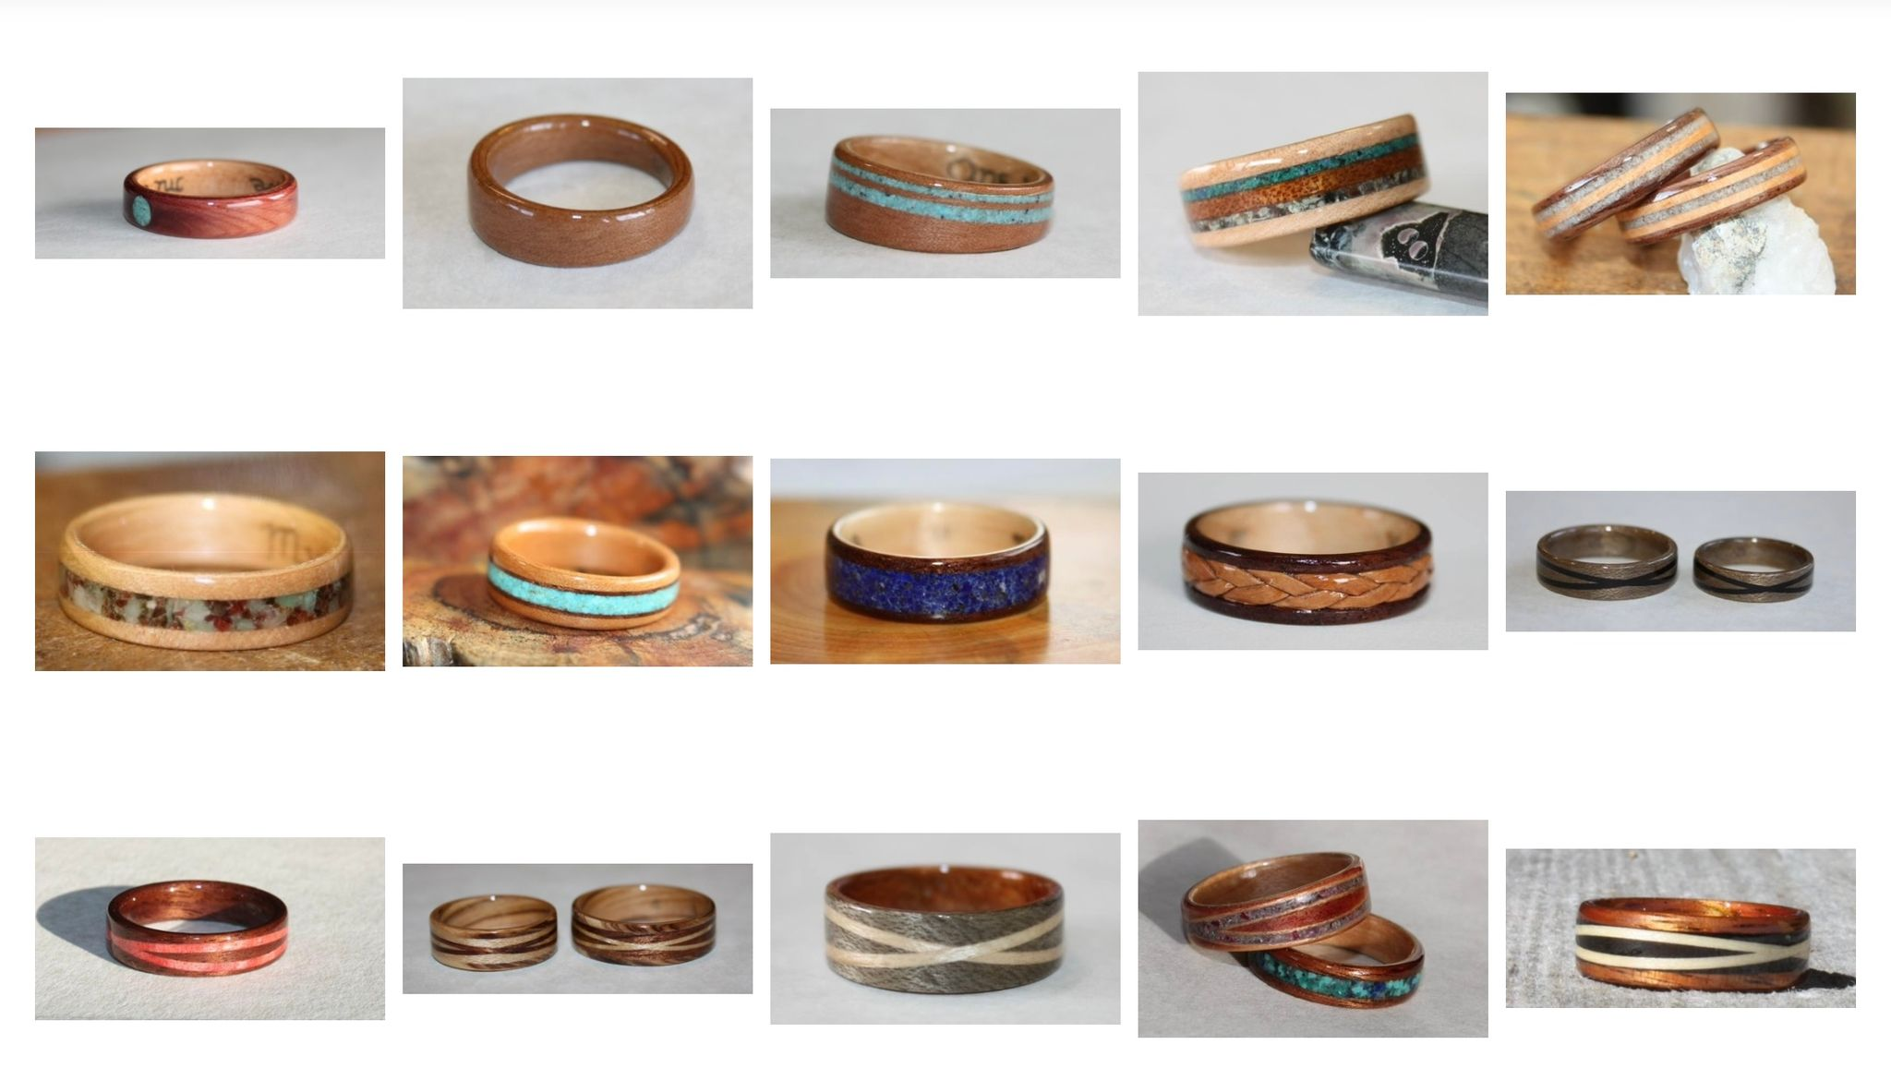

- ORDER AND WIDTH OF INLAYS: Remember that the total width of your inlaid bands can be no wider than the narrowest part of your ring. If you want to use another ring as an example of the proportions you like, you don’t really have to do the math. If your ring will be (for example) 6mm wide tapered to 4mm, then the total of your inlay width can be no more than 3mm.

- INTERIOR WOOD / LINER: A liner adds durability if you are using a softer or more porous wood (such as ancient kauri) for the main wood of your ring. Also, if you want an inscription to read very clearly on a ring you will be happiest with a light, hard interior wood such as maple or clear juniper.

- YOUR RING SIZE: Be sure to measure the finger that will be wearing the ring ~ not the finger of your opposite hand. And be specific please, David will make whatever size fits best; ¼, ½ or full sizes. Please visit a reputable jeweler and measure your finger specifically for the width of ring that you want David to make, because wide and narrow rings (tapered rings and different styles) will all fit a little differently.

- WIDTH OF YOUR RING: You will either want a consistent width all the way round the ring, or a ring that is wider at the front of your hand with a narrower fit on the inside of your hand as in (tapered to ….. mm)

- TAPERED TO ___ MM: If you want a ring wider than 6mm David will normally recommend a taper to at least 6mm. This is for your comfort and to protect the wood on the inside of your hand. Remember that inlaid and spiraled bands can be no wider than the narrowest (or tapered) part of your ring.

- INSCRIPTIONS are hand inscribed in hard fine point pencil prior to finishing and can be anything you like so long as it fits. 30 characters would be a very long inscription. The longer the inscription the smaller it must be written so it’s best to keep it short and sweet. Symbols should be uncomplicated, as in an eternity symbol or a heart

We like to know a little about you! If you feel comfortable sharing a photo that would be much appreciated. It’s nice to have a picture of you as we work with you on your ring.
Questions? Ideas you would like to run by us? Please write to us anytime at nikolafinch@outlook.com And please be sure to allow emails from this address. Check your Spam or Junk folder if you are expecting a response and haven’t heard back from me. Thanks!

Two pages on our Touch Wood Rings website that will be helpful in making decisions.
https://www.touchwoodrings.com/faq-s
https://www.touchwoodrings.com/designing-your-ring

Touch Wood Rings © 1999 -2026
David and Nicola Finch
nikolafinch@outlook.com

