Magic Dragon Preschool

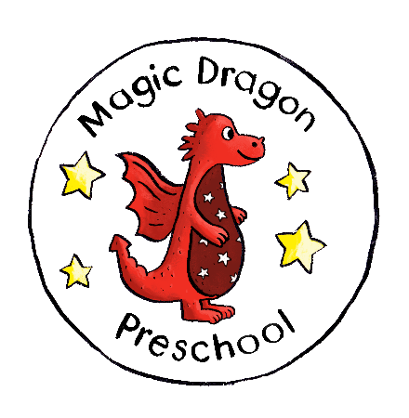

Safeguarding Children Overview

Monitoring
Date of Review: | September 2026
Signed by (Printed name and signature)

Date of next review: | September 2027

Safeguarding Children

Safeguarding is a term which is broader than ‘child protection’ as it also includes prevention. Whilst local authorities play a lead role, safeguarding children and protecting them from harm is everyone’s responsibility. Everyone who comes into contact with children and families has a role to play. We commit to creating and maintaining the safest possible environment for children.

Safeguarding and promoting the welfare of children is defined as:
• protecting children from maltreatment; , whether that is within or outside the home, including online;
• preventing impairment of children's mental and physical health or development;
• ensuring that children grow up in circumstances consistent with the provision of safe and effective care; and
• taking action to enable all children to have the best outcomes.

At Magic Dragon we will work with children, young people, their families and other agencies taking all reasonable measures to ensure that the risks of harm to children’s welfare are minimised; and where there are concerns about children and young people’s welfare, we will take appropriate action to address those concerns, working to agreed local policies and procedures in full partnership with other local agencies.

We recognise that safeguarding children is vital for registered childcare providers, as part of the legal requirements of their Ofsted registration, and for charities, as charity trustees have a duty of care towards the children with whom they have contact. We know that having safeguards in place within an organisation not only protects and promotes the welfare of children but also it enhances the confidence of staff, volunteers, parents/carers, management or trustees and the general public.

For the purposes of child protection legislation the term ‘child’ refers to anyone up to the age of 18 years.

We believe children have a right to play and be safe. We take steps to promote their safety.

Policies & framework
Magic Dragon’s child protection policy is central to this, but there are many areas that contribute to creating a safe environment, these include:

- Child protection policy and procedure
- Safe recruitment procedure (including suitability)
- Staff and volunteers are inducted and supervised
- Staff and volunteers code of conduct
- Photography, video, mobile phone use
- Management checked for suitability
- Training
- Health and Safety policy and procedures
- First Aid
- Fire Procedures
- Risk assessments
- Online use and safety
- Secure premises
- Managing Behaviour
- Child registration information
- Procedures for children's safe arrival and departure
- Deployment of staff
- Trip procedures
- Procedures for meeting the needs of disabled children and others with specific needs
- Listening to concerns from children, parents and carers
- Keeping Ofsted up to date with any changes to the registration of your service

Working with children
We believe in equipping children with a range of skills, information and confidence that will help them to protect themselves in the community. Staff will act as role models and listen to children. We will discuss in an age appropriate way:
- Choices
- Setting rules
- Values
- Expressing feelings
- Rights of a child
- Healthy relationships
- Friendships
- Appropriate touch
- Keeping safe online
- Recognising and assessing risk
- Problem solving and decision making
- How and where to get help when needed

For Further Information

- Working Together to Safeguard Children 2026
Working together to safeguard children 2026

- Requirements regarding the recruitment and selection of charity trustees are set out in the following guidance, ‘Finding new trustees: what charities need to know’
- Finding new trustees (CC30) - GOV.UK (www.gov.uk)

- South West Child Protection Procedures – provides detailed online information on all aspects of child protection https://swcpp.trixonline.co.uk/

- Keeping Bristol Safe Partnership sets out local arrangements and requirements for child protection Welcome to the Keeping Bristol Safe Partnership website.

- EYFS 2026 Safeguarding and Welfare Requirements
Early years foundation stage (EYFS) statutory framework - GOV.UK
EYFS statutory framework for group and school-based providers

