DROGHEDA BUSINESS EXCELLENCE AWARDS

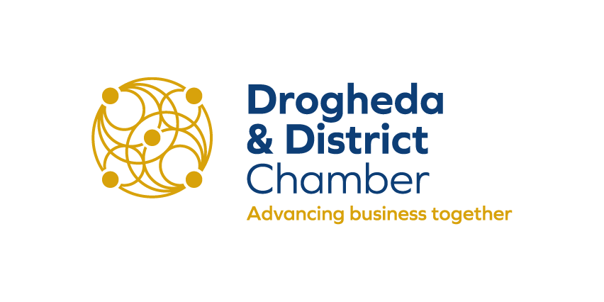
APPLICATION FORM 2019
Best Hotel of the Year
PLEASE CHOOSE THE CATEGORY YOU WISH TO ENTER
COMPANY NAME:
CONTACT NAME:
CONTACT ADDRESS:
PHONE NUMBER:
EMAIL ADDRESS:
COMPANY WEBSITE:
NUMBER OF YEARS IN BUSINESS:
NUMBER OF EMPLOYEES:
NATURE OF BUSINESS:

LEASE PART A COMPLETE THE FOLLOWING

Q1. Tell us a little about your Company/Business/Community Group  (Background / History /your story to date) | Words 200 Max

Q2. Describe what your  Product / Service Offering/Attraction is. | Words 500 Max Score 25points
PART B (continued)
PLEASE COMPLETE THE FOLLOWING

Q3. What makes your Organisation stand out from the competition? | Words 500 Max Score 25points

Q4. Tell us how your Business/Organisation has contributed to the economic and social fabric of the region since it was established. | Words 500 Max Score 25points
PART B (continued)
PLEASE COMPLETE THE FOLLOWING

Q5 How do you motivate, encourage and develop your employees | Words 500 Max Score 15points
Q6. Why should your organisation win in this category?  (Keep it specific to your industry sector. Include your successes, your growth, relevant future plans. Your most innovated activity in the last 12 months etc…) | Words 200 Max Score 10points

Optional
Lifetime Achievement Award - Please propose your chosen candidate

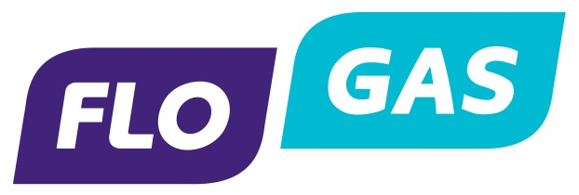
Lifetime Achievement Award
The Lifetime Achievement Award recognises the work and contribution of an individual in the wider Business Community whose pioneering spirit, resourcefulness and determination have contributed to our community - both in business and the social fabric of the community.
Nominate your choice for the Achievement Award
Drogheda & District Chamber is giving you the opportunity to put forward a nomination for our Lifetime Achievement Award as part of the Business Excellence Awards. The only stipulations regarding your nomination are below:
1. The nominee must be local or have a strong local connection with Drogheda Region
2. The nominee must be someone who has made a consistent and significant positive impact on business and/or the locality.
Please put forward the person's name along with their associated Business/Organisation if applicable and why you feel they should be nominated - no more than 200 words please. Email application to awards@droghedachamber.com - Closing Date 5pm Friday 13 September 2019

DISTRICT BUSINESS AWARDS 2018
TERMS & CONDITIONS
Please return your completed application form no later than 5pm on Friday September 13th to:
No applications will be accepted after this date

POST
Drogheda & District Chamber
Broughton House,
Dublin Road
Drogheda
Co. Louth

EMAIL
awards@droghedachamber.com

Additional information:

- Entry is FREE and open to both Chamber members and non-members
- Businesses can enter in up to 3 award categories this year
- All finalists will be called for interview on October 22nd
- Confidentiality – all information on the application document will be treated as confidential and will only be seen by the judging panel.
- By submitting this application, you hereby agree to the terms and conditions

Good Luck!

THANK YOU TO OUR 2019 SPONSORS
