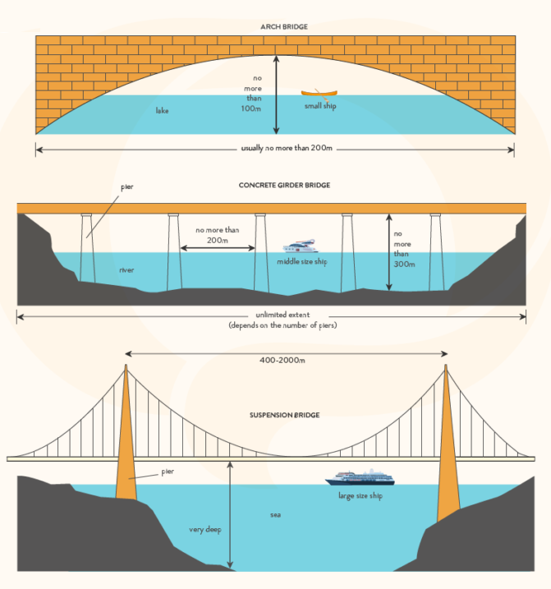

Given is the picture illustrating the differences in terms of architectural design of three types of bridges.
Overall, the number of piers as well as certain modes of maritime transportation differ according to the topographical features.
As can be seen in the upward arch bridge, since it constructed in the limited depth of water, less than 100 meters, it does not need any piers to support from below. Meanwhile, the concrete girder bridge which vaults over the river, with the maximum height of 300 meters, has no limit number of the pillars being proportional to the length of the bridge. In contrast, while the model of the suspension bridge is the biggest and built in very deeper body of water among the others, it only requires 2 large piers rooted into underwater cliffs close to the seaport. With regard to the means of transportation, the overhead clearance makes them strictly exclusive to certain types of transport. Particularly, with the bridge figures for the arch and concrete girder bridge, they only suitable for small and medium size boats such as wooden rafts and cruise ships, respectively, whereas the suspense bridge accommodates the operation of large-sized ships.
Regarding to the technical features, the arch bridge has abutments anchored to both side of the lake, whilst the concrete girder bridge’s pillars was spaced at a maximum interval of 200 meters from each other. Furthermore, the suspension bridge lends itself more to vast seas of immense depth so the 2 piers of the biggest, compared to the other two, are placed up to 2000 meters.
⇒ Mình chia bố cục ra thành 3 đoạn mỗi đoạn thân bài viết về 1 cây cầu sẽ dễ chia bố cục & dễ hiểu hơn mình đang viết
Lần 2:
Given is the picture illustrating the differences in terms of architectural design of three types of bridges.
Overall, the number of piers as well as certain modes of maritime transportation differ according to the topographical features.
As can be seen from the picture, since the arch bridge is constructed in small water bodies, the lake, and is less than 100m high, it does not need any piers to support from below. Meanwhile the concrete girder bridge which vaults over the river, with a maximum height of 300 meters, has no limit in the number of the pillars being proportional to the length of the bridge. In contrast, while the model of the suspension bridge is the biggest and is built in a much deeper body of water than the others, it only requires 2 large piers rooted into underwater cliffs close to the seaport.
With regard to means of transportation, while the arch bridge and concrete girder bridge are suitable for small and medium size boats, the suspense bridge accommodates the operation of large-sized ships. Regarding the technical features, the arch bridge has abutments anchored to both sides of the lake, which is less than 200 meters, whereas the concrete girder bridge’s pillars were spaced at a maximum interval of 200 meters from one another. In addition to this, 2 piers of the suspension bridge have the longest interval from 400m to 2000m

=> Bài của mình đang bị quá dài mình nên viết ~160w thôi (hiện tại là tận 260w) , mình cần chọn lọc thông tin thôi ko cần giải thích nhiều nhé, và tránh để các thông tin bị lặp đi lặp lại trong bài nha
đọc kĩ: https://www.ieltstutor.me/blog/nhom-so-lieu-ielts-task-1
- Câu overall (chọn 1-2 trong các ý sau):
  - It is readily apparent that concrete girder bridges are potentially the longest and tallest while suspension bridges allow for the largest ships to pass underneath.
  - Arch bridges are not as tall or long and admit only the smallest ships
  - The three bridges are designed according to the water body where they are situated, and thus differ greatly in terms of size and structures (Nhìn chung, ba loại cầu này được thiết kế dựa trên vùng nước nơi chúng được xây. Vì vậy, chúng khác nhau đáng kể về cấu trúc cũng như là kích cỡ)
- Thân bài vì bài này mô tả về 3 cây cầu khác nhau (three different kinds of bridges) nên rõ ràng nhất có thể chia thân bài thành 3 đoạn, mỗi đoạn viết về 1 bridge, có thể phân bố như sau:
  - Body 1: (Looking first of all at arch bridges)
    - Archbridge được xây dựng ở khu vực hồ, có chiều dài 200m và phần vòm cong phía dưới cách đáy hồ 100m. Khoảng cách như vậy nhằm để cho tàu nhỏ có thể di chuyển qua được.
      - The permissible height is no more than 100 meters, and the length is typically under 200m.
      - These bridges are built over lakes, have a conical shape, and cover the smallest ships.
  - Body 2: Viết về cầu số 2. concrete grinder bridge (Turning next to the concrete girder bridge)
    - Concrete grider bridge được xây dựng ở khu vực sông. Cấu tạo bao gồm nhiều cột trụ được xếp đều cách nhau 200m. Phần mặt cầu (deck) cách đáy sông nhiều nhất là 300m để cho thuyền kích cỡ trung bình di chuyển.
      - Concrete girder bridges can be an indeterminate length, though the maximum height is 300m.
      - Concrete bridges are built over rivers and require a series of piers spaced under 200m apart to provide support, only allowing for the passage of medium-sized ships.
  - Body 3: Viết về cầu số 3 suspension bridge (Regarding the suspension bridge)
    - Suspension bridge: Là loại cầu kích cỡ lớn nhất, phù hợp với vùng biển rộng và sâu nơi tàu lớn di chuyển. Cấu tạo gồm 2 cột trụ kích cỡ lớn được đặt cách nhau từ 400m đền 2000m. (Hai cột trụ này được hỗ trợ nhờ cấu trúc thanh treo dây cáp (cable suspenders).
      - The modern suspension bridge can be between 400 and 2000m long, and it is possible to build it over very deep seas as long as there is shallow land for pier structures to link at either end.
      - The distance between piers enables the largest ships to traverse below safely.

