Mango Turmeric Smoothie
by Raquel DeHoyos, comfortandheal.com, January 2020
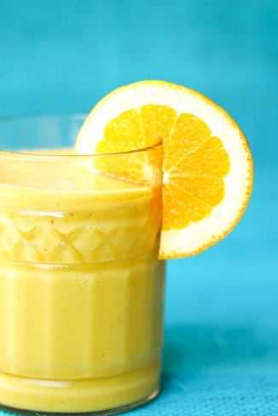
Ingredients
1 cup roughly chopped celery
2 small oranges, peeled
1 large frozen banana, peeled
1 cup frozen mango chunks
1-inch knob of fresh ginger, grated
1 teaspoon ground turmeric
2 teaspoons maple syrup
1 1/2 cups almond coconut milk (or your favorite dairy or non-dairy beverage)
Makes 4-1 cup servings
Instructions
Place all ingredients into a blender. Blend until everything is cold and creamy.
Health Notes
Ginger and turmeric are rhizomes or root stalks that both have been used in traditional herbal medicine. They can be consumed raw, as cooking spices, and even in capsule form as supplements. Ginger has long been recommended to help alleviate nausea, while turmeric is popular for its antioxidant and anti-inflammatory properties. If you are curious about incorporating one or both into your diet, familiarize yourself first with the flavor of both the raw and the dry spice. They can have an earthy, pungent or even bitter flavor that your palate may not be accustomed to, so try mixing them into drinks and dishes you enjoy, a small amount at a time until your taste buds adjust. Ginger is delicious in both sweet and savory dishes like fruit chutneys or stir fries. Turmeric's vivid yellow color makes a great spice to use in rice and grain dishes and even yogurt sauces and dressings.
Those managing their diabetes can still enjoy fruit smoothies. When making smoothies at home, include a good balance of fiber, protein and healthy fats and keep the carbohydrates and sugar low. Walnuts or almonds, oatmeal and leafy greens are all great additions and can be naturally sweetened with smaller portions of ripe fruit such as half of a banana or green apple. Fruit juices, honey and maple syrup all contain sugar and calories so keep amounts of these to a minimum. Even though non-dairy beverages do not contain natural sugars such as the lactose found in milk, they still can contain added sugars so read the nutrition label and ingredients carefully. Baking spices such as cinnamon and ginger also make great additions to boost the flavor and keep sugar low. And, as with all meals, portion control makes a huge difference. Have fun experimenting with your favorite flavor combinations and enjoy smoothies as part of a balanced meal or snack, in smaller portions, not as a full meal replacement.

