4. Describe a time when you waited for something special that would happen
You should say:
What you waited for
Where you waited
Why it was special
And explain how you felt while you were waiting
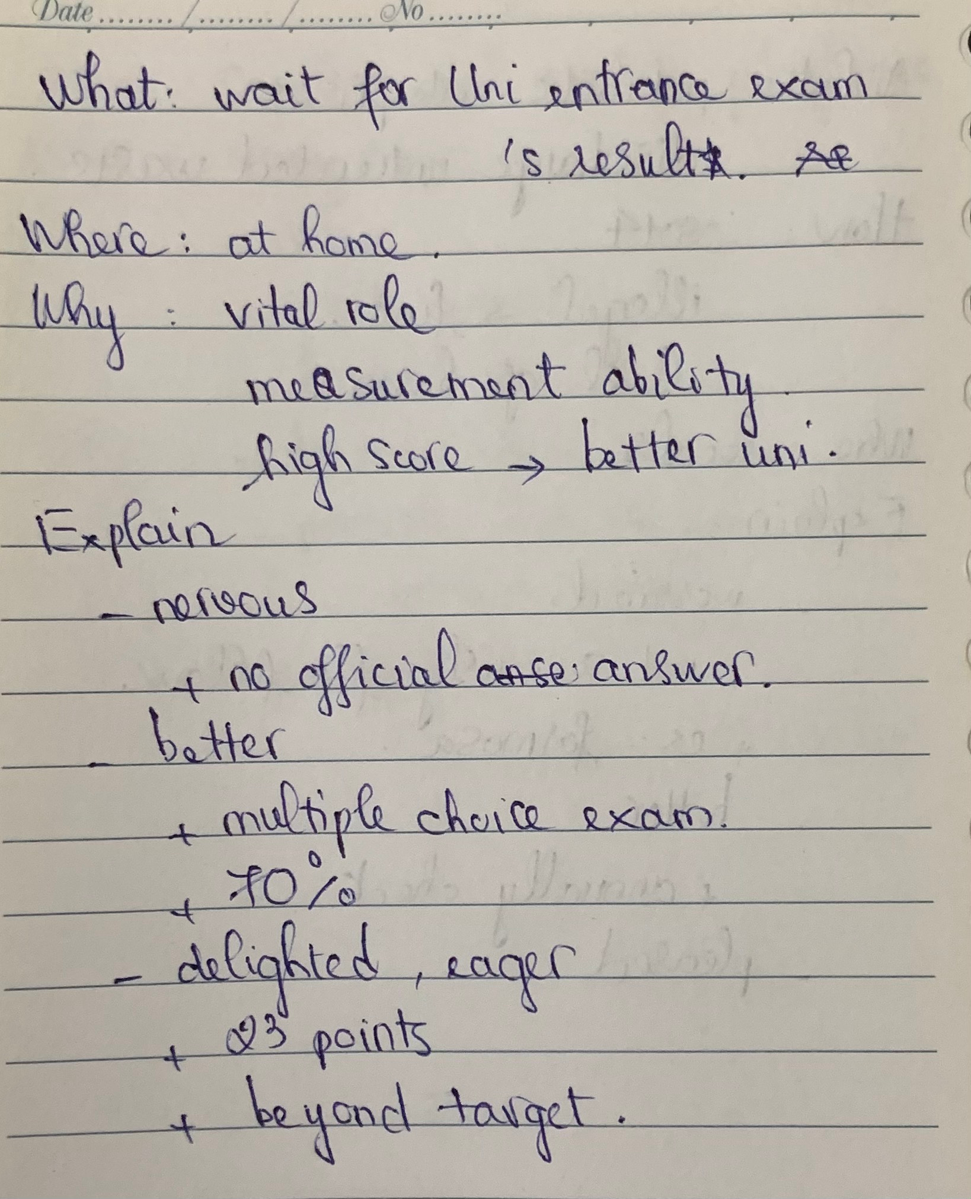
What you waited for
I would like to share with you the time that I waited for my university entrance exam’s result.
Where you waited
Unlike most of the other students who went on holiday to relax after taking the exam, I just stayed at home and wait for the score as well as do my favorite activities.
Why it was special
I don’t know how other countries' examinations are important, but I personally experience in Vietnam that university entrance exams play a vital role in every student’s life. More precisely, if I get a high score, I will be able to enter a well-known university. Therefore, I would say that it was very important to me.
And explain how you felt while you were waiting
When it comes to the time I waited for the result, it was an unforgettable memory to me.
At first, I was very nervous. I had no official answers from the ministry, and I was so worried because I thought that if I failed, I couldn’t study in university with my favorite major. Next, I felt much better because I had the official answers of multiple choice exam subjects. In fact, I checked that I could achieve 70% of my dream score, and the thing I did was wait for the final key of Literature – the last subject. Finally, I felt super delighted and eager. The day I received the result, I cried in happiness because I got, if I remember exactly, I got 23 points which was beyond my target. Actually, I was really proud of myself that I had tried a lot, and that score was so impressive to me.
=> Bố cục bài cuối này khá ổn
lưu ý bám sát vào cue card để trả lời nhé:
- What you waited for
  - I waited for the arrival of my auntie who was living in Holland. In fact, she told me that she would visit Viet Nam to attend my wedding party in July 2021; however, due to the corona pandemic, it was really hard for her to manage to come >> IELTS TUTOR hướng dẫn Cách dùng động từ "manage" tiếng anh
- Where you waited
  - Actually, when the corona pandemic was spreading at a rapid pace, I lost the hope of meeting her on my special day
- Why it was special
  - This event was worth waiting for two reasons. First, I hadn’t seen my auntie for 2 years. Second, it was she who spent a lot of time guiding me how to organise a nice wedding party, so it’s important that she could grace the ceremony >> IELTS TUTOR hướng dẫn Cách dùng "across" tiếng anh
- And explain how you felt while you were waiting
  - One fine day she had called me and told me that she would come back after 15 days. After listening to her words, I was in a state of euphoria at first. >> IELTS TUTOR hướng dẫn Cách dùng từ "after" tiếng anh
  - Then, I started to feel impatient when it seemed as if the waiting period was 15 months instead of 15 days >> I was so excited to meet her that I used t sleep for just 2-3 hours
  - Finally, I had a sign of relief when my auntie finally arrived

