Analysis of

Edgard Varèse’s

Octandre (movement 1)

By Mark Tse
For Professor Joel-Francois Durand
Music 472A
March 13, 2016

Introduction

Edgard Varèse (1883-1965) was an American composer of French birth. His music is well known for being the precursor to electronic music, thinking of “music” as “organized sound” and evidenced in such milestone works such as Poème électronique. This modernist perspective was also evidenced by his fascination with science but this affected his music more conceptually than methodologically; meaning that he was fascinated by the gestural reactions of “sound masses” colliding and their resultant changes rather than a literal, mathematical approach taken by Schoenberg (Griffiths 2016).
An octandra is a plant with 8 stamens and the piece is written for 8 players. In my analysis, I kept an open mind about what other ways the number 8 might appear in the composition: perhaps the octatonic scale, 8 sections, 8 measures, octaves etc.

Assessing Form

By listening and examining the score preliminarily, I tentatively assigned bars 1 – 9 as section A, bars 10 – 18 as B, 19 – 22 as C, 23 – 29 as D and 30 – 32 as A’.
Section A was defined by the long, lyrical oboe line and section B was defined by the introduction of more voices that came clamoring in to solidify as horizontal tone clusters, once in bar 12, again in bar 15 and yet again in bar 18. Section C was appeared to be a vertical block with relatively stable pitches. Section D was initially defined as bar 23-29 because of the melodic trumpet line imbedded within the other voices continuing in their blocked clusters. The horn would then have a melodic moment, followed by the bassoon. This assessment was incorrect and I will elaborate below how the analysis of pitches led me to conclude that the D section actually begins at bar 25 (though it is possible to declare bars 23-24 a transition between sections C and D. Section A’ at least is clearly its own section as a recapitulation of sorts of the introduction, but transposed up a tritone.

Searching for Evidence of 8 in the Form

Although the piece is 32 bars long, a multiple of 4, this is likely no more than a coincidence. Section A is 9 bars long, section B is also 9 bars long, C is 6 bars and D is 5 and A’ is 3.
Counting beats, section A is 42 beats long, B is 41, C is 25 and D is 21 and A’ is 15. Accounting the difference in tempi and calculating the time each section would take to perform also yielded no discernable pattern (0.67 minutes, 0.65, 0.43, 0.33 and 0.24).
Examining the analysis of changing meters also yielded no clues (figure 1).
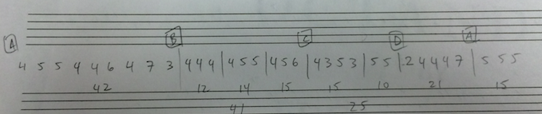
(figure 1)

Analyzing Pitches

Section A’

Although it is customary to begin analyzing a piece at the beginning, I decided that given the “recapitulation’s” short length of only three bars that I would begin there. The oboe statement at the end is nearly identical to the first three bars, save for the transposition up a tritone and the value of the last note (see figures 2 and 3).
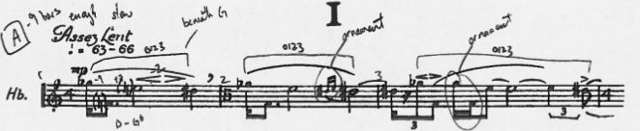
(figure 2)
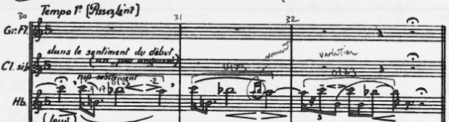
(figure 3)

Section A

The opening of Octandre begins with a tetrachord that could be described as pitch class set 0123. It starts with the descent of a m9, ascent of M7 and descent of m2. This figure is written-out through elaboration such as the sixteenth note ornamentations and slight changes in rhythms offsetting where the pitches occur within the bar. In bar 4, the oboe plays a new 0123 tetrachord, followed by what is figuratively a pivot tetrachord that crosses from bar 4-5 (see figures 4 and 5). This tetrachord straddles the missing G, as explained below.
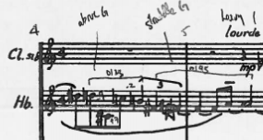
(figure 4)
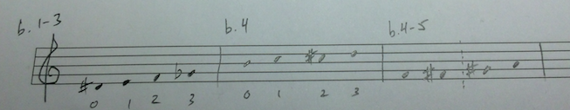
(figure 5)
Analyzing the rest of section A, I found that all pitches of the chromatic scale was represented with the exception of G, which only appears at the last moment with the dynamic marking of ffff (see figures 6 and 7).
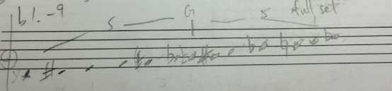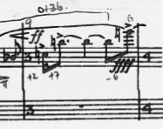
(figure 6) (figure 7)
As a side note, the pitches played by the clarinet and contrabass in bars 5 and 6 were already introduced by the oboe. It could be argued that the clarinet’s pitches form a symmetrical 013, which is a subset of the initial 0123 pitch class set (see figure 8).
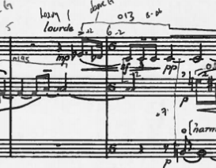
(figure 8)
The discover of a complete 12 note pitch set led me to look at each voice horizontally and each bar vertically to see which pitches were represented. Bars 10 – 12 complete a full set of all 12 chromatic pitches but this only happens in bar 11 with the flute’s G#. No voice alone and no bar alone (when examined vertically) contains all 12 pitches. The bassoon and horn voices introduce no new pitches, but do come in after the 12th pitch was introduced in beat 3 by the flute (figure 9).
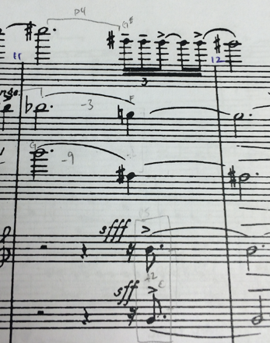
(figure 9)
Bars 13 – 15 similarly comprise of a total set of 12 pitches but no voice alone or bar alone contains all 12 (figure 10). Bars 16 – 18 is similar in these ways.
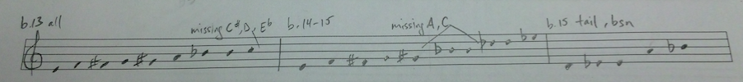
(figure 10)
Though it appears as though Varèse has situated block tone clusters in bars 11, 15 and 18 (see figure 11), I can discern no relation between the pitches of these blocks and the material around them. They neither introduce the necessary tones needed to complete the set of 12 pitches nor do they seem to have intervallic relations of discernable meaning. Gesturally, the B section does depict melodic lines interacting with block clusters.
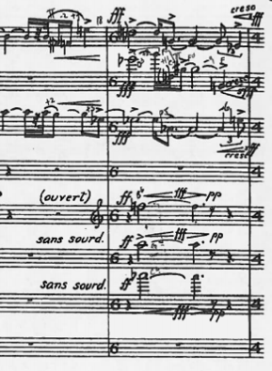
(figure 11)

Section C

This section represents a clear, vertical, block unit of sound. Bars 19-22 contain a complete set of 12 pitches (see figure 12).
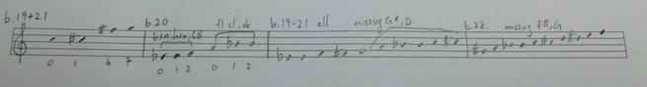
(figure 12)
In bar 20, one could argue that Varèse has taken a subset of the original 0123 pitch class set and stacked them one on top of the other, with the lower voices and upper voices each forming a 012.
The trumpet line in bar 23 forms the pitch set 013. Breaking from the rest of the piece, bar 23 does not have all the pitches to complete set of 12, but bar 24 alone does (see figure 13). This is the only instance of a complete set occurring within one bar or gesture in the whole piece.
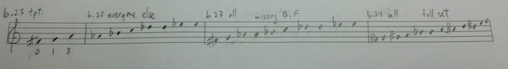
(figure 13)
It could be interpreted that these last two bars function as a transition between the full block clusters into a return of the single, linear lines that occur starting at bar 25. The fact that bar 24 is the only bar with a complete set of 12 pitches could signify it as the climax of the piece, or perhaps the result of leaving the climax of the piece at bar 23 with the crescendo to ff or fff in the voices.

Section D

Section D begins with the clear change in texture back to the “melodic” lines. The horn line in bar 26 is in a 013 pitch set (like the trumpet line of 23 and clarinet of bar 3. The bassoon line at bar 27 is written out through ornamentation in a similar manner as the opening oboe line. The total set of pitches found in measure 25-29 almost complete a set; they are missing the pitch G, the same pitch that was missing in the opening 9 bars (see figure 14).
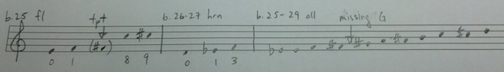
(figure 14)

Conclusion

Although I was open to finding occurrences of the number 8, the only definitive citing can be found in the number of players the piece is written for. One could argue that these players are like the stamen of the octandra flower, and (only) together, their pitches complete a set of 12 to create a cohesive unit.
Examining the metric changes and duration yielded no confirmations to the form that was not already gleaned by listening and examining the score holistically for gestures. The changes of horizontal to vertical gestures seems to be correct, as it is confirmed by the analysis of pitches. The pitch analysis revealed a loose basis on the germ of pitch class set 0123, as found in the beginning and end, but there is not the same level of recurrence as Beethoven’s “three short notes followed by a long” in his fifth symphony.
To review, the piece starts with a horizontal, melodic line by the oboe that begets the clarinet and contrabass in bars 5 and 6. This (A) section is completed with the final note needed to complete the 12 pitch set with a sudden, high pitched shrill at ffff.
In section B, the flute, clarinet and trumpet climb upwards. When the flute plays the final note of the 12 pitch series on beat 3 of bar 11, the bassoon and horn suddenly and aggressively join a sixteenth note later at sfff and sff. This imagery could be interpreted to be like the power of attraction that electrons experience to create stable noble gases, which coincidentally have 8 electrons in their outer shells to be complete, though it is an inexact analogy (because the appearance of the bassoon and horn happen after the set is complete, rather than completing the set by their appearance) and unlikely to be what Varèse was thinking about at the time.
There is another amassing of tone clusters in bar 15, which then seems to eject out a horizontal line in the bassoon, losing energy. The horizontal lines of the flute and oboe in bar 17 pick up in rhythmic and dynamic energy and are met with the blocked cluster of tones in the horn, trumpet and trombone in bar 18.
This texture suddenly transforms to the vertical, aggressive mass of tones of section C. In bar 23, the trumpet emerges with a horizontal line from within the body of tones of the other vertical voices.
The flute leaps up and down in bar 25, the opening of section D, as if to signify the embodiment of both horizontal and vertical natures of previous material. The horn embellishes and varies on the 013 germ and the bassoon follows with a similar line of rhythmic ornamentation and elaboration as the other voices cool off with stable quarter notes. The section is similar to the opening A section in that it is missing the pitch G, but this time it is never completed, not even with the final A’ section.
The piece ends with a return of the oboe line, transposed (transformed?) up a tritone.

Although other papers (Clayton 1986) (Moura 2004) cite the use of specific recurring pitches, direct and literal transformation of sound masses through interaction and symmetry in the form based on time elapsed, I found their arguments inconclusive and reaching beyond what the evidence could support. Having examined intervallic relations, pitch class sets, and recurring pitches as well, the only analysis I can confidently stand by is the one presented above where Varèse creates sound masses that can be identified by the completion of the 12 tones of a chromatic scale. Conclusions drawn about the relationship between vertical and horizontal masses is only speculative. If there is more definitive evidence, then it remains out of the scope of the author’s current skill of analysis.

Bibliography

Clayton, P.W. Varese: the chamber works of the 1920's: detailed analyses of Hyperprism, Octandre and Integrales. University of Sheffield, 1986.

Griffiths, Paul. Varèse, Edgard. Prod. Grove Music Online. Oxford University Press, March 14, 2016.

Moura, Eli-Eri. "Interaction between the generative cell and symmetrical operations in Varèse's Octandre." Contemporary Music Review, 2004: 17-44.

