ĐỀ THI BC – 17/8
TASK 1: The graph and chart below give information about the number of new graduates and their employment in the UK from 1992 to 2002. Summarise the information and Write at least 150 words.

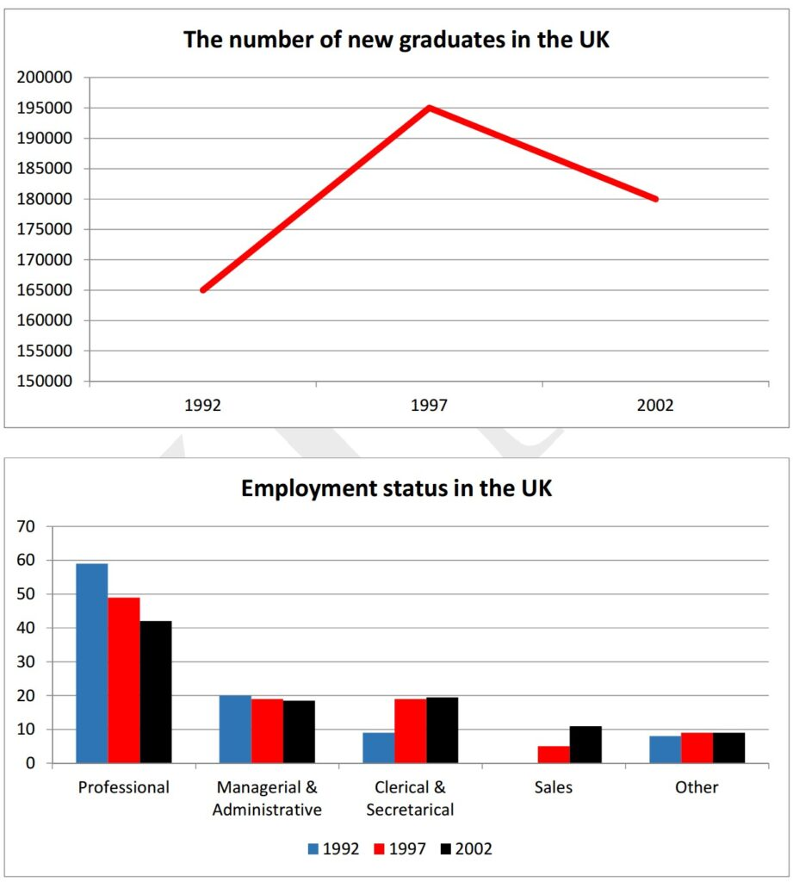
Dàn bài
Overall:
- Line: fluctuate
- Bar: professional – largest proportion ( huhu chị ơi hôm đó em canh thời gian còn 15p cho task 1+kiểm tra lại bài, nên khi xét hàng ngang em bối rối và không tìm ra xu hướng chung, nhìn mãi không ra nên em chuyển sang viết 2 body luôn ạ )
Body 1: line
- 1992: 165000 -> increased to 195000 in 1997 before a slight drop to 180000 in 2002
Body 2 : bar
- Professional’s work : dominate, decline
- Managerial & administrative ranked second, relatively equal
- Celerical & secretarical : 1992: 10%-> 2002: 20%
- Sales+others
Bài viết:
Given are the charts illustrating the number of the UK graduates as well as the proportions of their occupations over 10 years, starting from 1992.

In general, it is evident that there was a fluctuation in the data of new students graduating from schools in the UK. Moreover, the professional’s work had the largest proportion.
Regarding the line chart, the figure for the new UK graduates started at 165000 and experienced a significant growth to 195000 in 1997 before a slight drop to around 180000 in 2002.

Moving onto the other chart, the percentage of professional’s work dominated the chart, at approximately 60%, and the figure for this category declined to just over 40% in 2002. Furthermore, the proportion of managerial and administrative job ranked second and remained stable, at about 20% in a decade. Meanwhile, the rate of celerical and secretarical occupation was under 10% in 1997, followed by an increase to 20% in 2002. In addition, the percentage of sales was merely 5% in 1997, whereas the figure for other jobs were relatively equal over the period shown, with under 10%.

- Overall:
  - The number of fresh graduates in the UK underwent a sharp rise to a peak, followed by a less dramatic fall with an overall increasing trend.
  - The majority of UK students opted to follow professional careers upon graduating from university. (IELTS TUTOR gợi ý cách diễn đạt khác: While jobs requiring professional skills were the top preference of fresh graduates, working in a sales department was least opted HOẶC: professional jobs dominated the other jobs in the job market for graduates)
- Body 1:
  - In 1992, there were roughly 165,000 British students graduating from university.
  - This figure rose markedly to a peak of about 195,000 in 1997, before dropping thereafter to about 180,000 students in 2002. >> IELTS TUTOR hướng dẫn Cách dùng danh từ "figure" tiếng anh
- Body 2:
  - Nhóm có số liệu tăng
    - Careers in clerical and secretarial fields saw a marginal rise from 9% in 1992 to nearly 20% in 2002. >> IELTS TUTOR gợi ý PHÂN BIỆT "RISE / RAISE / ARISE" TIẾNG ANH
    - Sales and other professions also saw a rise in popularity among fresh graduating students, yet negligible, to around 10%. >> IELTS TUTOR hướng dẫn Cách dùng danh từ "student" tiếng anh
  - Nhóm có số liệu giảm
    - An opposite trend is seen in jobs related to management and administration, with the figures standing at 20% in 1992 and dropping by 1% 10 years later.
    - The figure for professional careers showed a downward trend although much steeper, from a peak of nearly 60% to its low of around 44%. >> IELTS TUTOR gợi ý Phân biệt ALTHOUGH/ THOUGH/ IN SPITE OF / DESPITE

TASK 2 It is more important to spend public money promoting a healthy lifestyle in order to prevent illness than to spend it on the treatment of people who are already ill. To what extent do you Agree or Disagree?
Bài viết:
In this day and age, more and more contemporary attention has been placed on the opinion that it is better to allocate an amount of money extracted from ordinary people to encourage residents to live in a healthy way than to spend this subsidization on the medication of citizens’ illness. From my perspective, I strongly agree with this viewpoint for the following reasons.
Firstly, the government should channel an amount of money into promoting locals to lead a healthy lifestyle instead of investing into the treatment of patients with illness. To be more specific, the health conditions of inhabitants become worse, which would lead the administrations to equip the healthcare system with a huge quantity of modern facilities in order to cure them, and hence create a burden on the funding. For this explanation, the budget ought to be subsidized to raise the public’s awareness of the healthy lifestyle.
Secondly, it is an effective way to motivate local inhabitants to live in a balanced way. In fact, the serious diseases could be attributed to the fact that dwellers lead a sedentary lifestyle, so if they are provided with the essential knowledge of this tendency, residents can gain deeper insights into the drawbacks of the bad habit as well as the significance of a healthy way of life, thereby avoiding dangerous healthrisks and strengthening their longevity. Therefore, it is more necessary to expend an amount of money into the encouragement of the general public’s healthy lifestyles.
In conclusion, for the compelling reasons above, I firmly opine that the public funding should be subsidized for the motivation of residents’ healthy lifestyles instead of the treatment of patients with diseases.
IELTS TUTOR lưu ý:
- Dạng opinion essay, nếu theo hướng TOTALLY AGREE có thể bố cục bài như sau:
  - Body 1: Nêu lí do thứ 1 vì sao TOTALLY AGREE
      - Main idea: If people remain vigilant to avoid severe ailments, they stand a lower chance of contracting them
      - Supporting idea: Human health can be reinforced and maintained effectively in the long term via varied approaches like dieting, exercising, and even spiritual therapy. >> IELTS TUTOR hướng dẫn Cách dùng động từ "approach" tiếng anh
      - Example:
        - If all people become fully convinced of the importance of choosing healthy diets involving less meat and more vegetables instead of consuming junk food, they will start to adopt such a healthy lifestyle and, therefore, will be able to avoid a host of health problems.
        - Working out on a daily basis will result in fewer patients visiting hospitals, thus reducing the amount of money spent on hospitalization and other medical fees. >> IELTS TUTOR hướng dẫn Cách paraphrase "every day" trong tiếng anh
  - Body 2: Nêu lí do thứ 2 vì sao TOTALLY AGREE
      - Main idea: this strategy appears more time- and cost-effective
      - Supporting idea:
      - Example: Once a patient is diagnosed with cancer, he or she will either pour their fortunes into immediate treatment, or choose to wait for their inevitable doom >> All this money can be well-saved, and time can be lengthened, thanks to proper preventative schemes.

