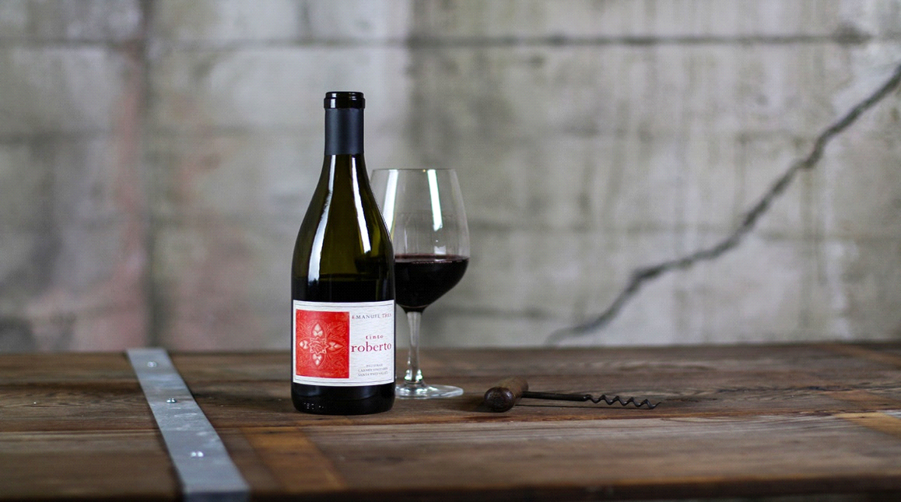
Emanuel Tres, Syrah,
Larner Vineyard
Santa Barbara, California 2012

Occasionally when I put my nose in a glass of California wine, time seems to stop. I wonder how something so incredible can be made in our own backyard. It really comes down to the clone, soil, climate and farming. Today’s 2012 Emanuel Tres, Tinto Roberto Syrah from Santa Barbara’s Ballard Canyon AVA is just such a wine. Derived from a special clone from the celebrated hill of Hermitage, this stunning Syrah was nurtured in a unique parcel from the organically farmed Larner Vineyard. This wine offers the classic flavor profile and elegant balance of a Northern Rhône Syrah with the perfect richness of fruit that combine to make it one of the best domestic Syrahs I have ever tasted. This staggering expression of old world elegance with a west coast accent will make you rethink California Syrah forever.
Ian Cauble, MS.

