Type of the Paper (Article, Review, Communication, etc.)
TITLE
Firstname Lastname ¹, Firstname Lastname ² and Firstname Lastname ^{3,}*
1 Address (affilation, department, street, post-code, country); e-mail@e-mail.com
2 Address (affilation, department, street, post-code, country); e-mail@e-mail.com
3 Address (affilation, department, street, post-code, country); e-mail@e-mail.com
* Correspondence: e-mail@e-mail.com

Abstract: The abstract should be a single paragraph of no more than 200 words. For research articles, it should provide a concise overview of the work. We recommend following a structured format without headings: (1) Background: Place the research question in a broad context and state the purpose of the study. (2) Methods: Briefly outline the main methods or treatments used. (3) Results: Summarize the primary findings of the article. (4) Conclusions: Highlight the key conclusions or interpretations. The abstract should objectively represent the article, excluding results not presented and substantiated in the main text, and should avoid exaggerating the main conclusions.
Keywords: keyword 1; keyword 2; keyword 3 (List three to ten pertinent keywords specific to the article yet reasonably common within the subject discipline.)

  - 1. INTRODUCTION
The introduction should succinctly place the study within a broad context, emphasizing its importance. It should clearly define the purpose and significance of the work. A thorough review of the current state of the research field is necessary, citing key publications and highlighting any controversial or differing hypotheses as needed. Finally, briefly state the main aim of the study and summarize the principal conclusions. Ensure the introduction is accessible to scientists outside your specific field. References should be numbered in the order they appear and indicated by numerals in square brackets, such as [1], [2,3], or [4–6]. Refer to the end of the document for more details on references.
  - 2. MATERIALS AND METHODS
The Materials and Methods section should be detailed enough to enable others to replicate and build upon the published results. Note that by publishing your manuscript, you agree to make all associated materials, data, computer code, and protocols available to readers. Any restrictions on the availability of materials or information must be disclosed at the submission stage. New methods and protocols should be described in detail, whereas well-established methods can be briefly outlined and appropriately cited.
  - 3. RESULTS
This section can be organized with subheadings. It should offer a clear and succinct summary of the experimental results, their interpretation, and the conclusions that can be derived from them.

3.1. Subsection
Text text text text text text text text text text text text :
- text text text text text text text text,
- text text text text text text text text text text text text text text text text text text text,
- text text text text text text text text text text text text text text text text text text text text text.

Text text text text text text text text text text text text text text text text text text text text text text text text text text text text text text text text text text text text text text text text text text text text text text text text text text text text text text text text text text text text text text text text.
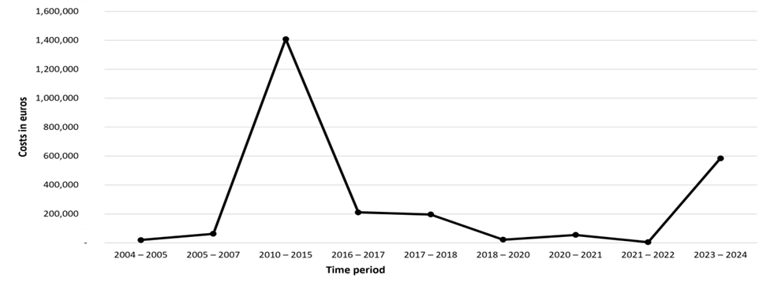
Figure 1 This is an example figure. Captions appear below each figure. Give enough detail for the reader to understand what they’re looking at, but leave detailed discussion to the main body of the text
Source: Varmus et al. (2024)
- text text text text text text text text,
- text text text text text text text text text text text text text text text text text text text,
- text text text text text text text text text text text text text text text text text text text text text text text text text text text text text text text text text text text text text.

3.1.1. Subsection
Text text text text text text text text text text text text text text text text text text text text text text text text text text text text text text text text text text text text text text text text text text text text text text text text text text text text text text text text text text text text text text text text text text text text.
Table 1 Models of the brand
AUTHORS | TANGIBLE AND VISUAL ELEMENTS | INTANGIBLE ELEMENTS
Aaker (1992) | Symbols and slogans | Identity, corporate brand, integrated communications, customer relationships
Biggar and Selame (1992) | Name, trademark | Positioning, brand communications
DMB & B (1993) | Product delivery | User identification; opportunity to share a dream
O’Malley (1991) | Functional values | Social and personal values
Young and Rubicam (1994) | Differentiation | Relevance, esteem and familiarity
Source: Young and Rubicam (1994)
  - 4. DISCUSSION
Authors should analyze the results, interpreting them in the context of prior research and the original hypotheses. They should explore the broader implications of the findings, situating them within the wider academic and practical landscape. Additionally, potential directions for future research should be outlined.
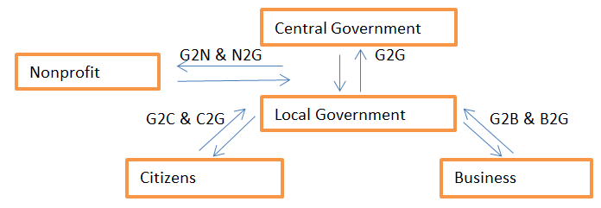
Figure 2 A broad schematic system for e-government models
Source: Horáková (2003)
  - 5. CONCLUSION
This section is not mandatory but can be added to the manuscript if the discussion is unusually long or complex.
  - ACKNOWLEDGMENT
In this section, you can acknowledge any support given. This may include administrative and technical support, or donations in kind (e.g., materials used for experiments).
  - REFERENCES
References must be numbered in order of appearance in the text (including citations in tables and legends) and listed individually at the end of the manuscript.
In the text, reference numbers should be placed in square brackets [ ] and placed before the punctuation; for example [1], [1–3] or [1,3]. For embedded citations in the text with pagination, use both parentheses and brackets to indicate the reference number and page numbers; for example [5] (p. 10), or [6] (pp. 101–105).
Citations in the text can be also formatted as follows: Adámik (2024) or (Varmus, 2019), Kubina et al. (2018) or (Kubina et al., 2018) and (Kubina et al. 2018, 2019; Adámik and Varmus, 2021; Varmus 2023).

- BLAŽKOVÁ, M. 2007. Marketingové řízení a plánovaní pro malé a střední firmy. Praha: Grada Publising, a. s., 2007. 280 s. ISBN 978-80-247-1535-3.
- BRADLEY, F. 2003. Strategic marketing in the customer driven organization. Chichester: John Wiley & Sons Ltd., 2004. 287 s. ISBN 0-470-84985-1.
- ĎAĎO, J. – KIRÁĽOVÁ, A. – LESÁKOVÁ, J. 1994. Marketing v drobnom a strednom podnikaní. Bratislava: Ekonomická univerzita, 1994. 143 s. ISBN 80-225-0420-3.
- HORÁKOVÁ, H. 2003. Strategický marketing. Praha: Grada Publishing a. s., 2003. 199 s. ISBN 80-247-0447-1.
- KUSÁ, A. – PIZANO, V. 2011. Marketingové analýzy a stratégie. Trnava: Univerzita sv. Cyrila a Metoda v Trnave, Fakulta masmediálnej komunikácie, 2011. 196 s. ISBN 978-80-8105-239-2.
- LESÁKOVÁ, D. a kol. 2011. Strategický marketing. Bratislava: Sprint dva, 2011. 366 s. ISBN 978-80-89393-56-5.
- VARMUS, M. – KUBINA, M. – KOMAN, G. – FERENC, P. 2018. Ensuring the Long-Term Sustainability Cooperation with Stakeholders of Sports Organizations in SLOVAKIA. [on-line]. [2023-11-16]. Available online: https://www.webofscience.com/wos/woscc/full-record/WOS:000436570100145

