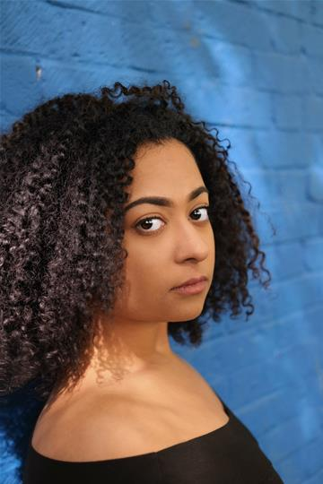
Leah
Kirby
They/ Them

Email: leah_kirby@hotmail.co.uk
Website:
Height: 5’4”
Weight: 11st
Hair: Black/Brown
Eyes: Black/Brown

Currently Filming for IM AN ACTOR Documentary
SOHO Theatres Writers Lab 2019- Present
Performing in Bitches in a Ford KA at The Vaults.
Lead singer in Drink the Kool Aid at the Vaults Lates 13/03/20 as CYRO in CYRO and The Drag Tingz

Credits

Stage

2019, Immersive, The Mad Hatter, The Mad Hatters Tea Party, Jessie- Lu Flynn
2019, Cooperate, Host of Infamy, SMIRNOFF RELAUNCH CAMPAIGN, Dean Rodgers
2019, Immersive, Cyro, BOOMTOWN: PARADISE HEIGHTS, Sam Dunstun
2019, Immersive/ Site specific, Jackdaw, THE UNHOLY MARRIAGE OF SLICE AND SWEETLY , Immercity
2019, Immersive (Ibiza), THE IMAGINATION CONCIERGE, Shotgun Carousel
2019, Stage, Cyro/ Dancer, GLASTONBURY: GUILTY PLEASURES, Shotgun carousel
2019, Stage, Cyro, MOLL AND THE FUTURE KINGS, Samwanamaker The Globe, Angela Clekin
2018-2019, Immersive/ Stage, Dionysus, DIVINE PROPORTIONS, Shotgun Carousel, Celine Lowenthal
2018-2019, Stage, Gee, BITCHES IN A FORD KA, Cold Dinner, Holly Barnard
2018, Stage, Ellie, HER NOT HIM, Lughnacy Productions, Amy Lawrence
2018, Stage, Nike, PSYCHOPOMP, Fen Theatre, Maisie Newman
2017, Stage, Burglar Betty, BURGLAR BILL, Pied Piper Theatre Company, Tina Williams
2017, Immersive/ Site Specific, Hana, BRIDGES Y PUENTES, Ragroof Players
2017, Stage, Howard Carter, EGYPTIAN EXTRAVAGANZA, Curious Flamingo Productions, Rosalind Othen
2017, Stage, Arry, THE TRIAL OF LE SINGE, The Heretical Historians, Matthew Jameson
2016, Stage, Nurse/Lawyer/Mother/Politician, GLAUCOMA, CapaTaro Theatre Company, Leah Kirby, Ines
Sampaio, Alice Whitehouse
2016, Stage, Nurse, HIPPOLYTOS, Thiasos Theatre company, MJ Coldiron
2015, Stage, Iona, CHAIN REACTION, Chain Reaction, Sarah Smit
2015, Stage, Joanna, HUMBLE PIE, Cavaliers theatre co, John Walton
2015, Stage, Lula, IMAGINARIUM, East 15, Devised Piece
2015, Stage, Rokujo, THE GHOSTS OF KANTAN, East 15, Franko Figueiredo
2014, Stage, Kecak conductor, BALI TEMPEST, Pak Nyoman Sedana
2014, Stage, Cherelle, HMP BRONZEFIELD, Blackwell Amelia, Sanderson Stephanie
2013, Stage, Myrhha, TALES OF OVID, East 15, Margret Coldiron

Film
2018-2019, Documentary, Themselves, IM AN ACTOR, Maria Webb and Harry Knight
2018, Feature Film, Ticket vendor, HOME SITTERS, Black Barn Productions, Will Terran
2018, Music Video, Female Lead, ‘BREAK THE BLUES’ Stefan Taylor, J Black Media
2018, Short Film, Gaia, HONEST ENCOUNTERS, Khevyn Ibrahim
2018, Short Film, Sara, ANYONE, Kenzie Armstrong
2017, Short Film, Grace, A DISAPPEARANCE, Butthead Films, Laura Spini
2017, TV, Restaurant Customer, GAME THEORY (BBC4), Wingspan Productions, Cat Gale

Voice over
2018, Voice Over, Emma Angstrom, DINO DASH, Six to start, Matt Wieteska
2017, Voice Over, Price, ZOMBIES, RUN! THE BOARD GAME, Six to Start, Matt Wieteska

Training
EAST 15 ACTING SCHOOL, BA World Performance, 3 years, 2012 - 2015
COLCHESTER INSTITUTE, BTEC Extended National Diploma in Musical Theatre, 2 years,
2010-2012

Drag Performer (CYRO)

Previously and currently performing in the UK and Worldwide in venues such as:
RVT, The Glory, Bar Wotever, The Chateau, CRAMPS, The Globe, Soho theatre, Hello Sailor, Drag to Watch out for 2, LESE MAJESTE, Elrow (Ibiza), Wiltons Music Hall, Boomtown 2019, Hey Gurl, Glastonbury 2019 (Williams Green Stage), Fantabulosa! (UK Tour), Queer Voices, The Glory, Drag World Olympia, Non binary Cabaret, Phantasmaglorious, Lese Majeste, The Village (Birmingham), The Fox (Birmingham), Birmingham Bullring and Grand Central, etc.

