Applicant Bio: 250 words
Wilson Li is a third-year medical student at the University of Saskatchewan and current CFMS Associate Director of Student Affairs, a role that has deepened his commitment to student wellness at the national level. Locally, he serves as Wellness Liaison for the Student Medical Society of Saskatchewan (SMSS), building on his earlier role as Wellness Representative and his experience co-founding and leading the USask Meditation Club.
Wilson's passion for wellness extends beyond formal roles. He facilitated a mindfulness seminar during the 2025 CFMS Wellness Month and maintains a personal practice anchored by three week-long silent meditation retreats, bringing lived authenticity to the work he champions. He is currently working on launching Balint groups with the Office of Student Affairs (OSA) for clerkship students at USask: small, confidential discussion groups where physicians and medical learners can reflect on the emotional and relational aspects of patient care.
Equally committed to mentorship, Wilson has supported pre-clerkship students through USask Medicine's PM² and Peer Learning Network programs, and regularly welcomes students to shadow him throughout clerkship because he believes community and guidance are foundational to physician and learner wellbeing.
Outside of medicine, Wilson stays grounded through reading, writing articles for the Canadian Medical Student Press, running, weightlifting, Brazilian Jiu-Jitsu, and soccer.
As CFMS Director of Student Affairs, Wilson hopes to ensure every Canadian medical student has access to the resources and habits that support a healthy mind and body; not just to survive training, but to thrive in a long, fulfilling life in medicine.
Platform: Portfolio Director (500 word max)
Canadian medical students are navigating one of the most demanding periods of their lives, and they deserve wellness support that is proactive, accessible, and built around their real experiences. As the former USask Wellness Representative and Associate Director of Student Affairs, I've spent the past few years turning that belief into action through wellness roundtables, national initiatives, and a team culture built on trust.
Through meetings and CFMS conferences, I was able to build team morale that encouraged Wellness Representatives from across the country to put their heads together and develop innovative plans to improve the wellbeing of medical students. By addressing both national and school-specific needs via wellness roundtables, we developed ideas and initiatives that empowered each school to support their learners' holistic wellbeing. This included projects such as National Wellness Challenge, launching our new initiative Perspectives in Medicine, and a shared initiative tracker to allow Wellness Representatives to draw from other schools’ ideas to use their allocated $1500 per school. I’m running for Director of this portfolio to build on this foundation and deliver for Canadian medical students country-wide.
My priorities:
- Building a national culture of proactive wellness support: Safe Spaces and Longitudinal Wellness Themes are two initiatives I've seen resonate with students, offering touchpoints throughout the year. Through open discussions on taboo topics in medicine and rotating resources on nutrition, mental health, and more, these initiatives meet students where they are. I will continue to champion them, while introducing a national clerkship panel focused on burnout, mental health strategies, and navigating the hidden curriculum to support students through this difficult transition.
- Funding for initiatives and participation in wellness activities/events through peer mentorship funding, National Wellness Challenge, and leadership awards. Many students never access funding and resources they're entitled to. I will create a central access point through Wellness Representatives with clear communication to ensure equitable access across Canada.
- Amplifying student voices: growing initiatives such as Perspectives in Medicine and partnering with the Canadian Medical Student Press to highlight insights and initiatives regarding the medical student experience. The aim is to allow students to recognize the shared experiences that may not be appreciated outside the context of medicine. Maintaining balance in medicine means normalizing the fact that healthcare holds many abnormal and distressing events. In addition to the difficulties, the peaks of medicine deserve equal recognition for what makes this work meaningful.
In order to support these priorities, I will lead my team members to feel valued. I've seen firsthand how intentional check-ins and a culture of genuine connection, not just productivity, determine whether a team shows up for each other when it matters. A Wellness Representative who feels valued and heard will advocate harder for their school's students. As someone who can connect with individuals from all types of backgrounds, I believe I can facilitate a Student Affairs portfolio that will both be enjoyable and effective for the 2026/2027 term.
Photo Headshot - also attached to email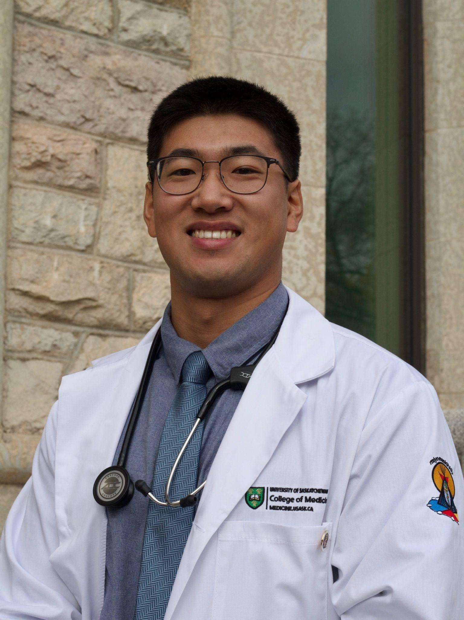
Relevant CV - attached to email

