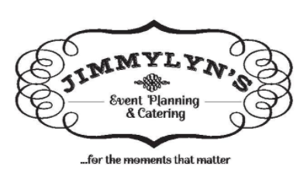
Gxcv

Frequently Asked Questions

- How long have you been in business?
  - Jimmy Lyn’s has been serving guests since June 2007!

- What is included with your meal?
  - With any entrée you chose, comes with a drink station of unsweet tea, sweet tea, water, sugar packets, extra cups and plenty of ice. We also include dinner rolls and butter on every table.

- How can I book Jimmy Lyn’s?
  - In order to book us we ask for 25% down of your estimate of choice. This deposit will hold your date and put you in our books! Payments can made up to two weeks before your wedding when we will need the final payment.
  - Deposits can be made through cash, check or even through our Venmo account : Cayce-Fagala (Cayce’s profile picture is her with her grandbaby )

- What china packages do you offer? Can we bring our own china?
  - Jimmy Lyn’s offers two china packages: Classic Porcelain China, and our acrylic (plastic) china. Our Classic china is $3.25 per head, while the acrylic is $1.25 a head.
  - Yes! You are more than welcome to bring your own china for us to serve on. Simply just put them in the kitchen on wedding day and we will take care of the rest! Keep in mind, that it is not on us if you are short a few plates/flatware.

- What makes your food different?
  - Jimmy Lyn’s is a scratch made kitchen. Our chefs use the freshest ingredients and cook with love. We offer a multitude of scratch made dressings, sauces and of course, our scratch made BBQ sauces.

- How do you staff your events?
  - We work very hard to maintain a long list of staff members to call and employ for events. Our group of employees consists of responsible, well-mannered young adults. This helps us maintain a familiar, fun-filled environment.

- How does gratuity work?
  - We do not charge gratuity. However, if you think our staff does a great job and want to tip them, please feel free to!

- What all does the service fee include?
  - Our staff arrives 2-3 hours prior to the start of the ceremony or event. We will act as servers for buffet style meals, or waiters during sit down plated dinners and cocktail hours. We also take on the responsibility of keeping the entire facility clean and clear of trash and dirty dishes (this includes bussing, trash disposal, and spill clean ups). We stay until the very end of your event, and help the venue with clean up. Our service fee includes a full 8 hour service.

- Can you accommodate dietary restrictions?
  - YES! We offer a selection of Gluten free, vegetarian and vegan options.

- Do you offer Kid’s Meals?
  - YES! We offer 2 types of kids meals: ½ portion of the adult entrée served at your event, or chicken nuggets, mac n cheese, and fruit.

- What happens with the leftover food?
  - Any food that is left over after all of your guests have been served, is packed up for the bride and groom (or host) to take with them at the end of the event. We also will package up 2 to-go meals for the bride and groom to enjoy after the event!

- What happens if my event runs over the 8 hour mark?
  - If the event runs longer than 8 hours, an additional Service Fee WILL BE CHARGED. However, the calculation of overtime is contingent upon the length of time and number of servers. All “extra fees” are due no later than 2 weeks after your event or an additional 5% will be added to the total.

