Describe a good service you received
You should say:
What the service was
When you received it
Who you were with
And how you felt about it
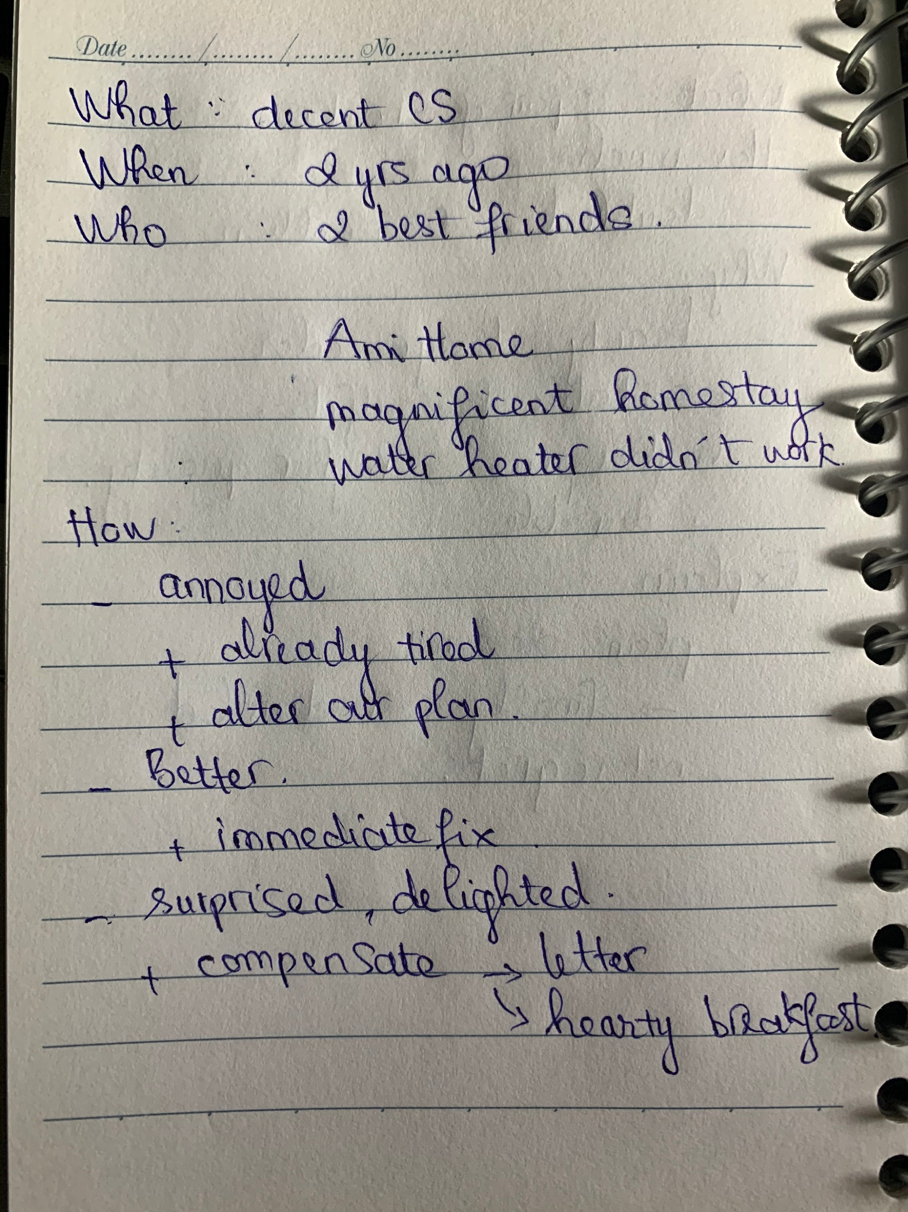
What the service was
Now, I would like to tell you about my experience of receiving a decent customer service from a homestay team in Da Lat.
When you received it + Who you were with
To tell you the truth, I had many times travel to Da Lat with my family, but the latest time I went there was about 2 years ago with my 2 best friends. At that time, we were second-year students, that’s why we didn’t have much money for the trip, so we decided to rent a homestay called Ami Home for 4 days in Da Lat.
At first, when we arrived at that homestay, we were surprised and overwhelmed by its wonderful decoration, and then we began to check in and moved to our room. We decided to do some personal hygiene and do some makeup to go out. Unfortunately, when I went to the bathroom I realized that the water heater didn’t work. Therefore, we quickly seek help from the homestay team.
And how you felt about it
At first, I felt so annoyed because after spending a long time traveling by car from HCMC to Da Lat, we were already tired, that’s why taking a shower at that time was so necessary for us. That’s not to mention we had to alter our plan. After that, when the anger was over, I felt much better, and that was also due to the immediate fix from the homestay. Finally, we were all surprised and delighted that the next day, they were very thoughtful to compensate us with a hearty breakfast for all 3 of us and an apology letter from the homestay team. Actually, they made our day since their customer service was so amazing, and we all agreed that we would use their services again when we visit Da Lat someday.
lưu ý:
- Intro: What was the service?
  - Kayak - a booking service for flight tickets and a hotel reservation.
  - Provide a user-friendly platform for users to search and book flight tickets and hotel rooms.
- When you received it & Who you were with?
  - Last summer, my brother and I made up our mind to go on a trip to Singapore. In fact, this time both me and my brother wanted to do everything on our own, from booking the plane tickets to choosing the hotel and planning the trip.
- An how you felt about it?
  - At first, I held a lot of doubt over this website since I had never bought plane tickets online before.
  - Then, after browsing through the site for a while, I was quite impressed by the sites’ smartly designed layout and easy-to-follow content, and furthermore, it only took a few minutes to find the plane tickets that I wanted. Another good point to mention about the service was how quickly and convenient the payment was when they offered a variety of payment methods, such as credit card, bank transfer or direct debit
  - Finally, I managed to book the plane tickets at a reasonable price and at lightning speed. Both my brother and I were completely satisfied with the service that we received, and we gave the website a 5 star rating on the user review page

