29TH NFMCPI NATIONAL CONVENTION
CAGAYAN DE ORO CITY
FEBRUARY 6-7, 2026

GROUP REGISTRATION FORM

CLUB REPRESENTATIVE DETAILS

Contact Person: ________________________________ Contact No: _________________ Email Address: ________________________ Island Group (Luzon, Visayas, Mindanao): ___________________

Province: ______________________________ City: ______________________________ Motorcycle Club (Please enter full motorcycle club name.): ____________________________________________

GROUP MEMBER INFORMATION
 |  |  |  |  |  |  |  | MOTORCYCLE DETAILS
NO | FIRST NAME | LAST NAME | DATE OF BIRTH | EMAIL ADDRESS | RELIGION | GENDER  (M/F) | TSHIRT SIZE  (S-6XL) | YEAR | MAKE | MODEL
1
2
3
4
5
6
7
8
9
10
PAYMENT DETAILS
To confirm your slot for the National Federation of Motorcycle Clubs of the Philippines Convention 2026.

Registration Fee:
- Early Bird Rates: ₱4,000 for NFMCPI member • Regular Rates: ₱5,000
₱5,000 for Non NFCMPI member Period: January 1, 2026 – January 31, 2026
Period: August 21, 2025 – December 31, 2025

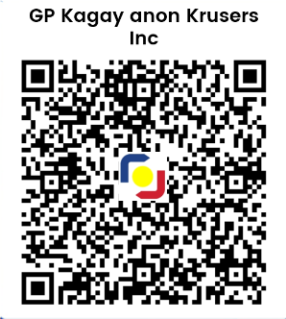
Inclusions: Bank Transfer
- Official Convention ID 🏦 Bank Name: RCBC
- Limited Edition Convention T-Shirt 🏢 Branch: Cagayan De Oro – VELEZ
- Event Giveaways & Souvenirs 👤 Account Name: KAGAY-ANON KRUSERS INC.
- Meals at the Convention Venue 🔢 Account Number: 7591 2783 34
- Access to Convention Rides, Booths, & Programs Or scan the QR code for GCASH transaction.

This fee grants you full access to all convention activities in Cagayan de Oro.

Send Registration Form and Payment Receipt via Email: For Inquiry/Sponsorship, email us at:

Natcon2026registration@kkcdo.com Natcon2026info@kkcdo.com

Make sure your receipt shows:
- Full Name of Participant • Date & Time of Payment
- Amount Paid • Reference Number

Signature of Club Representative: _________________________ Date: ___________________

✔
I HEREBY CERTIFY THAT ALL INFORMATION HEREIN ARE TRUE AND CORRECT, AND I UNDERSTAND AND ACCEPT THAT MY DATA MAY BE USED FOR ANALYSIS AND EVENT-RELATED PURPOSES.

