The bar chart below shows the percentage of Australian men and women in different age groups who did regular physical activity in 2010.

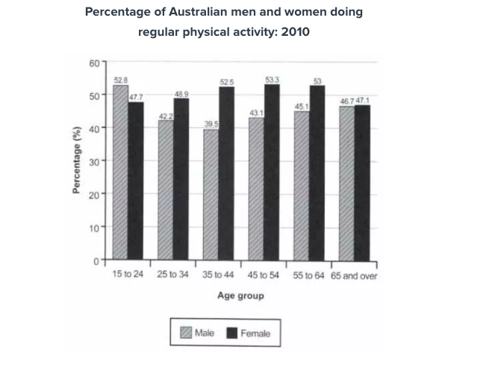

Dạng bar chart (no time)
chủ percentage of Australian men vs women
đơn %
thì past simple

Given the bar chart is demonstrating the proportions of Australian males and females in various groups of ages in terms of doing regular exercise in 2010.

Overall, the percentages of females mainly dominated that for males in doing regular physical activities in almost all groups of ages. Meanwhile, the proportion of women doing exercise regularly was highest at the age from 45 to 54, the figure of men peaked at 15 to 24 years old. ⇒

As can be seen in the chart, the proportion of female adults doing daily exercise aged 45 to 54 reached 53,3% while that of males just made up 43,1 %. Similarly, the percentages of women from 35 to 44 years old was about the same as that from 55 to 64, which accounted for 52,5% and 53% respectively. About men, that of them were nearly the same constituting 43,1% and 45,1 % in that order. ⇒ Mô tả số liệu còn sai vài chỗ nha, như 2 nhóm tuổi 35-44 và 55-64 số liệu của nam chưa hẳn là giống nhau
⇒ Bài task 1 này của mình hơi dài, nên là body 1 này có thể nêu số liệu 3 nhóm xử lí gọn hơn
- Nữ (3 nhóm tuổi) số liệu đều cao hơn 50%
- Còn nam (3 nhóm tuổi) số liệu thấp hơn khá nhiều, ở trong khoảng từ 39.5% đến 45.1%

Moving on the remaining group ages, between 25 to 34, the proportions of females occupied 48,9% while that of males made up 42,2%. However, during the age 15 to 24 years old, the figure of males (52,8%) did exercise regularly was higher compared to that of females (47,7%). Additionally, the group of adults aged 65 and over had approximately equal percentages in terms of both genders, at 46,7% and 47,1%.

Tức là chia bố cục theo
- Body 1: Những nhóm tuổi mà số liệu Nữ > Nam rõ rệt (khoảng cách lớn)
- Body 2: Những nhóm tuổi còn lại (chênh lệch ít + nhóm 15-24 Nam > Nữ + 65 trở lên số liệu gần bằng nhau)

⇒ Những chỗ chữ đỏ nhầm lẫn dấu chấm và dấu phẩy khi ngăn cách phần thập phân nha, nhớ sửa lại
https://www.tutorspeaking.com/blog/nham-lan-dau-ngan-cach-don-vi-so
Về bố cục thì bài này chia như này khá ổn rồi nhé

IELTS TUTOR lưu ý:
- Bài này nếu phân tích theo hướng phân tích tách riêng Males & Females có thể bố cục như sau:
  - Overall:
    - Women exercised more than men, with the exception of those aged 15-24 (IELTS TUTOR gợi ý cách diễn đạt khác: a higher percentage of women than men exercised regularly in every age group except the youngest) >> IELTS TUTOR hướng dẫn Cách dùng "with the exception of" tiếng anh
    - Boys aged 15 to 24 and women aged 45 to 54 accounted for the highest percentage of the total people who did regular exercise (IELTS TUTOR gợi ý cách diễn đạt khác: Middle aged females were the most physically active, proportionally while males aged 35 to 44 did the least physical activity HOẶC: while women’s participation was highest in the 45-54 age bracket, that of men peaked among 15- to 24-year-olds) >> IELTS TUTOR hướng dẫn Cách dùng danh từ "exclusion" tiếng anh
  - Body 1: Viết về Độ tuổi 15-44
    - The 15 to 24 age group was the only group in which the proportion of males taking regular exercise was higher than that of females, 52% and 47.7% respectively.
    - 48.9% women at the age between 25 and 34 exercised on a regular basis, whereas the figure for the opposite sex in the same age group was only 42.2%. >> IELTS TUTOR hướng dẫn Cấu trúc SO SÁNH trong IELTS Writing Task 1
  - Body 2: Viết về Các độ tuổi còn lại
    - Over 50% of women aged 35 to 64 exercised regularly while the figures for men in the same age groups were much lower, ranging from 39.5% to 45.1%.
    - Men and women aged 65 or older who did regular physical activity accounted for a similar percentage, at around 47%. >> IELTS TUTOR hướng dẫn Cụm giới từ (preposition phrase) tiếng anh

