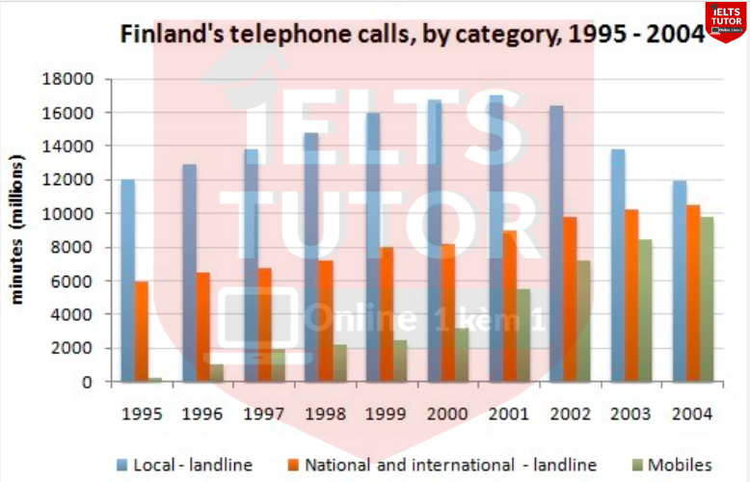

The graph illustrates how many minutes ( in millions) of telephone calls were spent in the UK in terms of three categories between 1995 and 2002.
Overall, there was an increase in the number of minutes spent on mobile, national and international-landline while the figure for local-landline witnessed a decreasing trend and always was the highest munites spent throughout the period.
The number of minutes spent on local- landline started at 12000 million, after which, it experienced a rise to about 16500 million minutes in 2000. Similarly, the figure for national and international- landline and mobiles were 6000 million and about 1 billion in 2000, followed by a slow increase to 8000 million and roughly 3000 million minutes in 2000 respectively.

Approximately 17000 million minutes were spent on local- landline in 2001, with a dramatic decrease and reaching 12000 million at the end of the period. In contrast, the figures for national and international- landline and mobiles saw opposite changes, increasing gradually from more than 8000 million minutes to 10000 million, and from 3000 million to above 10000 million minutes in 2004 respectively. → Body này thì tạm ổn
- Bài viết chưa có paraphrase
  - https://www.ieltsdanang.vn/blog/paraphrase-tu-landline-dien-dat-dien-thoai-co-dinh-tieng-anh
  - https://www.ieltsdanang.vn/blog/paraphrase-tu-mobile-phones-mobiles-dien-dat-dien-thoai-di-dong-tieng-anh
- Phân bố 2 đoạn thân bài chưa rõ ràng dẫn đến bài viết khó theo dõi (trước mỗi đoạn thân bài cần có câu dẫn để người đọc biết ý đồ chia 2 đoạn thân bài của mình là như nào) , diễn đạt xu hướng có sai & mô tả số liệu còn lộn xộn
- Cấu trúc & vocab còn đơn giản

Tham khảo bố cục bài:
  - Overall:
    - While local landline calls remained the most popular option in 2004, the gap between the three categories had significantly narrowed during the latter half of the period under consideration
    - There was an increase in the number of minutes spent on mobile, national, and international landline calls, whereas the figure for local landline witnessed an increasing-then-decreasing trend.>> IELTS TUTOR hướng dẫn PHÂN TÍCH ĐỀ THI 30/5/2020 IELTS WRITING TASK 2 (kèm bài sửa HS đạt 6.5)
  - Body 1: Viết số liệu category tăng + giảm (Local - landline)
    - Local landline calls experienced the highest usage, starting at 12,000 million minutes in 1995, peaking at just under 17,000 million minutes in 2000, but reverting to the 1995 level by 2004
  - Body 2: Viết số liệu category tăng (National and international - landline & Mobiles)
    - National & international - landline
      - National and international landline calls showed steady growth, increasing from 6,000 million in 1995 to 10,500 million by the end of the period although the rate of growth slowed in the last two years.
    - Mobiles
      - Mobile calls saw a remarkable surge, going from 250 in 1995 to 9,800 million minutes in 2004. >> IELTS TUTOR có hướng dẫn kĩ Hướng dẫn đề thi IELTS 21/11/2020 bài WRITING TASK 1 (map) về school library (kèm bài sửa cho HS đi thi)
      - This substantial increase was particularly notable between 2000 and 2004 when mobile phone usage tripled.

​​

