NORTHGATE CENTRE
Spring 2019 Members Newsletter
Dear Member
As you see above for this newsletter we have included our new logo at the top. This logo also appears on the new external sign above the front entrance of the Community Centre. It was agreed at AGM that the name of the Centre would be changed from Northgate Ward Community Centre to just Northgate Centre in order to refresh and modernise the image. We hope you like it. A side elevation sign to be seen from Sturry Road is also planned for the near future.
Since the last newsletter the staff and volunteers here at the Centre have put on a variety of events for residents. You may have come to the Quiz on Saturday 18th August, which was very well attended, or you might have come along to the big musical event on Friday 5th October, when we were brilliantly entertained by Abba Chique. Over 100 people came to sit and watch or to dance the night away. If you were there I am sure you would agree that it was a really good evening.
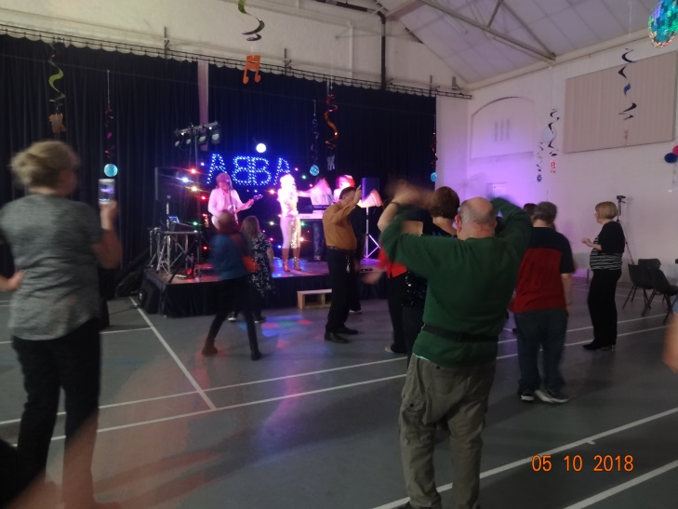
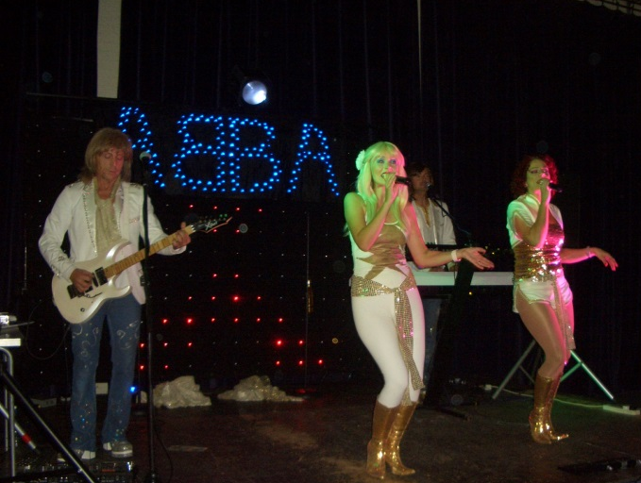

This event was then followed by our annual Christmas Fayre on Saturday 1st December 2019. This year the theme was ginger bread house and staff decorated the hall with an actual gingerbread house covered in sweeties and all good things to eat: across the hall ceiling- was strung candy canes and cut-out ginger bread men.
With Father Christmas grotto and all the brightly arranged stalls - the hall looked amazing. The event was opened by the Lord Mayor- Cllr. Colin Spooner, with all our local councillors helping out on stalls and clearing up.
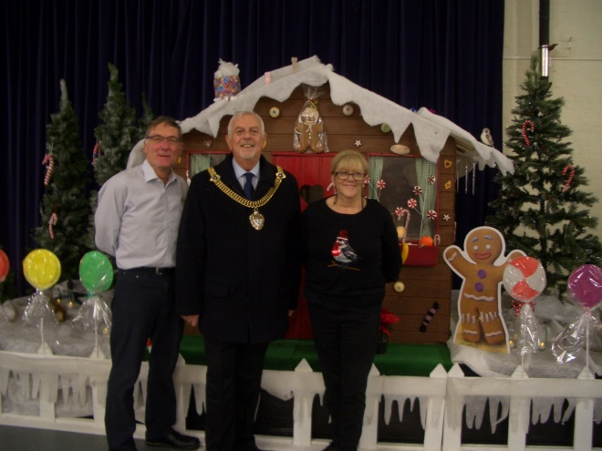

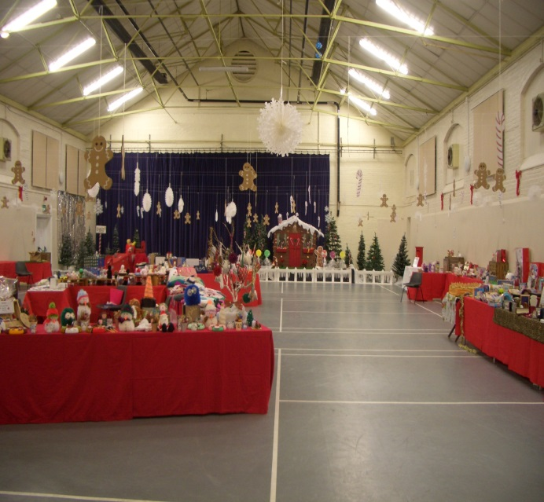
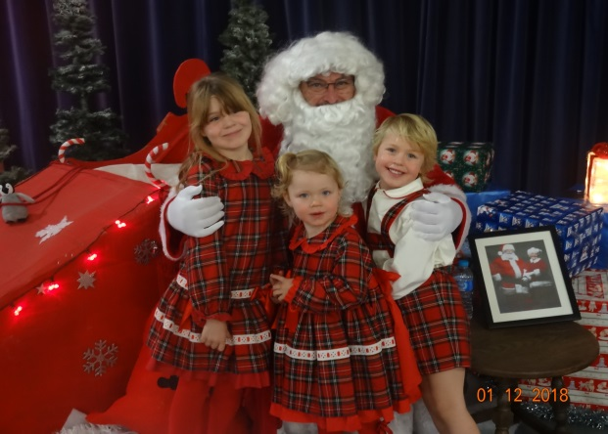

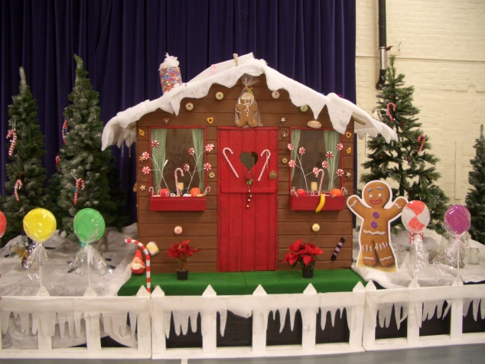
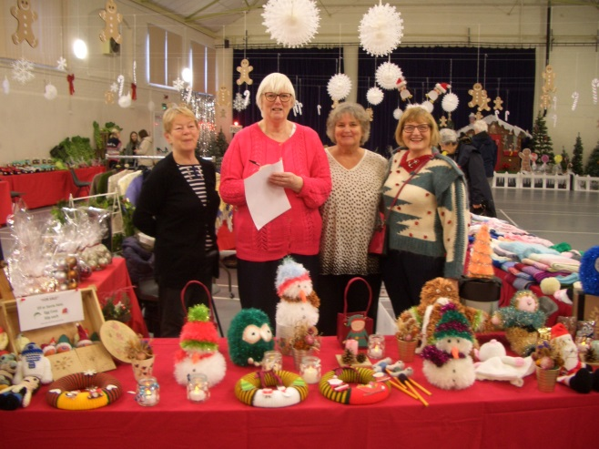

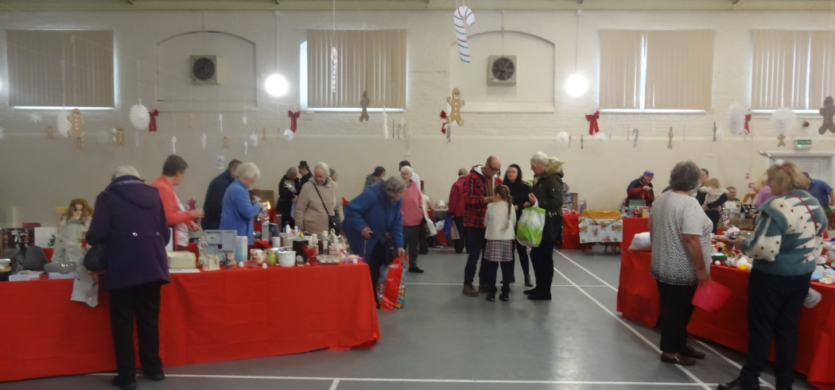

The event did very well helping to raise our annual fund raising income. This currently stands at £5703.75, but this figure will rise when the March quiz night is added to it. All money raised is put to support activities and services or to buy equipment and some is deposited in our reserve account for a rainy day.
‘Thank You’ to all who have supported the fund raising effort – whether you have attended an event, donated items to sell or made something for the stalls- Good Job! Your Centre keeps running on your generosity.
Finally for 2018 we must thank Colour Sergeant Paul Harris, Community Engagement SNCO with Army Tigers, Princess of Wales Royal Regiment 3rd, Territorial Army, Leros Barracks for a kind donation of food parcels and together with the Lord Mayor’s Christmas parcels many of our local older residents benefitted from receiving one of them.
So turning to 2019 - Our landlord Canterbury City Council is currently carrying out some external work to the building - to gutters, down pipes, some roof felting and painting.
Room 1 on the first floor has been upgraded with new carpet and new chairs, which go with the new tables we purchased last year, making this room a versatile room to book for training, meetings or leisure activities. Also on the first floor we have turned an empty space into a big store cupboard. The CCTV and alarm systems have been updated to better superior systems. All of the improvements have been made possible due to Kent County Councillor Graham Gibbens member’s grants with which he supports us with annually.
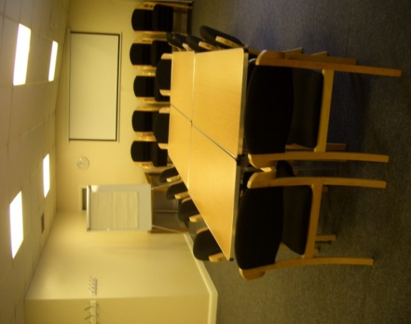

We are sad to say ‘Good Bye’ to Hilary Smith who has been a volunteer receptionist in the Centre since December 2013, we are very grateful for all the volunteering hours she gave to us and we wish her well in the future - I am sure she will be popping in to see us from time to time. We are however very pleased to welcome back Margaret Carson who has returned to help us out on the Reception desk. As you know the Centre could not remain open if it were not for all the wonderful volunteers we have who give so generously of their time.
We not only look forward to all the activities and services continuing in the Centre for the year ahead, but we have some special events and new projects planned. Please make a note on your calenders or in your diaries of the dates below.

NWCC 2019 UPCOMING EVENTS

Saturday 23rd March – Quiz Night from 7.30pm Tables of 8 or individual places. £5.00 per person
Monday April 1st - Eggtravaganza Easter Raffle – Tickets go on sale
Wednesday April 17th –Eggtravaganza Easter Raffle Draw in Café at 12 noon
Thursday 16th May – Tea Dance and Spring Sale from 10.30am to 12.30pm
Friday 7th June – Launch of new community activities in the Coffee Shop - More details still to be released
Saturday 15th June 7.00pm – 10.00 pm Big Musical Event – Details still to be finalised.
Saturday 6th July – Quiz Night from 7.30pm Tables of 8 or individual places. £5.00 per person
Thursday 22nd August -Tea Dance and Summer Sale from 10.30am to 12.30pm
Friday 1st November at 1.30pm –Over 60’s Annual General Meeting
Monday 4th November – Fantastic Festive Raffle with Fabulous prizes - Tickets on Sale
Friday 15th November at 1.30pm - NWDG (The Centre’s) Annual General Meeting
Saturday 30th November from 10.00 am to 1.00pm Christmas Event and Fantastic Festive Raffle with Fabulous Prizes Draw!

Finally:-
To put your clocks forward one hour on Sunday 31st March 2019!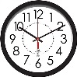
This happens to be Mothering Sunday too!

As always – Thank you to all members for supporting the Centre and to staff and volunteers who work untiringly to keep the Centre open for us all to enjoy.

Our thanks to

Canterbury City Council for the award of a RISE Improvement Grant
Kent County Council Councillor Graham Gibbens for Members Grant to buy new Centre Equipment
Local City Councillors - Alan Baldock and Jean Butcher for their continuing support

For more photos and details of activities and services in the Centre
look on our web site:-www.northgatewardcommunitycentre.co.uk
or alternatively

Telephone 01227 785293 and ask for our brochure.

