**What’s On Guide**

NORTHGATE CENTRE

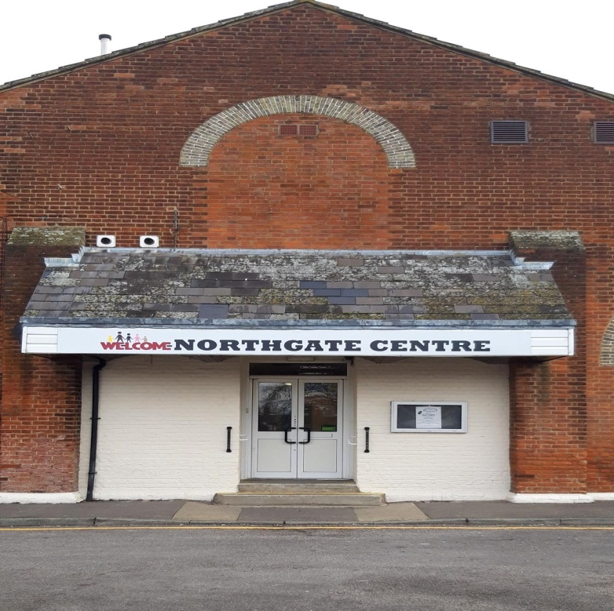

2019

**CONTENTS**

Page

Aim & Objectives 3

How to contact us and map 4-5

Weekly Activities 6-8

Monthly Services/Special Events 9

Room & Hall Hire 10

Coffee Shop 11

Services run from the Centre 12-13

Membership & Volunteers 14

Funding 15

**Northgate Ward Community Centre is a**

**project of**

**Northgate Ward Development Group**



**Aim & Objectives**

**To promote education, healthy lifestyles,**

**relieve poverty and provide cultural**

**opportunities by initiating projects, services,**

**leisure activities, advice and support in the**

**interest of social welfare for the residents**

**of Northgate Ward & Canterbury District.**

**HOW TO CONTACT US**

**Telephone 01227 785293**

To make an appointment, booking or just an enquiry, telephone the above number or drop in to the Centre and ask the receptionist

or

**E-mail** – [admin.nwcc@btconnect.com](mailto:admin.nwcc@btconnect.com)

**Web Site Address**

[www.northgatewardcommunitycentre.co.uk](http://www.northgatewardcommunitycentre.co.uk)

Or

Facebook & Twitter

**Address:-Northgate Ward Community Centre Military Road**

**Canterbury**

**Kent**

**CT1 1YX**

**There is disabled access to the building**

**The Centre Opening Times**

**Monday – Thursday 9.00am – 4.00pm**

**Friday 9.00am – 3.00pm**

**Evenings and weekends – Private Group or Individual**

**bookings**

**MAP OF WHERE TO FIND US**

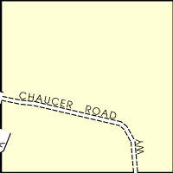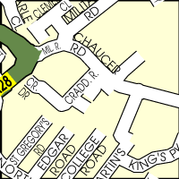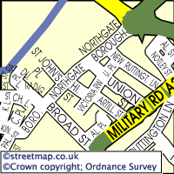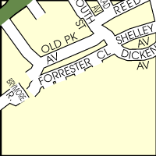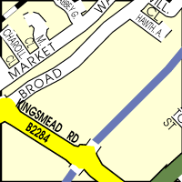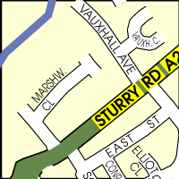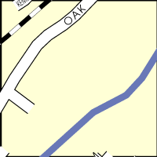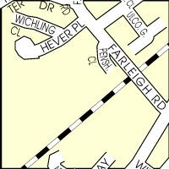

NORTHGATE WARD COMMUNITY CENTRE,

MILITARY ROAD

CANTERBURY. CT1 1YX



**Coffee Shop Opening Times:**

**Monday – Friday 8.30am – 2.30pm**

**WEEKLY ACTIVITIES IN THE CENTRE**

**Monday**

1.30pm to 3.30pm – **Art Group**

£1.50 per Session – most materials provided

1.00pm to 3.00pm – **Short Mat Bowls**

£1.50 per Session

1.30pm to 3.30pm – **Mind Games**.

Table Top Games played. £1.50 per session

6.00pm to 7.00pm - **Canterbury Walking Football**

A charge will be made per session

7.15pm to 9.15pm – **Racqueteers Badminton**

A charge will be made per session

Contact: John Copsey at

[jc1000@gmx.com](mailto:jc1000@gmx.com) or Tel: 01303 840588

**Tuesday**

10.30am Start – **Talk & Walk Group**

Walks last about 50 minutes, ask at reception for list

of walks.

12.30pm to 3.30pm – **The Chooseday Club** A lunch

club for the active older person. Also includes talks, entertainment and outings throughout the year.

Telephone 01227 456616 for full details

**Wednesday**

11.00 to 12.30 **Ladies Who Read**

3rd Wednesday of each month Female reading group.

Contact Irene - 01227 364884

2.00pm to 4.00pm **Art Group**  £1.50 per Session.

most materials provided – All Welcome

2.00pm to 4.00pm **Bingo** £1.50 Entry. Minimum age

18yrs and membership required – ask at Reception

**Thursday**

2.00pm to 4.00pm - **Hard of Hearing**

(1st & 3rd Thurs of month) Social gathering for those

who have hearing difficulties with **Hearing Aid**

**Maintenance**

2.00pm to 4.00pm - **Bingo**. £1.50 Entry. Minimum

age 18yrs and membership required – ask at Reception

6.00pm to 7.00pm - **Canterbury Walking Football**

A charge will be made per session

**Friday**

10.00am to 12.00 noon – **Knits & Sews**

Making items to sell for Centre fundraising

plus small sewing repair service (small donation required)

7.00pm to 9.30pm **Claire’s Friday Night Bingo**

£1.50 Entry - All Welcome

**(Must be over 18 and a member to play)**

**Monthly Services**

**Foot Clinic –** 9.00am to 2.30pm on the third Friday of

each month. Cost £15.00 per appointment. To book

Tel: 01227 456616



**Special Events**

**Throughout the year the Centre puts**

**on special events.**

**Look out for these advertised in the**

**Centre on posters, the TV Screen in the Coffee Shop, on our Web Site** [www.northgateward](http://www.northgateward)communitycentre.co.uk

**and Members Newsletters.**

**Room and Hall Hire**

There are a variety of meeting rooms and a

large hall available for group use and hire at

very reasonable rates.

There are three Badminton Courts for hire

Members benefit from discounted rates.

We always welcome people to come and look

around our Community Centre and to view

rooms prior to booking. This will ensure that

the correct room is selected to meet your

needs.

For information on charges please contact the

Centre by telephone 01227 785293

or E-mail

[admin.nwcc@btconnect.com](mailto:admin.nwcc@btconnect.com)

***MK CAFÉ & COFFEE SHOP***

Open Monday to Friday 8.30am To 2.30pm

Homemade Hot Light bites, take-away meal deals, teas, coffees and cakes & desserts

**Chef Meals**

Monday to Friday

12.00 noon to 2.00pm

See noticeboards for the days specials

Mid-week Roast on Wednesdays

Fish & Chips on Friday

Friday Night – open 6.00pm to 8.00pm – booking advisable

Free Wi Fi with a paid for Drink

**Affordable Catering**

Our chef can cater for your special event if booked here at the Centre – Weddings, children’s parties and other celebrations.

Local Authority approved

5-star Food Hygiene establishment

Arrange to meet your friends here for a

meal or just a coffee and a chat at affordable prices

Telephone 01227 785293 for further details

**OVER 60’S COMMUNITY SERVICE**

**(NORTHGATE WARD & CANTERBURY DISTRICT)**

A dedicated service for older people

over the age of sixty years. Many

services provided to assist with independence, including help to

apply for benefits entitled to,

practical help solutions,

shopping service and befriending

Please **telephone** **01227 456616** to

ask for their brochure

Or

**E-mail**

over60cs@gmail.com

**Canterbury Community Day Services**

**With meeting room and**

**‘special needs’ changing place.**

Canterbury Community Day Service is part of the

Adult Service Provider Unit which is run by

Kent County Council.

**Kent County Council logo**

To enable service users with learning disabilities to

access the community and also use the in-house

facilities within the unit. Catering for people from

the ages of 18 to 65, they assist service users in

gaining independence and reaching their full

potential at their own pace. The groups provide a

platform to mix with friends and build on skills and

develop hobbies.

If you have any questions or comments about the

service we provide do not hesitate to contact us.

**Telephone 01227 769961**

**Membership**

Become a member of the Centre and this will entitle you to:-

* Two Member’s Newsletters a year
* First offer of tickets to special events
* To take advantage of grant-funded activities for NWCC

members only.

To join Bingo groups you must become a member of the

Centre to comply with the Small Gaming Licence requirements

(Over 18yrs only)

**Yearly Membership**

**£5.00**

**Volunteers**

NWDG operates a Volunteering Policy.

The Northgate Ward Community Centre would not be able to

run without the dedication and support of the Volunteers who

give their time freely. They are valued team members and

help in all aspects of the Centre.

Volunteering can be very rewarding.

If you are interested in becoming a volunteer, please

01227 785293 and you will be invited for an informal chat

with the Manager.

**Please Note: All prices in this brochure are subject to change.**

**Northgate Ward Development Group**

**Sponsors: -**



[Kent County Council logo](http://www.kent.gov.uk/##)

**DONATIONS**

As a registered charity we are always

looking for funding to support services –

please consider donating any amount to

us if you wish, as all amounts would be

gratefully received and will go directly to

services for the community.

Thank you