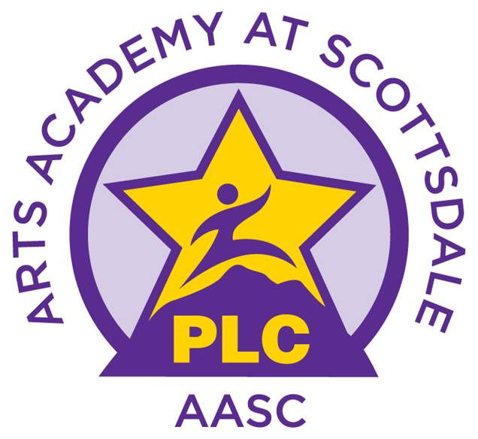

Fill in the necessary information and bring your order form and check made payable to “PLC AASC Inc.” to the Office. All orders will be delivered to the AASC campus. For questions call: 480-951-3190
UNIFORM SHIRT
ORDER FORM

ORDER DATE_________________
ORDERING DEADLINE__________

SOLD TO:

Student Name: ____________________________
Parent Name: ______________________CK#____

Phone #: ________________________

E-mail: __________________________

QTY. | ITEM NUMBER | ITEM DESCRIPTION AND COLOR | SIZE | UNIT PRICE
 |  |  | TOTAL

MAKE CHECKS PAYABLE TO “PLC AASC INC”

ALL SALES FINAL

