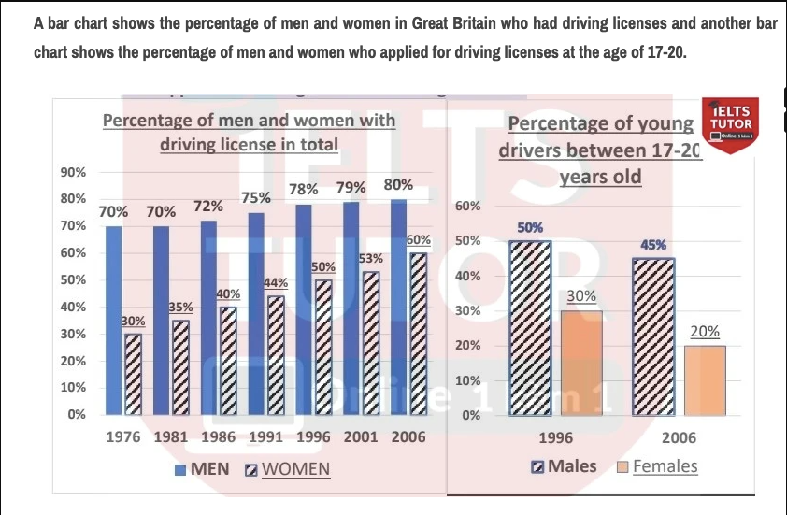
Given are the bar charts illustrating the percentage of British driving license holders categorized by gender as well as the proportion of drivers specifically in the 17-20 demographic.
Overall, the total number of individuals with a driving license in Britain generally increased, as opposed to that of those aged 17-20 which underwent a downward trend throughout the period. ⇒ Với Overview của bài như trên, thì mình có thể thấy được 2 phía riêng
- câu 1. Xu hướng tăng, nhưng Nam > Nữ
- câu 2. Xu hướng giảm, nhưng Nam ở độ tuổi 17-20 > Nữ ở cùng nhóm tuổi
→ Ghi thêm vế đó vào overall nha

Initiating at 70%, the percentage of male British drivers remained unchanged in the first 5 years before climbing up steadily to reach its peak of 80% in the year 2006. Notably, growth was more dramatic in the proportion of female license holders, nearly doubling from its initial baseline at 30% after the 30-year period. → body 1 ổn nha

As regards 17-20-year-olds who registered for driving licenses, the figure fell in both genders, with women dropping more sharply from 30% to merely one fifth after 10 years, compared to that of men decreasing by just 5% from its starting point of 50% in 1996. → ổn nha
157 words.

