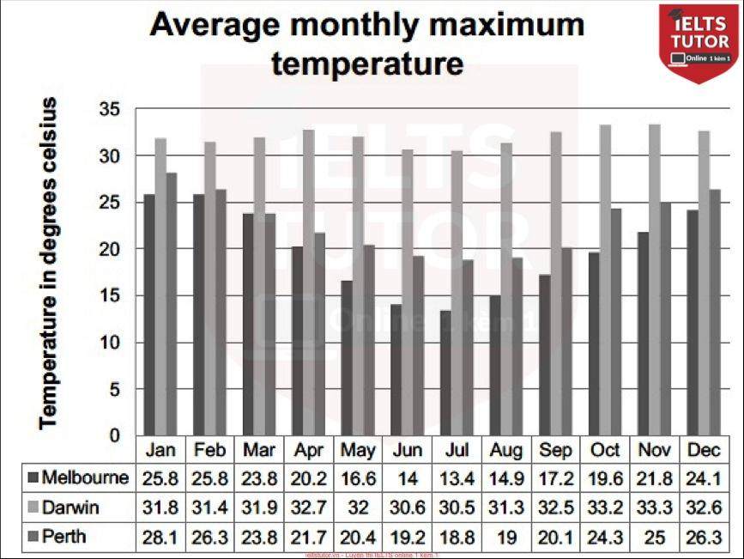

Overall:

* Temperature decreased towards the middle, increased until the end of the year
* Darwin – highest temperature.

Body 1: from Jan – Jul

* Temperature of Darwin slightly fluctuated from Jan to Apr + decrease to Jul
* Melbourne - lowest temperature in January (25.8 degrees) before a significant decrease
* Perth’s temperature ranked second + fall until its minimum temperature (Jul)

Body 2: Aug – Dec

* Darwin’s temperature gradually rose from before a slight decline to 32.6 degrees in Dec
* Melbourne and Perth - dramatic rises in temperature

Hướng dẫn làm bar chart:<https://www.ieltstutor.me/blog/bar-chart>

Given is the bar graph comparing the average maximum temperature every month in three cities namely Melbourne, Darwin and Perth.

Overall, the common trend in average temperature in three cities was the temperature decreased gradually towards the middle of the year and gradually increased until the end of the year. Moreover, Darwin had the highest temperature compared to the other two cities.

From January to July, the temperature of Darwin slightly fluctuated from 31.8 degrees celsius in January to 32.7 degrees in April and then witnessed a marginal decrease to reach 30.5 degrees in July. On the other hand, Melbourne had the lowest temperature in January, at 25.8 degrees before experiencing a significant decrease to 13.4 degrees celsius. Similarly, Perth’s temperature ranked second in January with 28.1 degrees and started to fall until its minimum temperature of 18.8 degrees in July.

In the last five months, Darwin’s temperature gradually rose from 31.3 degrees in August to 33.3 degrees in November before it had a slight decline to 32.6 degrees in December. However, Melbourne and Perth witnessed dramatic rises in temperature when it increased from 14.9 degrees and 19 degrees in August to 24.1 and 26.3 at the end of the year respectively.

Words: 202