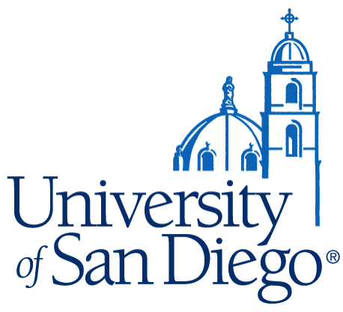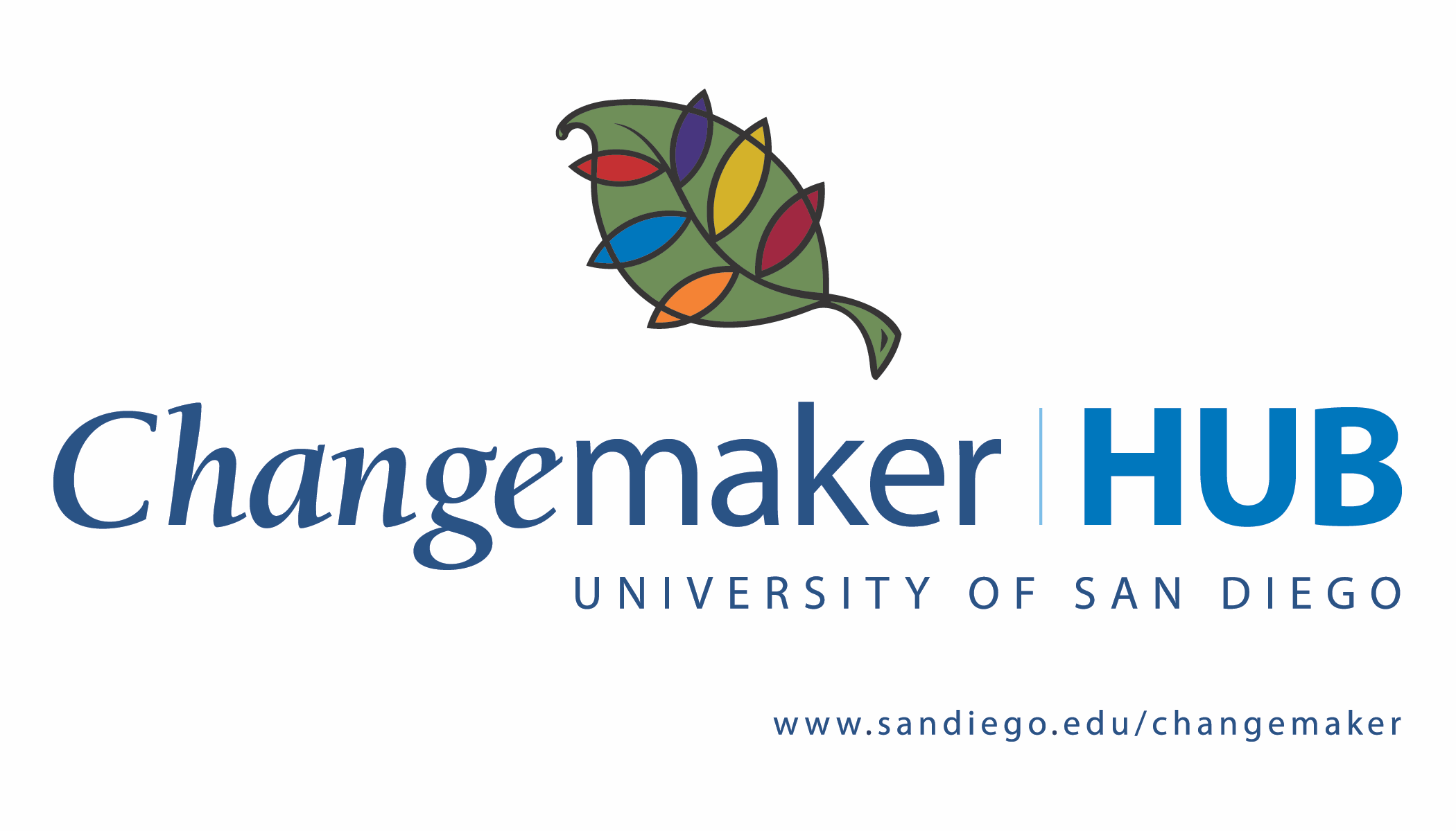

The Mulvaney Center for Community, Awareness and Social Action

Impact Linda Vista Initiative (ILVI) – Call for Proposals

Current context
Given the circumstances produced by the COVID-19 pandemic, since March of 2020 we have been focusing primarily on remote collaborations. We encourage both faculty members and community partners to continue thinking about leveraging virtual spaces and tools to foster engagement in ways that time and travel constraints may have hindered in the past. Similarly, we welcome the opportunity to brainstorm and discuss possibilities with you in light of safety guidelines established by USD and our community partners.

Semester and rolling cycles
The semester cycle aligns with the academic calendar of the university. A call for proposals is distributed one semester in advance in order to provide sufficient time for project ideation, co-creation sessions, and planning for implementation. We also have an open rolling cycle that enables applicants to apply for ILVI support at any time for collaborations that are currently in progress or outside the semester cycle.

Support for initiatives
Each faculty member who participates in ILVI will receive a stipend, and each community partner will receive a matching stipend. The participants may choose to use the funding to cover initiative expenses rather than as stipends. ILVI’s co-directors strive to provide guidance and support for all the initiatives, and both the Mulvaney Center and the Changemaker Hub provide additional support for the initiatives.

Criteria for evaluating proposals
- Projected positive impact in the community and in student learning
- Potential for sustainability into the future
- Potential for creating an equitable and mutually-beneficial partnership in the community
- Successful co-creation session(s) with faculty member(s) and community partner(s)

Participant expectations and outcomes
- A few meetings will be necessary with faculty members and community partners for the co-creation process and, thereafter, for the development and implementation of the initiative.
- The expected outcomes for both student learning and positive impact in the community should be clearly identified in the co-creation sessions and made explicit. For example, the collaboration should be integrated into the course syllabus and materials.
- We convene one required collective gathering with all the ILVI participants near the end of each semester. The date is announced well in advance.

Eligibility criteria
- All USD faculty members are eligible to apply. In addition, USD staff members whose work with students aligns with all the aforementioned principles are eligible.
- All community partners (former, current, or potentially new) are eligible to apply. Community partners do not need to have an existing relationship with USD in order to apply.

Next steps
To apply please send us a message at the e-mails indicated below. We’re happy to discuss any questions you may have.

Kevin Guerrieri Blake Hofstad
kevin2@sandiego.edu hofstad.b@gmail.com
ILVI Faculty Co-director ILVI Community Co-director

