A Story of Legacy, Leadership, and Community (1970s–2026)
Gloria Washington
The story of Arizona Black Law Enforcement Employees (ABLE) begins long before the organization carried its current name. Its roots stretch back to the 1970s, when African American law enforcement personnel in Arizona found themselves navigating a profession where opportunities were limited, representation was scarce, and support was often nonexistent. Out of necessity, unity, and determination, the first seeds of ABLE were planted.

The Early Years: Just Us (1970s–Mid-1980s)
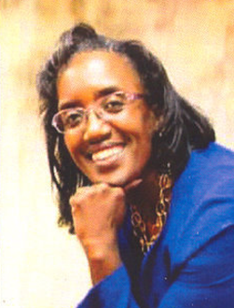
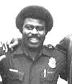
In the early 1970s, a group of African American officers came together to form an organization called Just Us. They were men and women who understood that success in law enforcement required more than hard work - it required mentorship, training, and a network of people who believed in one another. Phoenix Police Officers like A.J. Miller (Pheonix PD, Retired), Harold Hurtt, Bill Crawford, Jerry Oliver, Earl Nelson, Chip Thomas, Brenda Hill, Mike Johnson, Jim House, and Gloria Washington from Probation were among the early members who shaped the organization.
Andrew ‘AJ’ Miller

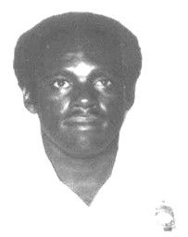
Just Us became a lifeline with AJ Miller serving as the President of the organization from 1977 to 1985. Members met to study for promotional exams, share training materials, and support each other through the challenges of policing during a time when African American officers were rarely promoted and often excluded from specialty assignments. Their meetings were first held at the Jesse Owens Medical Center and later at the Veterans of Foreign Wars building on Jackson Street. Just Us was more than a professional group — it was a community presence. They provided scholarships to elementary school students, participated in Juneteenth celebrations, and served as a bridge between the African American community and the Phoenix Police Department. When tensions arose, Chief Ruben Ortega often called on A.J. Miller to help mediate and maintain trust.
Bill Crawford

Due to the efforts of Just US and the tenacity of their members, promotions for black officers and their movement into specialty assignments increased. Just Us continued until the mid-1980s, when membership began to decline. But the spirit of unity they created never disappeared — it simply evolved.

The Rise of BPOF (Late 1980s–1990s)

By the late 1980s, a new generation of African American officers recognized the need for a similar support system. At that time, there were very few Black supervisors on the Phoenix Police Department. Officers preparing for the sergeant’s exam began studying together, and from that effort, the Black Police Officer Fellowship (BPOF) was born.

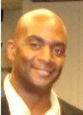
Sergeant George Henderson of the Phoenix Police Department became BPOF’s first president, serving during the organization’s formative years in the late 1980s and early 1990s. He played a pivotal role in shaping BPOF’s early direction, emphasizing the importance of creating a space where African American officers could bond, network, and support one another through the challenges of policing. Under his leadership, BPOF grew not only in membership but also in influence.

Sgt. Henderson also strengthened BPOF’s connection to the community. He was instrumental in securing grant support from the City of Phoenix, which allowed the organization to launch the SELF program — a rites‑of‑passage initiative for young men. Through SELF, BPOF members taught, mentored, and guided youth toward becoming responsible, confident citizens. The program became one of the organization’s earliest and most meaningful community outreach efforts.
George Henderson

He often said that the greatest benefit of BPOF — and later ABLE — was not something written in a mission statement or listed among the organization’s goals. It was the unspoken support members gave one another. When an officer faced difficulties on the job, he could turn to another BPOF or ABLE member for guidance or encouragement. This trust was possible because of the bonds formed during meetings, training sessions, and shared experiences. Members became friends, and friends became brothers — creating a circle of trust where concerns could be shared without fear of judgment or gossip.

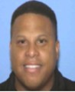
Following Sgt. Henderson’s influential tenure, Phoenix PD Sergeant Troy Holland stepped into leadership, becoming the next president of BPOF from 1992 to 1997. At the time, he had only been an officer for three years. He often recalled that he accepted the position with a mix of apprehension and humility. Both Sgt. Henderson and then‑Officer Lonnetta Sanders encouraged him to take on the role, believing in his potential even before he fully believed in himself. Their confidence in him became the push he needed to step forward.

When Sgt. Holland began his presidency, there were fewer than seventy‑five African American officers on the Phoenix Police Department and very few supervisors. The landscape was challenging, but he embraced the responsibility. Looking back, he expressed pride in seeing how many of the officers who were part of BPOF during his leadership went on to have long, successful careers. Many retired honorably; others continued to rise through the ranks. Their achievements, he said, were a testament to the unity and support that defined BPOF.
Troy Holland
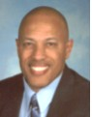
Leadership later transitioned to Retired DPS Sgt. Harold Sanders, who served as ABLE president from 1998 to 2000. Sgt. Sanders first became involved with BPOF/ABLE when he was invited to attend a meeting while working for the Arizona Highway Patrol out of Tucson. His commitment was evident from the beginning — every month, he traveled from Tucson to Phoenix to attend meetings, demonstrating unwavering dedication to the organization and its mission.
Harold Sanders
Sgt. Sanders brought with him a strong history of involvement in professional organizations. In the early to mid‑1980s, he was active in the National Black Police Officers Association Southern Arizona Chapter and the Southern Arizona Blacks in Criminal Justice, both based in Tucson. Drawing from these experiences, he was instrumental in connecting BPOF with the National Black Police Association (NBPA), expanding the organization’s reach and linking Arizona officers with colleagues across the United States, Canada, and Europe.

He valued the networking, the exchange of information, and the friendships that developed within BPOF/ABLE. Sgt. Sanders is widely credited with helping sustain the organization during the late 1990s, guiding it through a period of transition and ensuring its continued strength.

The Birth of ABLE (Late 1990s–2000)

As BPOF grew, so did its membership. Officers, detention staff, corrections personnel, and civilian employees all found value in the organization. To reflect this broader representation, BPOF officially became Arizona Black Law Enforcement Employees (ABLE). By the end of the 1990s, ABLE stood at a crossroads.

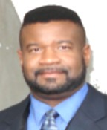
In 2000, the ABLE Board of Directors held a vote that would change the course of the organization’s history. The Board decided that ABLE should be dissolved and that its entire membership should join the Arizona NOBLE — the Doeg Nelson Chapter of the National Organization of Black Law Enforcement Executives. Many believed that consolidating the two groups would strengthen representation and streamline efforts.

At that time, Detective Terry Yahweh of the Phoenix Police Department was serving as ABLE’s Vice President. He strongly disagreed with the decision to dissolve the organization. Terry believed that ABLE and NOBLE could coexist, just as they had for years. He saw value in ABLE’s unique identity, its grassroots foundation, and its deep ties to the community and to African American officers across Arizona.
Terry Yahweh

But when the vote was cast, the decision was nearly unanimous — nine to one in favor of dissolving ABLE. Terry was the lone dissenting vote.

Standing alone in that moment, Terry made a bold declaration. He told the Board that if they would give him their blessing, he would keep ABLE alive. He believed too deeply in the organization’s purpose to let it disappear.

The Board agreed to honor his request. The remaining funds in ABLE’s bank account were distributed to nonprofit organizations, as was customary when dissolving a charitable group. And because Terry committed to keeping ABLE alive, he was handed $50 — the last of ABLE’s resources — to rebuild the organization from the ground up.

It was a symbolic amount, but Terry accepted it with determination. With that $50, a vision, and an unwavering belief in ABLE’s mission, he began the work of restoring the organization — a journey that would define the next era of ABLE’s history.

The Rebirth Under ABLE President Terry Yahweh (2000–2010)

When Detective Terry Yahweh stepped forward in 2000 to keep ABLE alive with nothing more than the Board’s blessing and $50, he knew the road ahead would not be easy. But he also knew the organization was worth saving. ABLE had a legacy, a purpose, and a community that needed it — even if that community had temporarily drifted away.
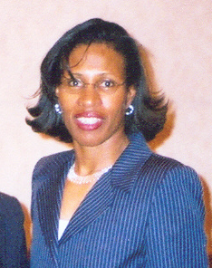

In early 2001, Terry met Sgt. Sunny Wilkins of the Chandler Police Department, who had recently joined ABLE. The two quickly became partners in rebuilding the organization. For several months, they were the only two people attending meetings — sitting together, planning, strategizing, and refusing to let ABLE fade into history. That year, ABLE had just eight members, but Terry and Sunny treated those eight as the foundation of something bigger.
Sunny Wilkins

Their persistence began to pay off. In 2002, Terry revived and consistently published ABLE’s newsletter, “Beyond the Blue.” The newsletter became a lifeline — a way to reconnect with former members, reach new ones, and remind the law enforcement community that ABLE was still here. Through this steady communication, membership more than doubled, growing to 19 members.

Momentum continued to build. In 2003, with the support of Chief Harold Hurtt, formerly of the Phoenix Police Department, ABLE reestablished its regular meeting schedule. Chief Hurtt spoke at the first membership meeting in May 2003, and his presence gave the organization a powerful boost. Membership surged to 42 members, drawing officers and civilian personnel from agencies across the Valley and even from Tucson.

By 2004, ABLE reached a peak of 50 members, marking a remarkable turnaround from the days when only two people sat in a room trying to keep the organization alive.

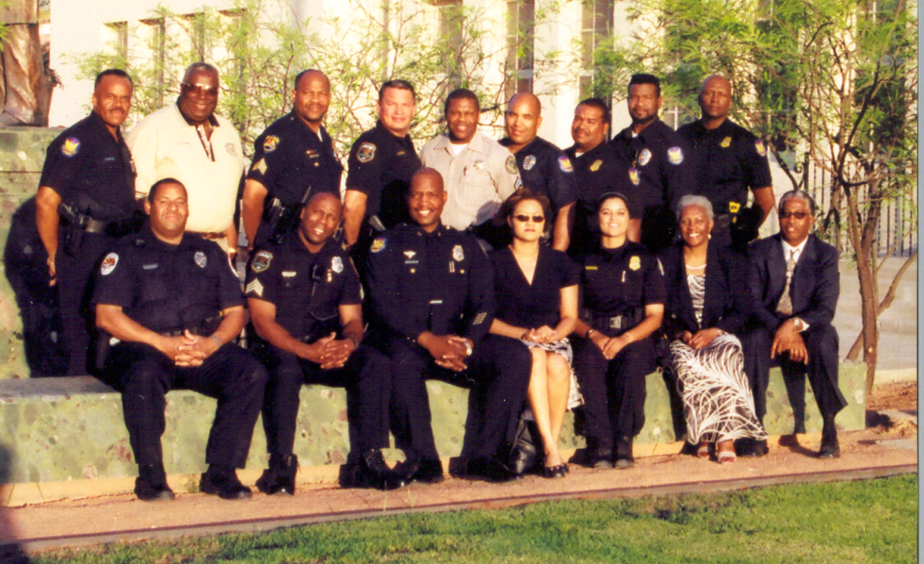
That same year, ABLE achieved one of its most significant accomplishments: hosting the National Black Police Association’s 32nd Annual Conference at the Hyatt Regency in Phoenix. Law enforcement professionals and community leaders from across the United States, Canada, and the United Kingdom attended. The conference was a tremendous success and placed ABLE firmly back on the national map.
Throughout this period, ABLE continued to strengthen its professional development efforts. The organization held law enforcement training sessions every two months, providing opportunities for officers to learn, network, and build relationships across agencies. The “Beyond the Blue” newsletter remained a consistent source of information, sharing updates on training, law enforcement issues, and topics relevant to the African American community.

Detective Yahweh’s decade of leadership transformed ABLE from an organization on the brink of dissolution into a thriving, respected, and influential force in Arizona’s law enforcement community. His determination, vision, and belief in ABLE’s mission laid the foundation for the modern organization that exists today.

By the mid‑2000s, Detective Terry Yahweh’s persistence had transformed ABLE from an organization on the brink of dissolution into a growing, energized network of law enforcement professionals. Membership was rising, meetings were consistent, and ABLE’s presence in the community was stronger than it had been in years. With the foundation rebuilt, Terry set his sights on something bigger — something that would elevate ABLE’s impact statewide.

The First Criminal Justice Conference (2007)

In 2007, ABLE prepared to take a historic step. After years of rebuilding, reconnecting, and reestablishing its credibility, the organization was ready to host its first Criminal Justice Conference. This event represented more than a professional gathering — it was a declaration that ABLE was back, thriving, and ready to lead.

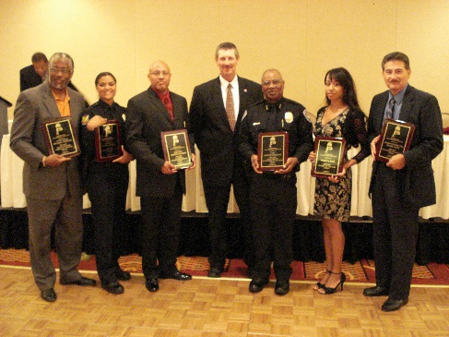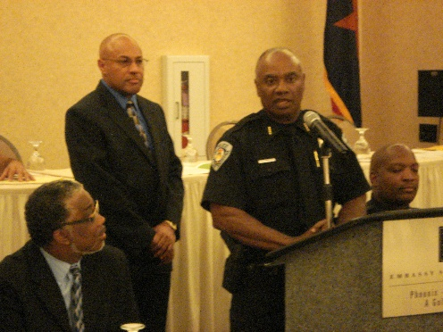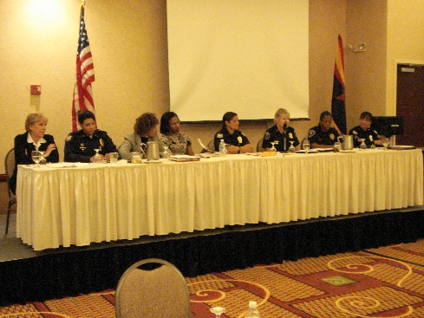

The 2006 conference also included ABLE’s second Law Enforcement Awards Ceremony, created to honor the accomplishments, leadership, and service of law enforcement professionals across Arizona. For many attendees, it was the first time they had seen African American officers recognized on such a visible and celebratory platform. The ceremony highlighted excellence, dedication, and community impact — values at the heart of ABLE’s mission.

The conference marked a turning point. It brought together officers, students, community members, and agency leaders from across the state. It showcased ABLE’s commitment to professional development, community engagement, and the advancement of African American law enforcement personnel. And it solidified Terry Yahweh’s legacy as the leader who not only saved ABLE but positioned it for a new era of growth. From that moment forward, the Criminal Justice Conference became one of ABLE’s signature events.

Expanding Opportunities: The First ABLE Scholarship (2009)

As ABLE grew, Terry remained committed to supporting youth and expanding pathways into the criminal justice field. In 2009, he established the first ABLE Scholarship, awarding $1,000 to one deserving student pursuing a career in criminal justice or public safety. This scholarship represented ABLE’s belief in investing directly in the next generation - the same young people Terry had welcomed into the conference just a few years earlier.
The scholarship program quickly gained traction. By 2011, ABLE expanded its support and awarded two scholarships, further strengthening its role in educational advancement and community empowerment. These early scholarships laid the foundation for what would eventually become one of ABLE’s most impactful and enduring programs.

A Decade of Leadership and a Legacy of Renewal

Throughout his presidency, Terry remained focused on rebuilding ABLE’s membership, strengthening partnerships, and expanding training and professional development opportunities. His leadership transformed ABLE from an organization that nearly dissolved into one that was thriving, visible, and influential across Arizona.

By the time his presidency concluded in 2012, ABLE had:
- Reestablished consistent meetings and training sessions
- Built strong relationships with agencies across the Valley
- Hosted a successful national conference
- Created youth engagement pathways
- Launched its first scholarship program
- Restored its statewide presence and credibility

Terry’s twelve years of leadership became known as the rebirth era — a period defined by resilience, growth, and renewed purpose.

Expanding Educational Access and Partnerships (2012–2014)
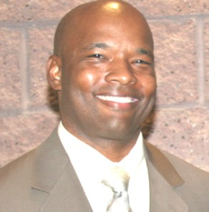
When Sgt Geoffrey Heard (Avondale PD, now retired) assumed the presidency in 2012, he inherited an organization that had been rebuilt and revitalized under Detective Terry Yahweh’s leadership. Geoffrey, his Vice President Reginald Johnson and the ABLE Board’s vision was to expand ABLE’s reach, deepen its community impact, and strengthen its educational partnerships. He believed that the Criminal Justice Conference could become not only a professional development event but also a gateway for students to explore careers in law enforcement and public safety.

During his first term, Geoffrey and the board worked tirelessly to broaden ABLE’s influence in schools and colleges across Arizona. He extended invitations to students from Arizona State University, Franklin Police and Fire High School, South Mountain High School’s Law Enforcement Magnet Program, and the East Valley Institute of Technology (EVIT). Through grant funding from the Maricopa County Attorney’s Office (MCAO) and the Police Officers of Scottsdale Association (POSA), Geoffrey was able to offer conference training free of charge to students — removing financial barriers and opening doors for young people interested in criminal justice careers.

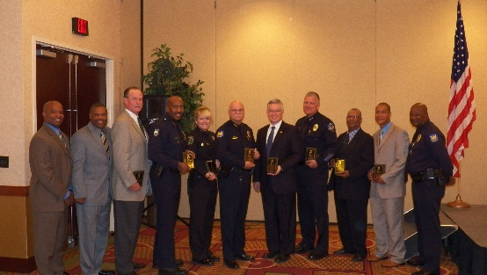
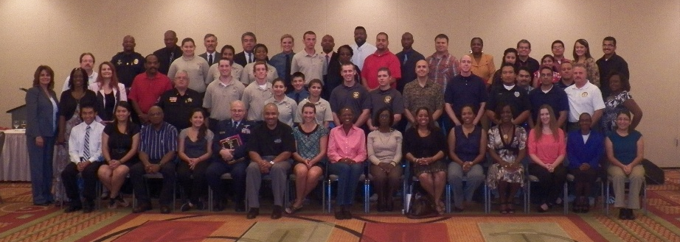

Geoffrey’s commitment to accessibility and education helped ABLE strengthen its reputation as a leader in mentorship and professional development. His efforts ensured that the organization’s annual conference became a place where students could learn directly from law enforcement professionals, network with mentors, and envision their future in public service.

Leadership Transitions and Continued Growth (2014–2017)

In 2014, Detective Terry Yahweh returned as president, continuing his mission of community engagement and organizational stability. He served until 2017, when Geoffrey Heard was once again elected president — marking the beginning of his second term and another period of innovation and expansion.

Modernization and Community Collaboration (2017–2020)
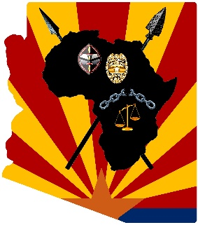
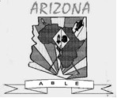
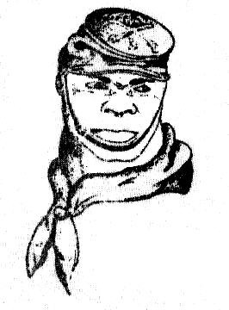

In 2017, Geoffrey led a major modernization effort, updating ABLE’s visual identity to reflect its growth and renewed energy. He redesigned the ABLE logo, making it more detailed, colorful, and vibrant, incorporating imagery that honored both African heritage and Arizona’s law enforcement legacy — from the Buffalo Soldier to the state’s iconic colors and symbols. The new logo became a proud emblem of ABLE’s evolution and unity.

Geoffrey also expanded grant opportunities, allowing even more students to attend the Criminal Justice Conference free of charge. He collaborated with the Maricopa Community Colleges, moving the conference from the Embassy Suites Hotel in Phoenix to Mesa Community College, which increased ABLE’s visibility on college campuses and strengthened its educational partnerships. Under Geoffrey’s leadership, ABLE expanded its scholarship program to award four $1,000 scholarships, significantly increasing its support for students pursuing careers in criminal justice and public service.

During this period, Geoffrey established a meaningful collaboration with AZLEOS (Arizona Law Enforcement Outreach and Support), which hosted the annual Shop with a Cop program. The initiative brought children in need together with police officers to shop at local Walmart’s through sponsorships and donations. ABLE became a proud sponsor — contributing funds and volunteering time. Officers from ABLE participated in the event, shopping alongside the children and building positive relationships between law enforcement and the community. The program became a shining example of ABLE’s commitment to service and compassion.

Resilience Through the COVID‑19 Pandemic (2020–2021)
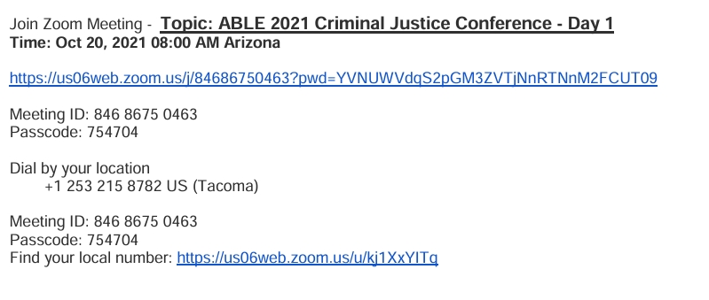
In 2020, the COVID‑19 pandemic brought all in‑person activities nationwide to a halt. ABLE could no longer host its annual conference in person, but Geoffrey refused to let the tradition end. He and his team were instrumental in transitioning the Criminal Justice Conference to a virtual platform, ensuring that training, networking, and recognition could continue despite the challenges. Although membership and attendance declined during the pandemic, ABLE persisted — adapting to new technology and maintaining its mission of connection and education. Geoffrey’s leadership during this period exemplified resilience, innovation, and unwavering dedication.

A Historic New Chapter (2022 – Present)
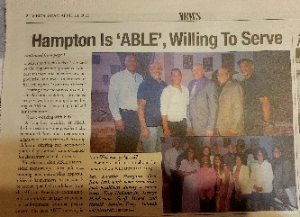
When Sergeant Latasha Hampton of the Tempe Police Department was elected president in 2022, she made history as the first female to lead the Arizona Black Law Enforcement Employees (ABLE). Her presidency marked a new chapter of innovation, outreach, and revitalization following the challenges of the COVID‑19 pandemic.

Leading ABLE Out of the Pandemic
Sgt. Hampton took office at a critical time. The pandemic had disrupted in‑person events, reduced membership engagement, and shifted community priorities. Under her leadership, ABLE emerged stronger and more connected. She relaunched the organization’s signature event — the 16th Annual Criminal Justice Conference — restoring it as a cornerstone of professional development and community collaboration. Attendance surged, with more officers, students, and community members participating than in previous years. Her focus on rebuilding relationships and expanding outreach led to a steady increase in membership enrollment and officer participation, reaffirming ABLE’s role as a statewide leader in law enforcement advocacy and education.

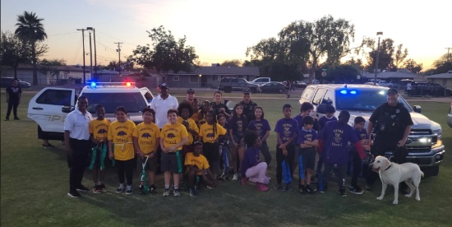
Expanding Community Engagement and Youth Programs
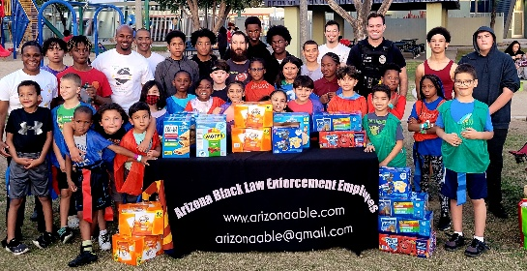
Sgt. Hampton believed that ABLE’s mission extended beyond professional development — it was about building trust and opportunity within the community. She expanded ABLE’s involvement in youth programs and community partnerships, ensuring that officers were visible not only as enforcers of the law but as mentors, educators, and role models. One of her most impactful initiatives was a partnership with Revived Fitness, which launched a free youth flag football league in the Tempe community. ABLE provided snacks, equipment, and volunteer officers who served as coaches and mentors, teaching teamwork, discipline, and leadership. The program became a model for positive engagement, helping children see law enforcement in a new light — as allies and supporters.

Strengthening Community Relationships
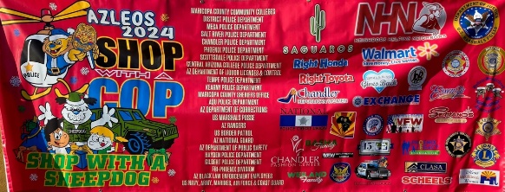
Under Sgt. Hampton’s leadership, ABLE deepened its collaboration with AZLEOS (Arizona Law Enforcement Outreach and Support) through the annual Shop with a Cop program. She increased the number of participating children and officers, creating more opportunities for meaningful interactions between law enforcement and families in need. Officers volunteered their time to shop with youth, fostering trust and building bridges between police and the community.


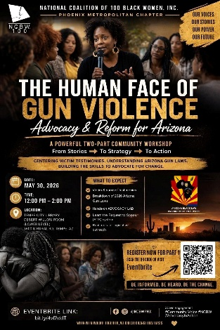
ABLE also expanded its presence at community events and educational forums, including the Queen Creek Black Heritage Festival, where members hosted a booth to educate attendees about fraud prevention, public safety, and community programs. These efforts complemented ABLE’s participation in initiatives such as the Elder Fraud Workshop and the Human Face of Gun Violence Forum, where members collaborated with organizations like the National Coalition of 100 Black Women, Phoenix Metropolitan Chapter, and Delta Sigma Theta Sorority, Inc. to promote legislative advocacy and awareness.

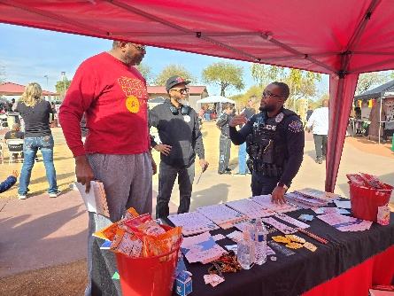
Empowering Through Education and Advocacy
ABLE’s outreach under Sgt. Hampton extended beyond community events. The organization partnered with schools, nonprofits, and civic groups to deliver dynamic law enforcement training and safety education, emphasizing prevention, awareness, and empowerment. Officers participated in speaking engagements across the Valley, connecting with youth and adults alike to discuss topics such as fraud, gun violence, understanding the law and civic engagement.

Through these partnerships, ABLE strengthened its reputation as a trusted resource for both law enforcement professionals and the communities they serve. The organization’s website, www.arizonaable.org, became a hub for information on upcoming events, scholarship opportunities, and community initiatives — reflecting Sgt. Hampton’s commitment to transparency and accessibility.

A Legacy of Leadership and Service
Sgt. Hampton’s presidency represents a period of renewal and progress. She not only led ABLE out of the pandemic but also expanded its reach, modernized its programs, and deepened its impact across Arizona. Her leadership embodies ABLE’s founding principles — advocacy, mentorship, education, and community empowerment — ensuring that the organization continues to thrive and inspire future generations of law enforcement professionals.

