Uniform Rate Negotiation Workbook

  - Instruction Guide
  - Office of Area Agencies on Aging
  - FFY 2020

Table of Contents
Table of Contents 1
1. Workbook Overview 2
Provider Total Budget by Service Worksheet 3
2. Completing the Worksheets 5
Provider Information Worksheet 5
Provider Total Budget by Service Worksheet 6
3. Home Delivered and Congregate Meal Budget Worksheets 11
In-Kind Match Certification Worksheet 16
Unit Rate Calculation 19
Certification 20
Analysis Tool 21
4. Technical Information 23
5. NSIP Funding 27

Workbook Overview

Purpose
Texas Health and Human Services (HHS) requires the use of this Rate Setting Workbook to establish and determine a cost per unit (CPU) meal rate and for submission of nutrition waiver requests. This Rate Setting Workbook is used for Home Delivered Meals (HDM) and/or Congregate Meals contractor and/or subrecipient nutrition service providers to develop budgets to record and allocate allowable costs for the meal programs.

Description of Worksheets included in the Workbook
The Rate Setting workbook contains the following color coded worksheets:
- Provider Information - Yellow
- Provider Information
- Provider Total Budget by Service
- Analysis Tool
- Home Delivered Meals - Purple
  - Home Delivered Meals Budget
  - HDM Unit Rate Calculation
  - HDM Certification
  - HDM In-Kind Certification
- Congregate Meals - Green
- Congregate Meals Budget
- Congregate Unit Rate Calculation
- Congregate Certification
- Congregate In-Kind Certification
Transportation (Blue) and Participant Assessment (Orange) worksheets are included in the Rate Setting workbook with the same functions as the HDM and Congregate Budget worksheets. The Transportation and Participant Assessment worksheets used for rate setting are optional.

Functions and Worksheet Calculations:
Costs are entered into the Provider Total Budget by Service worksheet under the “Cost Area”.
When costs are entered under the “Home Delivered Meal Program”, “Congregate Meal Program”, “Transportation” and Participant Assessment” columns, the corresponding worksheets in the “Proposed Budget” columns are automatically populated.
Entries into the Nutrition Clients AAA and Nutrition Clients Contracted Community Service (CCS) columns automatically populate the Nutrition Education line items in the HDM and Congregate Budget worksheets.
Provider Total Budget by Service Worksheet:
Example: Costs/dollar amounts entered for the line item “Salaries” will automatically sum and the “Total Salaries” amounts populated from those calculations.
Example: Mathematical equations are automatic and transferred to the HDM or Congregate Budget worksheets as costs are entered.
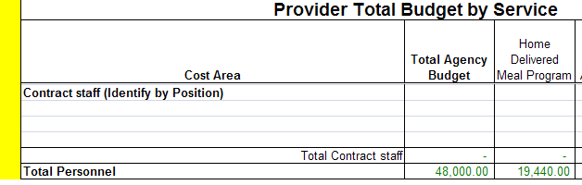
Example: Total Personnel costs are $19,440 on the “Provider Total Budget by Service” worksheet under the “Home Delivered Meal Program” column. This cost automatically populates into the “Home Delivered Meal Budget” worksheet under the “Proposed Budget” column.
Congregate Meal, Transportation and Participant Assessment Budget worksheets function the same as the example provided above.
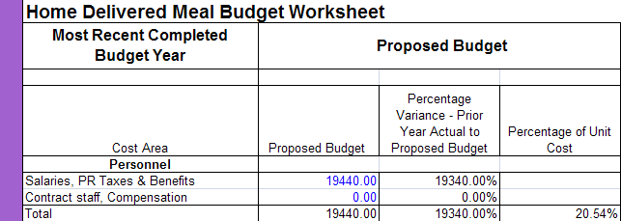
For information on Pop-up windows and protected cells see the Technical Information Section.

Completing the Worksheets

Provider Information Worksheet
Complete all information. The information will automatically populate to the other worksheets in this workbook. Answer all questions.
Many of the questions use a display box for the responses, the display box indicates “Select from list”. When an input cell is selected, a message box may appear. The message box contains helpful instruction on completing the question.
Check the Security Setting if you cannot Display Boxes. For help on Security Setting review the information on Security Settings in the Technical Information Section of this manual.
If a message box covers an input cell, the user may click on the message box and drag the message to a different location on the worksheet. This will change the location of all message boxes on the worksheet. When the workbook is saved, closed, and re-opened the message boxes will be return to their original locations.
Many of the questions will provide a “red” warning message. The message will disappear when a response to the question is selected or entered. All red warning messages must be addressed prior to completing the workbook.
Example: Message Box and Red Warning Message
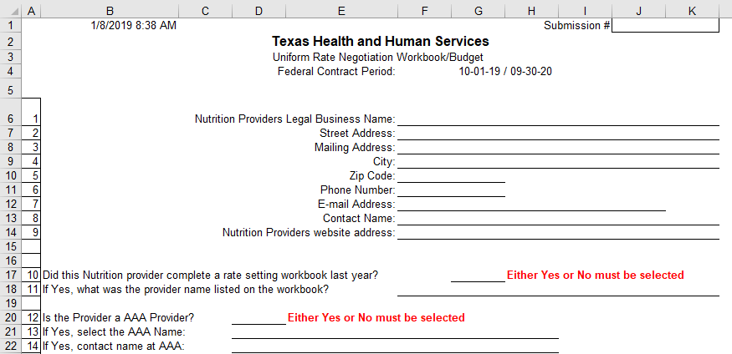
Cell B1 is an informational date and time cell. This cell will update each timethe workbook is opened and allowed to update. Cell J1 is optional and may be used by the provider to track the number of submissions provided to the AAA or Contracted Community Services contact.

Provider Total Budget by Service Worksheet

Cost Area
Provide all requested information in each Cost Area in the worksheet. Refer to the Cost Area and Cost Categories document for instructions on completing the line items.
Enter the total amount of the costs for each line item in the Cost Area in the “Total Agency Budget” column
Example: The line item “Salaries” include job titles with the salaries. Additional rows can be added, if needed. See the Technical Information Section for instructions on adding rows.
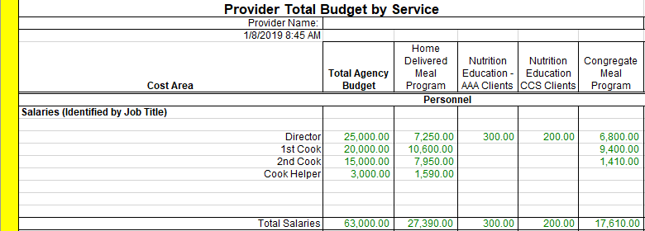
Example: Additional Line Items have been included to further delineate costs. Purchased Meals and the types of meals are included.
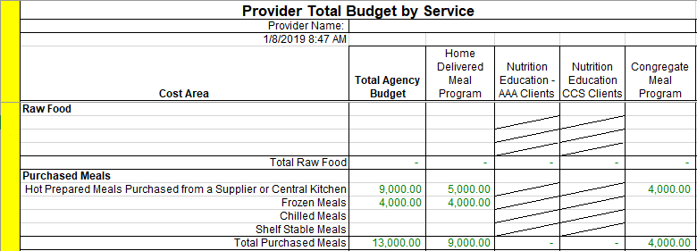

Columns for Allocation of Costs
Additional columns have been included in the worksheet. These added columns allow for other programs and costs not allowable for the Home Delivered and Congregate Meal Programs. The worksheet allows for adding additional columns if necessary. For information on how to insert a column see the Technical Information Section.
Column Titles for non-meal programs are unprotected and can be re-named to programs required by the provider. If the columns for the Participant Assessment or Transportation are changed the title of the worksheets will also change. This does not apply to the tab titles. The tabs must be manually re-named.
Use “Agency Budget not Applicable to Programs” column for cost that cannot be allocated to federally funded programs.
“If applicable, replace with title or other agency” columns are optional columns for other funding sources.
Example: Program columns for allocating costs
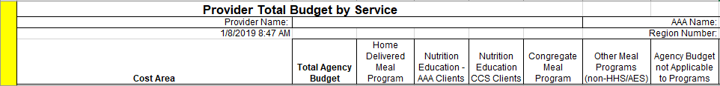

Balance Not Budgeted Column
The “Balance Not Budgeted” column, reconciles the cost allocated across the programs or funding sources to the “Total Agency Budget”.
If the amount in this column is not zero, the total budget was not allocated. This is the amount that has not been allocated to a program or the amount allocated was entered incorrectly.
This column must equal zero (0). If not, make corrections/explain.
Example: “Total Agency Budget” column, $25,000 is allocated in the total budget for the “Director”. The “Balance not Budgeted” column indicates $10,450 is not allocated to a program or another funding source. If the costs allocated do not equal the “Total Agency Budget,” the “Balance not Budgeted” column will not be “zero”.
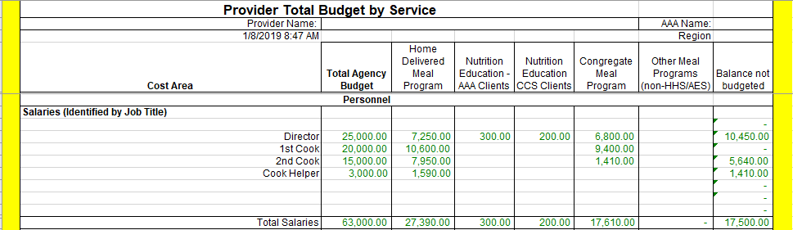

Percentage of Total Cost and Total Budgeted Meals
At the bottom of the worksheet the total cost of each program and the total cost of all programs are calculated. In addition, the percentage of the total cost of all programs applicable to each program is calculated.
At the bottom of the worksheet enter the number of meals by the type of meal for each program. The number of meals is automatically added and populated under the “Total Agency Budget” column and “Total Budgeted Meal” row. The percentage of total meals and the whole unit rate by program are calculated.
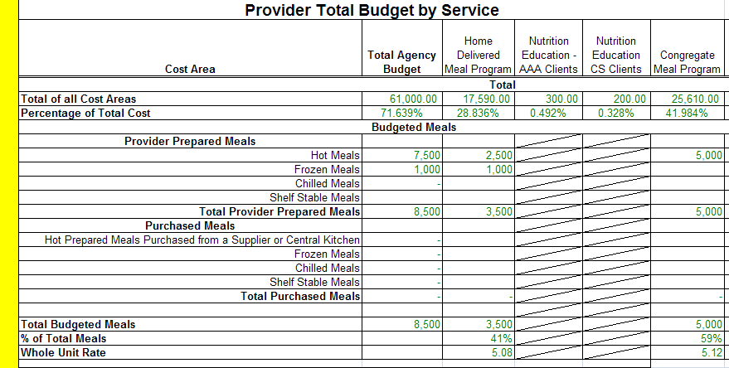

The “Total Budgeted Meals” row automatically populates this amount on the Home Delivered and/or Congregate Meal Budget worksheets.

Nutrition Education
Contracted Community Service (CCS) contracts: Nutrition Education costs are required to be included in the meal cost. Therefore, Contracted Community Services providers enter the budget amount for Nutrition Education in cells under the “Nutrition Education CCS Clients” column. The costs will automatically be included in the rate for the home delivered meal.
Example: Nutrition Education budget entries
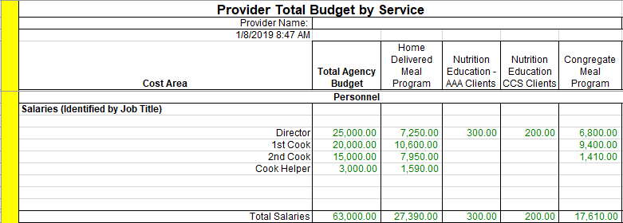

AAA contractors/vendors: Two options are available for AAA contractors/vendors to report Nutrition Education. Select one of the following options:
Option 1: Provide Nutrition Education as a separate service. This excludes the cost in the meal rate setting process.
Enter “N” in Nutrition Education cell – the boxed cell at the bottom of the worksheet. The worksheet is programmed to exclude the Nutrition Education costs from the meal rate calculation.
Example: Coding Nutrition Education
Option 2: Include Nutrition Education as part of the HDM and/or Congregate Meal Program that includes the cost in the meal rate setting process.
The Nutrition Education Cell remains blank. This allows the budgeted costs for “Nutrition Education” to be included in the meal rate calculation based upon the “% of Total Meals” entered in the appropriate program column. The resulting calculations are then linked to the Home Delivered and Congregate Meal Budget worksheets.
For AAA Providers: Estimated Number of Nutrition Education Units AAA Clients must be entered in each congregate and home delivered meal service tab to populate the Calculated Cost per Unit. Nutrition Education Budget – AAA Clients will automatically populate from the Provider Total Budget by Service tab.
The AAAs must report the calculated total of nutrition education by service on the Quarterly Performance Report (QPR). Instructions for reporting Nutrition Education costs can be found in the QPR User Manual: https://hhs.texas.gov/sites/hhs/files//documents/doing-business-with-hhs/providers/health/qprusermanual.pdf
Example: Nutrition Education Calculated Cost per Unit

Home Delivered and Congregate Meal Budget Worksheets
The HDM and Congregate Meals Budget worksheets identify the previous year’s actual end of year expenses as documented by the provider’s General Ledger. The worksheets identify costs in the previous year’s Approved Budget. These worksheets allow for the review of the actual expenses as compared to the approved budget cost. The variance between the budget and actual expenses is identified automatically both as a dollar amount and as a percentage.

The financial information entered on the Provider Total Budget by Service worksheet automatically populates into the “Proposed Budget” - Section of the HDM and Congregate Meals Budget worksheets.

The Participant Assessment and Transportation Budget worksheets function the same as the HDM and Congregate Meal Budget worksheets

Expense per General Ledger - Actual End of Year Expenses
Enter the most recent years – (2018) actual end of year general ledger expense for each Cost Area and line items listed. The “most recent completed budget year” is the period of time covered by the approved budget.
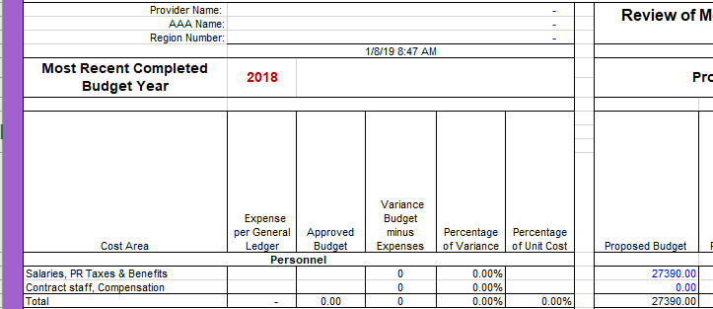

Approved Budget
Enter the 2018 approved budget amounts for each line item under the Cost Areas.

Variance Budget minus Expenses, Percentage of Variance and Percentage of Unit Cost Columns
The Columns – Variance Budget minus Expenses, Percentage of Variance and Percentage of Unit Cost calculate cells and provide information for conducting an analysis of the actual vs. planned budget results.
Example: Personnel was under expended by $2,500 [indicated with the (-)] with a variance of 3.03%. The Percentage of Unit Cost indicates the Total Personnel cost was 32.08% of the total expended.
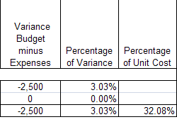

Proposed Budget
The Proposed Budget amounts are automatically populated from the Provider Budget by Service worksheet.
Example:

The Variance – Prior Year Actual to Proposed Budget - Column indicates the proposed Total Personnel costs are 8.31% higher than the actual expended the previous year.

Percentage of Unit Cost - Column indicates proposed Total Personnel costs are 39.60% of the total proposed HDM budget.

Review Alert – the cell will turn red when the % of cost is outside the expected high or low range for that cost area.

Explanation of Variances
Provide an explanation for each Cost Area that meets the criteria of #1 and/or #2. The Inflation Factor Information is provided in order to evaluate item #2.
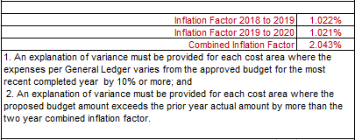
The explanation of variance for a cost area may be the same for all services provided; however, if the explanation is not accurate for the other services the explanation should be updated to reflect an accurate explanation.

Previous Years’ Actual and Contracted Number of Meals and Actual and Approved Rates
The information is located toward the bottom of the worksheet and is used to analyze Actual vs. Contracted for the Total Number of Meals and Actual vs. Contracted for the Cost per Meal.
Total Number of Meals – (Previous years) enter the actual number of meals in the “Expense per General Ledger” column, enter the contracted number of meals in the “Approved Budget” column.

Whole Cost per Meal – this number is calculated based on the number of meals and the total costs.

Approved Meal Rate – enter the actual approved meal rates under “Approved Budget” column and the rates are automatically populated under the “Expense per General Ledger” column.

Approved Meal Rate (Title XIX) – Rates for Title XIX Star+Plus home-delivered meals (HDM) are determined by the managed care organization (MCO); however the costs associated with the meals must be included in the rate setting process to show the full allocation of the HDM budget. Title XIX meals are recorded in columns H, L, M, or N.

Funding Source
The Funding Source is the last section of the HDM and Congregate Budget worksheets. Enter the number of proposed meals for each of the funding sources and include Program Income proposed meals, as applicable. The number of proposed meals is totaled under the line titled “Total Meals by Funding Source”.

When the meal numbers are included for XX, the calculated meal rate is automatically capped at $4.95.

The “Provider Total Budgeted Home Delivered Meals” line listed under funding source is automatically populated from the Provider Total Budget by Service worksheet.

The lines “Total Meals by Funding Source” and “Provider Total Budgeted Home Delivered Meals” must be the same number.

The line titled “Variance (Provider Total Budgeted Home Delivered Meals - Total Meals by Funding Source)” subtracts the number of Total Meals by Funding Source from the number of meals on the Provider Total Budgeted Home Delivered Meals line. The “Variance” line should be blank/zero. If the Variance line is not blank/zero make an adjustment until the difference is reconciled.

Enter the estimated number of Nutrition Education Units

Calculated Rate
The “Calculated Rate” - Section of the worksheet is automatically populated by the information entered on the Provider Total Budget by Service worksheet and the proposed number of meals by funding source.

These cells are protected and cannot be modified

The calculated meal rate will be capped at $4.95 when XX meal numbers are entered in the Funding Source section. When meal numbers are not entered for these Titles the calculated meal rate will not be capped.
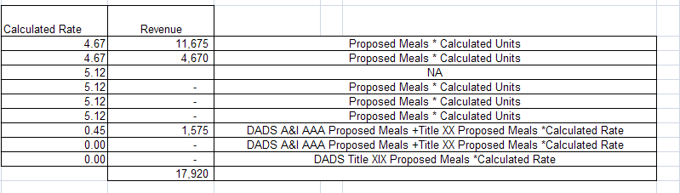

In-Kind Match Certification Worksheet
When a third-party organization furnishes the services of an employee, these services must be valued at the employee's regular rate of pay plus an amount of fringe benefits that is reasonable, necessary, allocable, and otherwise allowable. Donated property from third parties may include such items as equipment, office supplies, laboratory supplies, or workshop and classroom supplies. Value assessed to donated property included in the cost sharing or matching share must not exceed the fair market value of the property at the time of the donation.
The value of donated land and buildings must not exceed its fair market value at the time of donation to the non-Federal entity as established by an independent appraiser (e.g., certified real property appraiser or General Services Administration representative) and certified by a responsible official of the non-Federal entity as required by the Uniform Relocation Assistance and Real Property Acquisition Policies Act of 1970, as amended, (42 U.S.C. 4601-4655) (Uniform Act) except as provided in the implementing regulations at 49 CFR part 24.
The value of donated equipment must not exceed the fair market value of equipment of the same age and condition at the time of donation.
The value of donated space must not exceed the fair rental value of comparable space as established by an independent appraisal of comparable space and facilities in a privately-owned building in the same locality.
For third-party in-kind contributions, the fair market value of goods and services must be documented and to the extent feasible supported by the same methods used internally by the non-Federal entity.
Column D – Enter a description of the In-Kind or Match
Column F – Enter the date of receipt of the In-Kind or Match
Column G – Enter the amount of the calculated value
OAA Providers:
Retain monthly supporting documentation in the form of calculation worksheets, invoices, receipts, checks and any other tools or resources used as evidence of the reported In-Kind or Match.
HHS subrecipient monitoring procedures may include reviewing the documentation and systems of tracking and validating all evidence to support program income, In-Kind, and match for AAA providers.
Sub-recipient monitoring may include validation of documentation and systems of tracking to support program income, In-Kind, and match for AAA providers.

Unit Rate Calculation
The “Unit Rate Calculation” tab of the workbook is automatically populated from the data that was entered in other worksheets. This creates the Budget Worksheet Calculation of the per Meal Unit Rate.
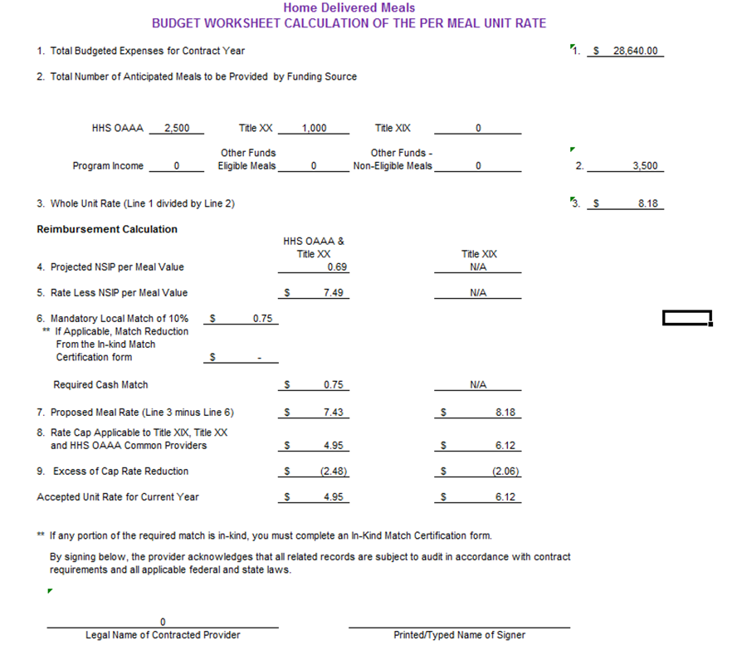

Certification
The “Certification” tab will provide the “Budget Worksheet Certification” form that is signed by the individual having signature authority for the provider agency.

Analysis Tool
Data in these two spreadsheets Section I and II are automatically populated from the Provider Total Budget by Service and HDM and Congregate Meal worksheets. Review the percentages and the distribution of costs. Use these tools to analyze the budget information and to determine if the allocation of costs is reasonable and equitable among the programs.
Example: Section I
Example: Section 2
Use this tool to analyze how the Cost Area and Cost Categories are allocated between the Home Delivered and Congregate Meal programs. Review the Percentage of Total Budgeted Meals. Review how the allocation of cost between the Home Delivered and Congregate Meal programs compare to the percentage of meals. Verify that costs are reasonable, necessary, allowable and allocated correctly and accurately to the cost areas and meal programs. Review the cost per unit for each cost area. Usually the cost per unit for raw food is the same for both meal programs; if not a “Review Alert” box will pop up to remind the reviewer to verify that the costs are correctly allocated.

Example: Review Alert Box
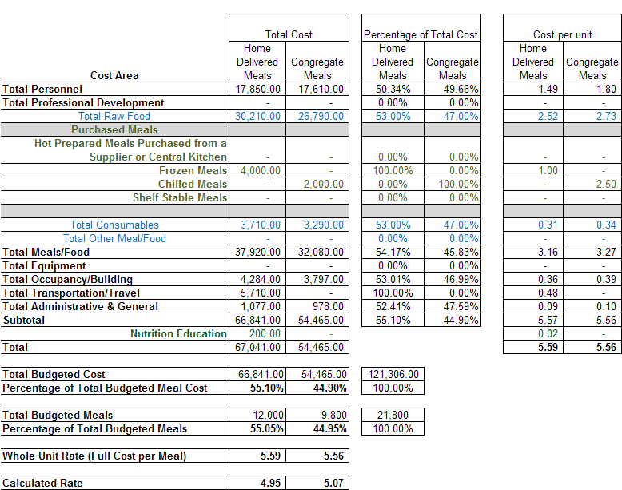

Technical Information
This workbook was created and tested in Microsoft Office 2003 and 2007. Earlier or later versions may experience technical problems.

Definitions
Cells – Spaces in the workbook where data can be entered.
Columns – Use the “Control-Q” key stroke to insert additional columns in the Provider Total Budget by Service worksheet.
A macro was added for this function to automatically copy the formulas into the new column. Additional columns may be added as necessary using this function. Columns may not be added to the other worksheets.
Printing the Worksheets – The worksheets print with a standard setup as follows:
All “Budget” worksheets are set to print landscape, legal, one page wide, multiple pages tall, with rows 1 to 7 or 8 as the header on every page. If providers insert columns and rows to the Provider Total Budget by Service worksheet the print setup may need to by adjusted prior to printing.
Expanding row heights for explanation of variances on the service budget worksheets may increase the number of pages and the page setup may need to be adjusted.
The remaining worksheets are set to print portrait, letter, one page wide, one page tall, with the exception of the “Analysis worksheet” which prints two pages tall.
Remember, settings vary with different printers and the user can change the printer settings.
Pop-up window – A pop-up window displays when attempting to enter or change the data in a protected cell.
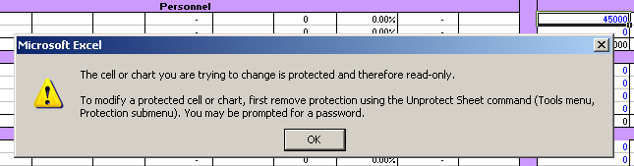
Protected Cells – Cells where data and information cannot be entered. Automatically populated cells are protected and costs cannot be entered into these cells.
Row – How to insert a row
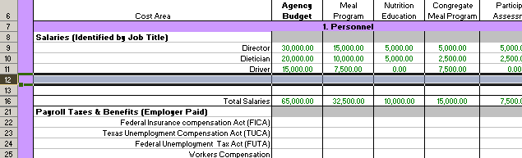
- Click on a row number. While the cursor is on high-lighted row number, right-click and then select “Insert”. A row will be inserted. Once the row has been inserted, additional rows can be added.
- Once the row has been inserted, enter the salary information and/or additional rows can be inserted, depending on the number of rows need for the specific job titles.
- When a row has been inserted, it is important to follow the row to the last column “Balance not budgeted” to ensure the formula that totals the row is copied. Repeat this process for every new row inserted to ensure the computations are correct.
- The worksheet will not allow the user to delete a row, including a row inserted by the user, to ensure computations are not changed.

To copy formulas to another cell:
- Click on the cell to be copied
- Right click and select “Copy”
- Click on the cell to insert the formula
- Right click and select “Paste Special”. Select “Formulas” in the pop-up box. The formula copies into the selected cell.
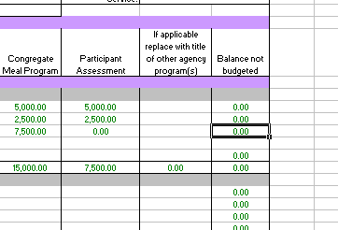
Security Settings in Microsoft Excel – Security Setting must be on medium low to enable the macros to work correctly. Go to Tools, Options, Security Tab and Macro Security, click on medium or low.
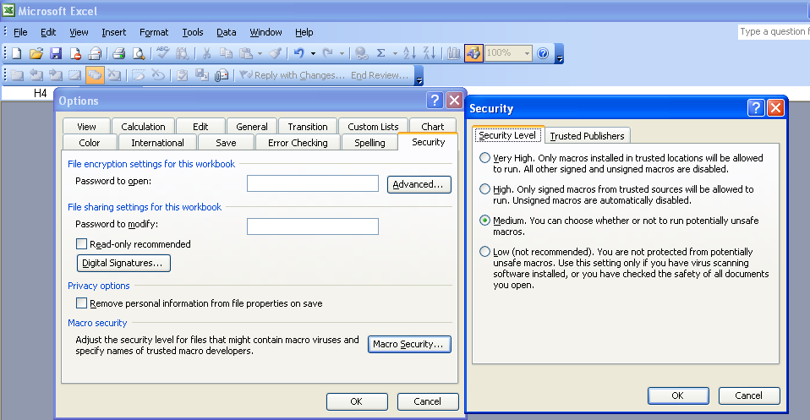
Security Warning – Select Enable Macros for the macros to work in the workbook.
TABS – Open a worksheet – Click on the tab at the bottom of the screen to open that worksheet.
Example: Worksheet tabs are labeled at the bottom of the worksheet.

NSIP Funding
The Nutrition Services Incentive Program (NSIP) provides grants to states to support Congregate and Home-Delivered Nutrition Programs by providing an incentive to serve more meals. The Department of Health and Human Service’s Administration on Aging (AoA) administers NSIP and provides State agencies funds to purchase food.
NSIP funds are to be used exclusively to purchase domestically produced food (OAA Section 311(d)(4)).
NSIP funds cannot be used to pay for program costs, administrative costs, meal production costs (such as labor, transportation, equipment, congregate site operations, home delivery costs or total catered cost of a meal), or other service costs such as nutrition education or nutrition counseling. Therefore, NSIP cannot be used as a fund identifier in SPURS.

