Link Đề bài: https://www.ieltstutor.me/blog/ielts-speaking-part-2-3-topic-media-culture

Hình Take note của Part 2:

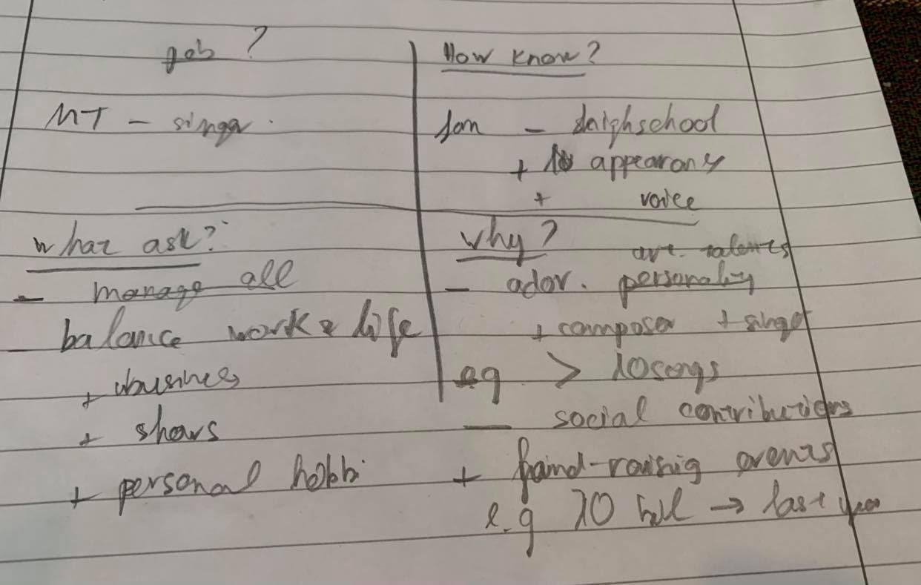

Phân tích các đề trong Part 2 về chủ đề Media and Culture
https://www.ieltstutor.me/blog/huong-dan-cach-tra-loi-ielts-speaking-part-2-3-topic-media-culture

Transcript Bài Nói Part 2 (Sắp xếp theo từng câu hỏi của đề)
Ví dụ:
Describe a person in the news that you want to meet

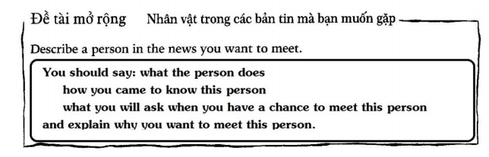
Lan 3:
What the person does
The person that I want to meet is My Tam, who is a leading singer in the Vietnamese entertainment market.
How you came to know this person
Regarding the first time that I came to know her, my friend invited me to her show 17 years ago when we were in high school. In the event, I was captivated by her lovely voice, eye-catching appearance and unique performance style.
What you will ask when you have a chance to meet this person
If I had a chance to meet My Tam, I would ask her how she can maintain a work-life balance. The thing is, she is not only a singer, a business owner but also an active donator in many charity events.
Explain why you want to meet this person
Generally speaking, I want to meet her in person for two reasons.
Firstly, she is my favorite idol for the ground that she has unique innate artistic talents which distinguish her from other singers. ⇒ https://www.ieltsdanang.vn/blog/cach-dung-danh-tu-ground-tieng-anh → chỗ này dùng sai grounds, thường là on the grounds that on grounds of

More specifically, she is not only a singer but also a composer of many vietnamese songs that are loved by a large number of fans.. For example, the number of the songs she composed has exceeded 10 in the last 20 years of her career.
Secondly, she has made adorable contributions to society through many charity activities.
In fact, My Tam has organized and participated in many fund-raising events, bringing both physical and mental values to misfortune people in rural regions.
For instance, in 2020, she donated more than 10 billion VND and invited other celebrities to join with her on these occasions.
⇒ Xem lại cách dùng the number of https://www.ieltstutor.me/blog/phan-biet-a-number-of-the-number-of
Chỗ part 2 nói ngập ngừng quá k thì điểm Fluency & Coherence sẽ cao hơn
Part 2 lần cuối tiến bộ hơn nhiều so với lần đầu, lần đầu ậm ừ fluency k ổn

Transcript Bài Nói Part 3 (Từng câu hỏi bắt buộc phải có Takescript)

1. Câu hỏi yêu cầu sự lựa chọn
Do you prefer reading an electronic book or a real book?
Lan 3:
Personally, I’m a fan of electronic books to paper ones for the reason that I feel more convenient and comfortable when I read virtually. Indeed, electronic devices nowadays, especially smartphones or e-book readers, offer a variety of advantages which are superior to traditional books. For example, e-book readers today are very handy and they can store thousands of books electronically, so users can bring them together on their trips easily.

2. Câu hỏi về sự phổ biến
What is the most popular reading material in your country?
Lan 3:
Well, electronic newspapers have become the most popular reading materials today in Vietnam. In fact, the popularity of the Internet and the advancement of modern devices, such smartphones or tablets, have brought far-reaching effects to human life nowadays. More specifically, people today, especially youngers, tend to read news on social networks or electronic newspapers platforms on their mobile phones. Độ dài đoạn 3 ngắn, chưa triển khai nhiều ví dụ

3. Câu hỏi về sự thay đổi
How has the way of reading changed?
Lan 3:
From my point of view, the way of reading has changed remarkably in the last few decades, mainly from physical to virtual.
In the past, printed materials such as books, magazines, newspapers, are the most popular reading materials simply because there was no better alternative. In fact, there was neither the Internet nor smartphones 70 years ago, so those who wanted to broaden their horizons at that time had the only choice, which is to read printed books or newspapers. For instance, my grandfather told me that he used to purchase daily newspapers to read the news of politics or economy when he was young.
However, printed materials have been gradually replaced by electronic ones in the modern world. More specifically, netizens today can easily access various online sources such as electronic newspapers, social networks, or other electronic platforms, to update their knowledge. For example, reading news on electronic platforms has become a hobby of many youngsters today as it is extremely fast and convenient thanks to the popularity of the wideband Internet connection and modern devices.
4. Câu hỏi về sự khác biệt
What are the differences between TV programmes and radio programmes?
Lan 3:
In my opinion, there are two major differences between TV and radio programs.
Firstly, the fundamental difference between these two types is the visual effects which are only available on TV. As a result, TV programs are usually developed with a higher level of sophistication and complexity compared to the ones on radios and they offer a variety of leisure options to audiences. For instance, spectators can watch various programs on TV such as football matches, music performances, or documentary films about animals..
Secondly, the news offered by radios and TV channels has a different level of latency. More specifically, while radio only broadcasts live programs, the ones on TV are mainly the recordings in the past. Therefore, radio programs seem to be suitable for those who are interested in only the latest news. For example, radio programs are used to broadcast the live traffic situation in some big cities to decrease the severity of traffic congestion.

5. Câu hỏi trình bày quan điểm
How do TV programmes influence children?
Lan 3:
From my point of view, TV programs bring both positive and negative impacts on children’s development.
On the one hand, TV programs offer a variety of shows and movies for children to entertain in their leisure time. More specifically, there are a wide range of programs on TV everyday, including sports, news, cartoons, movies, music, etc.; therefore, children can rely on them to release stress effectively. For instance, while some youngsters are fans of cartoons, others are fond of football matches.
On the other hand, the fact that children spend too much time watching TV creates many adverse impacts on their own development. More specifically, entertainment companies have invested tons of money on TV programs to attract their audiences; consequently, young children can be easily addicted to these entertainment shows and spend less time on outdoor activities, which are beneficial for their health. For example, TV addicts tend to ignore the importance of social or outdoor activities and spend their whole day in front of the screen. => Cần nói chậm lại chút để phát âm mấy âm cuối nha

    - Độ dài đoạn 3 câu 1 ngắn, chưa triển khai nhiều ví dụ
    - Đôi chỗ còn nói thiếu số nhiều performances
    - Chưa đa dạng về linking word More specifically, dùng nhiều → Đổi thành in fact, To be more specific…. https://www.ieltstutor.me/blog/linking-words

