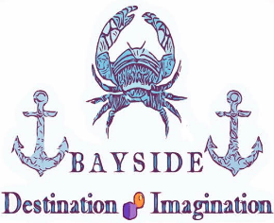
Please return application along with payment no later than Tuesday Oct 1st

Student name: ___________________________________ DOB:___________ Grade level: __________
Mailing address: ____________________________________________________________________________________
Phone (parent): __________________________ Phone (student): _______________________
Parent’s email address: __________________________________________________________________
STUDENTS: please mark your top 3 choices for which challenge you would prefer to work on. Mark from 1 to 3 on the blanks to indicate your 1st, 2nd, and 3rd preference. This information will help us in team selections. Note: you may find a description of each of the individual challenges at https://www.destinationimagination.org/challenge-program/challenge-previews/
____Scientific ____ Engineering ____ Fine Arts ____ Technical ____ Service Learning ____Improvisational
Please circle the day(s) you are available to participate: M Tu W Thu F
I have enclosed a check for $100 to cover registration and team fees
``````````````````````````````````````````````````````````````````````````````````````````````````````````````````````````````````````````````````
PARENTS:
In order to accommodate the large number of students who have expressed interest in joining DI, we are in need of parent volunteers to serve as team managers. Destination Imagination provides extensive training for managers. If you would like more information on becoming a team manager, please contact Beth Nowak at 703.405.7297 or baysidedestinationimagination@gmail.com .
I am interested in serving as a team manager
Parent name: __________________________________________ Phone: _________________________
Parent email: ____________________________________________ Day(s) available: M Tu W Th F

Please return application, student contract, & payment to Bayside DI at
4335 Little Falls Road Huntingtown, MD 20639

Student Contract
Destination Imagination teams and coaches need a supportive and encouraging environment as they work towards a solution of the long term challenge and prepare for the regional competition. To show my support for my fellow team members, team leaders, and other Destination Imagination teams:
□ I will encourage my fellow team members. I will listen to and consider their ideas and suggestions. I will show my respect for the feelings of my team members.

□ I will respect my team leaders. I will remember that all team leaders volunteer their time to help me and my team work towards our solution.

□ I agree to solve the long term challenge with my team members. I understand that “interference” is not permitted and agree to talk with my team leaders whenever I am not clear about what assistance is permitted. I understand that all creations, inventions, decorations, and ideas must be my team’s own.

□ I will be supportive of other Destination Imagination teams and team members. I will remember that good sportsmanship and proper behavior is expected of all Destination Imagination teams at all times.

□ I will remember that if a suggestion that I make to the team is not used, this does not mean that the suggestion was not valuable. It may be used at a later time.

□ I understand the Destination Imagination is a long term commitment to my fellow team members and to my team leaders. I agree to attend and participate at each team meeting and to work toward all team goals. If there is an attendance conflict, I will ensure that the team leaders are notified (in advance if possible).

Student Signature __________________________________________ Date _______________

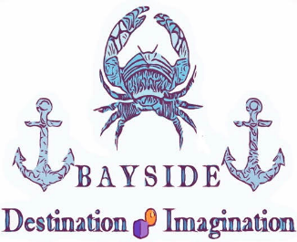

MEDIA RELEASE FORM

I hereby consent to Bayside Destination Imagination, Maryland Destination Imagination, and Destination Imagination, Inc. to use my photo or video for publicity purposes, fundraising efforts or any other lawful purpose whatsoever. (Your signature on this form permits the organizers and sponsors of the above-mentioned Destination Imagination programs to use videotapes and photographs of team members, team managers, and volunteers.)
Name: ________________________________________________________________
Home address: _________________________________________________________
City, State, Zip: _________________________________________________________
Home Phone: __________________________________________________________
SIGNATURE: __________________________________________________________
Date: _________________________________________________________________
Team Name: ___________________________________________________________
Team Number: _________________________________________________________
Team Manager’s Name (s): _______________________________________________

Persons under 18 years of age must have consent of parent or guardian.
I, the undersigned, being the parent of the above minor, do hereby consent to and agree to be bound by the above release.
Parent/Guardian Name: _________________________________________________
SIGNATURE: _________________________________________________________
DATE: _______________________________________________________________

